# 第一部分 Android App架构设计

## 一设计原则与设计模式

## 二 AOP架构设计

## 三 IOC架构设计

## 四 项目框架设计

## 五 App纵向架构设计

### 1 MVC

### 2 MVP

### 3 MVVM

使用DataBinding

### 4 AAC

Android架构组件四 Android Architecture Components LiveData组件解析

1 前言

简单的说，LiveData<T>是一个数据持有类,持有的数据可被观察者观察。它具有以下特点

数据可以被观察者订阅；

能够感知组件（Fragment、Activity、Service）的生命周期；

只有在组件出于激活状态（STARTED、RESUMED）才会通知观察者有数据更新；

当然这里的组件都是指实现了LifecycleOwner接口的组件。

官方推荐我们使用LiveData时结合ViewModel来使用，从而达到解耦的目的。那么为什么需要使用LiveData呢？或者说，使用LiveData能给我们带来什么好处呢？

2 LiveData的功能

从官方文档来看，LiveData的使用有以下几大好处

保证UI状态和数据的统一

LiveData采用了观察者设计模式。当生命周期状态改变时，LiveData会通知Observer对象。每次应用程序数据更改时，都会通知观察者对象，从而更新UI。

减少内存泄漏

LiveData能够感知到组件的生命周期，观察者绑定到生命周期对象，并在其相关生命周期被破坏后自行清理。

当Activity停止时不会引起崩溃

这是因为组件处于非激活状态时，不会收到LiveData中数据变化的通知

不需要额外的手动处理来响应生命周期的变化

 这一点同样是因为LiveData能够感知组件的生命周期，所以就完全不需要在代码中告诉LiveData组件的生命周期状态。

组件和数据相关的内容能实时更新

 组件在前台的时候能够实时收到数据改变的通知，这是可以理解的。当组件从后台到前台来时，LiveData能够将最新的数据通知组件，这两点就保证了组件中和数据相关的内容能够实时更新。

针对configuration change时，不需要额外的处理来保存数据

  我们知道，当你把数据存储在组件中时，当configuration change（比如语言、屏幕方向变化）时，组件会被recreate，然而系统并不能保证你的数据能够被恢复的。当我们采用LiveData保存数据时(结合ViewModel)，因为数据和组件分离了。当组件被recreate，数据还是存在LiveData中，并不会被销毁。

资源共享

 通过继承LiveData类，然后将该类定义成单例模式，在该类封装监听一些系统属性变化，然后通知LiveData的观察者，这个在继承LiveData中会看到具体的例子。

3 LiveData类图

4 LiveData解析

LiveData观察者模式如何实现？

LiveData如何感知组件生命周期？

LiveData如何通知观察者数据更新？

## 六 APP横向架构设计

### 1 模块化 组件化 插件化基本概念

#### 1模块化

以Module的形式存在工程中，可以是Android library java Library

模块更灵活，耦合较低，随意插拔

#### 2组件化

组件化是建立在模块化思想上的一次演进，一个变种。组件化本来就是模块化的概念。但是组件化的核心是

什么？ 是模块角色的可转换性。是的，就是可转换性。

**组件化的核心是角色的转换。 在打包时， 是library; 在调试时， 是application。**

组件化的耦合性比起模块化来说更低

#### 3插件化

插件化实现的也是解耦与加快编译，同时实现热插拔也就是热更新。

组件化的灵活性在于按加载时机切换，分离出独立的业务组件，比如微信的朋友圈

插件化的灵活性在于是加载apk, 完全可以动态下载，动态更新，比组件化更灵活。

### 2 横向架构的通信方式

**模块化：**模块化的通信方式，无非是相互引入；我抽取了common, 其他模块使用自然要引入这个module

**组件化：**组件化的通信方式，按理说可以划分为多种，主流的是隐式和路由。隐式的存在使解耦与灵活大大降低，因此路由是主流

**插件化：**插件化的通信方式，不同插件本身就是不同的进程了。因此通信方式偏向于Binder机制类似的进程间通信

### 3 组件化通信框架ARouter

### 4 组件化APP实战

对一个APP实行组件化，有两点指导思想

1 横向划分：业务模块化

2 纵向分层：代码逻辑分层

组件化一般会遇到以下几个问题

#### 1 组件模式和集成模式的转换

1、application属性，可以独立运行的Android程序，也就是我们的APP；

apply plugin: ‘com.android.application’

2、library属性，不可以独立运行，一般是Android程序依赖的库文件；

apply plugin: ‘com.android.library’

定义一个变量来控制

/**

* 定义一些公共变量 ext 为闭包

*/

ext{

/**

* 是否是Module 每次更改“isModule”的值后，需要点击 "Sync Project" 按钮

*/

isModule = false

}

然后在build.gradle中声明如下：

if (rootProject.ext.isModule.toBoolean()){

apply plugin: 'com.android.application'

}else {

apply plugin: 'com.android.library'

}

这样解决了组件模式和集成模式切换的问题

#### 2 组件之间AndroidManifest合并问题

这个问题解决思路就是在组件模式和集成模式下使用不同的manifest.xml

(1)main下新建module目录，新增manifest.xml文件

(2)build.gradle配置如下

sourceSets {

main {

if (isModule) {

manifest.srcFile 'src/main/module/AndroidManifest.xml'

} else {

manifest.srcFile 'src/main/AndroidManifest.xml'

java {

//全部Module一起编译的时候剔除debug目录

exclude '**/module/**'

}

}

}

}

#### 3 组件模式与集成模式Context等转换问题

与manifest.xml类似，我们也可以使用如下代码

1. 在module下创建java文件，存放java代码
2. build.gradle中配置

sourceSets {

main {

if (isModule) {

manifest.srcFile 'src/main/module/AndroidManifest.xml'

java.srcDirs = ['src/main/module/java']

} else {

manifest.srcFile 'src/main/AndroidManifest.xml'

java {

//全部Module一起编译的时候剔除debug目录

exclude '**/module/**'

}

}

}

}

#### 4 library依赖问题

对于重复依赖的库，编译错误时，在上层使用exclude命令，根据组件名排除或者根据包名排除

例如

dependencies {

compile fileTree(dir: 'libs', include: ['*.jar'])

compile("com.jude:easyrecyclerview:$rootProject.easyRecyclerVersion") {

exclude module: 'support-v4'//根据组件名排除

exclude group: 'android.support.v4'//根据包名排除

}

}

#### 5 组件之间调用和通信

这个问题一般的解决思路就是使用路由和面向接口编程来解决，具体说来

四大最贱跳转：使用URL路由，例如ARouter

远程调用：使用面向接口编程的IService来解决

例如ModuleA需要启动一个ActivityB，该Activity在ModuleB中，一般使用如下方式

#### 6 组件之间资源名冲突

build.gradle配置

//设置了resourcePrefix值后，所有的资源名必须以指定的字符串做前缀，否则会报错。

//但是resourcePrefix这个值只能限定xml里面的资源，并不能限定图片资源，所有图片资源仍然需要手动去修改资源名。

resourcePrefix "girls_"

但是设置了这个属性后有个问题，所有的资源名必须以指定的字符串做前缀，否则会报错，而且resourcePrefix这个值只能限定xml里面的资源，并不能限定图片资源，所有图片资源仍然需要手动去修改资源名；所以我并不推荐使用这种方法来解决资源名冲突。

#### 7 组件化项目的混淆方案

组件化项目的Java代码混淆方案采用在集成模式下集中在app壳工程中混淆，各个业务组件不配置混淆文件。集成开发模式下在app壳工程中build.gradle文件的release构建类型中开启混淆属性，其他buildTypes配置方案跟普通项目保持一致，Java混淆配置文件也放置在app壳工程中，各个业务组件的混淆配置规则都应该在app壳工程中的混淆配置文件中添加和修改。

之所以不采用在每个业务组件中开启混淆的方案，是因为 组件在集成模式下都被 Gradle 构建成了 release 类型的arr包，一旦业务组件的代码被混淆，而这时候代码中又出现了bug，将很难根据日志找出导致bug的原因；另外每个业务组件中都保留一份混淆配置文件非常不便于修改和管理，这也是不推荐在业务组件的 build.gradle 文件中配置 buildTypes （构建类型）的原因

#### 8 Fragment或View如何支持组件化

## 七 典型App架构设计

安居客

沪江学习

滴滴国际化

## 八 架构设计原则

1 可复用性

软件层次的划分，各个层次的依赖关系。功能模块的划分，便于各个子功能与基础功能的复用

2 可扩展性

利于后期需求的加入以及软件架构本身的演进

3 可维护性

有利于人力的分配，开发人员维护起来压力小。功能模块及层次划分，依赖解耦

4 人力资源与项目管理平衡

人力紧张与项目版本发布周期的平衡，主要体现在实际操作中，拉分支

# 第二部分 Android性能优化

## 简介

### 1 性能优化所面临的问题

* 性能表现差

app性能表现差，启动慢，卡顿，丢帧

内存占用高，抖动平凡，内存泄露，内存溢出

耗电，网络请求慢

奔溃率高，异常率高

* 线上问题无从追查

针对此，我们一般需要关注的问题是

如何保证异常感知

如何复现

如何快熟止血成功

* 性能优化长期开销大

如何问题扼杀在萌芽中

性能优化如何长期保持

### 2 app性能优化方案演进

* 项目初期

只关注崩溃率

* 项目壮大期

完善个个数据采集

接入一套APM

* 项目成熟期

关注重点性能问题，数据丰富，手段多样化

线上线下一整套解决方案

自建APM

* 线上线下对比

误区 对线上不重视

侧重点 线下预防，线上监控

方案不同 线下可用黑科技

### 3 业界优秀平台化实践

* crash收集平台

bugly

* APM平台

听云

* 自建解决方案

美团，携程，360等

优化思路：

AS3.0以后，都采用Android Profiler来进行性能分析

## 一 APP启动优化

### 1 APP启动类别

https://developer.android.com/topic/performance/vitals/launch-time

#### 1.冷启动

冷启动指的是应用程序从头开始：系统的进程没有，直到此开始，创建了应用程序的进程。 在应用程序自设备启动以来第一次启动或系统杀死应用程序等情况下会发生冷启动。 这种类型的启动在最小化启动时间方面是最大的挑战，因为系统和应用程序比其他启动状态具有更多的工作。

启动时分为以下几步

1 加载和启动app

2 加载空白window

3 创建App进程

随后进行如下步骤

1 创建Application对象，并回调其方法

2 启动主线程

3 创建MainActivity

4 初始化View和加载布局

5 布局屏幕

6 首帧绘制

#### 2.暖启动

当应用中的Activity被销毁，但在内存中常驻时，应用的启动方式就会变为暖启动。相比冷启动，暖启动过程减少了对象初始化、布局加载等工作，启动时间更短。但启动时，系统依然会展示一个空白背景，直到第一个Activity的内容呈现为止。

温启动只会走activity的生命周期，不会走Application的生命周期

#### 3.热启动

相比暖启动，热启动时应用做的工作更少，启动时间更短。热启动产生的场景很多，常见如：用户使用返回键退出应用，然后马上又重新启动应用。

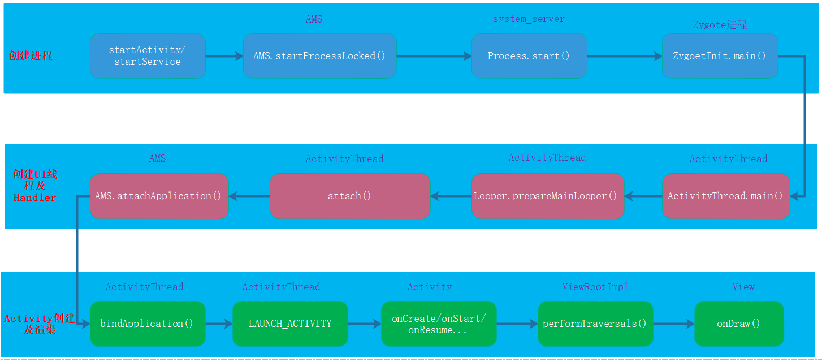

我们能做的是在LifeCycle阶段即创建Application对象之后能做，其他的都是系统行为，无法进行优化

优化方向：Application及Activity生命周期各个阶段

### 2 APP启动测量

#### 1 adb 命令测量

adb shell am start –W packageName/首屏Activity

例如：

adb shell am start –W com.qiyei.mall/com.qiyei.mall.ui.activity. MainActivity

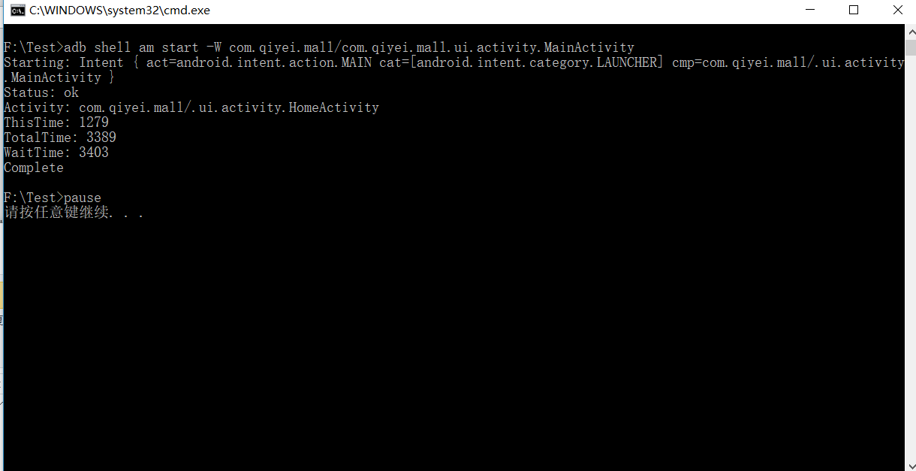

MainActivity 是首页，HomeActivity是主页

ThisTime: 最后一个Activity启动耗时

TotalTime: 启动所有Activity耗时

WaitTime: AMS启动Activity耗时

#### 2 ActivityManager中日志打印

ActivityManager: Displayed com.android.myexample/.StartupTiming: +3s534ms (total +1m22s643ms)

这个时间从应用启动（创建进程）开始计算，到完成视图的第一次绘制

#### 3 手动打点

在Application中的attachBaseContext和首个View完全展示完成后打点记录

这里首个View可以是界面的某个View绘制完成，也可以选择onWindowFocusChanged中，只是在界面的View中添加监听器较为准确一些。因为onWindowFocusChanged是首帧时间。

对于RecycleView可以选在在item的第一条展示时添加绘制监听回调

对于普通View也可以添加

if (position == 0 && !hasStart){

hasStart = true

holder.itemView.mDiscountAfterTextView.viewTreeObserver.addOnPreDrawListener(object : ViewTreeObserver.OnPreDrawListener{

override fun onPreDraw(): Boolean {

LauncherManager.getDefault().end("holder.itemView onPreDraw")

holder.itemView.mDiscountAfterTextView.viewTreeObserver.removeOnPreDrawListener (this)

return true

}

})

//holder.itemView.mDiscountAfterTextView.

}

对于普通View

xxxView.viewTreeObserver.addOnPreDrawListener(object : ViewTreeObserver.OnPreDrawListener{

override fun onPreDraw(): Boolean {

LauncherManager.getDefault().end("holder.itemView onPreDraw")

xxxView.viewTreeObserver.removeOnPreDrawListener (this)

return true

}

})

此方法可以带到线上去使用

#### 4 Systrace测量

使用Systrace也可以看到启动的耗时，不过一般不用来进行测量，systrace一般主要用于分析启动过程中的耗时在那个地方

### 3 App启动优化

#### 1 启动优化工具使用

##### 1 systrace分析启动耗时

找到要启动的进程com.qiyei.mall如下

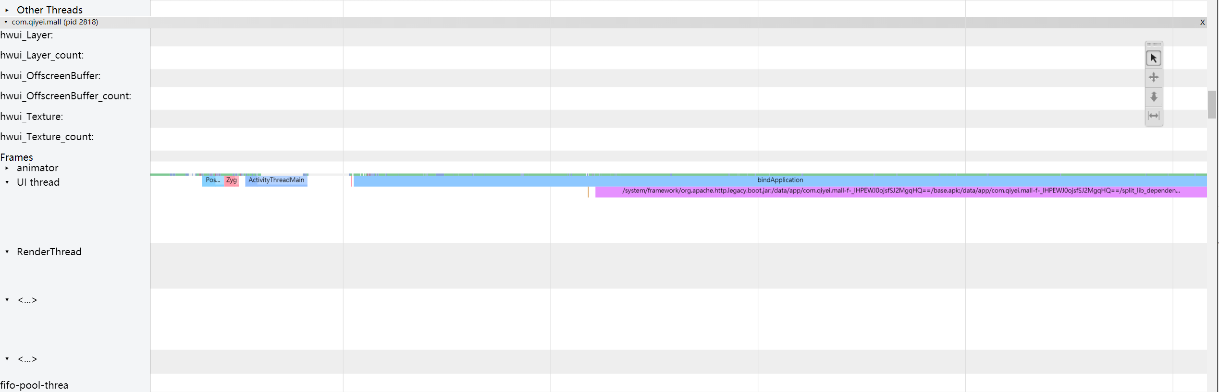

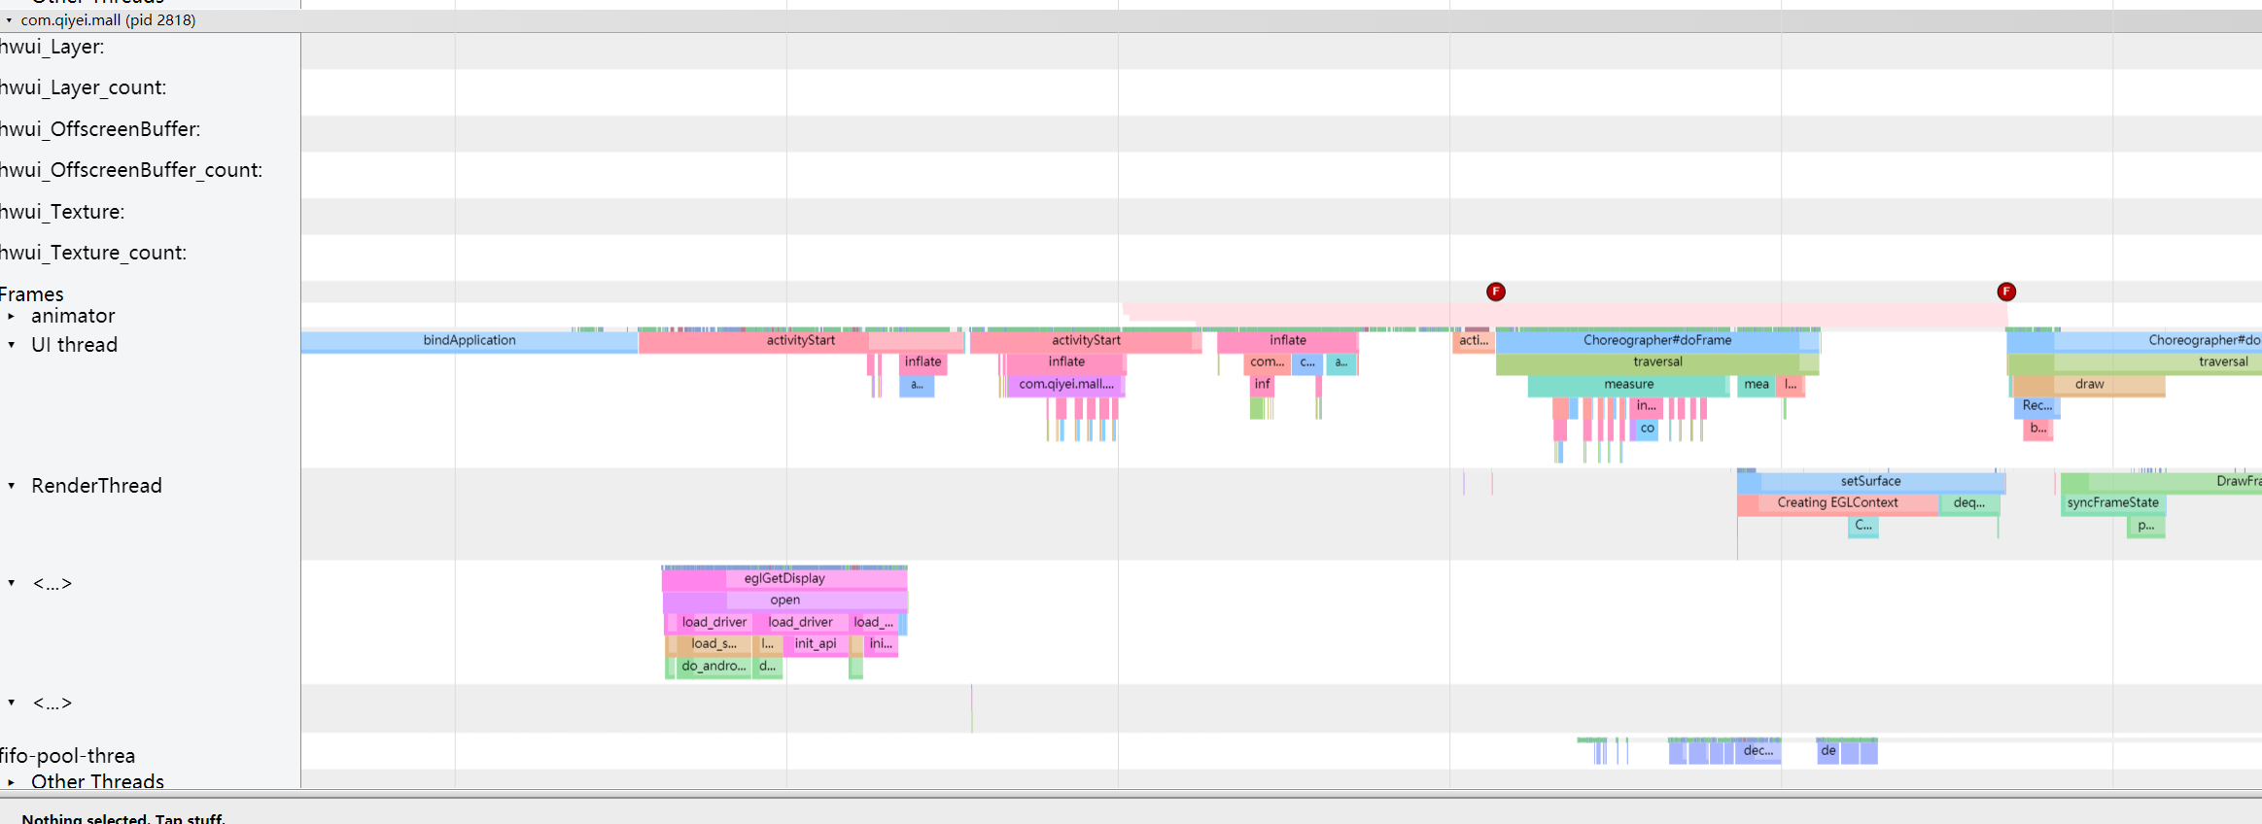

依次看以下几个

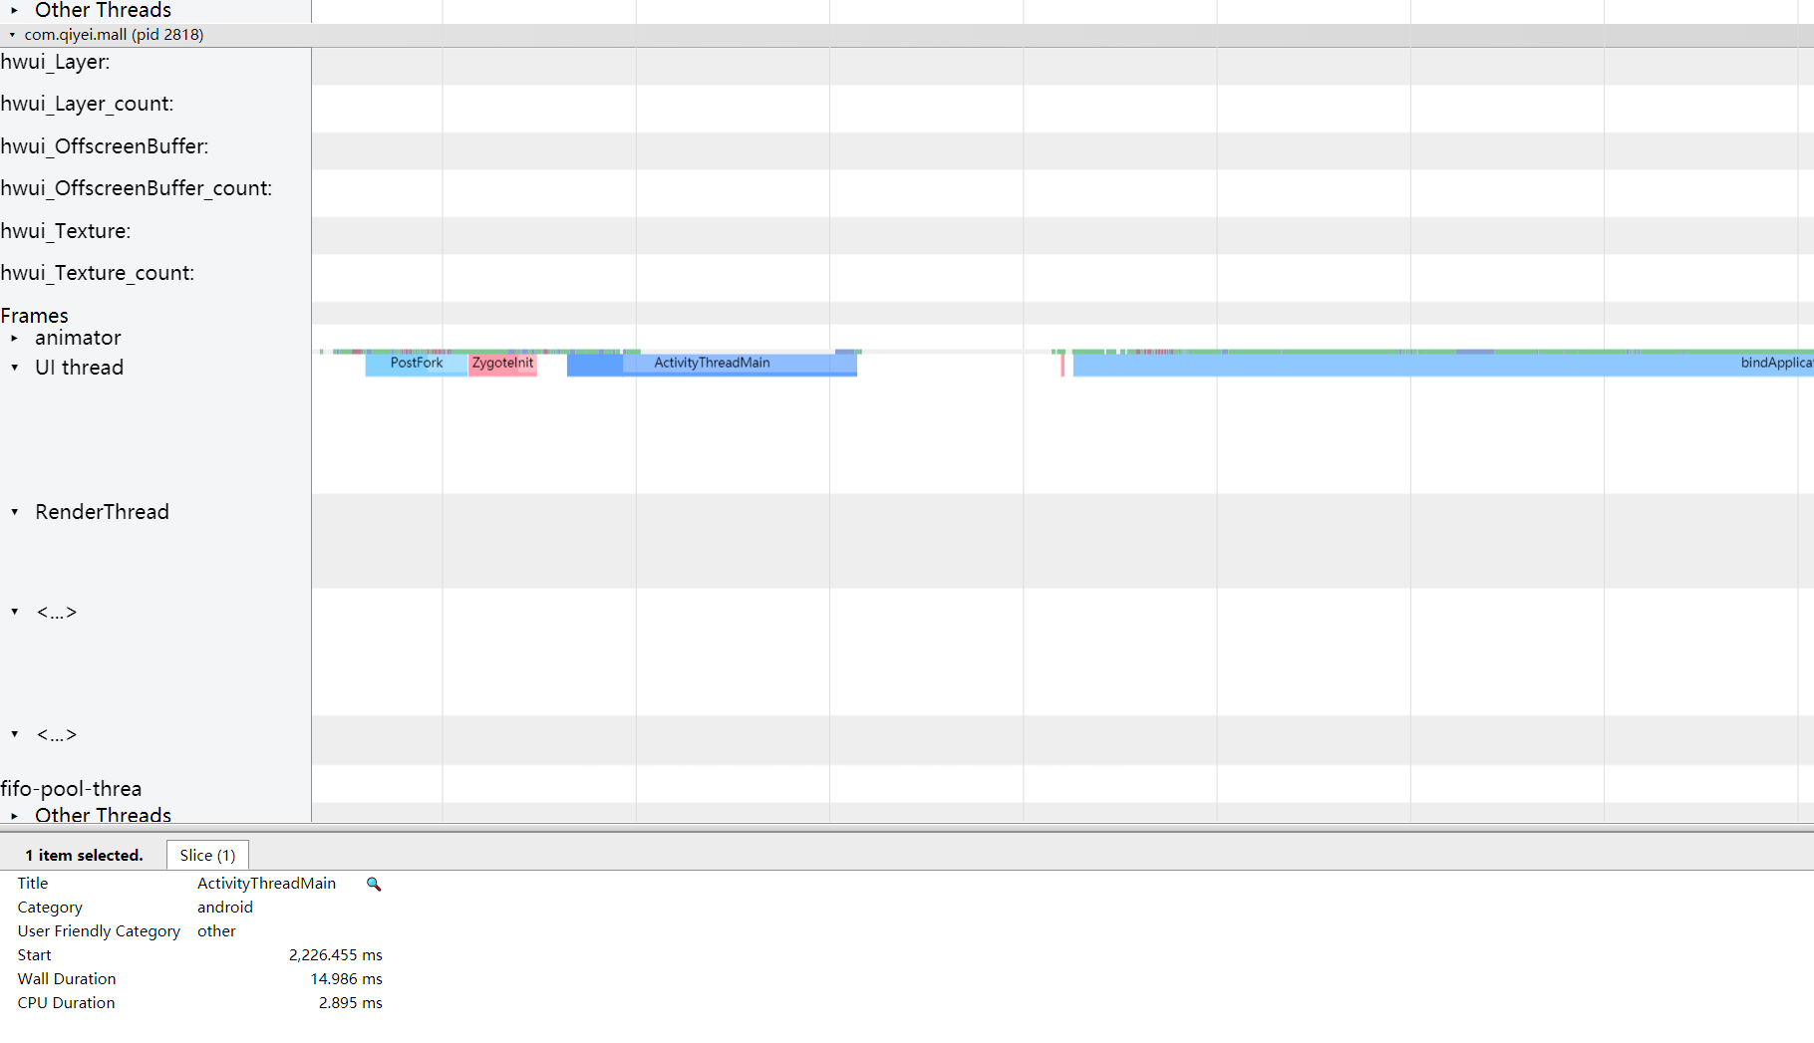

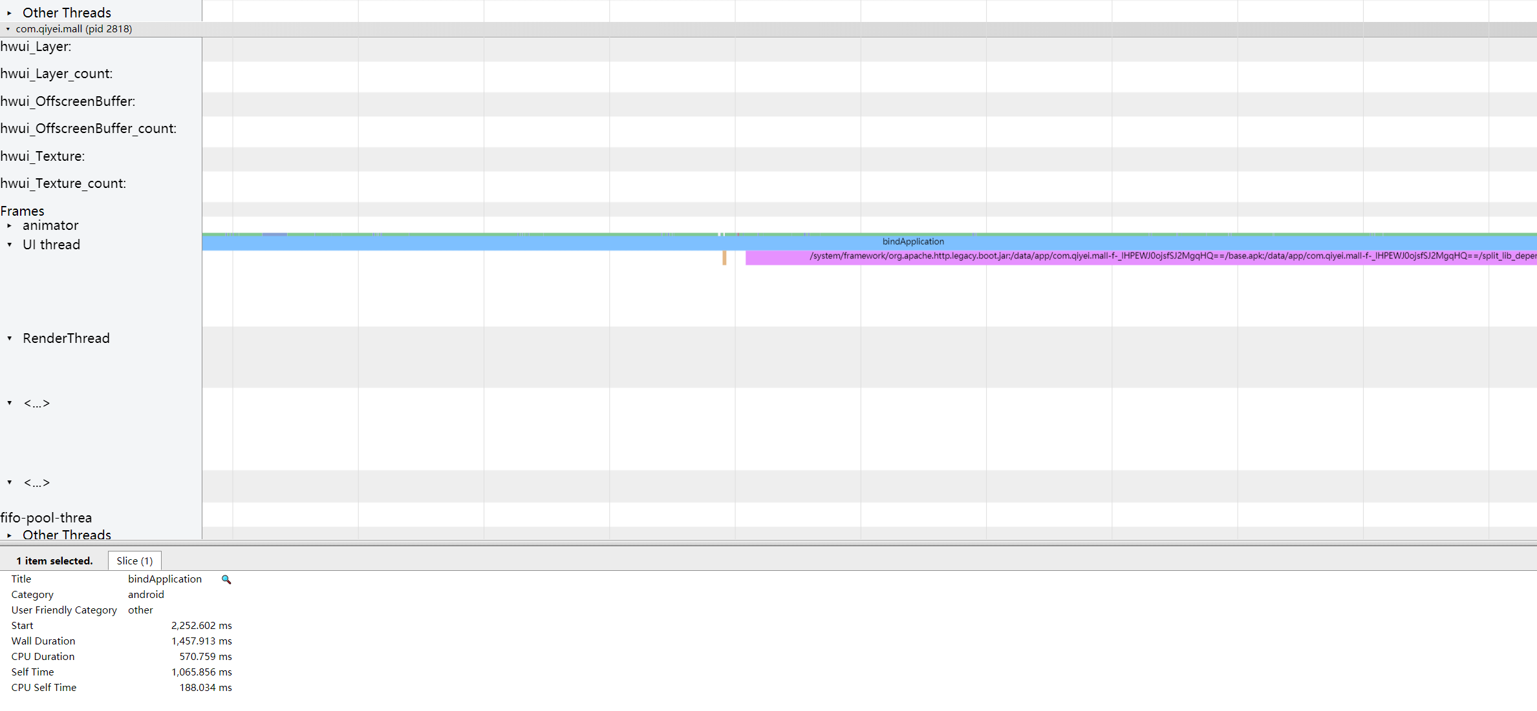

Wall Duration 代码持续耗时时间，即这段代码的耗时时间

CPU Duration 这段代码在CPU上真正的耗时

Wall Duration 代码总耗时:CPU耗时+CPU等待耗时

锁冲突会造成cpu 和wall不一样，锁等待会耗时

可以看到ActivityThreadMain中CPU Duration与Wall Duration相差不大，但是bindApplication中CPU Duration与Wall Duration相差两倍，因此我们知道在bindApplication过程中耗时较长，可以进行优化

依次查看其它过程，特别是绘制第一帧

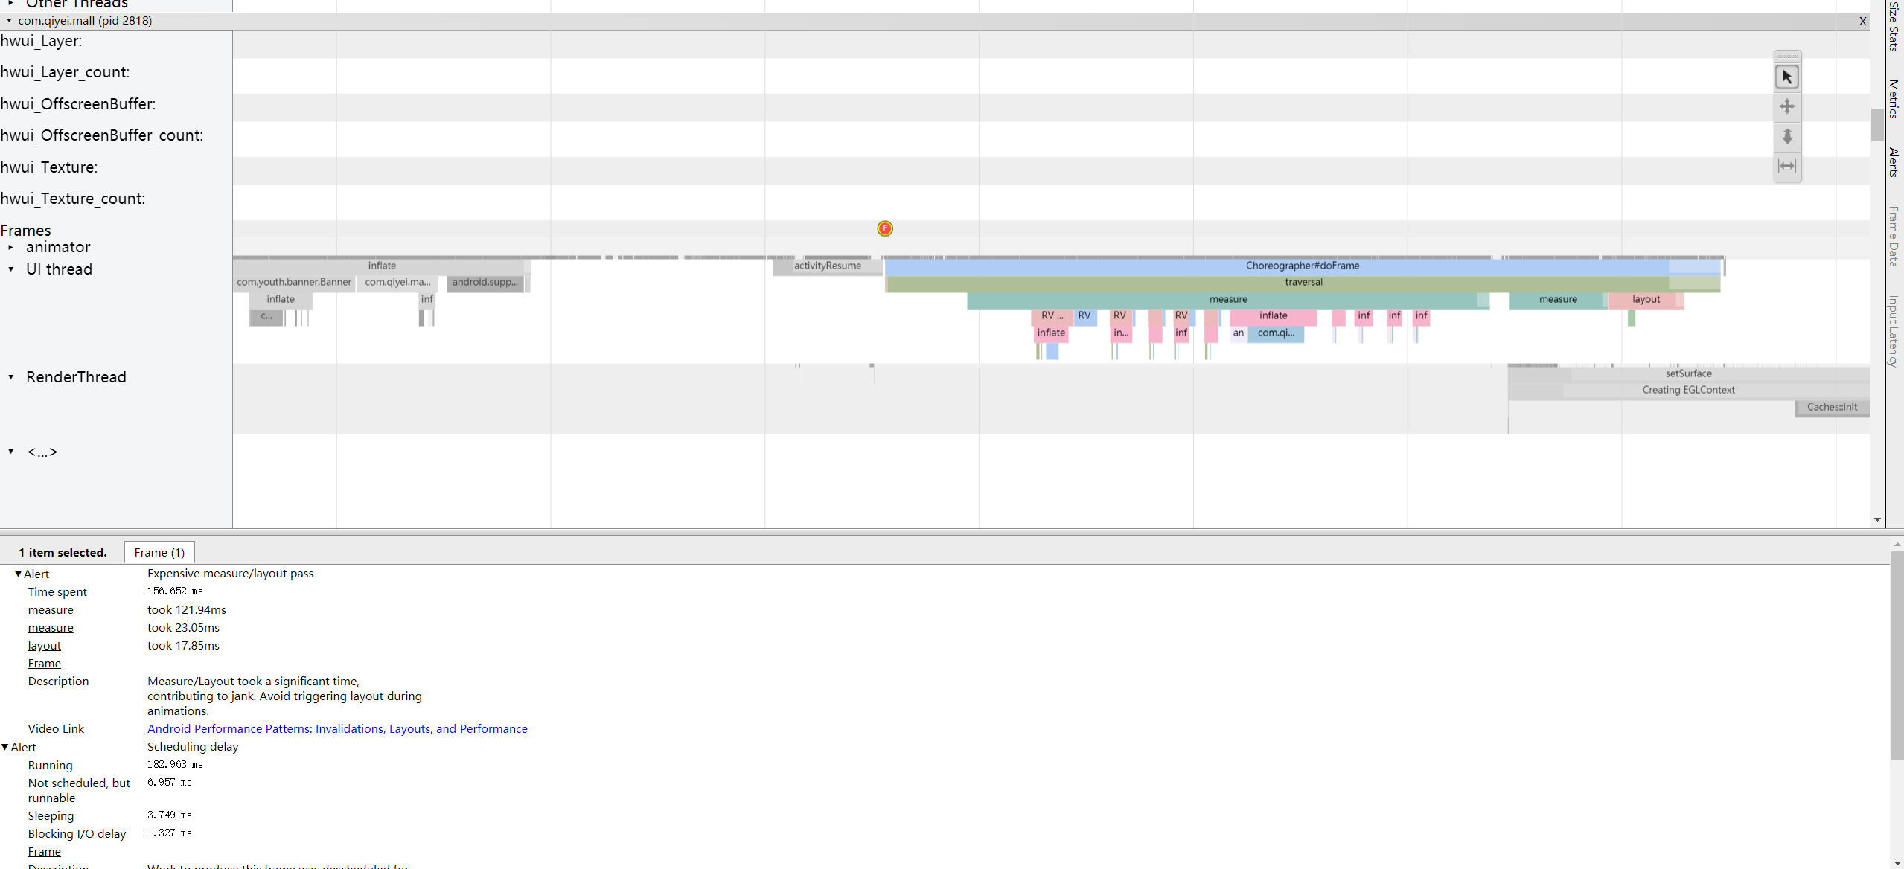

可以看到已经给我们了警告，我们的第一次测量花费了121.94ms,第二次为23.05ms,布局花了17.85ms

因此，综合systrace来看，我们的启动过程中耗时的主要地方在bindApplication和绘制第一帧过程中

##### 2 TraceView分析耗时

在Application中添加如下代码开始抓取TraceView

Debug.startMethodTracing("mall_start");

在HomeActivity中onWindowFocusChanged记录结束点

override fun onWindowFocusChanged(hasFocus: Boolean) {

super.onWindowFocusChanged(hasFocus)

Debug.stopMethodTracing()

}

#### 2 启动白屏/黑屏问题

##### 1 启动白屏黑屏原因

白屏或黑屏，具体是哪一个，取决于app的Theme使用的是dark还是light主题

Android Studio 引起的白屏

2.x时代的AS开启了instant run以后可能会导致白屏，但实际完整的apk包不会出现此问题

冷启动引起的白屏/黑屏

点击你app那一刻到系统调用Activity.onCreate()之间的时间段。在这个时间段内，WindowManager会先加载app主题样式中的windowBackground作为app的预览元素，然后再真正去加载activity的layout布局

暖启动/热启动引起的白屏/黑屏

这点在配置较好，内存空间充足的手机上不是很明显，但低端手机或者内存吃紧的情况下依旧会出现”闪屏”效果，持续时间很短，一闪而过

##### 2 启动白屏黑屏问题解决

此时我们已经“消除了”白屏/黑屏页，将冷启动的白屏/黑屏单调的纯色背景替换为我们即将展示给用户的 InitializeActivity界面的图片，从系统的Window到我们自己App跳转过程，使用了全屏属性，以达到无缝跳转

需要说明的是，这一步做了之后，对整体启动时间并没有任何的减少，时间不变，只是说给用户的体验要友好很多，不再显示一个突兀的白屏/黑屏界面 ------将锅甩给自己app，app太卡，居然在InitializeActivity要等这么久（当然用户不知道的是：系统window界面和InitializeActivity不是同一个界面）

当然也可以采用另一种方式，那就是将上面的主题中的backgroud设置为透明用户点击了图标开始启动的时候，界面上没有任何变化，因为此时系统启动的那个白屏/黑屏界面背景透明的 ------将锅甩给系统，太卡，点了图标居然隔了这么久才显示InitializeActivity

代码如下：

<style name="SplashTheme" parent="AppTheme">

<!-- Customize your theme here. -->

<item name="android:windowFullscreen">true</item>

<item name="android:windowBackground">@drawable/app_startup</item>

</style>

定义闪屏主题，在manifest中运用

<activity android:name=".ui.activity.MainActivity"

android:theme="@style/SplashTheme">

<intent-filter>

<action android:name="android.intent.action.MAIN"/>

<category android:name="android.intent.category.LAUNCHER"/>

</intent-filter>

</activity>

然后在MainActivity中在setContentView之前设置App原来的主题

override fun onCreate(savedInstanceState: Bundle?) {

setTheme(R.style.AppTheme)

super.onCreate(savedInstanceState)

setContentView(R.layout.activity_main)

….

}

这样启动白屏，黑屏的问题就解决了

#### 3 APP启动优化方案

要进行APP的启动优化，需要精确的拿到App和Activity的生命周期执行的方法耗时，因此需要先测量方法耗时

##### 1 AOP测量方法耗时

在Android中引入Aspectj等AOP框架，进行启动方法的耗时测量，根据测量结果得到谁在耗时

##### 2 异步加载初始化任务

异步优化核心思想 子线程分担主线程，并行减少时间

异步优化注意

部分代码不符合异步要求，修改其符合

需要在某个阶段必须完成，countdownlatch，处理好依赖关系

区分CPU密集型，IO密集型

##### 3 启动的设计

针对第二点的问题，设计启动器来针对APP启动优化，详细见工程代码

##### 4 延迟部分任务

对于部分业务可以进行延迟初始化，这个时候可以进行延迟处理

核心思想 对延迟任务进行分批初始化

利用idleHandler空闲执行

##### 5 启动优化其他方案

* 提前加载shareprefences

multidex之前加载，利用此阶段cpu

* 启动阶段不启动子进程

子进程会共享cpu之源，导致主进程cpu紧张

注意启动顺序，app oncreate之前是contentprovider

* 类加载优化，提前异步类加载

class.forname只加载类本身极其静态变量的引用

new实例 可以额外加载类成员变量的引用类

* 启动阶段抑制GC
* 启动阶段cpu锁频

#### 4 线上启动优化监控方案

##### 1 精确的统计Task方法耗时并上报

##### 2 线上监控多阶段时间

app activity生命周期以及间隔时间并处理聚合看趋势

##### 3 收敛启动代码修改权限

结合ci修改启动代码需要review或通知

### 4 启动优化面试指南

#### 1 你做启动优化是怎么做的？

* 分析现状，确认问题

用户反馈启动速度慢，测试测试启动速度慢

启动代码流程梳理，启动流程复杂，冗长

通过工具分析，发现主线程执行了太多代码

* 针对性优化

异步初始化，例如耗时任务

延迟初始化，做了一些延迟初始化

* 怎么长期保持优化效果？

#### 2 是怎么异步的，异步过程中遇到那些问题？

* 体现演进过程

1 普通异步方案 -> 启动器

* 详细介绍启动器

抽象task,排序，有向无环图

#### 3 你做了启动优化，有哪些容易忽略的点

* cpu time 与wall time的区别
* 延迟初始化的优化
* 介绍下黑科技 类加载异步
* cpu拉高

#### 4 版本迭代导致启动变慢有好的解决方式吗？

* 启动器
* 结合ci
* 监控完善各个生命周期

## 二 APP布局及卡顿优化

### 1 Android绘制原理

#### 1 绘制原理

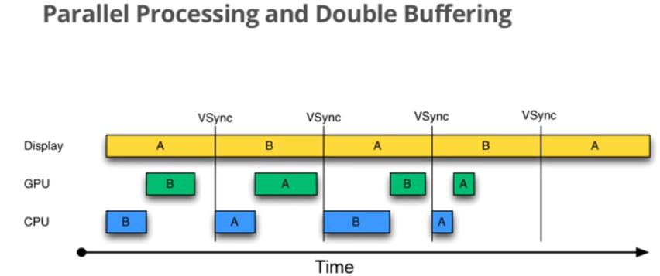

Vsync + Triple Buffer + Choreographer + SurfaceFlinger

60帧 16ms

#### 2 UI卡顿原因

绘制任务太重，导致绘制一帧时间太长

主线程太忙了，导致VSYNC信号来时还没有准备好数据导致丢帧

### 2 优化工具选择

#### 1 Systrace

使用TraceCompat开启trace抓取

关注frames这一行

正常:绿色圆点，

丢帧:黄色或红色

关注Alers栏

#### 2 CPU Profiler

记录和检查函数跟踪，点击record后记录,设置您的应用生成跟踪日志

##### 1 Call Chart 标签检查跟踪

Call Chart 标签提供函数跟踪的图形表示形式，其中，水平轴表示函数调用（或调用方）的时间段和时间，并沿垂直轴显示其被调用者

对系统 API 的函数调用显示为橙色，对应用自有函数的调用显示为绿色，对第三方 API（包括 Java 语言 API）的函数调用显示为蓝色。

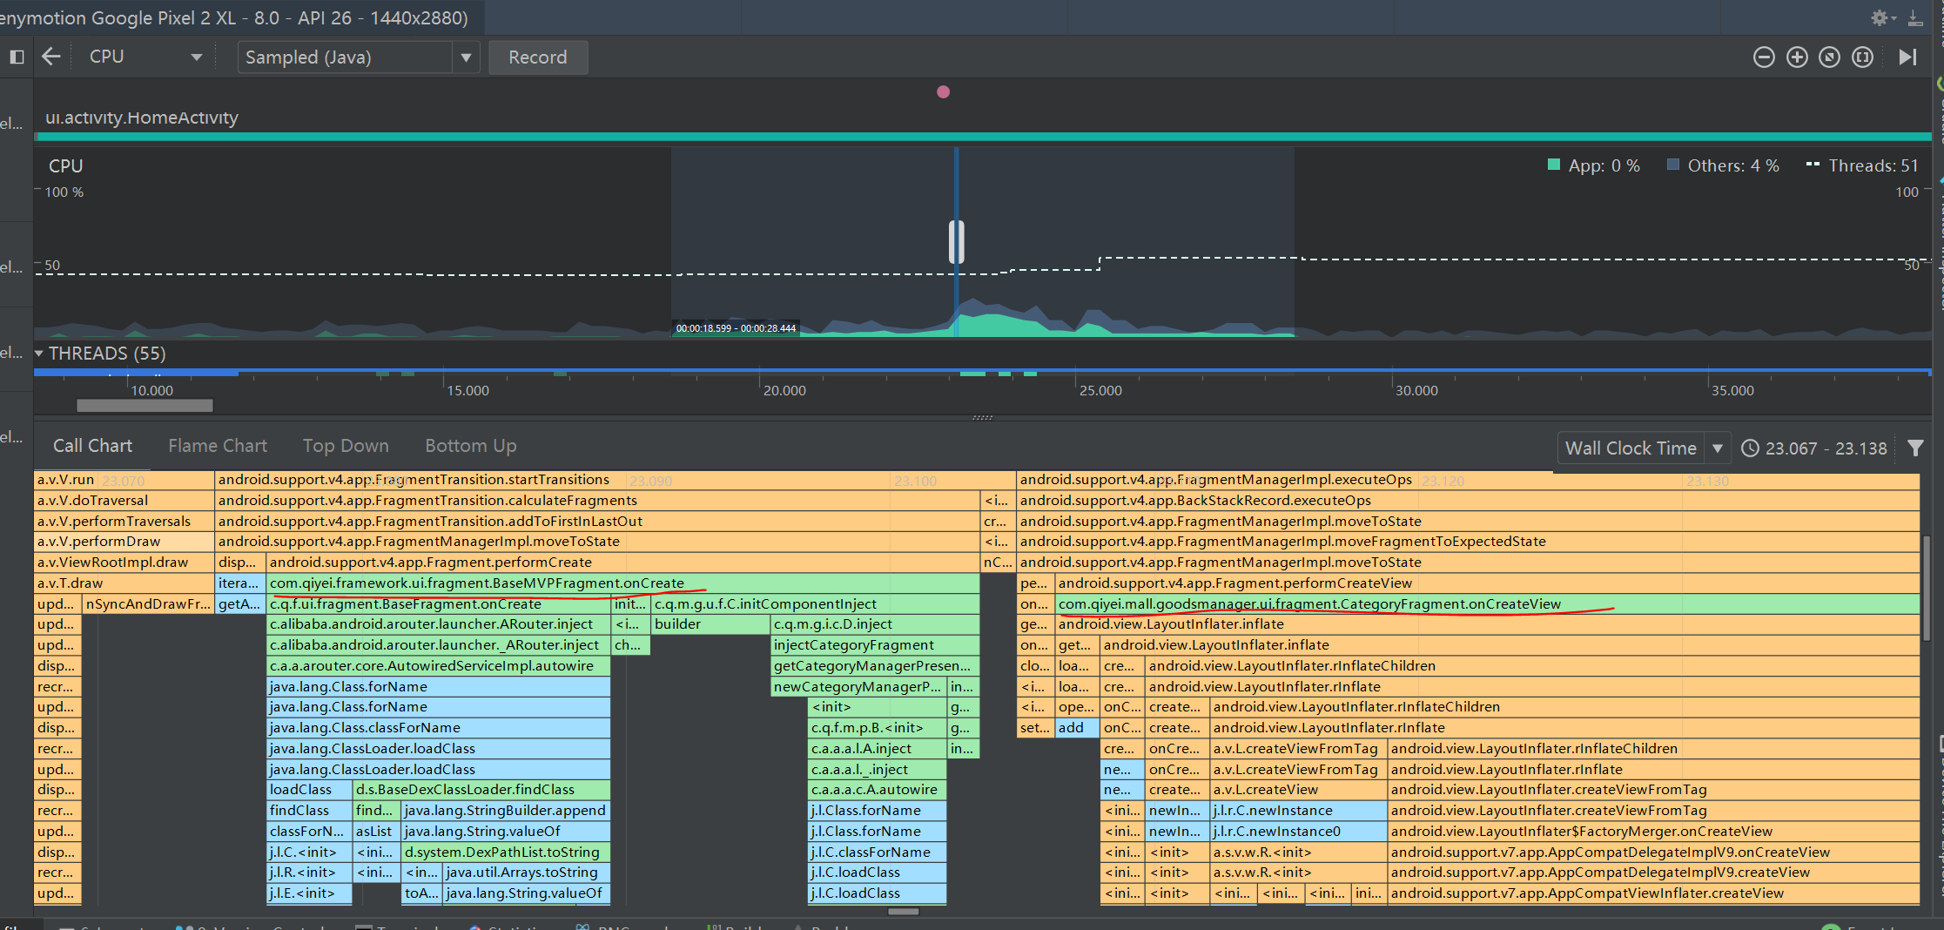

可以精确的看到每个自定义函数的执行时间

一个调用图表示例，描绘了函数 D 的 self、children 及总时间。

提示： 若要跳转到某个函数的源代码，请右键点击该函数并选择 Jump to Source。 这适用于任一跟踪窗格标签。

分析思路，着重看耗时长的函数，看一下耗时的时间在哪儿

##### 2 使用 Flame Chart 标签检查跟踪

Flame Chart 标签提供一个倒置的调用图表，其汇总相同的调用堆栈。 即，收集共享相同调用方顺序的完全相同的函数，并在火焰图中用一个较长的横条表示它们（而不是将它们显示为多个较短的横条，如调用图表中所示）。 这样更方便您查看哪些函数消耗最多时间。 不过，这也意味着水平轴不再代表时间线，相反，它表示每个函数相对的执行时间。

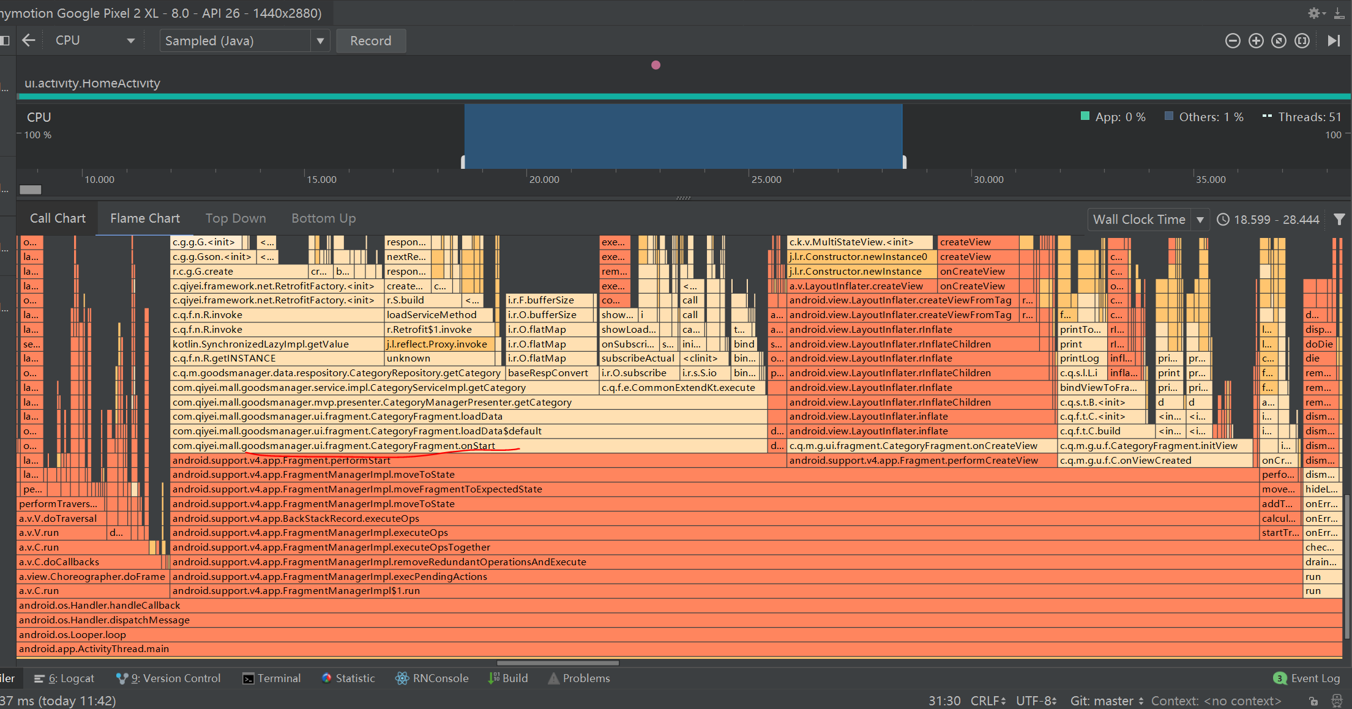

##### 3 使用 Top Down 和 Bottom Up 检查跟踪

Top Down 标签显示一个函数调用列表，在该列表中展开函数节点会显示函数的被调用方。 图 7 显示图 3 中调用图表的“Top Down”图表。图表中的每个箭头都从调用方指向被调用方。

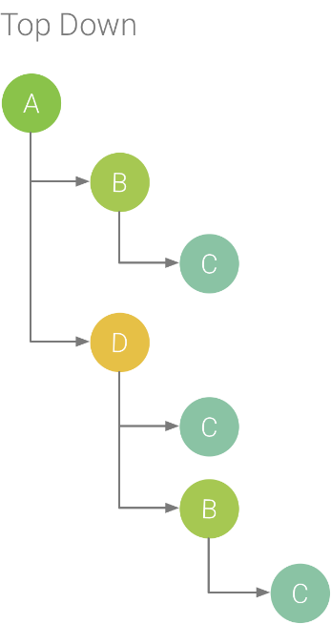

如图 7 所示，在“Top Down”标签中展开函数 A 的节点可显示它的被调用方，即函数 B 和 D。 然后，展开函数 D 的节点可显示它的被调用方，即函数 B 和 C 等等。 与 Flame chart 标签相似，“Top Down”树汇总共享相同调用堆栈的相同函数的跟踪信息。 也就是说，Flame chart 标签可提供Top down 标签的图形化表示形式。

Top Down 标签提供以下信息以帮助说明在每个函数调用上所花费的 CPU 时间（时间也可以用线程总时间占所选时间范围的持续时间的百分比表示）：

* Self： 表示函数调用在执行自己的代码（而非被调用方的代码）上所花的时间，如图 3 中的函数 D 所示。
* Children： 表示函数调用在执行自己的被调用方（而非自己的代码）上所花的时间，如图 3 中的函数 D 所示。
* 总和： 函数的 Self 和 Children 时间的总和。 这表示应用在执行函数调用上所花的总时间，如图 3 中函数 D 所示。

实例

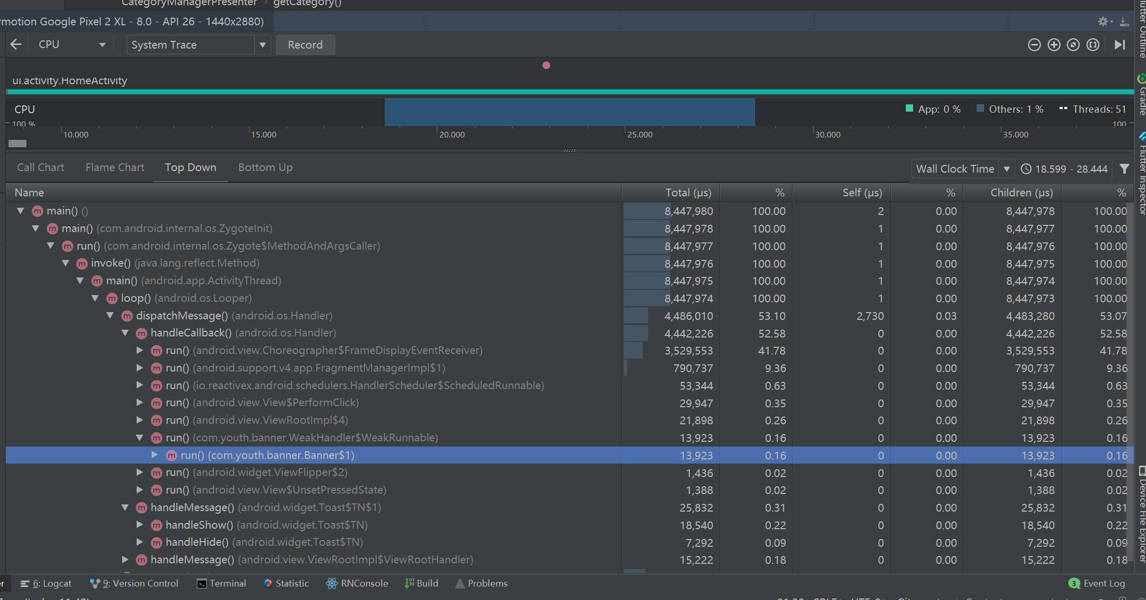

Bottom Up 标签显示一个函数调用列表，在该列表中展开函数节点将显示函数的调用方。 通过使用图 7 中展示的跟踪示例，图 8 为函数 C 提供了一个“Bottom Up”树。 在“Bottom Up”树中打开函数 C 的节点可显示它独有的调用方，即函数 B 和 D。 请注意，尽管 B 调用 C 两次，但在“Bottom Up”树中展开函数 C 的节点时，B 仅显示一次。 然后，展开 B 的节点显示其调用方，即函数 A 和 D。

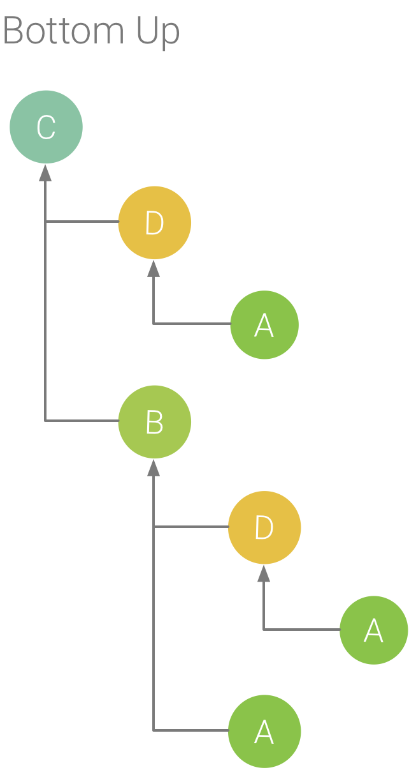

Bottom Up 标签用于按照消耗最多（最少）CPU 时间排序函数。 您可以检查每个节点以确定在调用函数上哪些调用方花了最多 CPU 时间。 与“Top Down”树相比，“Bottom Up”树中的每个函数的时间信息引用每个树顶部的函数（顶部模式）。 CPU 时间也可表示为在该记录期间占线程总时间的百分比。 下表有助于阐述如何解释顶部节点的时间信息及其调用方函数（子节点）。



#### 3 TraceView

使用代码开启

Debug.startMethodTracing()

…..

Debug.stopMethodTracing()

TraceView 分析函数调用过程，精确到每个函数执行时间 分析.trace文件

AS中cpu哪儿可以生成.trace文件

#### 4 BlockCanary 监控UI卡顿

#### 5 Profile GPU rendering

开发者模式 Profile GPU rendering 查看掉帧

#### 6 Choreographer类

可以获取FPS,可以线上使用

#### 7 Layout Inspector

替代Hierarchy View

查看布局树层次

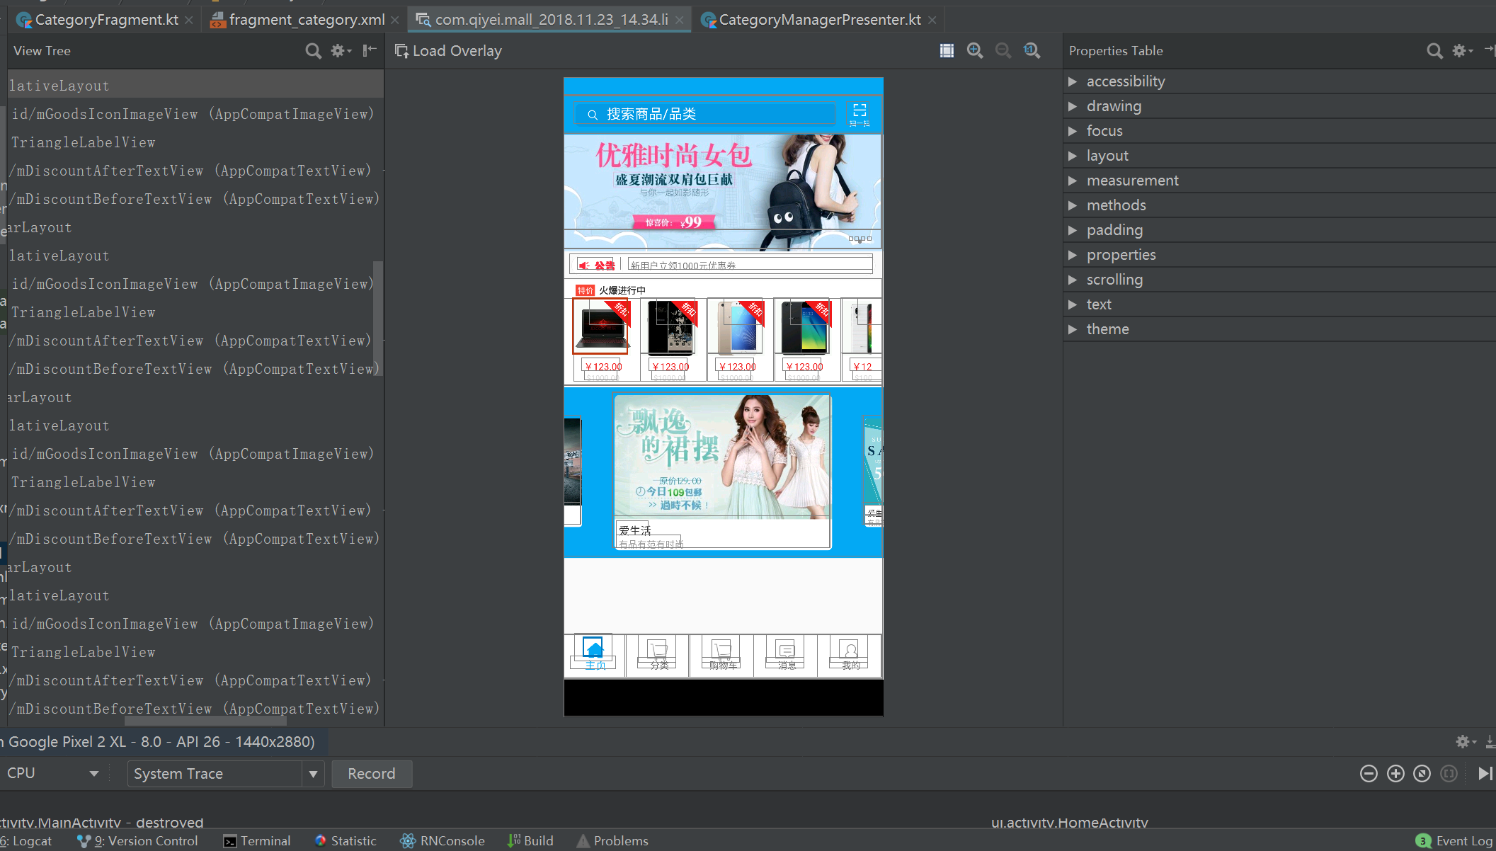

### 3 Android 布局加载原理

#### 1 setContentView流程

#### 2 布局的性能瓶颈

解析xml io 瓶颈

反射

### 4 布局优化实战

#### 1 优雅获取布局界面耗时

常规方法，直接获取setContentView()

ART Hook方式setContentView()

#### 2 获取某一控件的绘制耗时

LayoutInflaterCompat.setFactory2(LayoutInflater.from(this), new LayoutInflater.Factory2() {

@Nullable

@Override

public View onCreateView(@Nullable View parent, @NonNull String name, @NonNull Context context, @NonNull AttributeSet attrs) {

long time = System.nanoTime();

View view = getDelegate().createView(parent,name,context,attrs);

LogManager.i(TAG,"create " + name + " cost" + (System.nanoTime() - time)/1000 + " us");

return view;

}

@Nullable

@Override

public View onCreateView(@NonNull String name, @NonNull Context context, @NonNull AttributeSet attrs) {

return getDelegate().createView(null,name,context,attrs);

}

});

在super.onCreate(savedInstanceState)之前调用

#### 3 异步加载布局

AsyncLayoutInflater的使用

#### 4 布局优化

X2C框架实战

https://github.com/iReaderAndroid/X2C

#### 5 其他布局技巧

##### 1减少层级及复杂度

##### 2 include viewstub merge

##### 3 避免过度绘制

开发者模式下过度绘制检测开关

具体问题具体分析

检测线程部分

<!--代码示例：在application中进行配置即可-->

StrictMode.setThreadPolicy(new StrictMode.ThreadPolicy.Builder()

.detectAll()//监测所有内容

.penaltyLog()//违规对log日志

.penaltyDeath()//违规Crash

.build());

过度绘制解决思路

移除不必要的backgroud

在自定义View onDraw中使用canvas.clipRect指定绘制区域，防止重叠组件发生过度绘制

### 5 界面秒开实战

#### 1 Systrace

优雅异步,优雅延迟初始化

2 异步inflate

x2c 绘制优化

#### 3 提前获取页面数据

#### 4 秒开率统计

create 到Windowsfoucuschanged

或者特定接口

Lancet AOP 框架 监控生命周期耗时

### 6 耗时盲区监控

Handler 的耗时盲区

线下 可以用traceview 来监控

线上 使用统一的handler

定制gradle 插件，编译期替换

### 7 卡顿优化总结

#### 1卡顿优化实践经验

耗时操作:异步，延迟

布局优化 异步inflate X2C 重辉解决

内存问题 降低内存占用，减少GC 次数

2

### 8 Android Lint

代码扫描，关注性能部分，关注xml部分

### 9 布局与卡顿优化面试

#### 1 你在做布局优化中用到了哪些工具？

根据场景不同，使用不同的工具,线上，线下

* 获取FPS: Choreographer
* 获取布局耗时:AOP,Hook
* 线下工具:Systrace(每一帧耗时，以及做了什么), Layout Inspector

#### 2 布局为什么会导致卡顿，你又是怎么优化的？

从layoutInflate加载开始说起

* IO,反射，遍历，重绘

方案

* 异步Inflate，X2C,减少层级，重绘
* 使用AOP建立卡顿监控体系

#### 3 做完布局优化，你有哪些成果产出？

* 体系化监控手段:线上+线下

线下:AOP

线上:FPS

* 指标:FPS,加载时间，布局层级
* APP业务核心路径保障(每次上线前测试)

#### 4 你是怎么做卡顿优化的？

项目经历了不同阶段

* 第一阶段：使用系统工具定位，解决

对卡顿的代码进行异步处理和重构

* 第二阶段:自动化卡顿方案及优化

思路来自于android 消息处理机制

完善ANR的上报

* 第三阶段：线上监控及线下检测工具的建设

#### 5 怎么自动化获取卡顿信息？

思路来自于android消息处理机制

* mLogging.println
* 高频采集，找出重复堆栈

一个周期内，高频采集堆栈信息，上报给服务端

#### 6 卡顿的一整套解决方案怎么做的？

* 首先，线上，线下工具想结合

线上，监控的完整性

线下：尽早的暴露问题

* 特定难题突破:单点问题，耗时盲区监控

AOP获取可能耗时的逻辑

* 线上监控建设

## 三 内存优化

### 1 内存问题分类

#### 1 内存抖动

内存抖动：锯齿状，GC频繁，GC卡顿

内存抖动越剧烈，说明分配的内存越大

#### 2 内存泄漏

内存泄漏：可用内存减少，频繁GC

#### 3 内存溢出

内存溢出：OOM 程序异常

### 2 Android内存机制

#### 1 java内存回收算法

#### 2 ART/ Dalvik内存回收区别

Dalvik 分为两部分

Zygote Space:zygote进程预加载和创建的各种对象，各进程共享

Allocation Space:各个进程启动后分配的对象，各个进程间彼此独立

GC算法主要是标记-清除算法

ART根据不同垃圾回收算法有不同的划分，默认是以下四部分

Zygote Space:zygote进程预加载和创建的各种对象，各进程共享

Allocation Space:各个进程启动后分配的对象，各个进程间彼此独立

Image Space:图片对象

Large Object Space:大对象

### 3 内存优化工具

#### 1 LeakCanary

检测内存泄漏

#### 2 Memory Profiler

查看内存占用，生成内存快照

##### 1 Memory Profiler 概览

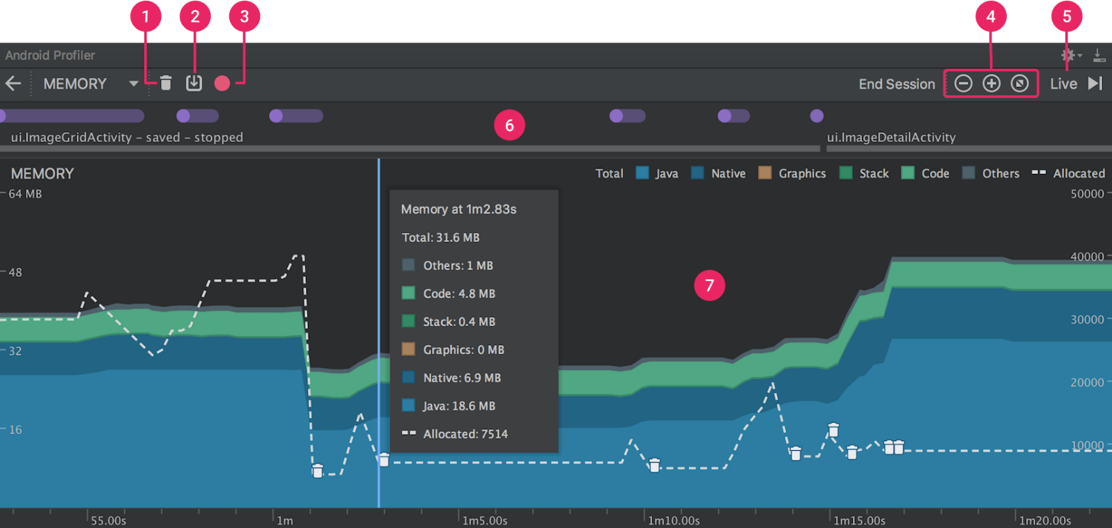

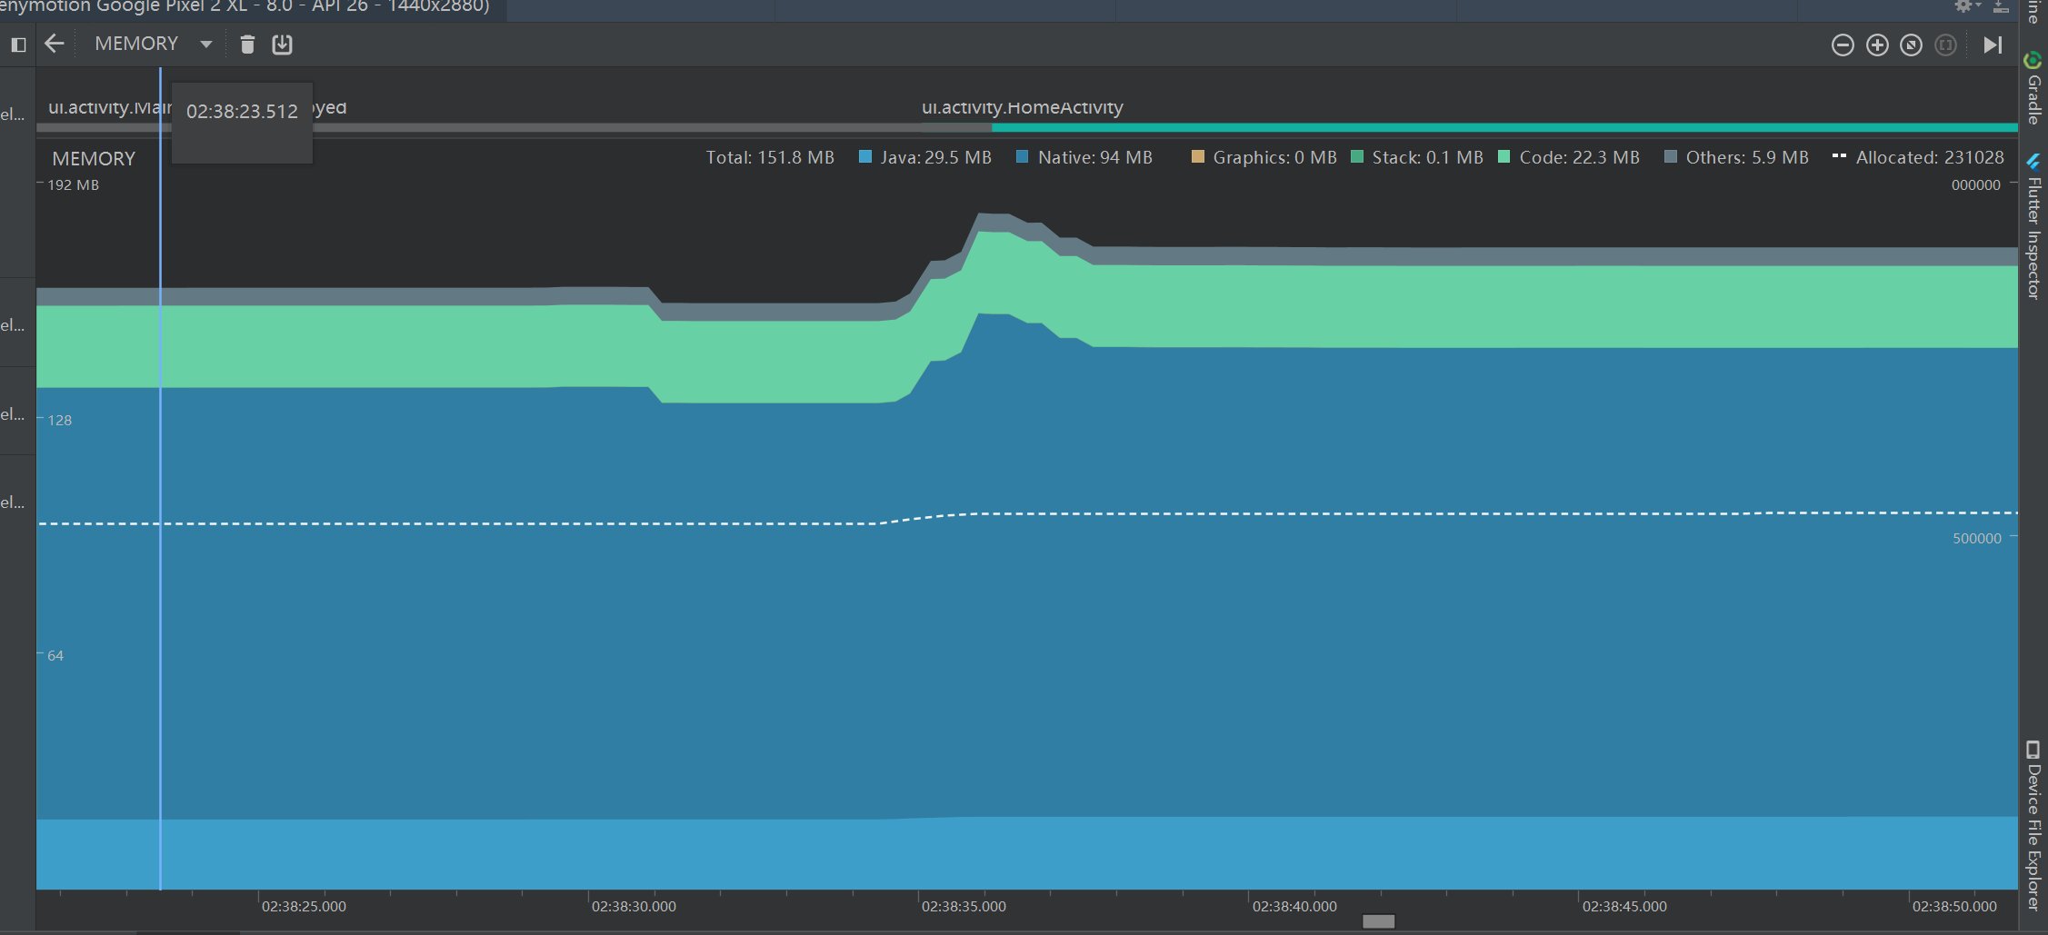

内存计数中的类别如下所示：

* Java：从 Java 或 Kotlin 代码分配的对象内存。
* Native：从 C 或 C++ 代码分配的对象内存。

即使您的应用中不使用 C++，您也可能会看到此处使用的一些原生内存，因为 Android 框架使用原生内存代表您处理各种任务，如处理图像资源和其他图形时，即使您编写的代码采用 Java 或 Kotlin 语言。

* Graphics：图形缓冲区队列向屏幕显示像素（包括 GL 表面、GL 纹理等等）所使用的内存。 （请注意，这是与 CPU 共享的内存，不是 GPU 专用内存。）
* Stack： 您的应用中的原生堆栈和 Java 堆栈使用的内存。 这通常与您的应用运行多少线程有关。
* Code：您的应用用于处理代码和资源（如 dex 字节码、已优化或已编译的 dex 码、.so 库和字体）的内存。
* Other：您的应用使用的系统不确定如何分类的内存。
* Allocated：您的应用分配的 Java/Kotlin 对象数。 它没有计入 C 或 C++ 中分配的对象。

当连接至运行 Android 7.1 及更低版本的设备时，此分配仅在 Memory Profiler 连接至您运行的应用时才开始计数。 因此，您开始分析之前分配的任何对象都不会被计入。 不过，Android 8.0 附带一个设备内置分析工具，该工具可记录所有分配，因此，在 Android 8.0 及更高版本上，此数字始终表示您的应用中待处理的 Java 对象总数。

与以前的 Android Monitor 工具中的内存计数相比，新的 Memory Profiler 以不同的方式记录您的内存，因此，您的内存使用量现在看上去可能会更高些。 Memory Profiler 监控的类别更多，这会增加总的内存使用量，但如果您仅关心 Java 堆内存，则“Java”项的数字应与以前工具中的数值相似。

然而，Java 数字可能与您在 Android Monitor 中看到的数字并非完全相同，这是因为应用的 Java 堆是从 Zygote 启动的，而新数字则计入了为它分配的所有物理内存页面。 因此，它可以准确反映您的应用实际使用了多少物理内存。

注：目前，Memory Profiler 还会显示应用中的一些误报的原生内存使用量，而这些内存实际上是分析工具使用的。 对于大约 100000 个对象，最多会使报告的内存使用量增加 10MB。 在这些工具的未来版本中，这些数字将从您的数据中过滤掉。

##### 2 查看内存分配

内存分配显示内存中每个对象是如何分配的。 具体而言，Memory Profiler 可为您显示有关对象分配的以下信息：

* 分配哪些类型的对象以及它们使用多少空间。
* 每个分配的堆叠追踪，包括在哪个线程中。
* 对象在何时被取消分配（仅当使用运行 Android 8.0 或更高版本的设备时）。

如果您的设备运行 Android 8.0 或更高版本，您可以随时按照下述方法查看您的对象分配： 只需点击并按住时间线，并拖动选择您想要查看分配的区域（如视频 1 中所示）。 不需要开始记录会话，因为 Android 8.0 及更高版本附带设备内置分析工具，可持续跟踪您的应用分配。

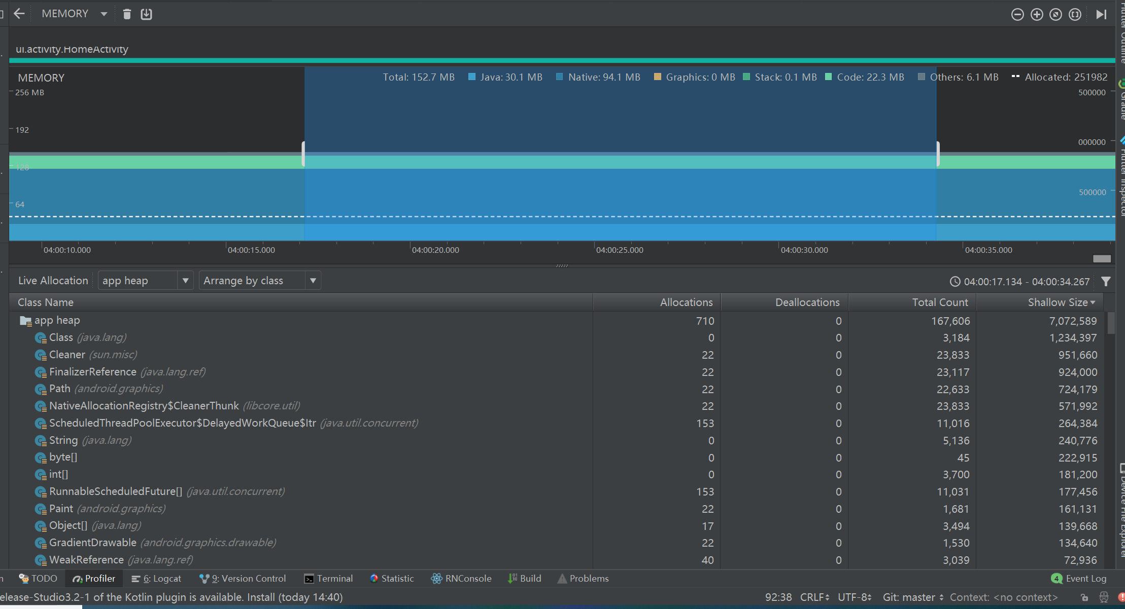

在选择一个时间线区域后（或当您使用运行 Android 7.1 或更低版本的设备完成记录会话时），已分配对象的列表将显示在时间线下方，按类名称进行分组，并按其堆计数排序。

注：在 Android 7.1 及更低版本上，您最多可以记录 65535 个分配。 如果您的记录会话超出此限值，则记录中仅保存最新的 65535 个分配。 （在 Android 8.0 及更高版本中，则没有实际的限制。）

要检查分配记录，请按以下步骤操作：

浏览列表以查找堆计数异常大且可能存在泄漏的对象。 为帮助查找已知类，点击 Class Name 列标题以按字母顺序排序。 然后点击一个类名称。 此时在右侧将出现 Instance View 窗格，显示该类的每个实例，如图 3 中所示。

在 Instance View 窗格中，点击一个实例。 此时下方将出现 Call Stack 标签，显示该实例被分配到何处以及哪个线程中。

在 Call Stack 标签中，点击任意行以在编辑器中跳转到该代码。

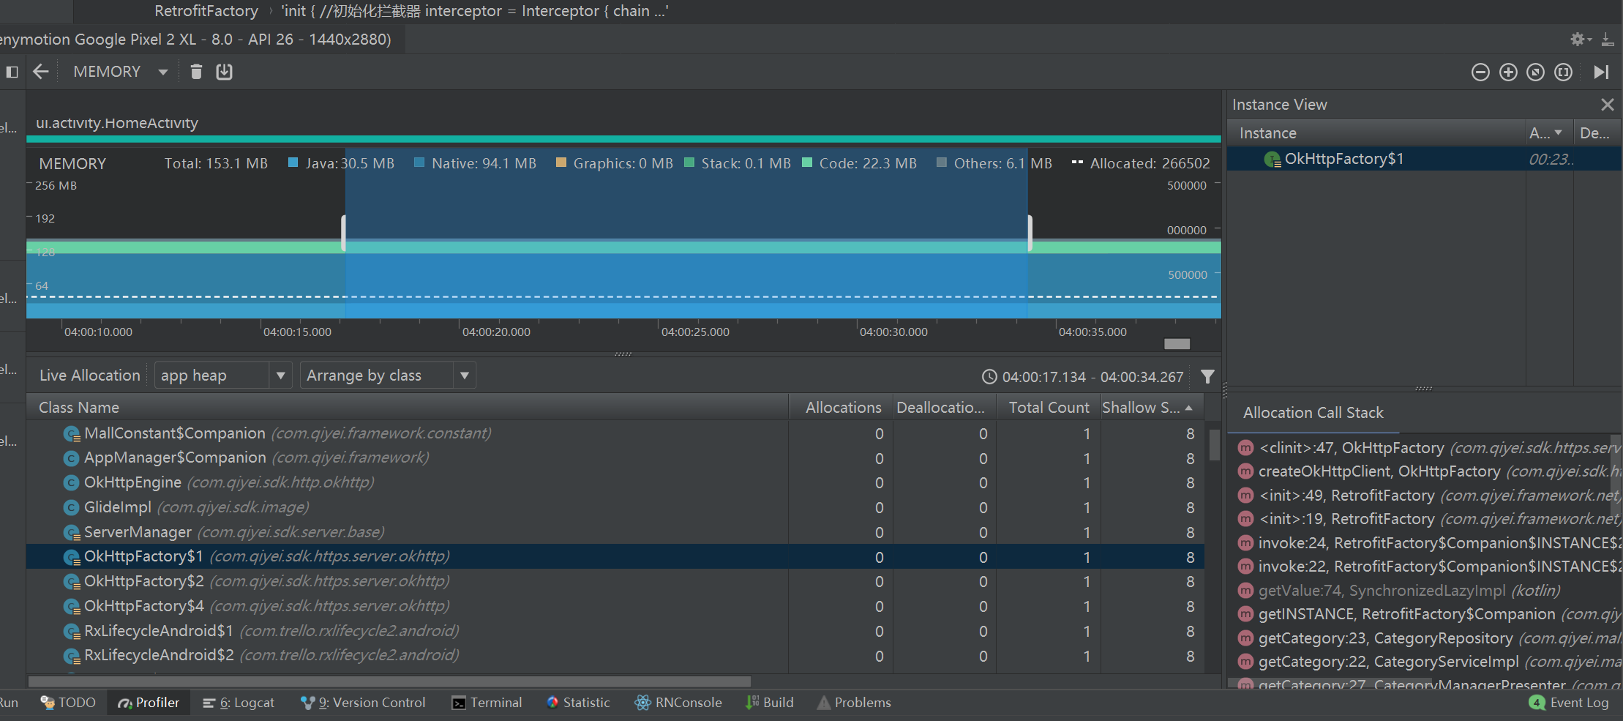

默认情况下，左侧的分配列表按类名称排列。 在列表顶部，您可以使用右侧的下拉列表在以下排列方式之间进行切换：

Arrange by class：基于类名称对所有分配进行分组。

Arrange by package：基于软件包名称对所有分配进行分组。

Arrange by callstack：将所有分配分组到其对应的调用堆栈。

##### 3 捕获堆转储

堆转储显示在您捕获堆转储时您的应用中哪些对象正在使用内存。 特别是在长时间的用户会话后，堆转储会显示您认为不应再位于内存中却仍在内存中的对象，从而帮助识别内存泄漏。 在捕获堆转储后，您可以查看以下信息：

* 您的应用已分配哪些类型的对象，以及每个类型分配多少。
* 每个对象正在使用多少内存。
* 在代码中的何处仍在引用每个对象。
* 对象所分配到的调用堆栈。 （目前，如果您在记录分配时捕获堆转储，则只有在 Android 7.1 及更低版本中，堆转储才能使用调用堆栈。）

要捕获堆转储，在 Memory Profiler 工具栏中点击 Dump Java heap 。 在转储堆期间，Java 内存量可能会暂时增加。 这很正常，因为堆转储与您的应用发生在同一进程中，并需要一些内存来收集数据。

堆转储显示在内存时间线下，显示堆中的所有类类型，如图 4 所示。

注：如果您需要更精确地了解转储的创建时间，可以通过调用 dumpHprofData() 在应用代码的关键点创建堆转储。

要检查您的堆，请按以下步骤操作：

浏览列表以查找堆计数异常大且可能存在泄漏的对象。 为帮助查找已知类，点击 Class Name 列标题以按字母顺序排序。 然后点击一个类名称。 此时在右侧将出现 Instance View 窗格，显示该类的每个实例，如图 5 中所示。

在 Instance View 窗格中，点击一个实例。此时下方将出现 References，显示该对象的每个引用。

或者，点击实例名称旁的箭头以查看其所有字段，然后点击一个字段名称查看其所有引用。 如果您要查看某个字段的实例详情，右键点击该字段并选择 Go to Instance。

在 References 标签中，如果您发现某个引用可能在泄漏内存，则右键点击它并选择 Go to Instance。 这将从堆转储中选择对应的实例，显示您自己的实例数据。

默认情况下，堆转储不会向您显示每个已分配对象的堆叠追踪。 要获取堆叠追踪，在点击 Dump Java heap 之前，您必须先开始记录内存分配。 然后，您可以在 Instance View 中选择一个实例，并查看 Call Stack 标签以及 References 标签，如图 5 所示。不过，在您开始记录分配之前，可能已分配一些对象，因此，调用堆栈不能用于这些对象。 包含调用堆栈的实例在图标 上用一个“堆栈”标志表示。 （遗憾的是，由于堆叠追踪需要您执行分配记录，因此，您目前无法在 Android 8.0 上查看堆转储的堆叠追踪。）

在您的堆转储中，请注意由下列任意情况引起的内存泄漏：

长时间引用 Activity、Context、View、Drawable 和其他对象，可能会保持对 Activity 或 Context 容器的引用。

可以保持 Activity 实例的非静态内部类，如 Runnable。

对象保持时间超出所需时间的缓存。

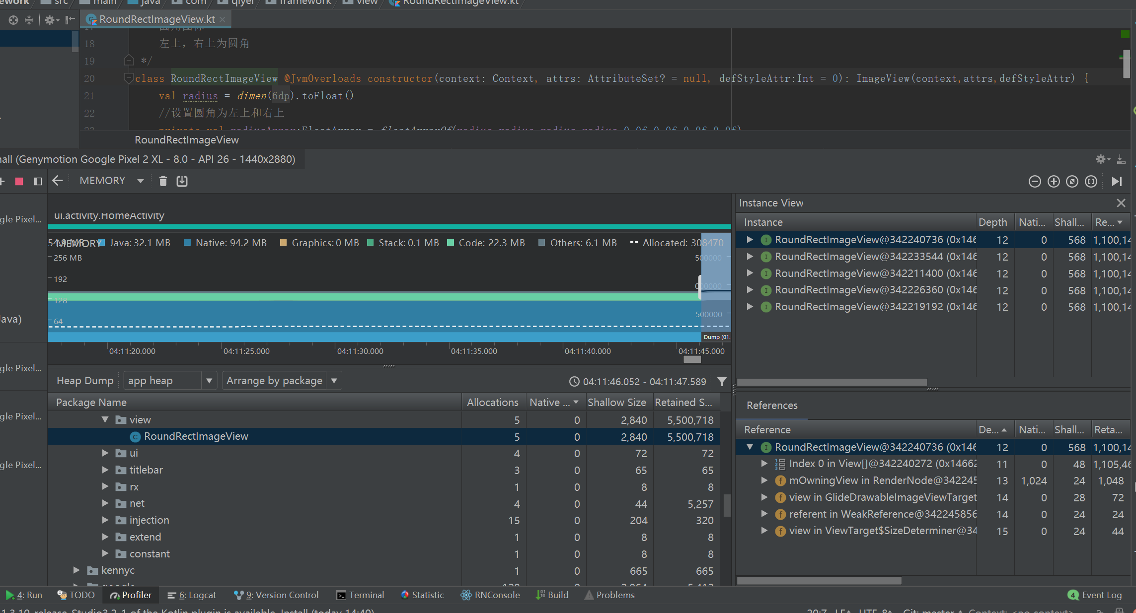

您还可以通过以下方式之一触发内存泄漏：

将设备从纵向旋转为横向，然后在不同的 Activity 状态下反复操作多次。 旋转设备经常会导致应用泄漏 Activity、Context 或 View 对象，因为系统会重新创建 Activity，而如果您的应用在其他地方保持对这些对象之一的引用，系统将无法对其进行垃圾回收。

处于不同的 Activity 状态时，在您的应用与另一个应用之间切换（导航到主屏幕，然后返回到您的应用）。

#### 3 MAT

#### 4 使用StrictMode 严格模式

StrictMode.setVmPolicy(new StrictMode.VmPolicy.Builder()

.detectAll()//监测所以内容

.penaltyLog()//违规对log日志

.penaltyDeath()//违规Crash

.build());

日志中查找StrictMode 开头即可

### 4 内存抖动优化

一般在循环，频繁调用的地方可能发生内存抖动

例如普通循环中，Adapter的get View或者onBinderView等方法中可能会发生内存抖动

#### 1 内存抖动定位及优化

使用Memory Profiler抓取内存实时显示图

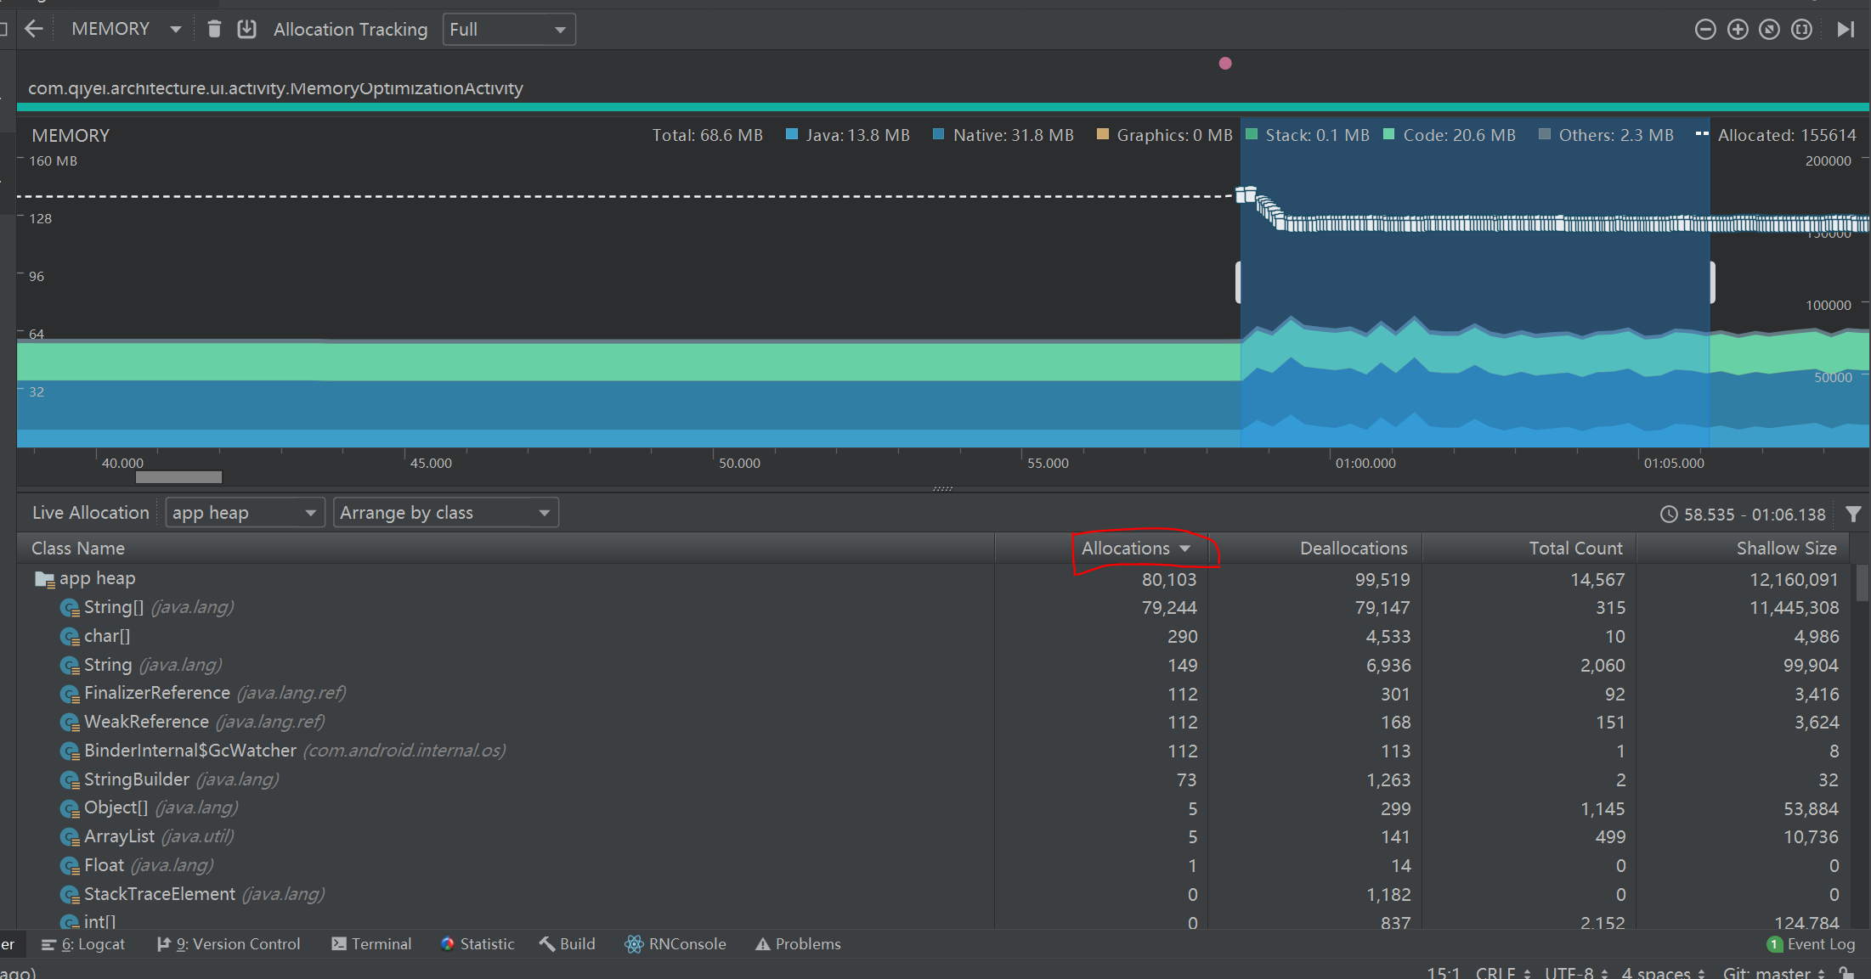

找到内存抖动的地方，进行捕获。然后根据Allocations进行排序

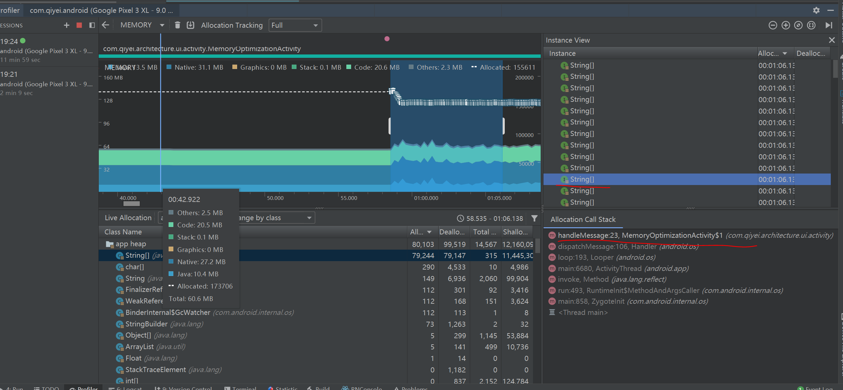

可以看到，内存中根据对象分配的数量进行排序，由于是内存抖动，需要特别留意数量多的对象，这里就是String[]对象，因此点击查看调用栈。然后查看代码

或者使用CPU profiler查看也可以

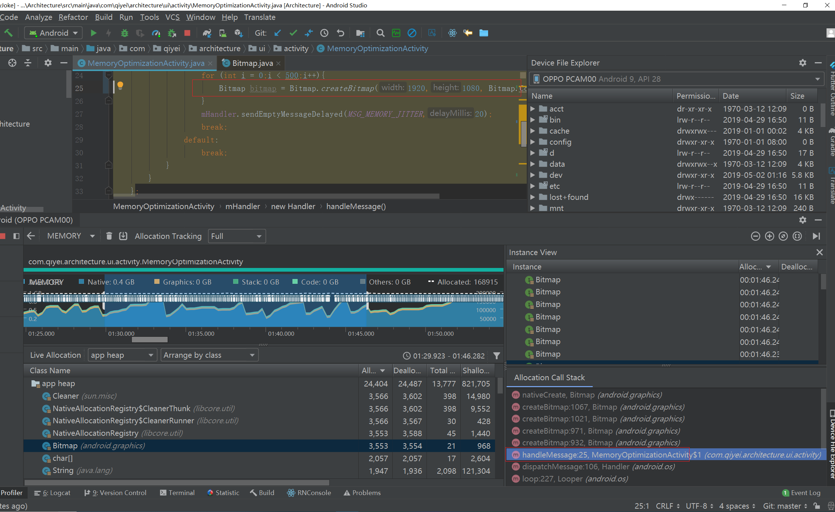

#### 2 内存抖动的解决

找到了内存抖动，进行优化，一般来说就是避免在循环中创建内存抖动，可以使用对象复用等方式

### 5 内存泄漏优化

#### 1 内存泄漏常见场景

##### 1 单例导致内存泄露

单例引用Context,Activity,Service,View等

##### 2 静态变量导致内存泄露

静态变量直接或间接引用Context,Activity,Service,View等

##### 3 非静态内部类导致内存泄露

Handler及延时消息,内部类(匿名内部类)

改进：

Handler使用静态内部类，弱引用Activity，在结束时移除消息

##### 4 未取消注册或回调导致内存泄露

在结束时移除消息

##### 5 Timer和TimerTask导致内存泄露

Activity销毁的时候要立即cancel掉Timer和TimerTask，以避免发生内存泄漏。

##### 6 集合中的对象未清理造成内存泄露

这个比较好理解，如果一个对象放入到ArrayList、HashMap等集合中，这个集合就会持有该对象的引用。当我们不再需要这个对象时，也并没有将它从集合中移除，这样只要集合还在使用（而此对象已经无用了），这个对象就造成了内存泄露。并且如果集合被静态引用的话，集合里面那些没有用的对象更会造成内存泄露了。所以在使用集合时要及时将不用的对象从集合remove，或者clear集合，以避免内存泄漏。

##### 7 资源未关闭或释放导致内存泄露

在使用IO、File流或者Sqlite、Cursor等资源时要及时关闭。这些资源在进行读写操作时通常都使用了缓冲，如果及时不关闭，这些缓冲对象就会一直被占用而得不到释放，以致发生内存泄露。因此我们在不需要使用它们的时候就及时关闭，以便缓冲能及时得到释放，从而避免内存泄露。

##### 8 属性动画造成内存泄露

动画同样是一个耗时任务，比如在Activity中启动了属性动画（ObjectAnimator），但是在销毁的时候，没有调用cancle方法，虽然我们看不到动画了，但是这个动画依然会不断地播放下去，动画引用所在的控件，所在的控件引用Activity，这就造成Activity无法正常释放。因此同样要在Activity销毁的时候cancel掉属性动画，避免发生内存泄漏。

##### 9 WebView造成内存泄露

关于WebView的内存泄露，因为WebView在加载网页后会长期占用内存而不能被释放，因此我们在Activity销毁后要调用它的destory()方法来销毁它以释放内存。

另外在查阅WebView内存泄露相关资料时看到这种情况：

Webview下面的Callback持有Activity引用，造成Webview内存无法释放，即使是调用了Webview.destory()等方法都无法解决问题（Android5.1之后）。

最终的解决方案是：在销毁WebView之前需要先将WebView从父容器中移除，然后在销毁WebView。详细分析过程请参考这篇文章：WebView内存泄漏解决方法。

@Override

protected void onDestroy() {

super.onDestroy();

// 先从父控件中移除WebView

mWebViewContainer.removeView(mWebView);

mWebView.stopLoading();

mWebView.getSettings().setJavaScriptEnabled(false);

mWebView.clearHistory();

mWebView.removeAllViews();

mWebView.destroy();

}

#### 2 内存泄漏定位及优化

1 重复多次操作，使之发生内存泄漏

例如多次重复进入某个Activity等

2 使用Memory Profiler的堆转储的功能

Memory Profiler 工具栏中点击 Dump Java heap，然后保存成文件

3 使用hprof-conv命名进行转换层MAT可识别的格式

sdk\platform-tools 下有这个命令

4 使用MAT打开文件

5 打开Histogram 搜索Activity

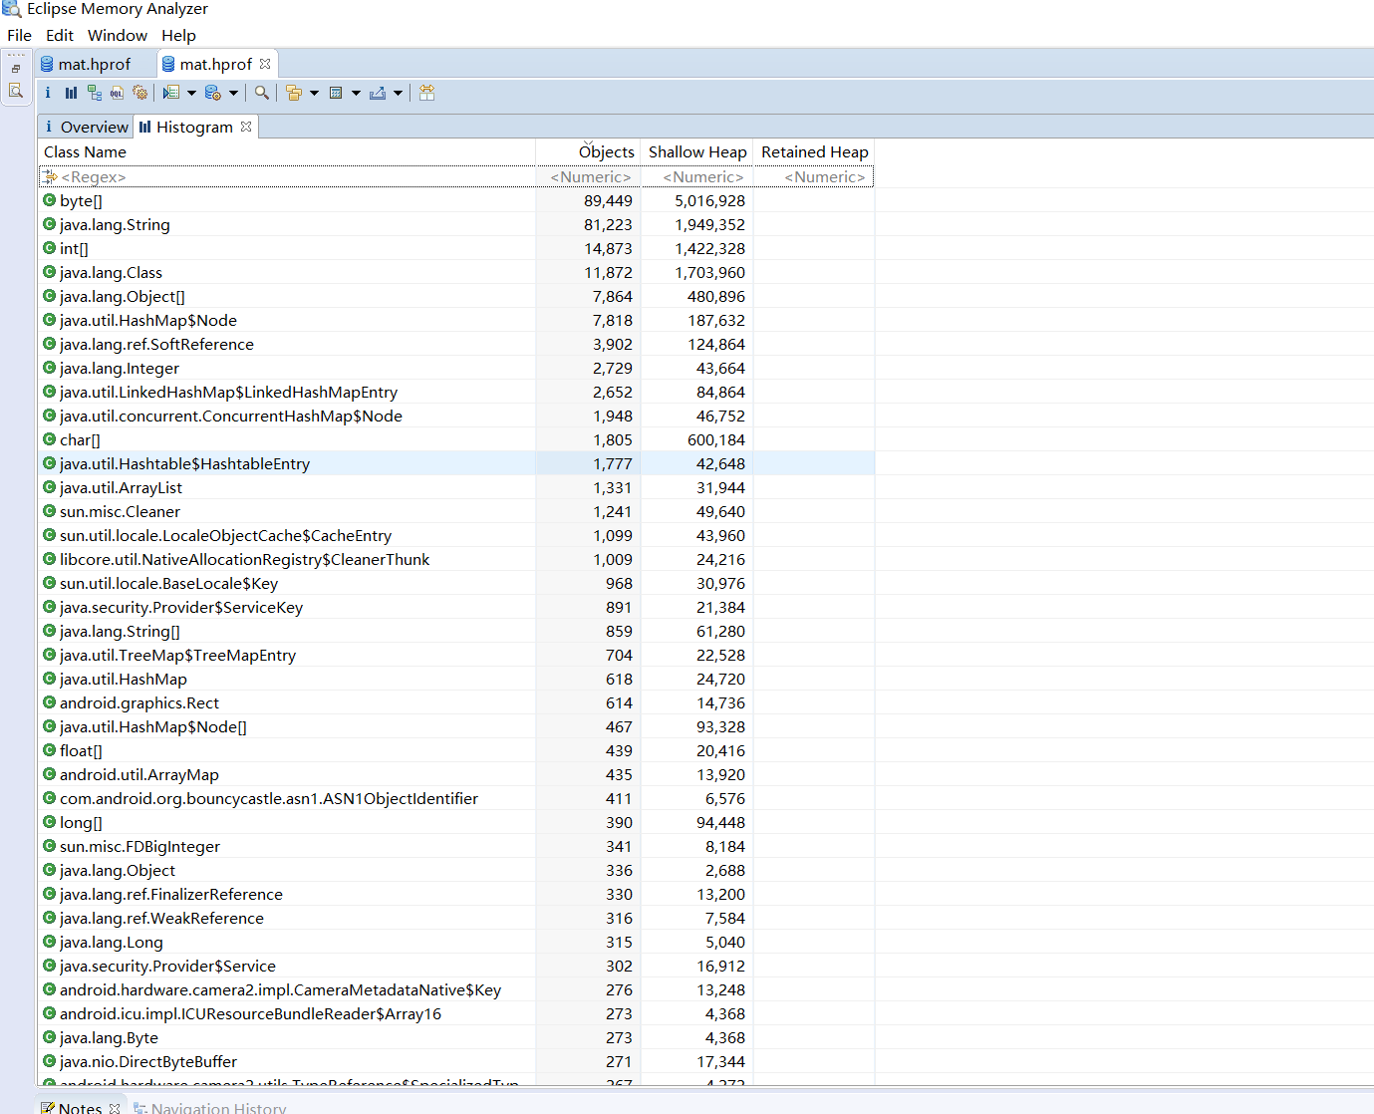

一般对于内存泄漏，主要的表象是Activity没有被回收，因此我们就通过搜索对应的Activity来看是否发生内存泄漏

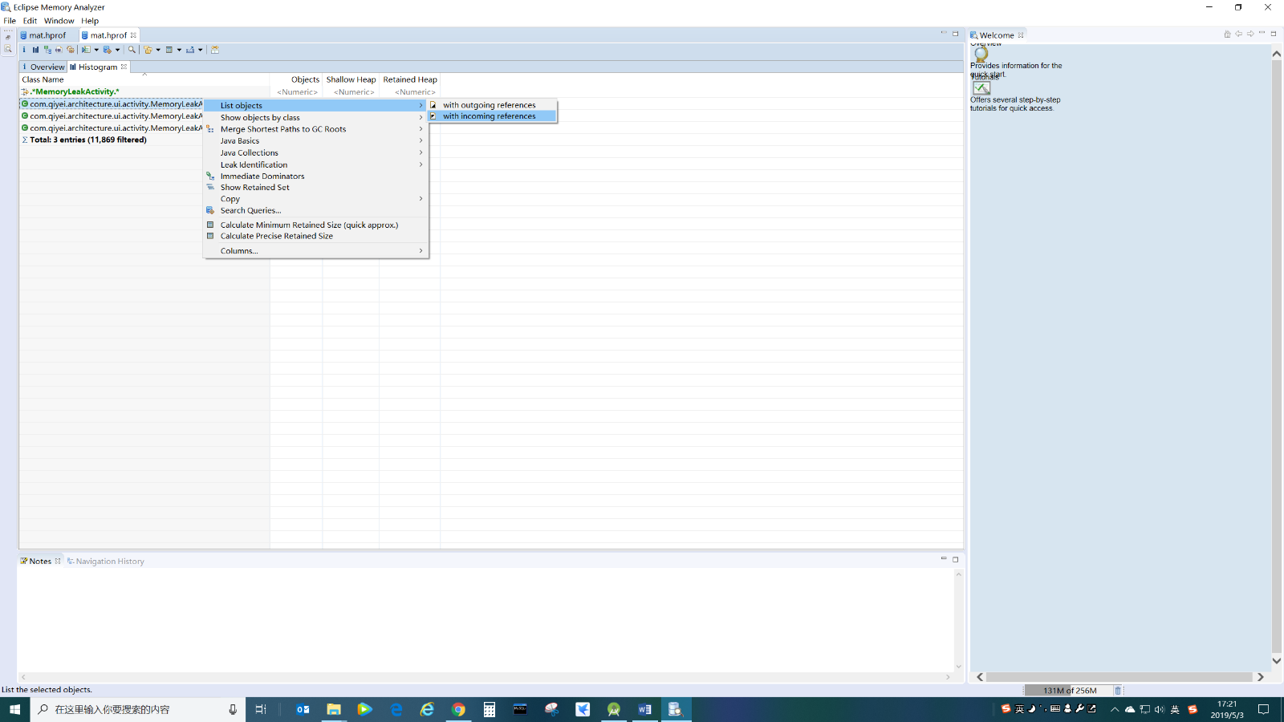

with incoming refences 表示的是谁在引用这个对象，表示我们当前的activity被谁引用导致不能释放

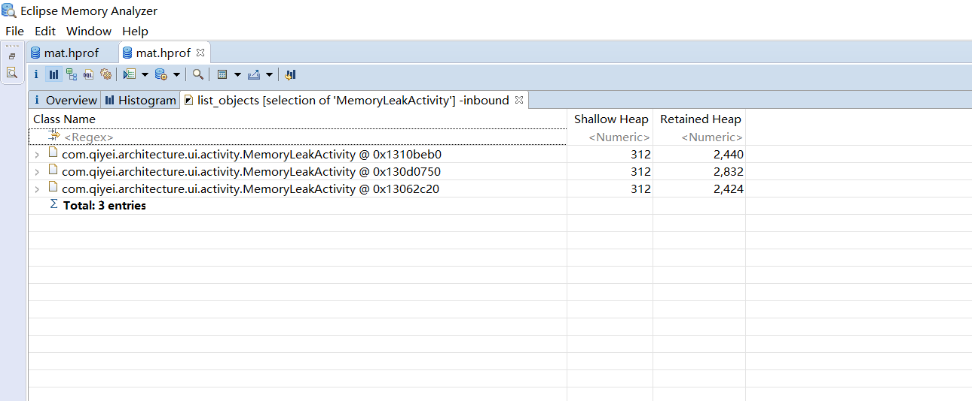

选中一个对象，然后选择path to GC roots

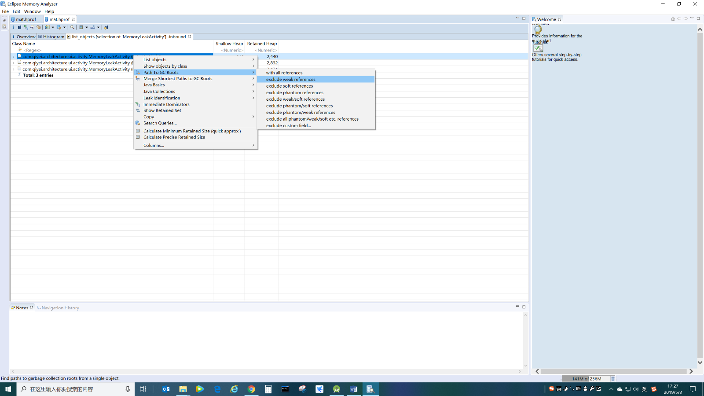

然后找到带c的即可找到，最终被引用的地方，从而找到了内存泄漏的地方

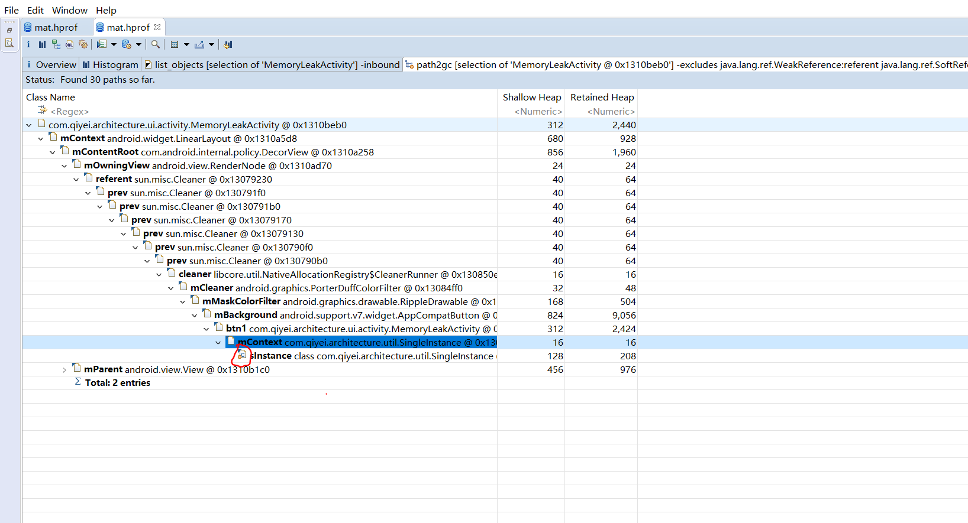

这样就找到内存泄漏的点了

### 6 Bitmap内存预警

对于内存溢出问题，一般是大内存对象的分配才会出现，特别是针对Bitmap对象，特别容易造成内存溢出

#### 1 怎么获取图片内存

Api10 之前自身在java中，像素在native中。Api10以后都在java中。Bitmap在Api26以后将像素内存放在native中，java中只放对象本身内存，当java对象被回收时，通知native层被回收

如何获取Bitmap所占内存？

* 调用Bitmap. getByteCount()
* 图片内存 = 宽*高*单个像素所占内存*宽压缩比*高压缩比

#### 2 ARTHook检测Bitmap使用内存

一般在设置给ImageView时需要预先判断下设置的Bitmap的大小及所占内存。

* 常规方案是使用继承ImageView然后复写其setImageBitmap()方法，在其中判断其大小

但是不够优雅及方便

* Epic java method hook框架

https://github.com/tiann/epic

### 7 线上内存监控方案

#### 1 设定场景线上内存dump

Debug.dumpHprofData();

比如内存占用达到200M之后dump内存

#### 2 LeakCanary定制

预设埋点，发现泄漏回传分析

预设怀疑点:自动找怀疑点

分析泄露链路慢:分析retain size大的对象

分析oom 对象裁剪，不全部加载到内存

3 线上内存监控完整方案

待机内存，重点模块内存，oom率

整体及重点模块的GC次数及时间

增强的leakcanary自动化内存泄露分析

开启largeheap属性

Application中开启

@Override

public void onLowMemory() {

super.onLowMemory();

}

@Override

public void onTrimMemory(int level) {

super.onTrimMemory(level);

}

谨慎使用SP

### 8 内存优化面试指南

#### 1 你们内存优化项目是怎么做的？

* 分析现状，确认问题

线上OOM率较高

AS中内存抖动频繁

存在内存泄漏问题(leankCanary)

review code Bitmap使用不合理

* 针对性优化

例如内存抖动，根据AS中，然后去查看代码

* 效率提升

1 不增加业务同学开发工作量(使用AOP或者ARTHook)

2 梳理出内存优化的文档

#### 2 你做内存优化，最大的感受是什么？

* 技术方面提升

学习工具使用，了解内存回收机制，学习官方文档

* 技术优化必须结合业务代码

例如Bitmap的内存预警，

* 系统化的解决方案

#### 3 如何检测所有不合理的地方？

* AOP:ARTHook

重点强调于普通方案的区别

## 四 存储优化

### 1 常规方案

确保io操作发生在非主线程

hook或者aop辅助

### 2 SP集合

加载慢 初始化加载整个文件

全量写入 单次改动会导致整体写入

卡顿 补偿策略导致

微信开原 mmkv

### 3 日志存储优化

常规实现

没产生一个文件，写一遍到磁盘中

开辟内存，写到内存中，再存文件

mmap

内存映射文件

优势，高性能，不丢失

业界实现 xlog logan log4a

1 数据存储同一管理

分类，内存，sp,数据库，以及文件

2 序列化保存

3 SP优化

IO性能，同步锁问题

避免频繁的读写SP

4 数据库优化

开源数据库引入

## 五 APP网络优化

### 1 网络优化的维度

#### 1 流量消耗

* 一段时间内流量消耗的精准度量，网络类型，前后台
* 监控相关 用户流量消耗均值，异常率（消耗多，次数多）
* 完整链路全部监控（request response），主动上报response

#### 2 网络请求质量

* 用户体验:请求速度，成功率
* 监控相关:请求时长，业务成功率，失败率，TOP 失败接口

#### 3 其他

* 公司成本:带宽，服务器数，CDN

#### 4 优化误区

只关注流量消耗，忽视其他纬度

只关注均值，整体，忽视个体

### 2 网络优化工具

#### 1 network profiler

AS自带

显示实时网络活动:发送，接受数据及连接数

需要启用高级分析

只支持HttpUrlConnection okhttp两个网络库

#### 2 抓包工具

charles

fiddler windows使用较多

wireshark

tcpdump

#### 3 stetho

强大的应用调试桥，连接android和chrome

网络监控，视图查看，数据库查看，命令行扩展等

总结 针对网络工具，最长使用的是抓包工具

### 3 精准获取流量消耗实战

### 4 网络请求流量优化实战

#### 1 数据缓存

okhhtp加缓存

#### 2 增量数据更新

加上版本的概念，只传输有变化的数据

#### 3 数据压缩

* Post请求Body使用GZip压缩
* 请求头压缩(请求头一样时，后续只传MD5值)
* 图片上传之前必须压缩

引入top.zibin.luban

https://github.com/Curzibn/Luban

#### 4 优化发送频率和时机

* 合并网络请求，减少请求次数
* 性能日志上报:批量+特定场景上报

#### 5 图片相关

* 图片使用策略细化:优先缩略图
* 使用WebP格式图片

### 5 网络请求质量优化实战

#### 1 质量指标

* 网络请求成功率
* 网络请求速度

网络请求首先受DNS影响

#### 2 DNS相关

问题：DNS被劫持，DNS解析慢

方案:使用HttpDNS,绕过运营商域名解析过程

优势:降低平均访问时长，提高连接成功率

使用阿里云提供的httpdns解析服务

#### 3 HTTP协议版本升级

使用 HTTP 1.1 及2.0

#### 4 网络请求质量监控

* 接口请求耗时，成功率，错误码
* 图片加载的每一步耗时

利用okHttp的EventListener

#### 5 网络容灾机制

备用服务器分流

#### 6其他

CDN加速，提高贷款，动静资源分离

减少传输量，注意请求时机和频率

### 6 网络体系化方案建设

#### 1 线下测试

方案：只抓单独App

侧重点：请求有误，多余，网络切换，弱网，无网测试

#### 2 线上监控

##### 1 服务端监控

* 请求耗时 (区分地域，时间段，版本，机型)
* 失败率，业务失败与请求失败
* Top失败接口，异常接口

##### 2 客户端监控

* 接口的每一步详细信息(DNS 连接，请求等)
* 请求次数，网络包大小，失败原因等
* 图片监控

3 异常监控体系

* 服务器防刷：超限拒绝访问
* 客户端：大文件预警，异常兜底策略
* 单点问题追查

### 7 网络优化面试

#### 1 在网络优化方面你们做了哪些监控，建立了哪些指标？

答案：

* 演进过程，优化背景
* 质量:请求成功率，每步耗时，状态码，Top失败接口，异常接口
* 流量监控:精确统计，前后台

#### 2 如何有效降低用户流量消耗？

答案：

要注意结合例子

数据：缓存，增量更新

上传:压缩

图片:缩略图，webp

#### 3 用户反馈消耗流量多这种问题怎么查？

答案

可能存在用户小号流量多

* 精准的流量获取能力
* 所有请求大小及次数的监控
* 主动预警能力

### 1 移动网络优化基础

#### 1 网络不可用

* GFW的拦截，原因你懂的。
* DNS的劫持，端口的意外封禁等
* 偏远地区网络基础设施比较差。

#### 2 网络加载时间长

* 移动设备出于省电的目的，发出网络请求前需要先预热通信芯片。
* 网络请求需要跨网络运营商，物理路径长。
* HTTP请求是基于Socket设计的，请求发起之前会经历三次握手，断开时又会进行四次挥手。

### 2 短连接优化

#### 1 短连方案一、域名合并方案

域名多了以后：

HTTP请求需要跟不同服务器建立连接。增加了网络的并发连接数量。

每条域名都需要经过DNS服务来解析服务器IP

#### 2 短连方案二、IP直连方案

程序启动的时候拉取"api.dianping.com"对应的所有的IP列表；对所有IP进行跑马测试，找到速度最快的IP。后续所有的HTTPS请求都将域名更换为跑马最快的IP即可。

#### 3 DNS优化

降低 DNS 的耗时，减少域名劫持

DNS 查询时，会先在本地缓存中尝试查找，如果不存在或是记录过期，就继续向 DNS 服务器发起递归查询,这里的 DNS 服务器一般就是运营商的 DNS 服务器。

DNS查询

HTTP DNS

根治域名解析异常: 绕过运营商的 DNS，向具备 DNS 解析功能的 HTTP WEB 服务器发起查询;

调度精准: HTTP DNS 能够直接获取到用户的 IP 地址，从而实现准确导流;

扩展性强: 本身基于 HTTP 协议，可以实现更强大的功能扩展;

策略上我们能够配置其核心 API 域名走 HTTP DNS，而对于非核心请求我们仍希望它先尝试走 LocalDNS, 在异常情况下才升级走 HTTP DNS

LocalDNS

IP 记录的 TTL 时间: 在 DNS 劫持发生的情况下，返回的 TTL 可能会有非常大的值;

解析耗时: 如果一个 DNS 服务器解析耗时不理想，那么它也不是我们希望的;

返回的 IP 的可连接性: 对返回的 IP 进行质量测试，如果连接状况不佳，那么这个 DNS 服务器有劫持的可疑;

对于HTTPS握手问题，在HostnameVerifier中解决

### 3 长连通道建设

#### 1 HTTP/2技术

具有异步连接多路复用、头部压缩、请求响应管线化等众多优点。

#### 2 代理长连模式

在客户端与业务服务器之间架设代理长连服务器，客户端与代理服务器建立TCP长连通道，客户端的HTTP请求被转换为了TCP通道上的二进制数据包。代理服务器负责与业务服务器进行HTTP请求，请求的结果通过长连通道送回客户端

优点：对DNS无依赖，不同域名的请求可以复用同一条长连通道。通道易优化

使用腾讯的维纳斯（WNS）服务

### 4 网络优化建议

1 使用网络监控。引入网络监控机制。美团的Cat监控系统。Cat开源地址为http://github.com/dianping/cat 。

2 收拢网络底层

3 尝试进行短连优化。前文中提到的域名合并和IP直连方案都是简单有效的手段

4 可以尝试HTTP/2或腾讯WNS长连服务

参考：

https://mp.weixin.qq.com/s?__biz=MzAwMDU1MTE1OQ==&mid=2653549209&idx=1&sn=9afc07f9a80db5f0be2fe2b2e69878bf&chksm=813a6301b64dea174ec708baf4ddf74975983f50dd9bdbe9778fd0879265fad7263f18b0be44&mpshare=1&scene=23&srcid=1130a9e0WKkv31lpqlrR2H2i#rd

## 六 APP功耗电量优化

### 电量优化介绍及方案

方案

#### 1 设置—耗电排行

直观，但是没有详细数据，对解决问题没有太多帮助

#### 找特定场景专项测试

#### 3 获取Action_battery_changed广播

获取电池电量，充电状态，电池状态等信息

但是价值不大，针对的是手机整体的耗电量，而非特定APP

实时性差，精度也较低

#### 4 耗电检测工具Battery Historian

功能强大，推荐使用

可视化展示指标：耗电比例，执行事件，次数

适合线下使用

#### 5 测试相关

耗电场景测试:复杂运算，视频播放

传感器相关:使用时长，耗电量，发热

后台静默测试

### 2 Battery Historian实战

#### 1 安装

https://github.com/google/battery-historian

Docker安装

根据说明安装

#### 2 导出电量信息

电量重置

adb shell dumpsys batterystats --reset

开启电量分析

adb shell dumpsys batterystats --eable full-wake-history

开始操作APP

导出数据

adb bugreport bugreport.zip

上传分析，上传到localhost:9999

备用网站

<https://bathist.ef.lc/>

#### 3 分析

### 3 电量辅助监控实战

#### 1 power_profile文件

运行时能耗文件都保存在power_profile文件中

adb pull /system/framework/framework-res.apk

反编译xml->找到power_profile文件

#### 2 运行时获取使用时长

AOP辅助统计：次数，时间

以WakeLock为例，直接HookWake的调用

#### 3 线程运行时长

超过阈值预警

### 电量优化套路总结

#### 1 CPU时间片

Systrace或Cpu Profiler获取运行过程CPU小号，定位CPU占有率异常丰富

减少后台应用的主动运行

#### 2 网络相关

请求时机及次数控制

数据压缩，减少时间

禁止使用轮询功能

#### 3 传感器及定位相关

根据场景谨慎选择定位模式

考虑网络定位代替GPS

使用后务必及时关闭，减少更新频率

#### 4 WakeLock相关

注意成对出现:acquire与release

使用带参数的acquire

finally确保一定会被释放

常量场景使用keepScreenOn即可

#### 5 JobScheduler

在符合某些条件时创建执行在后台的任务

把不紧急的任务放到更合适的时机批量处理

### 5 电量优化面试

#### 1 怎么做电量测试

结论：电量相关的测试难做一些

分场景逐个击破，将APP按功能

Battery Historian

辅助监控

#### 2 有哪些有效的电量优化手段

4小节

优化方向

显示 LCD OLED

网络

CPU

计算优化

push优化

使用jobScheduler

## 七 APK瘦身优化

### 1 APK分析方案

1 ApkTool反编译工具

2 AS自带 Analyze APK

3 https://nimbledroid.com app性能分析

4 android-classyshark 二进制检查工具

apk jar class so等

### 2 代码瘦身实战

1 代码混淆

2 三方库处理

基础库统一

选择更小的库

引入所需的功能

3 移除无用代码

AOP统计使用情况

切构造器，看看是否使用

### 3 资源瘦身实战

1 冗余资源

右键 refactor remove unused resource

2 图片压缩

https://tinypng.com及TinyPngPlugin

图片格式选择

3 资源混淆

AndResGuard

图片只保留一份

### 4 so瘦身实战

1 完美支持所有类型设备代价太大

2 都放在armeabi目录，根据cpu类型加载对应so

代码中适配即可

3 so动态下发

4 插件化

### 5 面试

1 怎么降低apk包大小

as自带分析包大小

主要从代码，资源，so三个方面入手

答案就是这章讲的

2 APK瘦身问题长效治理

发版之前与上个版本包体积对比，超过阈值必须优化

推进插件化架构改造

## 八 APP稳定性优化

### 1 如何提升APP的稳定性

#### 1 稳定性纬度

crash纬度

性能纬度

业务高可用纬度

#### 2 优化概述

重在预防，监控必不可少

思考更深一层，重视隐含信息

长效保持需要科学流程

### 2高crash率的破解之道

#### 1 crash相关指标

UV,PV Crash率

UV

java Native Crash 率

启动，重点流程crash率

增量，存量crash率

#### 2 crash关键问题

尽可能的还原crash现场

堆栈，设备，os版本，进程，线程，logcat

前后台，使用时长，app版本，渠道

cpu架构，内存信息，线程数，资源包信息，行为日志

#### 3 crash治理方案

### 3 移动端业务高可用方案建设

#### 1 业务高可用重要性

高可用 性能+业务

业务高可用侧重于用户功能完整可用

业务高可用真实的影响收入

#### 2 业务高可用方案建设

1 数据采集

梳理项目主流程，核心路径，关键节点

aop自动采集，统一上报

2 报警策略

阈值报警

趋势报警

特定指标报警，直接上报

3 异常监控

catch代码块

异常逻辑

4 单点追查

需要针对性分析的特定问题

全量日志回捞，专项分析

兜底策略

配置中心，功能开关

跳转分发中心

3 业务高可用总结

### 4 移动端容灾方案

必要性

传统流程 用户反馈，重新打包，渠道更新，不可接受

新方案

#### 1 功能开关

发生异常，功能不可用

#### 2 跳转中心

界面切换通过路由，路由决定是否重定向

#### 3 动态化修复

热修复

#### 4 安全模式

根据crash信息自动恢复，多次启动失败重置app

严重bug可阻塞性热修

异常熔断 多次请求失败则主动拒绝

### 5 稳定性长效治理

#### 1开发阶段

统一编码规范，增强技术功底，技术评审，coderwview

架构优化:能力收敛，统一容错

#### 2 测试阶段

功能测试，自动化测试，回归测试，覆盖安装

特殊场景，机型等边界测试

云测平台

#### 3合码阶段

编译检查，静态扫描

预编译流程，主流程自动回归

#### 4发布阶段

多轮灰度

分场景，纬度全面覆盖

#### 5运维阶段

灵敏监控

回滚，降级策略

热修，容灾方案

### 6 面试

#### 1 你们做了那些稳定性方面的优化

crash专项优化

性能稳定性专项优化

业务稳定性优化

搭建稳定性平台，监控

#### 2 性能稳定性是怎么做的？

线下发现问题，优化为主

线上监控为主

crash专项

#### 3 业务稳定性如何保障

数据采集 +报警

异常监控+单点追查

#### 4 如果发生了异常情况，怎么快速止损

能力 功能开关，跳转中心

动态修复 热修，资源包更新

### 1 代码质量提高

静态扫描工具 findBugs AndroidLint

codeReview

### 2 Crash监控

java监控，自定义ExecptionHandler

### 3 Native监控

写代码监控Native Crash (本周)

native层监控

1 注册crash 信号量处理函数(crash 内核会发错误信号通知当前进程)

2 获取linux内核堆栈信息

## 九 应用ANR

### 1 ANR原因

应用本身来说，主要有以下几种

* 耗时操作
* 死循环
* 线程阻塞
* 线程挂起

其他进程来说，主要如下：

* CPU被抢占

#### 2 ANR分析流程

1 ANR现场

日志：ANR进程 ANR原因，CPU占用率

traces.txt:堆栈信息



1. 查找ANR进程，以及ANR原因
2. 检查CPU负载情况
3. 查看调用栈，分析代码

分析trace文件

几种ANR

1、主线程对输入事件在5秒内没有处理完毕

2、主线程在执行BroadcastReceiver的onReceive函数时10秒内没有执行完毕

3、主线程在执行Service的各个生命周期函数时20秒内没有执行完毕

### 3 input ANR

#### 1 ANR原理

#### 2 ANR分析策略

#### 3 实战

##### 1 主线程阻塞 -> 主线程休眠20秒

09-01 22:14:21.111 5382-5382/? I/CarrierServices: [2] ar.b: TeleWifiMonitor.updateSignalState, (is connected: true, signal level: 99%, link speed: 144Mbps) -> (is connected: true, signal level: 94%, link speed: 144Mbps)

09-01 22:14:22.261 799-869/? I/InputDispatcher: Application is not responding: Window{9aef4de u0 com.qiyei.android/com.qiyei.architecture.ui.activity.ANRActivity}. It has been 5006.3ms since event, 5005.7ms since wait started. Reason: Waiting to send non-key event because the touched window has not finished processing certain input events that were delivered to it over 500.0ms ago. Wait queue length: 12. Wait queue head age: 5510.2ms.

09-01 22:14:22.268 799-869/? I/WindowManager: Input event dispatching timed out sending to com.qiyei.android/com.qiyei.architecture.ui.activity.ANRActivity. Reason: Waiting to send non-key event because the touched window has not finished processing certain input events that were delivered to it over 500.0ms ago. Wait queue length: 12. Wait queue head age: 5510.2ms.

09-01 22:14:22.346 799-816/? I/Process: Sending signal. PID: 19857 SIG: 3

09-01 22:14:22.346 19857-19864/com.qiyei.android I/zygote64: Thread[3,tid=19864,WaitingInMainSignalCatcherLoop,Thread*=0x78da4bf400,peer=0x12f40088,"Signal Catcher"]: reacting to signal 3

09-01 22:14:22.411 19857-19864/com.qiyei.android I/zygote64: Wrote stack traces to '/data/anr/traces.txt'

09-01 22:14:22.411 799-816/? I/Process: Sending signal. PID: 799 SIG: 3

09-01 22:14:22.412 799-804/? I/zygote64: Thread[2,tid=804,WaitingInMainSignalCatcherLoop,Thread*=0x78d060e000,peer=0x139002c0,"Signal Catcher"]: reacting to signal 3

09-01 22:14:22.888 799-804/? I/zygote64: Wrote stack traces to '/data/anr/traces.txt'

09-01 22:14:22.888 799-816/? I/Process: Sending signal. PID: 11864 SIG: 3

09-01 22:14:22.889 11864-11872/? I/zygote64: Thread[3,tid=11872,WaitingInMainSignalCatcherLoop,Thread*=0x78da4bf400,peer=0x12d00230,"Signal Catcher"]: reacting to signal 3

09-01 22:14:22.974 11864-11872/? I/zygote64: Wrote stack traces to '/data/anr/traces.txt'

09-01 22:14:22.974 799-816/? I/Process: Sending signal. PID: 3738 SIG: 3

09-01 22:14:22.975 3738-3744/? I/zygote64: Thread[3,tid=3744,WaitingInMainSignalCatcherLoop,Thread*=0x78da4bf400,peer=0x12dc0230,"Signal Catcher"]: reacting to signal 3

09-01 22:14:23.073 3738-3744/? I/zygote64: Wrote stack traces to '/data/anr/traces.txt'

09-01 22:14:23.073 799-816/? I/Process: Sending signal. PID: 3792 SIG: 3

09-01 22:14:23.074 3792-3800/? I/zygote64: Thread[3,tid=3800,WaitingInMainSignalCatcherLoop,Thread*=0x78da4bf400,peer=0x13b023e0,"Signal Catcher"]: reacting to signal 3

09-01 22:14:23.154 3792-3800/? I/zygote64: Wrote stack traces to '/data/anr/traces.txt'

09-01 22:14:23.154 799-816/? I/Process: Sending signal. PID: 3782 SIG: 3

09-01 22:14:23.155 3782-3788/? I/zygote64: Thread[3,tid=3788,WaitingInMainSignalCatcherLoop,Thread*=0x78da4bf400,peer=0x13a40230,"Signal Catcher"]: reacting to signal 3

09-01 22:14:23.239 3782-3788/? I/zygote64: Wrote stack traces to '/data/anr/traces.txt'

09-01 22:14:23.239 799-816/? I/Process: Sending signal. PID: 1848 SIG: 3

09-01 22:14:23.240 1848-1869/? I/zygote64: Thread[3,tid=1869,WaitingInMainSignalCatcherLoop,Thread*=0x78da4bf400,peer=0x13482b60,"Signal Catcher"]: reacting to signal 3

09-01 22:14:23.377 1848-1869/? I/zygote64: Wrote stack traces to '/data/anr/traces.txt'

09-01 22:14:23.378 799-816/? I/Process: Sending signal. PID: 1316 SIG: 3

09-01 22:14:23.378 1316-1329/? I/zygote64: Thread[3,tid=1329,WaitingInMainSignalCatcherLoop,Thread*=0x78da4bf400,peer=0x12f80230,"Signal Catcher"]: reacting to signal 3

09-01 22:14:23.446 570-880/? E/QC-QMI: linux_qmi_qmux_io_wake_lock: Err in writing wakelock=qmuxd_port_wl_0, error [1:Operation not permitted]

09-01 22:14:23.447 570-880/? E/QC-QMI: linux_qmi_qmux_io_wake_unlock: Err in writing wakelock=qmuxd_port_wl_0, error [1:Operation not permitted]

09-01 22:14:23.507 1316-1329/? I/zygote64: Wrote stack traces to '/data/anr/traces.txt'

09-01 22:14:23.507 799-816/? I/zygote64: libdebuggerd_client: started dumping process 431

09-01 22:14:23.508 604-604/? I//system/bin/tombstoned: tombstoned registered intercept for pid 431

09-01 22:14:23.510 431-431/? I/libc: Requested dump for tid 431 (surfaceflinger)

09-01 22:14:23.564 20073-20073/? I/crash_dump64: obtaining output fd from tombstoned

09-01 22:14:23.565 604-604/? I//system/bin/tombstoned: received crash request for pid 431

found intercept fd 512 for pid 431

09-01 22:14:23.565 20073-20073/? I/crash_dump64: performing dump of process 431 (target tid = 431)

09-01 22:14:23.644 799-816/? I/zygote64: libdebuggerd_client: done dumping process 431

09-01 22:14:23.645 799-816/? I/zygote64: libdebuggerd_client: started dumping process 582

09-01 22:14:23.645 604-604/? I//system/bin/tombstoned: tombstoned registered intercept for pid 582

09-01 22:14:23.646 582-582/? I/libc: Requested dump for tid 582 (audioserver)

09-01 22:14:23.688 20076-20076/? I/crash_dump32: obtaining output fd from tombstoned

09-01 22:14:23.688 604-604/? I//system/bin/tombstoned: received crash request for pid 582

found intercept fd 512 for pid 582

09-01 22:14:23.689 20076-20076/? I/crash_dump32: performing dump of process 582 (target tid = 582)

09-01 22:14:23.813 799-816/? I/zygote64: libdebuggerd_client: done dumping process 582

libdebuggerd_client: started dumping process 583

09-01 22:14:23.817 604-604/? I//system/bin/tombstoned: tombstoned registered intercept for pid 583

09-01 22:14:23.818 583-583/? I/libc: Requested dump for tid 583 (cameraserver)

09-01 22:14:23.855 20080-20080/? I/crash_dump32: obtaining output fd from tombstoned

09-01 22:14:23.856 604-604/? I//system/bin/tombstoned: received crash request for pid 583

found intercept fd 512 for pid 583

"main" prio=5 tid=1 Sleeping

| group="main" sCount=1 dsCount=0 flags=1 obj=0x73f69670 self=0x78da4bea00

| sysTid=19670 nice=-10 cgrp=default sched=0/0 handle=0x78deb409b0

| state=S schedstat=( 1486097254 88590997 578 ) utm=134 stm=13 core=5 HZ=100

| stack=0x7fe4e3d000-0x7fe4e3f000 stackSize=8MB

| held mutexes=

at java.lang.Thread.sleep(Native method)

- sleeping on <0x040ca160> (a java.lang.Object)

at java.lang.Thread.sleep(Thread.java:373)

- locked <0x040ca160> (a java.lang.Object)

at java.lang.Thread.sleep(Thread.java:314)

at com.qiyei.architecture.ui.activity.ANRActivity.lambda$initView$1$ANRActivity(ANRActivity.java:41)

at com.qiyei.architecture.ui.activity.ANRActivity$$Lambda$1.onClick(unavailable:-1)

at android.view.View.performClick(View.java:6256)

at android.view.View$PerformClick.run(View.java:24697)

at android.os.Handler.handleCallback(Handler.java:789)

at android.os.Handler.dispatchMessage(Handler.java:98)

at android.os.Looper.loop(Looper.java:164)

at android.app.ActivityThread.main(ActivityThread.java:6541)

at java.lang.reflect.Method.invoke(Native method)

at com.android.internal.os.Zygote$MethodAndArgsCaller.run(Zygote.java:240)

at com.android.internal.os.ZygoteInit.main(ZygoteInit.java:767)

可以看到是输入事件在5秒内无法分发，原因是线程休眠了

##### 2 主线程阻塞 -> 主线程太忙

模拟CPU占用率高 IO操作等

09-05 21:51:41.713 797-812/? E/ActivityManager: ANR in com.qiyei.android (com.qiyei.android/com.qiyei.architecture.ui.activity.ANRActivity)

PID: 11350

Reason: Input dispatching timed out (Waiting to send non-key event because the touched window has not finished processing certain input events that were delivered to it over 500.0ms ago. Wait queue length: 6. Wait queue head age: 5750.1ms.)

Load: 7.49 / 7.0 / 4.39

CPU usage from 143915ms to 0ms ago (2018-09-05 21:49:15.140 to 2018-09-05 21:51:39.054):

6.8% 7063/com.greenpoint.android.mc10086.activity: 6.2% user + 0.6% kernel / faults: 69645 minor

6.6% 797/system_server: 4.2% user + 2.3% kernel / faults: 37292 minor 5 major

3.8% 3810/com.google.android.gms.persistent: 2.6% user + 1.1% kernel / faults: 14988 minor 34 major

2.2% 169/hwrng: 0% user + 2.2% kernel

2% 428/surfaceflinger: 0.7% user + 1.2% kernel / faults: 293 minor 3 major

1.9% 3950/com.microsoft.launcher: 1.1% user + 0.8% kernel / faults: 5787 minor 2 major

1.7% 4023/com.google.android.gms: 1.1% user + 0.5% kernel / faults: 9130 minor 156 major

0.9% 9108/com.muzhiwan.market: 0.7% user + 0.1% kernel / faults: 26951 minor

0.7% 4666/com.estrongs.android.pop: 0.5% user + 0.1% kernel / faults: 2875 minor 49 major

0.7% 257/mmcqd/0: 0% user + 0.7% kernel

0.1% 4062/adbd: 0% user + 0.1% kernel / faults: 6271 minor

0.6% 1121/com.android.systemui: 0.4% user + 0.1% kernel / faults: 2993 minor 1 major

0.5% 10888/mdss_fb0: 0% user + 0.5% kernel

0.5% 10/rcu_preempt: 0% user + 0.5% kernel

0.4% 480/irq/215-fc38800: 0% user + 0.4% kernel

0.3% 10912/kworker/u16:2: 0% user + 0.3% kernel

0.3% 249/cfinteractive: 0% user + 0.3% kernel

0.3% 10825/kworker/u16:1: 0% user + 0.3% kernel

0.3% 301/msm-core:sampli: 0% user + 0.3% kernel

0.3% 5493/com.android.vending: 0.2% user + 0% kernel / faults: 3547 minor 74 major

0.3% 40/kworker/u17:0: 0% user + 0.3% kernel

0.3% 10466/com.android.chrome: 0.1% user + 0.1% kernel / faults: 169 minor

0.2% 21/kworker/2:0: 0% user + 0.2% kernel

0.2% 8376/lte.trunk.tapp: 0.1% user + 0% kernel / faults: 580 minor

0.2% 426/msm_irqbalance: 0% user + 0.1% kernel

0.2% 5219/com.tencent.mobileqq:MSF: 0.1% user + 0% kernel / faults: 240 minor

0.2% 3/ksoftirqd/0: 0% user + 0.2% kernel

0.2% 576/audioserver: 0% user + 0.1% kernel / faults: 3 minor

0.2% 208/kworker/u16:3: 0% user + 0.2% kernel

0.2% 3970/com.google.process.gapps: 0.1% user + 0% kernel / faults: 982 minor

0.2% 6975/kworker/2:3: 0% user + 0.2% kernel

0.2% 10936/kworker/0:3: 0% user + 0.2% kernel

0.2% 362/logd: 0% user + 0.1% kernel / faults: 27 minor

0% 5604/com.google.android.apps.messaging: 0% user + 0% kernel / faults: 1391 minor

0.1% 15/ksoftirqd/1: 0% user + 0.1% kernel

0.1% 10916/kworker/1:3: 0% user + 0.1% kernel

0.1% 134/kswapd0: 0% user + 0.1% kernel

0.1% 326/kworker/u16:4: 0% user + 0.1% kernel

0.1% 563/thermal-engine: 0% user + 0.1% kernel

0.1% 592/netd: 0% user + 0% kernel / faults: 484 minor

0.1% 8129/com.tencent.mm:push: 0.1% user + 0% kernel / faults: 219 minor

0.1% 363/servicemanager: 0% user + 0% kernel / faults: 1 minor

0.1% 10906/irq/504-synapti: 0% user + 0.1% kernel

0.1% 341/kworker/u17:2: 0% user + 0.1% kernel

0.1% 427/lmkd: 0% user + 0% kernel

0.1% 537/dmcrypt_write: 0% user + 0.1% kernel

0.1% 547/jbd2/dm-2-8: 0% user + 0.1% kernel

0% 677/kworker/u17:6: 0% user + 0% kernel

0% 20/ksoftirqd/2: 0% user + 0% kernel

0% 331/ueventd: 0% user + 0% kernel / faults: 11 minor

0% 5204/kworker/u17:9: 0% user + 0% kernel

0% 25/ksoftirqd/3: 0% user + 0% kernel

0% 565/perfd: 0% user + 0% kernel / faults: 99 minor

0% 574/zygote64: 0% user + 0% kernel / faults: 907 minor

0% 4458/com.google.android.apps.photos: 0% user + 0% kernel / faults: 332 minor

0% 179/kgsl_worker_thr: 0% user + 0% kernel

0% 422/android.hardware.wifi@1.0-service: 0% user + 0% kernel / faults: 5 minor

0% 1619/com.android.phone: 0% user + 0% kernel / faults: 162 minor

0% 6006/com.google.android.gms.unstable: 0% user + 0% kernel / faults: 654 minor

0% 7921/com.greenpoi

09-05 21:51:41.778 797-11531/? I/OpenGLRenderer: Initialized EGL, version 1.4

09-05 21

----- pid 11350 at 2018-09-05 21:51:39 -----

Cmd line: com.qiyei.android

Build fingerprint: 'google/angler/angler:8.0.0/OPR5.170623.011/4397986:user/release-keys'

ABI: 'arm64'

Build type: optimized

Zygote loaded classes=4681 post zygote classes=817

Intern table: 43404 strong; 137 weak

JNI: CheckJNI is on; globals=560 (plus 37 weak)

Libraries: /system/lib64/libandroid.so /system/lib64/libcompiler_rt.so /system/lib64/libjavacrypto.so /system/lib64/libjnigraphics.so /system/lib64/libmedia_jni.so /system/lib64/libsoundpool.so /system/lib64/libwebviewchromium_loader.so libjavacore.so libopenjdk.so (9)

Heap: 1% free, 41MB/42MB; 727025 objects

Dumping cumulative Gc timings

Start Dumping histograms for 38 iterations for concurrent copying

ProcessMarkStack: Sum: 334.954ms 99% C.I. 4.059ms-27.316ms Avg: 8.814ms Max: 27.785ms

VisitConcurrentRoots: Sum: 149.021ms 99% C.I. 1.650ms-14.686ms Avg: 3.921ms Max: 14.739ms

ClearFromSpace: Sum: 93.593ms 99% C.I. 0.185ms-11.479ms Avg: 2.462ms Max: 11.479ms

ScanImmuneSpaces: Sum: 46.390ms 99% C.I. 0.426ms-3.681ms Avg: 1.220ms Max: 3.696ms

ThreadListFlip: Sum: 37.634ms 99% C.I. 37us-18959.999us Avg: 990.368us Max: 21603us

RecordFree: Sum: 17.769ms 99% C.I. 170us-1229us Avg: 467.605us Max: 1229us

FlipThreadRoots: Sum: 13.058ms 99% C.I. 9.500us-640.500us Avg: 343.631us Max: 642us

SweepSystemWeaks: Sum: 7.698ms 99% C.I. 99us-540.500us Avg: 202.578us Max: 547us

FlipOtherThreads: Sum: 7.410ms 99% C.I. 83us-416us Avg: 195us Max: 416us

InitializePhase: Sum: 6.912ms 99% C.I. 75us-568us Avg: 181.894us Max: 568us

GrayAllDirtyImmuneObjects: Sum: 6.895ms 99% C.I. 68us-773.999us Avg: 181.447us Max: 840us

SweepLargeObjects: Sum: 6.568ms 99% C.I. 12us-3451.499us Avg: 172.842us Max: 4007us

VisitNonThreadRoots: Sum: 3.624ms 99% C.I. 39us-430.999us Avg: 95.368us Max: 449us

ProcessReferences: Sum: 2.499ms 99% C.I. 0.316us-183us Avg: 32.881us Max: 183us

MarkZygoteLargeObjects: Sum: 1.734ms 99% C.I. 14us-145.250us Avg: 45.631us Max: 146us

ResumeRunnableThreads: Sum: 1.475ms 99% C.I. 18us-110us Avg: 38.815us Max: 110us

EnqueueFinalizerReferences: Sum: 1.449ms 99% C.I. 17us-302.499us Avg: 38.131us Max: 321us

ClearRegionSpaceCards: Sum: 1.395ms 99% C.I. 14us-153us Avg: 36.710us Max: 153us

MarkingPhase: Sum: 1.106ms 99% C.I. 11us-158us Avg: 29.105us Max: 158us

(Paused)ClearCards: Sum: 751us 99% C.I. 0.250us-30us Avg: 1.235us Max: 30us

EmptyRBMarkBitStack: Sum: 722us 99% C.I. 6us-292.999us Avg: 19us Max: 309us

ReclaimPhase: Sum: 647us 99% C.I. 4us-220us Avg: 17.026us Max: 220us

(Paused)FlipCallback: Sum: 412us 99% C.I. 3us-25us Avg: 10.842us Max: 25us

SweepAllocSpace: Sum: 381us 99% C.I. 3us-32us Avg: 10.026us Max: 32us

ResumeOtherThreads: Sum: 358us 99% C.I. 1us-31us Avg: 9.421us Max: 31us

MarkStackAsLive: Sum: 354us 99% C.I. 4us-24us Avg: 9.315us Max: 24us

ForwardSoftReferences: Sum: 323us 99% C.I. 5us-26us Avg: 8.500us Max: 26us

SwapBitmaps: Sum: 266us 99% C.I. 3us-18us Avg: 7us Max: 18us

Sweep: Sum: 117us 99% C.I. 1us-8us Avg: 3.078us Max: 8us

UnBindBitmaps: Sum: 24us 99% C.I. 250ns-3000ns Avg: 631ns Max: 3000ns

Done Dumping histograms

concurrent copying paused: Sum: 45.653ms 99% C.I. 0.129ms-19.149ms Avg: 1.201ms Max: 21.935ms

concurrent copying total time: 745.539ms mean time: 19.619ms

concurrent copying freed: 9793815 objects with total size 336MB

concurrent copying throughput: 1.31461e+07/s / 451MB/s

Cumulative bytes moved 7345704

Cumulative objects moved 137310

Total time spent in GC: 745.539ms

Mean GC size throughput: 426MB/s

Mean GC object throughput: 1.31365e+07 objects/s

Total number of allocations 10520830

Total bytes allocated 360MB

Total bytes freed 318MB

Free memory 777KB

Free memory until GC 777KB

Free memory until OOME 150MB

Total memory 42MB

Max memory 192MB

Zygote space size 652KB

Total mutator paused time: 45.653ms

Total time waiting for GC to complete: 22.815us

Total GC count: 38

Total GC time: 745.539ms

Total blocking GC count: 0

Total blocking GC time: 0

Histogram of GC count per 10000 ms: 0:3,2:1,4:1

Histogram of blocking GC count per 10000 ms: 0:5

Registered native bytes allocated: 6703565

/data/app/com.qiyei.android-POPNCG_0lsUCuAyjHGrcgw==/oat/arm64/base.odex: quicken

Current JIT code cache size: 102KB

Current JIT data cache size: 59KB

Current JIT capacity: 256KB

Current number of JIT code cache entries: 149

Total number of JIT compilations: 179

Total number of JIT compilations for on stack replacement: 1

Total number of JIT code cache collections: 3

Memory used for stack maps: Avg: 258B Max: 19KB Min: 24B

Memory used for compiled code: Avg: 701B Max: 41KB Min: 4B

Memory used for profiling info: Avg: 195B Max: 5KB Min: 32B

Start Dumping histograms for 182 iterations for JIT timings

Compiling: Sum: 361.153ms 99% C.I. 0.124ms-22.004ms Avg: 2.017ms Max: 79.529ms

TrimMaps: Sum: 13.895ms 99% C.I. 7us-1097.250us Avg: 77.625us Max: 1494us

Code cache collection: Sum: 2.659ms 99% C.I. 313us-1701us Avg: 886.333us Max: 1701us

Done Dumping histograms

Memory used for compilation: Avg: 163KB Max: 8MB Min: 21KB

ProfileSaver total_bytes_written=9319

ProfileSaver total_number_of_writes=1

ProfileSaver total_number_of_code_cache_queries=1

ProfileSaver total_number_of_skipped_writes=0

ProfileSaver total_number_of_failed_writes=0

ProfileSaver total_ms_of_sleep=45001

ProfileSaver total_ms_of_work=12

ProfileSaver max_number_profile_entries_cached=16

ProfileSaver total_number_of_hot_spikes=3

ProfileSaver total_number_of_wake_ups=4

suspend all histogram: Sum: 37.560ms 99% C.I. 3.150us-18206.720us Avg: 782.500us Max: 21569us

DALVIK THREADS (17):

"main" prio=5 tid=1 Runnable

| group="main" sCount=0 dsCount=0 flags=0 obj=0x73f69670 self=0x7cdacbea00

| sysTid=11350 nice=-10 cgrp=default sched=0/0 handle=0x7cdf4749b0

| state=R schedstat=( 8677146479 92949114 975 ) utm=664 stm=202 core=4 HZ=100

| stack=0x7fef6d5000-0x7fef6d7000 stackSize=8MB

| held mutexes= "mutator lock"(shared held)

native: #00 pc 000000000039d278 /system/lib64/libart.so (_ZN3art15DumpNativeStackERNSt3__113basic_ostreamIcNS0_11char_traitsIcEEEEiP12BacktraceMapPKcPNS_9ArtMethodEPv+212)

native: #01 pc 00000000004645d0 /system/lib64/libart.so (_ZNK3art6Thread9DumpStackERNSt3__113basic_ostreamIcNS1_11char_traitsIcEEEEbP12BacktraceMapb+348)

native: #02 pc 000000000047b7e0 /system/lib64/libart.so (_ZN3art14DumpCheckpoint3RunEPNS_6ThreadE+884)

native: #03 pc 0000000000465400 /system/lib64/libart.so (_ZN3art6Thread21RunCheckpointFunctionEv+416)

native: #04 pc 0000000000112688 /system/lib64/libart.so (_ZN3art8CheckJNI25GetPrimitiveArrayElementsEPKcNS_9Primitive4TypeEP7_JNIEnvP7_jarrayPh+1504)

native: #05 pc 00000000000192c0 /system/lib64/libjavacrypto.so (???)

native: #06 pc 00000000000100fc /system/framework/arm64/boot-conscrypt.oat (Java_com_android_org_conscrypt_NativeCrypto_RAND_1bytes___3B+172)

at com.android.org.conscrypt.NativeCrypto.RAND_bytes(Native method)

at com.android.org.conscrypt.OpenSSLRandom.engineNextBytes(OpenSSLRandom.java:40)

at java.security.SecureRandom.nextBytes(SecureRandom.java:551)

- locked <0x0aa31a4d> (a java.security.SecureRandom)

at java.util.UUID.randomUUID(UUID.java:145)

at com.qiyei.sdk.util.UUIDUtil.get32UUID(UUIDUtil.java:79)

at com.qiyei.architecture.ui.activity.ANRActivity.writeFile(ANRActivity.java:120)

at com.qiyei.architecture.ui.activity.ANRActivity.access$100(ANRActivity.java:26)

at com.qiyei.architecture.ui.activity.ANRActivity$1.onClick(ANRActivity.java:75)

at android.view.View.performClick(View.java:6256)

at android.view.View$PerformClick.run(View.java:24697)

at android.os.Handler.handleCallback(Handler.java:789)

at android.os.Handler.dispatchMessage(Handler.java:98)

at android.os.Looper.loop(Looper.java:164)

at android.app.ActivityThread.main(ActivityThread.java:6541)

at java.lang.reflect.Method.invoke(Native method)

at com.android.internal.os.Zygote$MethodAndArgsCaller.run(Zygote.java:240)

at com.android.internal.os.ZygoteInit.main(ZygoteInit.java:767)

可以看到也是主线程事件超时导致的ANR，具体原因就是

##### 4 service中超时

9-05 22:07:52.449 797-812/? E/ActivityManager: ANR in com.qiyei.android

PID: 12251

Reason: executing service com.qiyei.android/com.qiyei.architecture.service.ANRService

Load: 7.4 / 6.9 / 6.13

CPU usage from 257571ms to 0ms ago (2018-09-05 22:03:32.276 to 2018-09-05 22:07:49.848):

6.7% 7063/com.greenpoint.android.mc10086.activity: 6.2% user + 0.5% kernel / faults: 127316 minor

3.7% 169/hwrng: 0% user + 3.7% kernel

3.4% 797/system_server: 2.2% user + 1.2% kernel / faults: 42933 minor

0.8% 4023/com.google.android.gms: 0.6% user + 0.1% kernel / faults: 12841 minor 10 major

0.8% 3810/com.google.android.gms.persistent: 0.5% user + 0.2% kernel / faults: 3055 minor 7 major

0.7% 5493/com.android.vending: 0.5% user + 0.2% kernel / faults: 3804 minor 17 major

0.7% 9108/com.muzhiwan.market: 0.6% user + 0.1% kernel / faults: 39244 minor 1 major

0.6% 4666/com.estrongs.android.pop: 0.4% user + 0.1% kernel / faults: 2878 minor 8 major

0.4% 257/mmcqd/0: 0% user + 0.4% kernel

0.3% 249/cfinteractive: 0% user + 0.3% kernel

0.3% 1121/com.android.systemui: 0.3% user + 0% kernel / faults: 5071 minor 2 major

0.3% 563/thermal-engine: 0% user + 0.2% kernel

0.3% 428/surfaceflinger: 0.1% user + 0.1% kernel / faults: 61 minor

0.3% 4062/adbd: 0% user + 0.2% kernel / faults: 7073 minor

0.2% 10912/kworker/u16:2: 0% user + 0.2% kernel

0.2% 10/rcu_preempt: 0% user + 0.2% kernel

0.2% 3950/com.microsoft.launcher: 0.2% user + 0% kernel / faults: 7391 minor 2 major

0.2% 301/msm-core:sampli: 0% user + 0.2% kernel

0.2% 8376/lte.trunk.tapp: 0.2% user + 0% kernel / faults: 753 minor

0.2% 5219/com.tencent.mobileqq:MSF: 0.1% user + 0% kernel / faults: 325 minor

0.2% 426/msm_irqbalance: 0% user + 0.1% kernel

0.2% 480/irq/215-fc38800: 0% user + 0.2% kernel

0.1% 11304/com.android.vending:instant_app_installer: 0.1% user + 0% kernel / faults: 1940 minor 3 major

0.1% 8129/com.tencent.mm:push: 0.1% user + 0% kernel / faults: 494 minor 1 major

0.1% 416/kworker/u16:5: 0% user + 0.1% kernel

0.1% 592/netd: 0% user + 0% kernel / faults: 808 minor

0.1% 11728/kworker/0:1: 0% user + 0.1% kernel

0.1% 3/ksoftirqd/0: 0% user + 0.1% kernel

0.1% 9304/com.muzhiwan.market:mult: 0% user + 0% kernel / faults: 3124 minor

0.1% 40/kworker/u17:0: 0% user + 0.1% kernel

0.1% 11931/kworker/u16:1: 0% user + 0.1% kernel

0% 303/msm_thermal:fre: 0% user + 0% kernel

0% 15/ksoftirqd/1: 0% user + 0% kernel

0% 5604/com.google.android.apps.messaging: 0% user + 0% kernel / faults: 860 minor

0% 10466/com.android.chrome: 0% user + 0% kernel / faults: 240 minor

0% 362/logd: 0% user + 0% kernel / faults: 5 minor

0% 576/audioserver: 0% user + 0% kernel / faults: 9 minor

0% 363/servicemanager: 0% user + 0% kernel

0% 547/jbd2/dm-2-8: 0% user + 0% kernel

0% 537/dmcrypt_write: 0% user + 0% kernel

0% 6006/com.google.android.gms.unstable: 0% user + 0% kernel / faults: 705 minor

0% 4458/com.google.android.apps.photos: 0% user + 0% kernel / faults: 181 minor

0% 9090/com.google.android.youtube: 0% user + 0% kernel / faults: 415 minor 2 major

0% 331/ueventd: 0% user + 0% kernel

0% 21/kworker/2:0: 0% user + 0% kernel

0% 3970/com.google.process.gapps: 0% user + 0% kernel / faults: 416 minor

0% 1068/com.google.android.inputmethod.pinyin: 0% user + 0% kernel / faults: 1636 minor 4 major

0% 57/system: 0% user + 0% kernel

0% 42/kworker/u17:1: 0% user + 0% kernel

0% 427/lmkd: 0% user + 0% kernel

0% 7921/com.greenpoint.android.mc10086.activity:McPushservice: 0% user + 0% kernel / faults: 48 minor

0% 20/ksoftirqd/2: 0% user + 0% kernel

0% 1619/com.android.phone: 0% user + 0% kernel / faults: 280 minor

0% 11801/kworker/u17:2: 0% user + 0% kernel

0% 256/nanohub: 0% user + 0% kernel

0% 5147/.esfm: 0% user + 0% kernel / faults: 190 minor

0% 44/irq/51-cpr: 0% user + 0% kernel

0% 5204/kworker/u17:9: 0% user + 0% kernel

0% 423/healthd: 0% user + 0% kernel

0% 10936/kworker/0:3: 0% user + 0% kernel

0% 8/rcuc/0: 0% user + 0% kernel

0% 134/kswapd0: 0% user + 0% kernel

0% 25/ksoftirqd/3: 0% user + 0% kernel

0% 565

09-05 22:07:52

----- pid 12251 at 2018-09-05 22:07:49 -----

Cmd line: com.qiyei.android

Build fingerprint: 'google/angler/angler:8.0.0/OPR5.170623.011/4397986:user/release-keys'

ABI: 'arm64'

Build type: optimized

Zygote loaded classes=4681 post zygote classes=818

Intern table: 43405 strong; 137 weak

JNI: CheckJNI is on; globals=553 (plus 37 weak)

Libraries: /system/lib64/libandroid.so /system/lib64/libcompiler_rt.so /system/lib64/libjavacrypto.so /system/lib64/libjnigraphics.so /system/lib64/libmedia_jni.so /system/lib64/libsoundpool.so /system/lib64/libwebviewchromium_loader.so libjavacore.so libopenjdk.so (9)

Heap: 7% free, 90MB/97MB; 541148 objects

Dumping cumulative Gc timings

Start Dumping histograms for 55 iterations for concurrent copying

ProcessMarkStack: Sum: 743.274ms 99% C.I. 4.600ms-29.560ms Avg: 13.514ms Max: 29.697ms

VisitConcurrentRoots: Sum: 321.536ms 99% C.I. 1.664ms-14.328ms Avg: 5.846ms Max: 14.328ms

ClearFromSpace: Sum: 295.808ms 99% C.I. 0.161ms-14.925ms Avg: 5.378ms Max: 15.164ms

ThreadListFlip: Sum: 125.420ms 99% C.I. 0.039ms-35.080ms Avg: 2.280ms Max: 40.036ms

ScanImmuneSpaces: Sum: 86.408ms 99% C.I. 0.468ms-3.553ms Avg: 1.571ms Max: 3.609ms

RecordFree: Sum: 35.459ms 99% C.I. 167us-2488.750us Avg: 644.709us Max: 2707us

FlipThreadRoots: Sum: 35.323ms 99% C.I. 6.875us-9119.999us Avg: 642.236us Max: 12076us

SweepLargeObjects: Sum: 31.150ms 99% C.I. 11us-12320us Avg: 566.363us Max: 13141us

SweepSystemWeaks: Sum: 18.012ms 99% C.I. 124us-1243.750us Avg: 327.490us Max: 1419us

GrayAllDirtyImmuneObjects: Sum: 15.572ms 99% C.I. 84us-2856.249us Avg: 283.127us Max: 3749us

InitializePhase: Sum: 14.589ms 99% C.I. 83us-686us Avg: 265.254us Max: 686us

FlipOtherThreads: Sum: 12.720ms 99% C.I. 96us-503us Avg: 231.272us Max: 503us

VisitNonThreadRoots: Sum: 8.302ms 99% C.I. 40us-378us Avg: 150.945us Max: 378us

ProcessReferences: Sum: 6.317ms 99% C.I. 0.429us-222.499us Avg: 57.427us Max: 248us

ClearRegionSpaceCards: Sum: 3.541ms 99% C.I. 13us-141us Avg: 64.381us Max: 141us

MarkZygoteLargeObjects: Sum: 3.356ms 99% C.I. 17us-381.250us Avg: 61.018us Max: 415us

ResumeRunnableThreads: Sum: 3.023ms 99% C.I. 16us-141us Avg: 54.963us Max: 141us

EnqueueFinalizerReferences: Sum: 2.375ms 99% C.I. 17us-208.749us Avg: 43.181us Max: 234us

MarkingPhase: Sum: 1.934ms 99% C.I. 12us-89us Avg: 35.163us Max: 89us

(Paused)ClearCards: Sum: 1.648ms 99% C.I. 0.250us-49.863us Avg: 1.872us Max: 135us

ReclaimPhase: Sum: 980us 99% C.I. 5us-67us Avg: 17.818us Max: 67us

(Paused)FlipCallback: Sum: 914us 99% C.I. 4us-70us Avg: 16.618us Max: 70us

EmptyRBMarkBitStack: Sum: 901us 99% C.I. 6us-86.250us Avg: 16.381us Max: 96us

SweepAllocSpace: Sum: 847us 99% C.I. 5us-54us Avg: 15.400us Max: 54us

MarkStackAsLive: Sum: 761us 99% C.I. 4us-72us Avg: 13.836us Max: 72us

SwapBitmaps: Sum: 695us 99% C.I. 3us-39us Avg: 12.636us Max: 39us

ResumeOtherThreads: Sum: 691us 99% C.I. 1us-40us Avg: 12.563us Max: 40us

ForwardSoftReferences: Sum: 641us 99% C.I. 5us-31us Avg: 11.654us Max: 31us

Sweep: Sum: 299us 99% C.I. 1us-13us Avg: 5.436us Max: 13us

UnBindBitmaps: Sum: 69us 99% C.I. 0.250us-3us Avg: 1.254us Max: 3us

Done Dumping histograms

concurrent copying paused: Sum: 143.461ms 99% C.I. 0.145ms-35.950ms Avg: 2.608ms Max: 40.199ms

concurrent copying total time: 1.772s mean time: 32.228ms

concurrent copying freed: 24901894 objects with total size 876MB

concurrent copying throughput: 1.4053e+07/s / 494MB/s

Cumulative bytes moved 5365360

Cumulative objects moved 115697

Total time spent in GC: 1.772s

Mean GC size throughput: 454MB/s

Mean GC object throughput: 1.40485e+07 objects/s

Total number of allocations 25450800

Total bytes allocated 894MB

Total bytes freed 804MB

Free memory 7MB

Free memory until GC 7MB

Free memory until OOME 101MB

Total memory 97MB

Max memory 192MB

Zygote space size 652KB

Total mutator paused time: 143.461ms

Total time waiting for GC to complete: 81.098us

Total GC count: 55

Total GC time: 1.772s

Total blocking GC count: 0

Total blocking GC time: 0

Histogram of GC count per 10000 ms: 0:1,2:1,20:1,21:1

Histogram of blocking GC count per 10000 ms: 0:4

Registered native bytes allocated: 6703565

/data/app/com.qiyei.android-uJK9pwSz1dR25bPnZ7SDaw==/oat/arm64/base.odex: quicken

Current JIT code cache size: 122KB

Current JIT data cache size: 74KB

Current JIT capacity: 256KB

Current number of JIT code cache entries: 166

Total number of JIT compilations: 186

Total number of JIT compilations for on stack replacement: 1

Total number of JIT code cache collections: 3

Memory used for stack maps: Avg: 261B Max: 19KB Min: 24B

Memory used for compiled code: Avg: 701B Max: 41KB Min: 4B

Memory used for profiling info: Avg: 203B Max: 5KB Min: 32B

Start Dumping histograms for 189 iterations for JIT timings

Compiling: Sum: 359.146ms 99% C.I. 0.145ms-27.063ms Avg: 1.930ms Max: 77.987ms

TrimMaps: Sum: 13.641ms 99% C.I. 12us-1327.999us Avg: 73.338us Max: 1666us

Code cache collection: Sum: 1.355ms 99% C.I. 356us-502us Avg: 451.666us Max: 502us

Done Dumping histograms

Memory used for compilation: Avg: 164KB Max: 8MB Min: 21KB

ProfileSaver total_bytes_written=0

ProfileSaver total_number_of_writes=0

ProfileSaver total_number_of_code_cache_queries=0

ProfileSaver total_number_of_skipped_writes=0

ProfileSaver total_number_of_failed_writes=0

ProfileSaver total_ms_of_sleep=5000

ProfileSaver total_ms_of_work=0

ProfileSaver max_number_profile_entries_cached=16

ProfileSaver total_number_of_hot_spikes=3

ProfileSaver total_number_of_wake_ups=1

suspend all histogram: Sum: 124.865ms 99% C.I. 0.005ms-34.078ms Avg: 1.951ms Max: 40.025ms

DALVIK THREADS (17):

"main" prio=5 tid=1 Runnable

| group="main" sCount=0 dsCount=0 flags=0 obj=0x73f69670 self=0x7cdacbea00

| sysTid=12251 nice=-10 cgrp=default sched=0/0 handle=0x7cdf4749b0

| state=R schedstat=( 21072504741 129172564 1372 ) utm=1582 stm=524 core=6 HZ=100

| stack=0x7fef6d5000-0x7fef6d7000 stackSize=8MB

| held mutexes= "mutator lock"(shared held)

native: #00 pc 000000000039d278 /system/lib64/libart.so (_ZN3art15DumpNativeStackERNSt3__113basic_ostreamIcNS0_11char_traitsIcEEEEiP12BacktraceMapPKcPNS_9ArtMethodEPv+212)

native: #01 pc 00000000004645d0 /system/lib64/libart.so (_ZNK3art6Thread9DumpStackERNSt3__113basic_ostreamIcNS1_11char_traitsIcEEEEbP12BacktraceMapb+348)

native: #02 pc 000000000047b7e0 /system/lib64/libart.so (_ZN3art14DumpCheckpoint3RunEPNS_6ThreadE+884)

native: #03 pc 0000000000465400 /system/lib64/libart.so (_ZN3art6Thread21RunCheckpointFunctionEv+416)

native: #04 pc 00000000004e8c0c /system/lib64/libart.so (_ZN3art29JniMethodFastEndWithReferenceEP8_jobjectjPNS_6ThreadE+68)

native: #05 pc 00000000000b1eec /system/framework/arm64/boot.oat (Java_java_lang_String_fastSubstring__II+156)

at java.lang.String.fastSubstring(Native method)

at java.lang.String.substring(String.java:1941)

at java.util.UUID.digits(UUID.java:386)

at java.util.UUID.toString(UUID.java:376)

at com.qiyei.sdk.util.UUIDUtil.get32UUID(UUIDUtil.java:80)

at com.qiyei.architecture.util.Utils.writeFile(Utils.java:34)

at com.qiyei.architecture.service.ANRService.onCreate(ANRService.java:18)

at android.app.ActivityThread.handleCreateService(ActivityThread.java:3404)

at android.app.ActivityThread.-wrap4(ActivityThread.java:-1)

at android.app.ActivityThread$H.handleMessage(ActivityThread.java:1683)

at android.os.Handler.dispatchMessage(Handler.java:105)

at android.os.Looper.loop(Looper.java:164)

at android.app.ActivityThread.main(ActivityThread.java:6541)

at java.lang.reflect.Method.invoke(Native method)

at com.android.internal.os.Zygote$MethodAndArgsCaller.run(Zygote.java:240)

at com.android.internal.os.ZygoteInit.main(ZygoteInit.java:767)

##### 5 锁的同步

主要是主线程中有阻塞的锁，被子线程获取了，子线程不释放锁导致主线程阻塞

09-05 22:51:52.206 797-812/? E/ActivityManager: ANR in com.qiyei.android

PID: 27247

Reason: Broadcast of Intent { flg=0x14 cmp=com.qiyei.android/com.qiyei.sdk.SDKManager$StartCoreServiceReceiver (has extras) }

Load: 8.69 / 8.56 / 8.19

CPU usage from 56758ms to 0ms ago (2018-09-05 22:50:52.195 to 2018-09-05 22:51:48.954):

99% 27247/com.qiyei.android: 99% user + 0% kernel / faults: 3 minor

23% 797/system_server: 11% user + 11% kernel / faults: 829 minor

7.2% 7063/com.greenpoint.android.mc10086.activity: 6.8% user + 0.4% kernel / faults: 26657 minor

5.4% 12431/perfd: 2.5% user + 2.9% kernel / faults: 593 minor

2.1% 4062/adbd: 0.4% user + 1.7% kernel / faults: 4344 minor

1.4% 169/hwrng: 0% user + 1.4% kernel

0.7% 23637/kworker/u16:6: 0% user + 0.7% kernel

0.5% 10/rcu_preempt: 0% user + 0.5% kernel

0.5% 249/cfinteractive: 0% user + 0.5% kernel

0.4% 301/msm-core:sampli: 0% user + 0.4% kernel

0.4% 9108/com.muzhiwan.market: 0.3% user + 0% kernel / faults: 1191 minor

0.4% 480/irq/215-fc38800: 0% user + 0.4% kernel

0.4% 23592/kworker/u16:3: 0% user + 0.4% kernel

0.3% 4666/com.estrongs.android.pop: 0.2% user + 0% kernel / faults: 160 minor

0.3% 3/ksoftirqd/0: 0% user + 0.3% kernel

0.2% 1121/com.android.systemui: 0.2% user + 0% kernel / faults: 68 minor

0.1% 8129/com.tencent.mm:push: 0.1% user + 0% kernel / faults: 156 minor

0.1% 40/kworker/u17:0: 0% user + 0.1% kernel

0.1% 426/msm_irqbalance: 0% user + 0.1% kernel

0.1% 24020/kworker/2:0: 0% user + 0.1% kernel

0.1% 3810/com.google.android.gms.persistent: 0.1% user + 0% kernel / faults: 41 minor

0.1% 5219/com.tencent.mobileqq:MSF: 0.1% user + 0% kernel / faults: 48 minor

0.1% 257/mmcqd/0: 0% user + 0.1% kernel

0.1% 4023/com.google.android.gms: 0% user + 0% kernel / faults: 54 minor

0.1% 15/ksoftirqd/1: 0% user + 0.1% kernel

0.1% 563/thermal-engine: 0% user + 0.1% kernel

0.1% 363/servicemanager: 0% user + 0% kernel

0.1% 428/surfaceflinger: 0% user + 0% kernel

0.1% 11304/com.android.vending:instant_app_installer: 0% user + 0% kernel / faults: 18 minor

0% 20/ksoftirqd/2: 0% user + 0% kernel

0% 471/ksoftirqd/6: 0% user + 0% kernel

0% 19136/kworker/0:2: 0% user + 0% kernel

0% 13/rcuc/1: 0% user + 0% kernel

0% 25/ksoftirqd/3: 0% user + 0% kernel

0% 331/ueventd: 0% user + 0% kernel

0% 25215/perfd: 0% user + 0% kernel / faults: 70 minor

0% 8/rcuc/0: 0% user + 0% kernel

0% 302/msm_thermal:hot: 0% user + 0% kernel

0% 422/android.hardware.wifi@1.0-service: 0% user + 0% kernel

0% 485/kworker/4:1: 0% user + 0% kernel

0% 537/dmcrypt_write: 0% user + 0% kernel

0% 592/netd: 0% user + 0% kernel / faults: 19 minor

0% 5493/com.android.vending: 0% user + 0% kernel / faults: 9 minor

0% 7921/com.greenpoint.android.mc10086.activity:McPushservice: 0% user + 0% kernel / faults: 17 minor

0% 9543/com.tencent.mm: 0% user + 0% kernel / faults: 6 minor

0% 16082/kworker/u17:1: 0% user + 0% kernel

0% 18871/kworker/1:1: 0% user + 0% kernel

0% 7/migration/0: 0% user + 0% kernel

0% 14/migration/1: 0% user + 0% kernel

0% 18/rcuc/2: 0% user + 0% kernel

0% 23/rcuc/3: 0% user + 0% kernel

0% 24/migration/3: 0% user + 0% kernel

0% 362/logd: 0% user + 0% kernel

0% 423/healthd: 0% user + 0% kernel

0% 469/rcuc/6: 0% user + 0% kernel

0% 470/migration/6: 0% user + 0% kernel

0% 547/jbd2/dm-2-8: 0% user + 0% kernel

0% 595/wificond: 0% user + 0% kernel

0% 5147/.esfm: 0% user + 0% kernel / faults: 3 minor

0% 5653/com.google.android.ims: 0% user + 0% kernel / faults: 13 minor

0% 9090/com.google.android.youtube: 0% user + 0% kernel / faults: 6 minor

0% 9304/com.muzhiwan.market:mult: 0% user + 0% kernel

0% 11223/kworker/4:2: 0% user + 0% kernel

0% 11322/com.android.printspooler: 0% user + 0% kernel

0% 12524/kworker/u17:6: 0% user + 0% kernel

0% 12525/kworker/u17:7: 0% user + 0% kernel

0% 23398/kworker/u17:2: 0% user + 0% kernel

0% 23399/kworker/u17:3: 0% user + 0% kernel

0% 23587/kworker/u16:1: 0% user + 0% kernel

0% 25000/logcat: 0% user + 0% kernel

0% 25527/kworker/0:1: 0% user + 0% kernel

+0% 2

----- pid 27247 at 2018-09-05 22:51:49 -----

Cmd line: com.qiyei.android

Build fingerprint: 'google/angler/angler:8.0.0/OPR5.170623.011/4397986:user/release-keys'

ABI: 'arm64'

Build type: optimized

Zygote loaded classes=4681 post zygote classes=820

Intern table: 43406 strong; 137 weak

JNI: CheckJNI is on; globals=554 (plus 37 weak)

Libraries: /system/lib64/libandroid.so /system/lib64/libcompiler_rt.so /system/lib64/libjavacrypto.so /system/lib64/libjnigraphics.so /system/lib64/libmedia_jni.so /system/lib64/libsoundpool.so /system/lib64/libwebviewchromium_loader.so libjavacore.so libopenjdk.so (9)

Heap: 27% free, 1909KB/2MB; 32474 objects

Dumping cumulative Gc timings

Start Dumping histograms for 2 iterations for concurrent copying

ProcessMarkStack: Sum: 13.971ms 99% C.I. 5.070ms-8.901ms Avg: 6.985ms Max: 8.901ms

VisitConcurrentRoots: Sum: 7.661ms 99% C.I. 3.339ms-4.322ms Avg: 3.830ms Max: 4.322ms

ScanImmuneSpaces: Sum: 2.018ms 99% C.I. 0.874ms-1.144ms Avg: 1.009ms Max: 1.144ms

MarkingPhase: Sum: 1.620ms 99% C.I. 125us-1486.500us Avg: 810us Max: 1495us

RecordFree: Sum: 1.065ms 99% C.I. 268us-795us Avg: 532.500us Max: 797us

ClearFromSpace: Sum: 750us 99% C.I. 194us-556us Avg: 375us Max: 556us

ThreadListFlip: Sum: 480us 99% C.I. 100us-380us Avg: 240us Max: 380us

GrayAllDirtyImmuneObjects: Sum: 366us 99% C.I. 164us-202us Avg: 183us Max: 202us

VisitNonThreadRoots: Sum: 361us 99% C.I. 83us-278us Avg: 180.500us Max: 278us

FlipOtherThreads: Sum: 334us 99% C.I. 147us-187us Avg: 167us Max: 187us

SweepSystemWeaks: Sum: 323us 99% C.I. 123us-200us Avg: 161.500us Max: 200us

InitializePhase: Sum: 322us 99% C.I. 152us-170us Avg: 161us Max: 170us

EnqueueFinalizerReferences: Sum: 233us 99% C.I. 41us-192us Avg: 116.500us Max: 192us

FlipThreadRoots: Sum: 141us 99% C.I. 4us-137us Avg: 70.500us Max: 137us

MarkZygoteLargeObjects: Sum: 112us 99% C.I. 39us-73us Avg: 56us Max: 73us

(Paused)ClearCards: Sum: 94us 99% C.I. 0.250us-20us Avg: 2.937us Max: 20us

ResumeRunnableThreads: Sum: 91us 99% C.I. 40us-51us Avg: 45.500us Max: 51us

ProcessReferences: Sum: 70us 99% C.I. 1us-45us Avg: 17.500us Max: 45us

ClearRegionSpaceCards: Sum: 62us 99% C.I. 26us-36us Avg: 31us Max: 36us

SweepAllocSpace: Sum: 59us 99% C.I. 22us-37us Avg: 29.500us Max: 37us

SweepLargeObjects: Sum: 48us 99% C.I. 21us-27us Avg: 24us Max: 27us

EmptyRBMarkBitStack: Sum: 46us 99% C.I. 20us-26us Avg: 23us Max: 26us

(Paused)FlipCallback: Sum: 28us 99% C.I. 8us-20us Avg: 14us Max: 20us

ForwardSoftReferences: Sum: 22us 99% C.I. 10us-12us Avg: 11us Max: 12us

SwapBitmaps: Sum: 19us 99% C.I. 7us-12us Avg: 9.500us Max: 12us

Sweep: Sum: 7us 99% C.I. 3us-4us Avg: 3.500us Max: 4us

ResumeOtherThreads: Sum: 2us 99% C.I. 1us-1us Avg: 1us Max: 1us

Done Dumping histograms

concurrent copying paused: Sum: 965us 99% C.I. 385us-580us Avg: 482.500us Max: 580us

concurrent copying total time: 30.375ms mean time: 15.187ms

concurrent copying freed: 6229 objects with total size 2MB

concurrent copying throughput: 207633/s / 69MB/s

Cumulative bytes moved 2944216

Cumulative objects moved 60517

Total time spent in GC: 30.375ms

Mean GC size throughput: 68MB/s

Mean GC object throughput: 205070 objects/s

Total number of allocations 38703

Total bytes allocated 3MB

Total bytes freed 2MB

Free memory 735KB

Free memory until GC 735KB

Free memory until OOME 190MB

Total memory 2MB

Max memory 192MB

Zygote space size 652KB

Total mutator paused time: 965us

Total time waiting for GC to complete: 3.647us

Total GC count: 2

Total GC time: 30.375ms

Total blocking GC count: 0

Total blocking GC time: 0

Registered native bytes allocated: 6707719

/data/app/com.qiyei.android-n8A8nZsdGIaJ8dRFEJBvHg==/oat/arm64/base.odex: quicken

Current JIT code cache size: 110KB

Current JIT data cache size: 87KB

Current JIT capacity: 256KB

Current number of JIT code cache entries: 157

Total number of JIT compilations: 157

Total number of JIT compilations for on stack replacement: 1

Total number of JIT code cache collections: 2

Memory used for stack maps: Avg: 239B Max: 19KB Min: 24B

Memory used for compiled code: Avg: 679B Max: 41KB Min: 4B

Memory used for profiling info: Avg: 187B Max: 5KB Min: 32B

Start Dumping histograms for 159 iterations for JIT timings

Compiling: Sum: 496.753ms 99% C.I. 0.343ms-67.775ms Avg: 3.164ms Max: 196.453ms

TrimMaps: Sum: 15.201ms 99% C.I. 23us-2112.249us Avg: 96.821us Max: 3758us

Code cache collection: Sum: 1.065ms 99% C.I. 513us-552us Avg: 532.500us Max: 552us

Done Dumping histograms

Memory used for compilation: Avg: 153KB Max: 8MB Min: 21KB

ProfileSaver total_bytes_written=0

ProfileSaver total_number_of_writes=0

ProfileSaver total_number_of_code_cache_queries=0

ProfileSaver total_number_of_skipped_writes=0

ProfileSaver total_number_of_failed_writes=0

ProfileSaver total_ms_of_sleep=5000

ProfileSaver total_ms_of_work=0

ProfileSaver max_number_profile_entries_cached=16

ProfileSaver total_number_of_hot_spikes=2

ProfileSaver total_number_of_wake_ups=0

suspend all histogram: Sum: 585us 99% C.I. 1us-351.680us Avg: 48.750us Max: 366us

DALVIK THREADS (18):

"Thread-4" prio=5 tid=18 Runnable

| group="main" sCount=0 dsCount=0 flags=0 obj=0x12e54eb0 self=0x7cbd15e200

| sysTid=27380 nice=0 cgrp=default sched=0/0 handle=0x7cc0b734f0

| state=R schedstat=( 64499346339 145518354 1544 ) utm=6448 stm=1 core=0 HZ=100

| stack=0x7cc0a71000-0x7cc0a73000 stackSize=1037KB

| held mutexes= "mutator lock"(shared held)

at com.qiyei.architecture.ui.activity.ANRActivity$5$1.run(ANRActivity.java:143)

- locked <0x03096014> (a java.lang.Object)

at java.lang.Thread.run(Thread.java:764)

"Signal Catcher" daemon prio=5 tid=3 Runnable

| group="system" sCount=0 dsCount=0 flags=0 obj=0x137c0108 self=0x7cdacbf400

| sysTid=27253 nice=0 cgrp=default sched=0/0 handle=0x7cd12024f0

| state=R schedstat=( 26990260 919947 36 ) utm=1 stm=0 core=1 HZ=100

| stack=0x7cd1108000-0x7cd110a000 stackSize=1005KB

| held mutexes= "mutator lock"(shared held)

native: #00 pc 000000000039d278 /system/lib64/libart.so (_ZN3art15DumpNativeStackERNSt3__113basic_ostreamIcNS0_11char_traitsIcEEEEiP12BacktraceMapPKcPNS_9ArtMethodEPv+212)

native: #01 pc 00000000004645d0 /system/lib64/libart.so (_ZNK3art6Thread9DumpStackERNSt3__113basic_ostreamIcNS1_11char_traitsIcEEEEbP12BacktraceMapb+348)

native: #02 pc 000000000047b7e0 /system/lib64/libart.so (_ZN3art14DumpCheckpoint3RunEPNS_6ThreadE+884)

native: #03 pc 00000000004741f4 /system/lib64/libart.so (_ZN3art10ThreadList13RunCheckpointEPNS_7ClosureES2_+472)

native: #04 pc 0000000000473bf0 /system/lib64/libart.so (_ZN3art10ThreadList4DumpERNSt3__113basic_ostreamIcNS1_11char_traitsIcEEEEb+796)

native: #05 pc 0000000000473784 /system/lib64/libart.so (_ZN3art10ThreadList14DumpForSigQuitERNSt3__113basic_ostreamIcNS1_11char_traitsIcEEEE+924)

native: #06 pc 0000000000448b74 /system/lib64/libart.so (_ZN3art7Runtime14DumpForSigQuitERNSt3__113basic_ostreamIcNS1_11char_traitsIcEEEE+196)

native: #07 pc 0000000000452404 /system/lib64/libart.so (_ZN3art13SignalCatcher13HandleSigQuitEv+1684)

native: #08 pc 0000000000451200 /system/lib64/libart.so (_ZN3art13SignalCatcher3RunEPv+356)

native: #09 pc 0000000000066a4c /system/lib64/libc.so (_ZL15__pthread_startPv+36)

native: #10 pc 000000000001eb94 /system/lib64/libc.so (__start_thread+68)

(no managed stack frames)

"main" prio=5 tid=1 Blocked

| group="main" sCount=1 dsCount=0 flags=1 obj=0x73f69670 self=0x7cdacbea00

| sysTid=27247 nice=-10 cgrp=default sched=0/0 handle=0x7cdf4749b0

| state=S schedstat=( 2304006316 214050934 905 ) utm=217 stm=12 core=0 HZ=100

| stack=0x7fef6d5000-0x7fef6d7000 stackSize=8MB

| held mutexes=

at com.qiyei.architecture.ui.activity.ANRActivity$5.onClick(ANRActivity.java:159)

- waiting to lock <0x03096014> (a java.lang.Object) held by thread 18

at android.view.View.performClick(View.java:6256)

at android.view.View$PerformClick.run(View.java:24697)

at android.os.Handler.handleCallback(Handler.java:789)

at android.os.Handler.dispatchMessage(Handler.java:98)

at android.os.Looper.loop(Looper.java:164)

at android.app.ActivityThread.main(ActivityThread.java:6541)

at java.lang.reflect.Method.invoke(Native method)

at com.android.internal.os.Zygote$MethodAndArgsCaller.run(Zygote.java:240)

at com.android.internal.os.ZygoteInit.main(ZygoteInit.java:767)

### 4 广播ANR

#### 1 ANR原理

广播的ANR原理如下所示

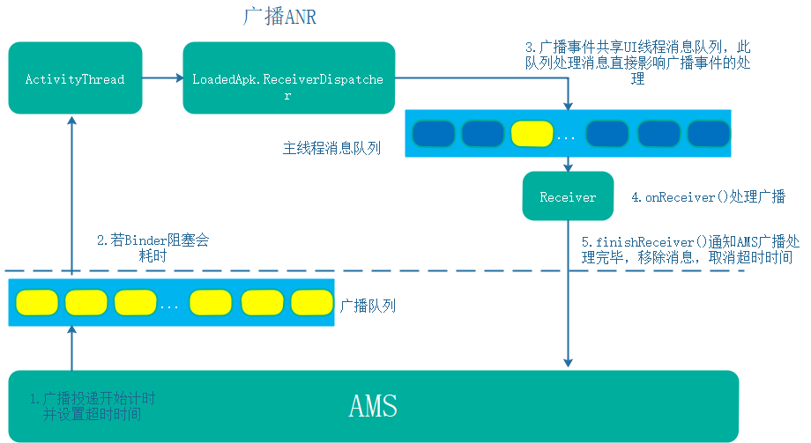

#### 2 ANR分析策略

1. 打开广播的动态开关

adb shell dumpsys activity log broadcast 1// 1为打开，0为关闭，以查看更多日志

广播传到应用端会有以下日志，TAG为ActivityThread



//开始传到ReceiverDispatcher中

Slog.i(ActivityThread.TAG, "Receiving broadcast " + intent.getAction() + " seq=" + seq + " to " + (rd != null ? rd.mReceiver : null));

//广播开始入主线程队列

Slog.i(ActivityThread.TAG, "Enqueueing broadcast " + intent.getAction() + " seq=" + seq + " to " + mReceiver);

//主线程开始分发

Slog.i(ActivityThread.TAG, "Dispatching broadcast " + mCurIntent.getAction() + " seq=" + seq + " to " + mReceiver);

Slog.i(ActivityThread.TAG, " mRegistered=" + mRegistered + " mOrderedHint=" + ordered);

//结束分发

Slog.i(ActivityThread.TAG, "Finishing broadcast to component " + mToken);

1. 查看该广播注册信息

adb shell dumpsys activity broadcasts //查看广播注册信息

3．广播的处理状态

Slog.w()

IN_ENQUEUEING = 1 收到通知

IN_HANDING = 2 消息入队

IN_FINISHING = 3 处理完成

#### 3 实战

##### 1 主线程阻塞 –广播超时未处理

09-05 22:31:57.468 797-812/? E/ActivityManager: ANR in com.qiyei.android

PID: 19360

Reason: Broadcast of Intent { flg=0x14 cmp=com.qiyei.android/com.qiyei.sdk.SDKManager$StartCoreServiceReceiver (has extras) }

Load: 8.62 / 8.1 / 7.64

CPU usage from 237100ms to 0ms ago (2018-09-05 22:27:57.362 to 2018-09-05 22:31:54.462):

10% 797/system_server: 6% user + 4.2% kernel / faults: 71197 minor 2 major

7.2% 7063/com.greenpoint.android.mc10086.activity: 6.6% user + 0.5% kernel / faults: 118308 minor 1 major

1.9% 12431/perfd: 0.9% user + 1% kernel / faults: 649 minor

1.4% 9108/com.muzhiwan.market: 1.1% user + 0.2% kernel / faults: 59307 minor

1% 4062/adbd: 0.2% user + 0.7% kernel / faults: 9198 minor

1% 428/surfaceflinger: 0.5% user + 0.5% kernel / faults: 94 minor

0.9% 4023/com.google.android.gms: 0.6% user + 0.2% kernel / faults: 4897 minor 2 major

0.8% 3950/com.microsoft.launcher: 0.6% user + 0.1% kernel / faults: 11931 minor

0.7% 4666/com.estrongs.android.pop: 0.5% user + 0.1% kernel / faults: 4230 minor 1 major

0.7% 3810/com.google.android.gms.persistent: 0.4% user + 0.2% kernel / faults: 2373 minor 3 major

0.4% 14770/kworker/u16:8: 0% user + 0.4% kernel

0.4% 10/rcu_preempt: 0% user + 0.4% kernel

0.4% 1121/com.android.systemui: 0.3% user + 0% kernel / faults: 2436 minor

0.4% 169/hwrng: 0% user + 0.4% kernel

0.4% 301/msm-core:sampli: 0% user + 0.4% kernel

0.3% 249/cfinteractive: 0% user + 0.3% kernel

0.3% 5493/com.android.vending: 0.2% user + 0% kernel / faults: 1395 minor 2 major

0.3% 257/mmcqd/0: 0% user + 0.3% kernel

0.3% 576/audioserver: 0% user + 0.2% kernel

0.2% 480/irq/215-fc38800: 0% user + 0.2% kernel

0.2% 12320/kworker/u16:6: 0% user + 0.2% kernel

0.2% 5604/com.google.android.apps.messaging: 0.2% user + 0% kernel / faults: 1591 minor

0.2% 3/ksoftirqd/0: 0% user + 0.2% kernel

0.2% 5219/com.tencent.mobileqq:MSF: 0.1% user + 0% kernel / faults: 321 minor

0.2% 18871/kworker/1:1: 0% user + 0.2% kernel

0.2% 426/msm_irqbalance: 0% user + 0.1% kernel

0.1% 16070/mdss_fb0: 0% user + 0.1% kernel

0.1% 16166/kworker/u16:2: 0% user + 0.1% kernel

0.1% 8129/com.tencent.mm:push: 0.1% user + 0% kernel / faults: 458 minor

0.1% 9304/com.muzhiwan.market:mult: 0.1% user + 0% kernel / faults: 3020 minor

0.1% 40/kworker/u17:0: 0% user + 0.1% kernel

0.1% 362/logd: 0% user + 0% kernel / faults: 21 minor

0.1% 363/servicemanager: 0% user + 0% kernel

0.1% 563/thermal-engine: 0% user + 0.1% kernel

0.1% 16673/kworker/0:1: 0% user + 0.1% kernel

0.1% 57/system: 0% user + 0.1% kernel

0.1% 11304/com.android.vending:instant_app_installer: 0% user + 0% kernel / faults: 151 minor

0.1% 15/ksoftirqd/1: 0% user + 0.1% kernel

0% 592/netd: 0% user + 0% kernel / faults: 546 minor

0% 8376/lte.trunk.tapp: 0% user + 0% kernel / faults: 304 minor

0% 20/ksoftirqd/2: 0% user + 0% kernel

0% 6006/com.google.android.gms.unstable: 0% user + 0% kernel / faults: 473 minor

0% 12332/kworker/1:0: 0% user + 0% kernel

0% 1619/com.android.phone: 0% user + 0% kernel / faults: 570 minor

0% 5653/com.google.android.ims: 0% user + 0% kernel / faults: 331 minor

0% 547/jbd2/dm-2-8: 0% user + 0% kernel

0% 4458/com.google.android.apps.photos: 0% user + 0% kernel / faults: 159 minor

0% 537/dmcrypt_write: 0% user + 0% kernel

0% 12094/kworker/u16:3: 0% user + 0% kernel

0% 25/ksoftirqd/3: 0% user + 0% kernel

0% 422/android.hardware.wifi@1.0-service: 0% user + 0% kernel

0% 16064/kworker/u16:1: 0% user + 0% kernel

0% 331/ueventd: 0% user + 0% kernel

0% 427/lmkd: 0% user + 0% kernel

0% 3923/com.android.nfc: 0% user + 0% kernel / faults: 2296 minor 11 major

0% 565/perfd: 0% user + 0% kernel / faults: 111 minor

0% 574/zygote64: 0% user + 0% kernel / faults: 1269 minor

0% 7921/com.greenpoint.android.mc10086.activity:McPushservice: 0% user + 0% kernel / faults: 43 minor

0% 8/rcuc/0: 0% user + 0% kernel

0% 595/wificond: 0% user + 0% kernel

0% 5204/kworker/u17:9: 0% user + 0% kernel

0% 12524/kworker/u17:6: 0% user + 0% kernel

0% 261/irq/224-spdm_bw: 0% user + 0% kernel

0% 160

----- pid 19360 at 2018-09-05 22:31:54 -----

Cmd line: com.qiyei.android

Build fingerprint: 'google/angler/angler:8.0.0/OPR5.170623.011/4397986:user/release-keys'

ABI: 'arm64'

Build type: optimized

Zygote loaded classes=4681 post zygote classes=819

Intern table: 43407 strong; 137 weak

JNI: CheckJNI is on; globals=552 (plus 37 weak)

Libraries: /system/lib64/libandroid.so /system/lib64/libcompiler_rt.so /system/lib64/libjavacrypto.so /system/lib64/libjnigraphics.so /system/lib64/libmedia_jni.so /system/lib64/libsoundpool.so /system/lib64/libwebviewchromium_loader.so libjavacore.so libopenjdk.so (9)

Heap: 43% free, 1672KB/2MB; 28524 objects

Dumping cumulative Gc timings

Start Dumping histograms for 2 iterations for concurrent copying

ProcessMarkStack: Sum: 20.902ms 99% C.I. 6.954ms-13.930ms Avg: 10.451ms Max: 13.948ms

VisitConcurrentRoots: Sum: 8.369ms 99% C.I. 4.117ms-4.252ms Avg: 4.184ms Max: 4.252ms

ScanImmuneSpaces: Sum: 3.099ms 99% C.I. 1.337ms-1.762ms Avg: 1.549ms Max: 1.762ms

FlipThreadRoots: Sum: 1.017ms 99% C.I. 5us-1012us Avg: 508.500us Max: 1012us

RecordFree: Sum: 990us 99% C.I. 303us-687us Avg: 495us Max: 687us

ClearFromSpace: Sum: 901us 99% C.I. 397us-504us Avg: 450.500us Max: 504us

InitializePhase: Sum: 616us 99% C.I. 211us-405us Avg: 308us Max: 405us

GrayAllDirtyImmuneObjects: Sum: 592us 99% C.I. 276us-316us Avg: 296us Max: 316us

ThreadListFlip: Sum: 507us 99% C.I. 64us-443us Avg: 253.500us Max: 443us

SweepSystemWeaks: Sum: 504us 99% C.I. 178us-326us Avg: 252us Max: 326us

FlipOtherThreads: Sum: 471us 99% C.I. 224us-247us Avg: 235.500us Max: 247us

EnqueueFinalizerReferences: Sum: 392us 99% C.I. 62us-330us Avg: 196us Max: 330us

VisitNonThreadRoots: Sum: 257us 99% C.I. 125us-132us Avg: 128.500us Max: 132us

MarkingPhase: Sum: 197us 99% C.I. 39us-158us Avg: 98.500us Max: 158us

SweepAllocSpace: Sum: 150us 99% C.I. 57us-93us Avg: 75us Max: 93us

ProcessReferences: Sum: 149us 99% C.I. 2us-124us Avg: 37.250us Max: 124us

(Paused)ClearCards: Sum: 127us 99% C.I. 0.250us-28us Avg: 3.968us Max: 28us

ResumeRunnableThreads: Sum: 96us 99% C.I. 46us-50us Avg: 48us Max: 50us

MarkZygoteLargeObjects: Sum: 94us 99% C.I. 42us-52us Avg: 47us Max: 52us

ClearRegionSpaceCards: Sum: 88us 99% C.I. 38us-50us Avg: 44us Max: 50us

EmptyRBMarkBitStack: Sum: 79us 99% C.I. 29us-50us Avg: 39.500us Max: 50us

MarkStackAsLive: Sum: 63us 99% C.I. 25us-38us Avg: 31.500us Max: 38us

SweepLargeObjects: Sum: 59us 99% C.I. 28us-31us Avg: 29.500us Max: 31us

(Paused)FlipCallback: Sum: 38us 99% C.I. 18us-20us Avg: 19us Max: 20us

ForwardSoftReferences: Sum: 26us 99% C.I. 11us-15us Avg: 13us Max: 15us

ReclaimPhase: Sum: 25us 99% C.I. 11us-14us Avg: 12.500us Max: 14us

Sweep: Sum: 8us 99% C.I. 4us-4us Avg: 4us Max: 4us

UnBindBitmaps: Sum: 3us 99% C.I. 1us-2us Avg: 1.500us Max: 2us

Done Dumping histograms

concurrent copying paused: Sum: 1.240ms 99% C.I. 377us-863us Avg: 620us Max: 863us

concurrent copying total time: 39.871ms mean time: 19.935ms

concurrent copying freed: 8954 objects with total size 1867KB

concurrent copying throughput: 229590/s / 46MB/s

Cumulative bytes moved 3253960

Cumulative objects moved 66181

Total time spent in GC: 39.871ms

Mean GC size throughput: 45MB/s

Mean GC object throughput: 224574 objects/s

Total number of allocations 37478

Total bytes allocated 3MB

Total bytes freed 1867KB

Free memory 1303KB

Free memory until GC 1303KB

Free memory until OOME 190MB

Total memory 2MB

Max memory 192MB

Zygote space size 652KB

Total mutator paused time: 1.240ms

Total time waiting for GC to complete: 3.644us

Total GC count: 2

Total GC time: 39.871ms

Total blocking GC count: 0

Total blocking GC time: 0

Registered native bytes allocated: 6706103

/data/app/com.qiyei.android-YE8gfgyKHGUDNhwn3DzDzw==/oat/arm64/base.odex: quicken

Current JIT code cache size: 108KB

Current JIT data cache size: 65KB

Current JIT capacity: 256KB

Current number of JIT code cache entries: 149

Total number of JIT compilations: 168

Total number of JIT compilations for on stack replacement: 1

Total number of JIT code cache collections: 3

Memory used for stack maps: Avg: 274B Max: 19KB Min: 24B

Memory used for compiled code: Avg: 696B Max: 41KB Min: 4B

Memory used for profiling info: Avg: 195B Max: 5KB Min: 32B

Start Dumping histograms for 172 iterations for JIT timings

Compiling: Sum: 451.184ms 99% C.I. 0.220ms-47.736ms Avg: 2.669ms Max: 123.878ms

TrimMaps: Sum: 17.182ms 99% C.I. 15us-2809.250us Avg: 101.668us Max: 3906us

Code cache collection: Sum: 2.664ms 99% C.I. 541us-1565us Avg: 888us Max: 1565us

Done Dumping histograms

Memory used for compilation: Avg: 160KB Max: 8MB Min: 21KB

ProfileSaver total_bytes_written=9544

ProfileSaver total_number_of_writes=1

ProfileSaver total_number_of_code_cache_queries=1

ProfileSaver total_number_of_skipped_writes=0

ProfileSaver total_number_of_failed_writes=0

ProfileSaver total_ms_of_sleep=44999

ProfileSaver total_ms_of_work=3

ProfileSaver max_number_profile_entries_cached=16

ProfileSaver total_number_of_hot_spikes=3

ProfileSaver total_number_of_wake_ups=2

suspend all histogram: Sum: 579us 99% C.I. 1us-394.880us Avg: 48.250us Max: 401us

DALVIK THREADS (18):

"Thread-4" prio=5 tid=18 Runnable

| group="main" sCount=0 dsCount=0 flags=0 obj=0x12fa3550 self=0x7cc2d4ea00

| sysTid=19424 nice=0 cgrp=default sched=0/0 handle=0x7cc0b724f0

| state=R schedstat=( 62521890475 60078256 1350 ) utm=6251 stm=0 core=4 HZ=100

| stack=0x7cc0a70000-0x7cc0a72000 stackSize=1037KB

| held mutexes= "mutator lock"(shared held)

at com.qiyei.architecture.ui.activity.ANRActivity$4$1.run(ANRActivity.java:121)

- locked <0x00d0ea67> (a java.lang.Object)

at java.lang.Thread.run(Thread.java:764)

"Signal Catcher" daemon prio=5 tid=3 Runnable

| group="system" sCount=0 dsCount=0 flags=0 obj=0x130c0000 self=0x7cdacbf400

| sysTid=19366 nice=0 cgrp=default sched=0/0 handle=0x7cd12024f0

| state=R schedstat=( 21918076 305521 5 ) utm=0 stm=0 core=6 HZ=100

| stack=0x7cd1108000-0x7cd110a000 stackSize=1005KB

| held mutexes= "mutator lock"(shared held)

native: #00 pc 000000000039d278 /system/lib64/libart.so (_ZN3art15DumpNativeStackERNSt3__113basic_ostreamIcNS0_11char_traitsIcEEEEiP12BacktraceMapPKcPNS_9ArtMethodEPv+212)

native: #01 pc 00000000004645d0 /system/lib64/libart.so (_ZNK3art6Thread9DumpStackERNSt3__113basic_ostreamIcNS1_11char_traitsIcEEEEbP12BacktraceMapb+348)

native: #02 pc 000000000047b7e0 /system/lib64/libart.so (_ZN3art14DumpCheckpoint3RunEPNS_6ThreadE+884)

native: #03 pc 00000000004741f4 /system/lib64/libart.so (_ZN3art10ThreadList13RunCheckpointEPNS_7ClosureES2_+472)

native: #04 pc 0000000000473bf0 /system/lib64/libart.so (_ZN3art10ThreadList4DumpERNSt3__113basic_ostreamIcNS1_11char_traitsIcEEEEb+796)

native: #05 pc 0000000000473784 /system/lib64/libart.so (_ZN3art10ThreadList14DumpForSigQuitERNSt3__113basic_ostreamIcNS1_11char_traitsIcEEEE+924)

native: #06 pc 0000000000448b74 /system/lib64/libart.so (_ZN3art7Runtime14DumpForSigQuitERNSt3__113basic_ostreamIcNS1_11char_traitsIcEEEE+196)

native: #07 pc 0000000000452404 /system/lib64/libart.so (_ZN3art13SignalCatcher13HandleSigQuitEv+1684)

native: #08 pc 0000000000451200 /system/lib64/libart.so (_ZN3art13SignalCatcher3RunEPv+356)

native: #09 pc 0000000000066a4c /system/lib64/libc.so (_ZL15__pthread_startPv+36)

native: #10 pc 000000000001eb94 /system/lib64/libc.so (__start_thread+68)

(no managed stack frames)

"main" prio=5 tid=1 Blocked

| group="main" sCount=1 dsCount=0 flags=1 obj=0x73f69670 self=0x7cdacbea00

| sysTid=19360 nice=-10 cgrp=default sched=0/0 handle=0x7cdf4749b0

| state=S schedstat=( 2113287269 98016707 573 ) utm=197 stm=13 core=4 HZ=100

| stack=0x7fef6d5000-0x7fef6d7000 stackSize=8MB

| held mutexes=

at com.qiyei.architecture.ui.activity.ANRActivity$MyReceiver.onReceive(ANRActivity.java:148)

- waiting to lock <0x00d0ea67> (a java.lang.Object) held by thread 18

at android.app.LoadedApk$ReceiverDispatcher$Args.lambda$-android_app_LoadedApk$ReceiverDispatcher$Args_51267(LoadedApk.java:1295)

at android.app.-$Lambda$FilBqgnXJrN9Mgyks1XHeAxzSTk.$m$0(unavailable:-1)

at android.app.-$Lambda$FilBqgnXJrN9Mgyks1XHeAxzSTk.run(unavailable:-1)

at android.os.Handler.handleCallback(Handler.java:789)

at android.os.Handler.dispatchMessage(Handler.java:98)

at android.os.Looper.loop(Looper.java:164)

at android.app.ActivityThread.main(ActivityThread.java:6541)

at java.lang.reflect.Method.invoke(Native method)

at com.android.internal.os.Zygote$MethodAndArgsCaller.run(Zygote.java:240)

at com.android.internal.os.ZygoteInit.main(ZygoteInit.java:767)

### 5 Service ANR

### 6 Provider ANR

## 十 APP专项技术优化

### 1 线程优化

#### 1 Android线程调度

* nice值及priority优先级

process中定义

值越小，优先级越高

默认是0

Process.THREAD_PRIORITY_DEFAULT = 0

* cgroup群组调度策略

保证前台线程可以获取到更多的CPU

优先级具有继承性，因此定义线程是应该指定其优先级和线程名字

#### 2 Android异步方式汇总

* Thread
* HandlerThread

适合长时间执行的任务

优先级低的任务

* IntentService

适合优先级较高的任务，并且不容易被后台杀死

* AsyncTask

需要注意版本不一致

* java线程池
* Rxjava

#### 3 如何锁定线程创建者

1 项目变大以后收敛线程

2 避免线程恶化

创建线程的位置获取堆栈

所有的异步方式，都会走到new thread

特别适合hook手段

#### 4 基础库怎么使用线程

1 直接依赖线程库

2基础库内部暴露API setExecutor

初始化的时候统一注入

#### 5 统一线程库

区分io密集型cpu型

io密集不消耗cpu，核心池可以很大

cpu密集型任务核心池大小和cpu核心数相关

#### 6 线程问题面试

线程使用会遇到问题

怎么在项目中

### 2 列表卡顿优化

#### 1 常规方案

convertview复用，使用viewholder

耗时操作异步处理

#### 2 布局相关

减少布局层级，避免过度绘制

异步ibflate或者x2c

#### 3 图片

避免过大尺寸，gc频繁，内存抖动

避免ui线程被抢占

#### 4 textview优化

原因 复杂文本性能不佳

直接使用facebook textlayoutbuilder

#### 5 注意字符串拼接

### 3 WebView异常监控

#### 1 性能适配 vassonic

问题

#### 2 监控白屏率

思路 监控屏幕是不是白屏，白屏则webview有问题

# 第三部分 Android 应用层进阶

## 一 Activity的工作流程

### 1 Activity启动流程

Activity的启动一般分为三部分

#### 1 Client到AMS过程

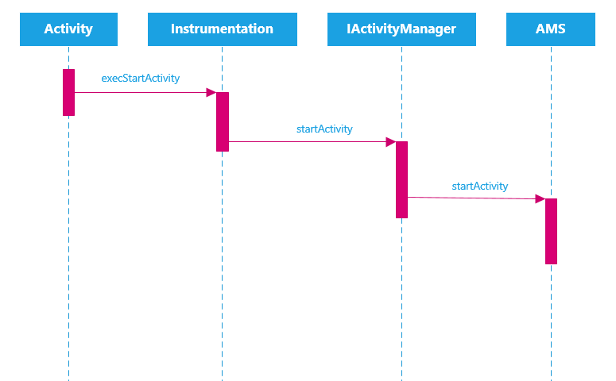

#### 2 AMS到ApplicationThread过程

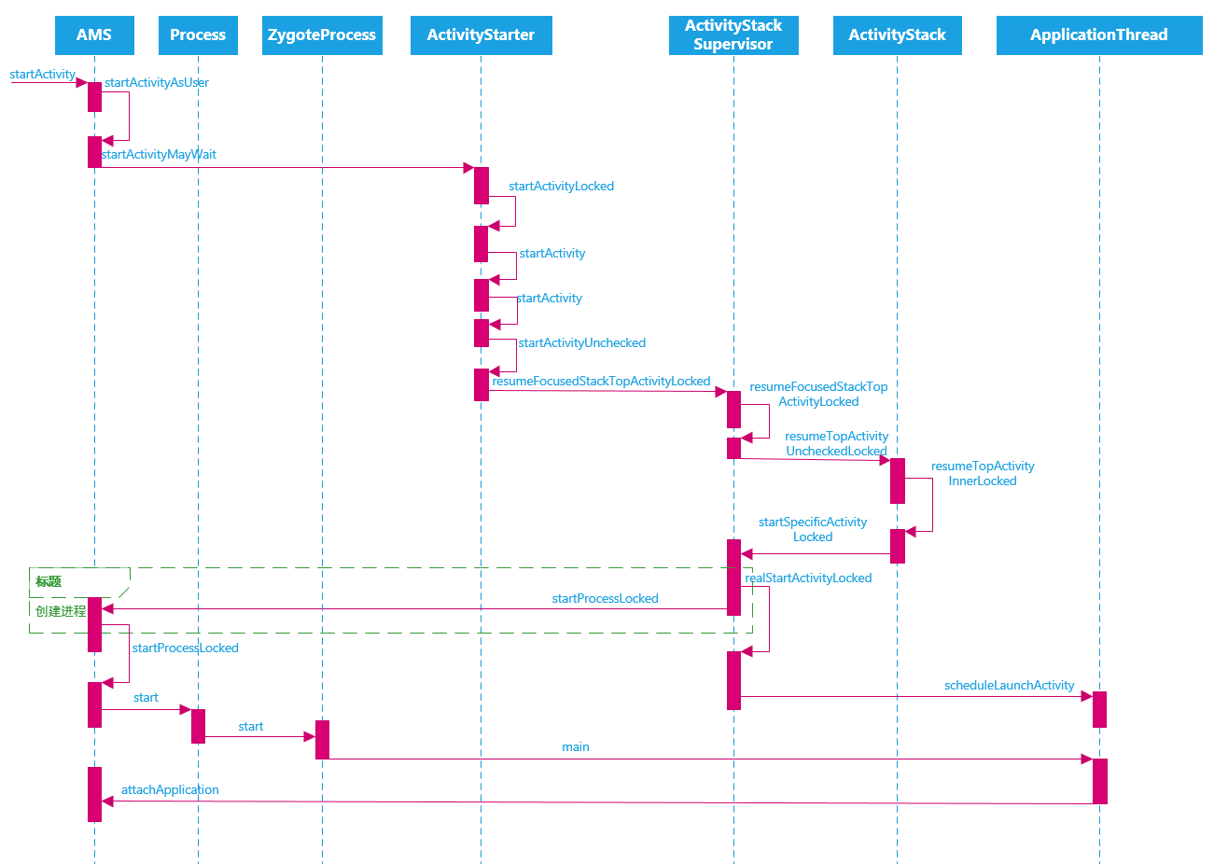

#### 3 ActivityThread中H启动Activity过程

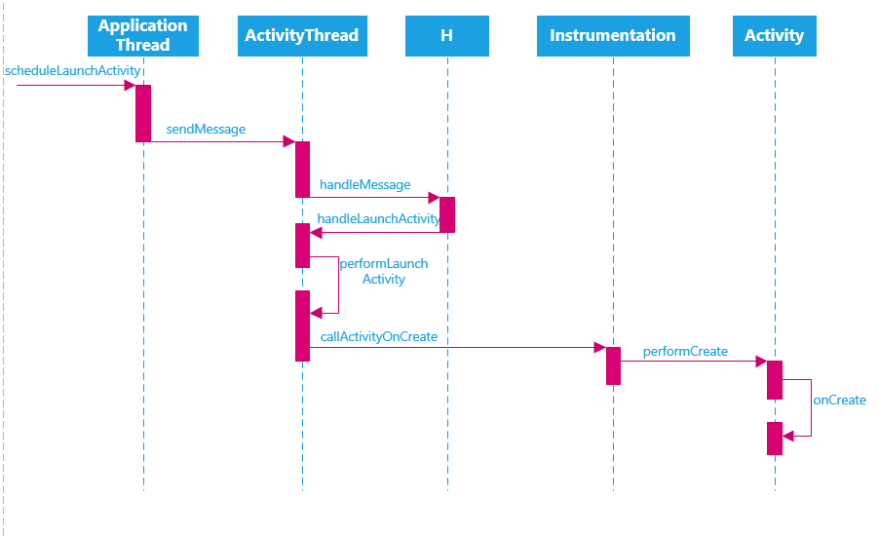

该过程较为简单

#### 4 launcher启动新Activity

会涉及到4个进程

launcher Zogote App进程，SystemServer进程

### 2 Android启动模式与Activity栈

四种启动模式

TaskAffinity:指定任务栈

allowTaskReparenting:允许任务栈中activity复用？

## 二 Service工作流程

### 1 start service工作流程

#### ContextImpl到AMS

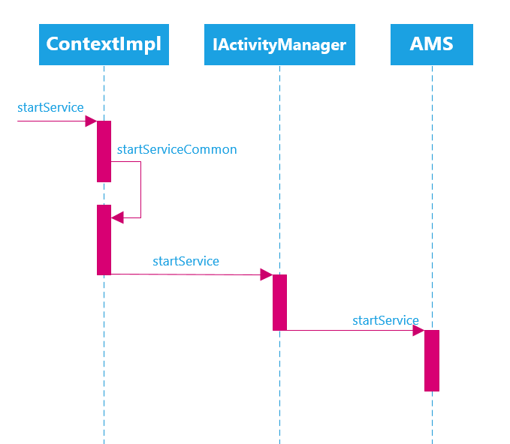

#### 2 AMS到ActivityThread

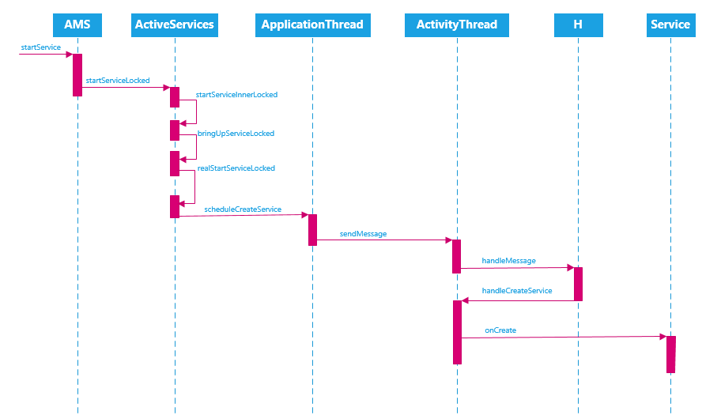

### 2 BindService流程

#### 1 ContextImpl到AMS

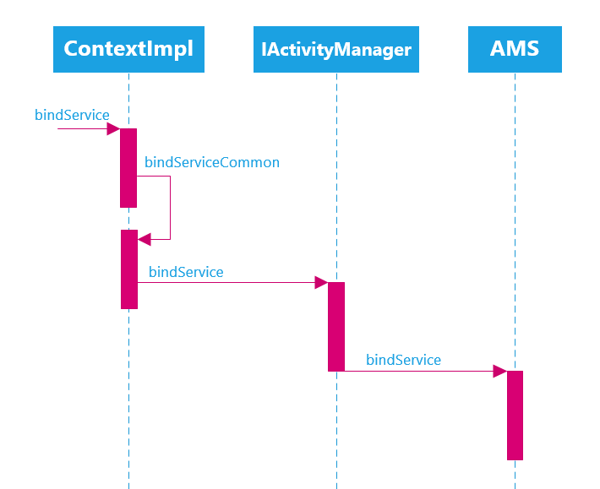

#### 2 AMS到Service

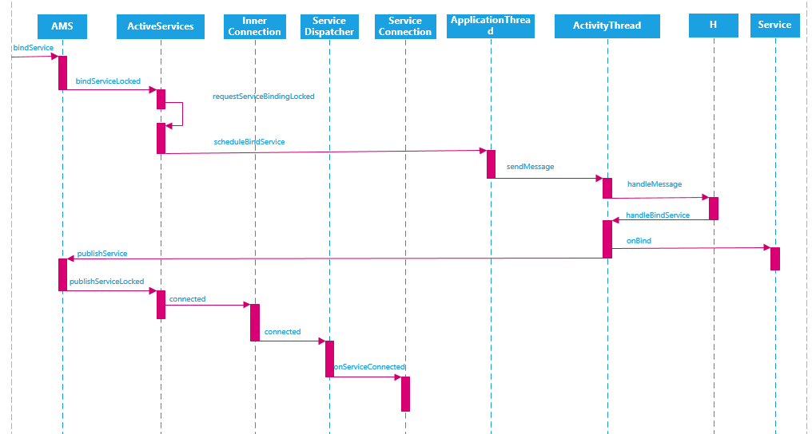

## 三 Receiver工作流程

### 1 Receiver注册流程

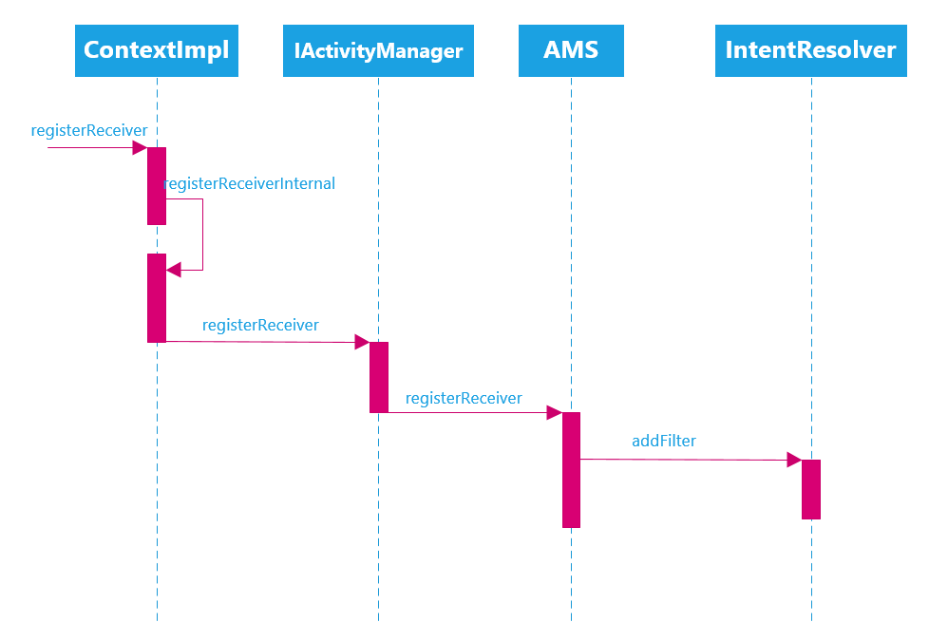

#### 1 Client逻辑

* 将BroadcastReceiver包装成LoadedApk.ReceiverDispatcher对象
* ReceiverDispatcher内部包含IIntentReceiver.Stub对象
* 将InnerReceiver对象(IIntentReceiver.Stub)注册到AMS中

#### 2 AMS中逻辑

* AMS中将InnerReceiver包装成ReceiverList对象，并注册到mRegisteredReceivers(Map中)
* 将IntentFilter包装成BroadcastFilter，并注册到ReceiverList和mReceiverResolver中

#### 3 前台广播与后台广播

前台队列的超时时间是10s，而后台是60s

Intent intent = new Intent(Intent.ACTION_SHUTDOWN);

intent.addFlags(Intent.FLAG_RECEIVER_FOREGROUND);

### 2 Receiver发送与接收流程

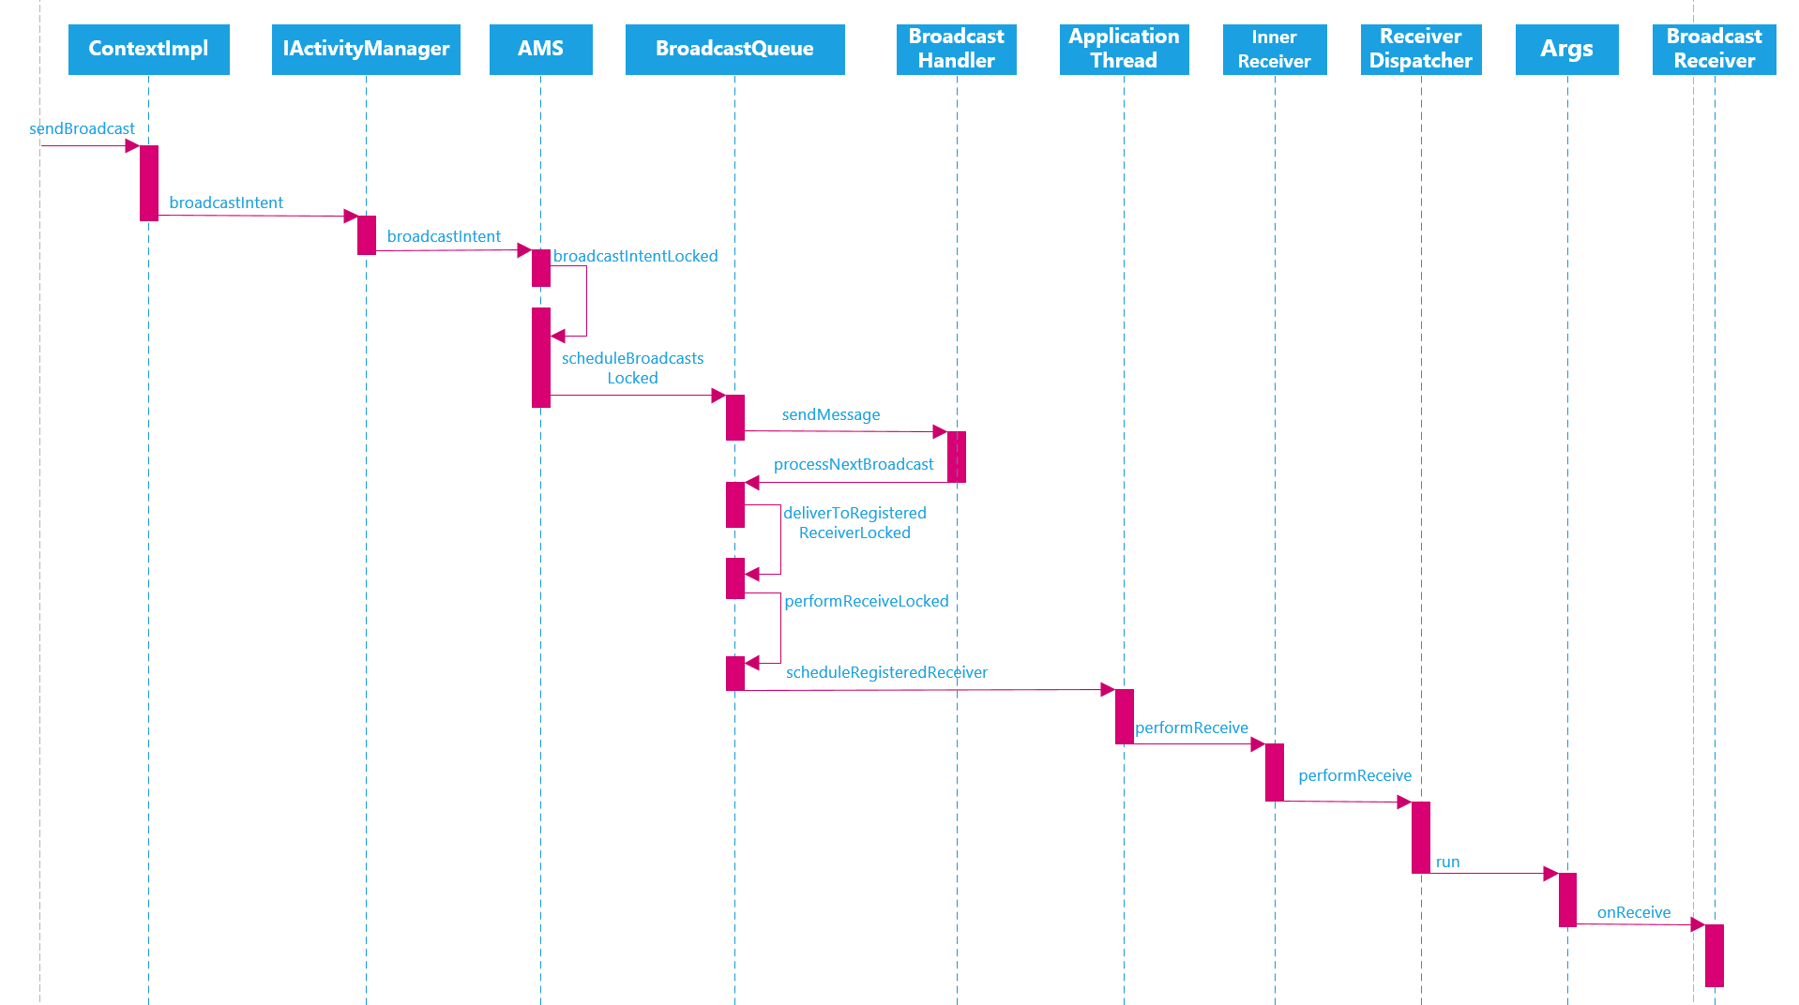

## 四 Provider工作流程

### 1 Provider启动流程

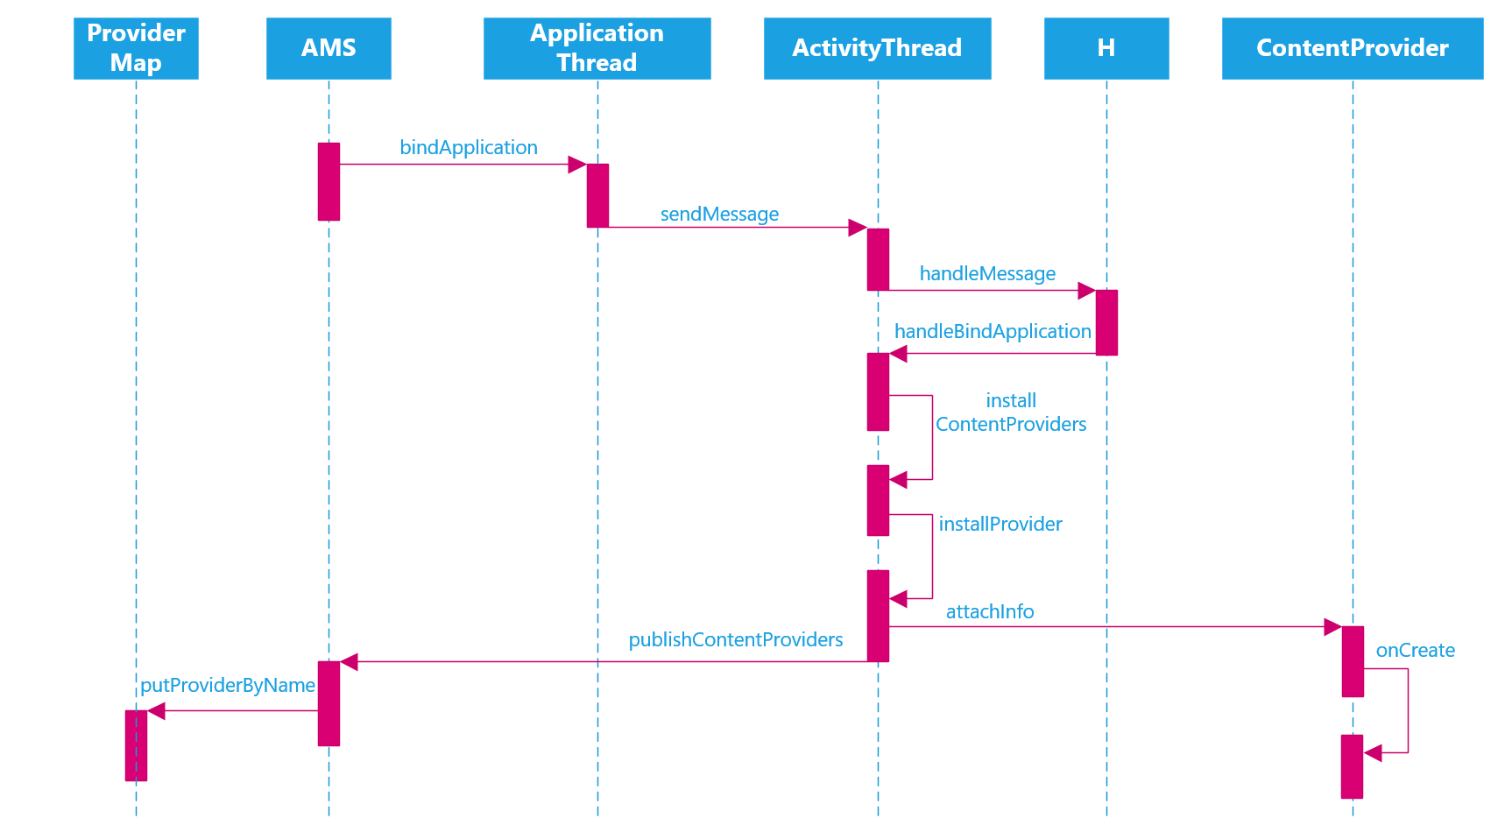

* ContentProvider中含有mTransport(IContentProvider子类)对象
* 进一步会将mTransport封装成ContentProviderHolder对象
* 启动成功后会将ContentProviderHolder注册到AMS中
* AMS会将ContentProviderHolder注册到ProviderMap对象中

### 2 Provider查询流程

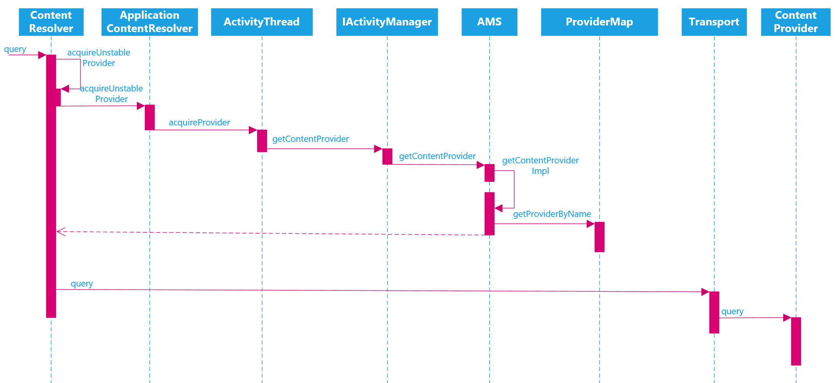

#### 1 获取IContentProvider对象

* 通过ActivityThread最终获取到IContentProvider对象(Transport对象)

#### 2 查询返回Cursor

* 调用Transport对象查询数据，最终调用到ContentProvider对象的query方法

## 五 Android 上下文Context

### 1 总体框架

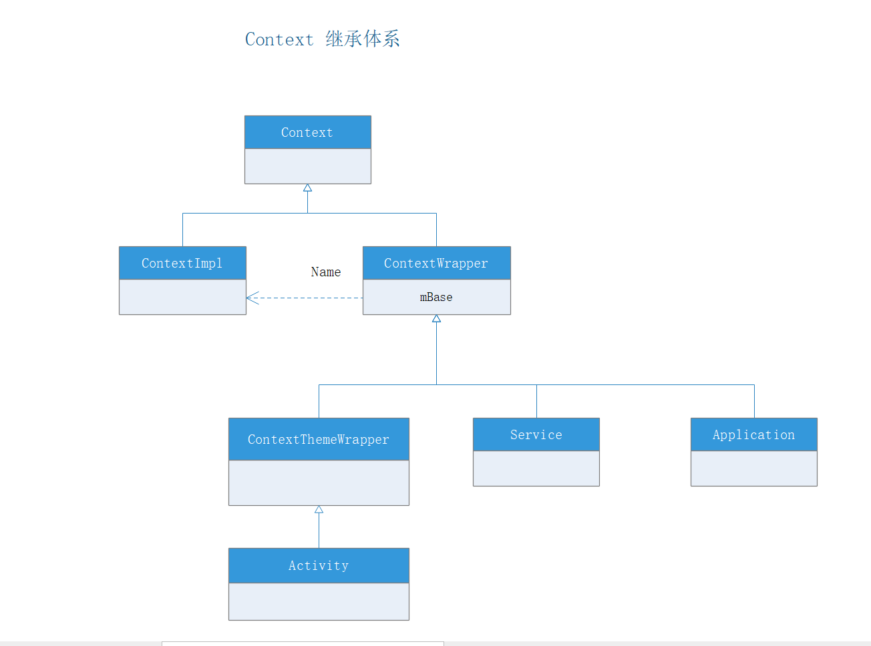

### 2 Application Context的创建

handleBindApplication中会调用LoadedApk的makeApplication，这里面会创建Application的Context

private void handleBindApplication(AppBindData data) {

....

try {

// If the app is being launched for full backup or restore, bring it up in

// a restricted environment with the base application class.

app = data.info.makeApplication(data.restrictedBackupMode, null);

mInitialApplication = app;

....

}

LoadedApk中

public Application makeApplication(boolean forceDefaultAppClass,

Instrumentation instrumentation) {

....

ContextImpl appContext = ContextImpl.createAppContext(mActivityThread, this);

app = mActivityThread.mInstrumentation.newApplication(

cl, appClass, appContext);

appContext.setOuterContext(app);

....

return app;

}

### 3 Activity Context的创建

在AcivityThread的performLaunchActivity中

private Activity performLaunchActivity(ActivityClientRecord r, Intent customIntent) {

….

ContextImpl appContext = createBaseContextForActivity(r);

Activity activity = null;

try {

java.lang.ClassLoader cl = appContext.getClassLoader();

activity = mInstrumentation.newActivity(

cl, component.getClassName(), r.intent);

StrictMode.incrementExpectedActivityCount(activity.getClass());

r.intent.setExtrasClassLoader(cl);

r.intent.prepareToEnterProcess();

if (r.state != null) {

r.state.setClassLoader(cl);

}

} catch (Exception e) {

if (!mInstrumentation.onException(activity, e)) {

throw new RuntimeException(

"Unable to instantiate activity " + component

+ ": " + e.toString(), e);

}

}

….

appContext.setOuterContext(activity);

activity.attach(appContext, this, getInstrumentation(), r.token,

r.ident, app, r.intent, r.activityInfo, title, r.parent,

r.embeddedID, r.lastNonConfigurationInstances, config,

r.referrer, r.voiceInteractor, window, r.configCallback);

….

return activity;

}

1. 创建Context
2. 创建Activity
3. 设置Context
4. activity. attach

### 4 Service Context的创建

private void handleCreateService(CreateServiceData data) {

….

Service service = null;

try {

java.lang.ClassLoader cl = packageInfo.getClassLoader();

service = (Service) cl.loadClass(data.info.name).newInstance();

} catch (Exception e) {

if (!mInstrumentation.onException(service, e)) {

throw new RuntimeException(

"Unable to instantiate service " + data.info.name

+ ": " + e.toString(), e);

}

}

try {

if (localLOGV) Slog.v(TAG, "Creating service " + data.info.name);

**ContextImpl context = ContextImpl.createAppContext(this, packageInfo);**

**context.setOuterContext(service);**

**Application app = packageInfo.makeApplication(false, mInstrumentation);**

**service.attach(context, this, data.info.name, data.token, app,**

**ActivityManager.getService());**

**service.onCreate();**

mServices.put(data.token, service);

….

}

1 创建Context

2 创建Service

4 设置Context

5 service.attach

## 六 Android消息处理机制

### 1 Handler Loop机制

java 层机制

Handler Looper MessageQueue Mesaage

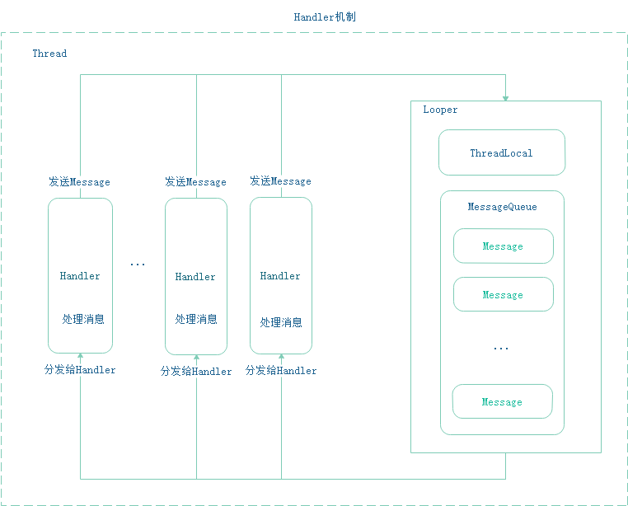

* native层

1 使用epoll机制

2 java层持有native层的MessageQueue地址

3 唤醒后会先处理Native层的消息，再处理java层的消息

* 循环机制:

1 Looper.loop()第一次调用时会调用到MessageQueue中的nativePollOnce(ptr, nextPollTimeoutMillis);超时时间是0，所以会立即返回。

2 这个时候如果MessageQueue没有消息：设置nextPollTimeoutMillis = -1，并且标注mBlocked = true

3 接下来如果有IdleHandler，则处理其回调，没有就继续循环，阻塞在nativePollOnce(ptr, nextPollTimeoutMillis)，该方法会在native层调用epoll_wait()挂起

4 新添加消息会在enqueueMessage()中根据mBlocked = true来唤醒队列，即会调用nativeWake(mPtr);来唤醒nativePollOnce()的挂起

#### 1 ThreadLocal

ThreadLocal是一个线程内部类，主要用来存储一些线程相关的数据，其他线程无法访问。例如对于Handler来说，它需要获取跟线程相关的Looper,因此，其实与Hanlder相关的Looper就是存在ThreadLocal中的。

Thread中ThreadLocal是定义成泛型形式的。

private ThreadLocal<T> xxx

ThreadLocal有get/set方法。

#### 2 MeaageQueue工作原理

MessageQueue是一个基于链表形式的管理Message的这样一种结构(插入，删除代价低)。主要的操作就是插入和读取。插入的操作是MessageQueue的boolean enqueueMessage(Message msg,long when),读取伴随着删除，方法是MessageQueue的Message next()

#### 3 Looper工作原理

Looper具体扮演的角色就是不停的查询MessageQueue中是否有消息，如果没有就阻塞。有的话就处理消息。每一个Looper是和Handler与线程相关的。Looper的构造方法会关联线程和MessageQueue。

private Looper(){

mQueue = new MessageQueue(quitAllowed);

mThread = Thread.currentThread();

}

为一个线程创建Looper对象直接调用Looper的静态方法：prepare()及：Looper.prepare()即可。

主线程创建Looper是调用Looper.prepareMainLooper()方法。获取主线程的Looper可以调用Looper.getMainLooper()

Loop调用其loop()方法才开启消息循环。才会源源不断的从MessageQueue取出消息来处理。

在loop()方法中有这样一个循环

for (;;) {

Message msg = queue.next(); // might block

if (msg == null) {

// No message indicates that the message queue is quitting.

return;

}

// This must be in a local variable, in case a UI event sets the logger

Printer logging = me.mLogging;

if (logging != null) {

logging.println(">>>>> Dispatching to " + msg.target + " " +

msg.callback + ": " + msg.what);

}

msg.target.dispatchMessage(msg);

….

}

只有当MessageQueue对象queue的next()方法返回null时，该循环才退出(MessageQueue的quit方法被调用)，否则要么挂起，要么循环执行。执行到msg.target.dispatchMessage(msg);就开始处理消息了。具体怎么处理见下面。

#### 4 Handler的工作原理

* Send Message

Handler的工作流程主要就是发送消息和处理消息，其中post方法最终也是通过send方法发送消息的。Send方法最终会调用到：sendMessageAtTime()

public boolean sendMessageAtTime(Message msg, long uptimeMillis) {

MessageQueue queue = mQueue;

if (queue == null) {

RuntimeException e = new RuntimeException(

this + " sendMessageAtTime() called with no mQueue");

Log.w("Looper", e.getMessage(), e);

return false;

}

return enqueueMessage(queue, msg, uptimeMillis);

}

这里的mQueue就是Looper中所关联的MessageQueue。

private boolean enqueueMessage(MessageQueue queue, Message msg, long uptimeMillis) {

msg.target = this;

if (mAsynchronous) {

msg.setAsynchronous(true);

}

return queue.enqueueMessage(msg, uptimeMillis);

}

Hanlder 发送消息的主要是往MessageQueue队列里添加了一个消息，并且把这个消息的targer关联了自己。以方便后面Handler处理消息。

* Handle Message

在Looper循环中，我们通过MessageQueue的next()方法返回一个消息对象，注意此时已经在另外一个线程中了。会调用msg.target.dispatchMessage(msg);处理消息，这里的msg.target就是前面的Handler对象了，因此这里将会直接调用Handler的public void dispatchMessage(Message msg)处理消息。

public void dispatchMessage(Message msg) {

if (msg.callback != null) {

handleCallback(msg);

} else {

if (mCallback != null) {

if (mCallback.handleMessage(msg)) {

return;

}

}

handleMessage(msg);

}

}

注意：这里的msg.callback就是Handler post(Runable r)中 的r。接着看mCallback是否为空，mCallback就是

Handler在实例化对象的时候说传入的Callback接口参数，它里面也有一个handleMessage(Message msg)方法。最后才是最普通的handleMessage(msg);

public interface Callback {

public boolean handleMessage(Message msg);

}

Callback可以创建一个Handler实例但并不需要派生其子类，为我们创建Handler实例提供了另外一种方法。

#### 5 主线程的消息循环

Android主线程就是ActivityThread，入口方法为public static void main(String[] args)

在该方法中通过Looper.prepareMainLooper来初始化主线程Looper对象及MessageQueue对象。然后通过Looper.loop()开启消息循环。ActivityThread中的Hander是H，定义如下：

private class H extends Handler {

public static final int LAUNCH_ACTIVITY = 100;

public static final int PAUSE_ACTIVITY = 101;

…..

public void handleMessage(Message msg) {

…..

}

}

### 2 HandlerThread

(1) 本质上是一个Thread子类

(2) 封装了Looper，并在run()中初始化了Looper,并开启了Looper 循环，注意该Looper是可以退出的

(3) 唯一的作用就是获取HandlerThread中的Looper，该Looper可用于其他Handler中，注意该Looper是不是主线程的Looper

### 3 IntentService

(1) 本质上是一个Service，继承与Service

(2) 持有Looper和Handlerd对象，并在其onCreate()中完成的初始化

(3) 在onStart()中发送消息到Looper中，处理消息的逻辑在Handler的子类ServiceHandler中

(4) IntentService要执行的task放在onHandleIntent()中，该方法运行在子线程。子类只需要在这里面实现逻辑即可

(5)调用onHandleIntent()完毕会自动结束Service

### 4 AsyncTask

低版本

android3.0以前是并发执行任务的

高版本

基于线程池

Android3.0以后默认是串行执行task的(调用execute(Params... params))

也可以采用executeOnExecutor()来并发的执行task

这两个方法的Executor不一样，execute主要是默认的executor,另外一个可以选THREAD_POOL_EXECUTOR

## 七 View绘制流程及事件处理机制

### 1 View绘制流程

View树的绘制流程

#### 1 ViewRoot

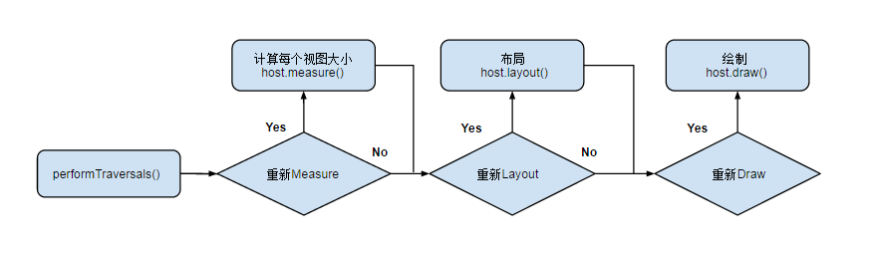

View 绘制流程函数调用链

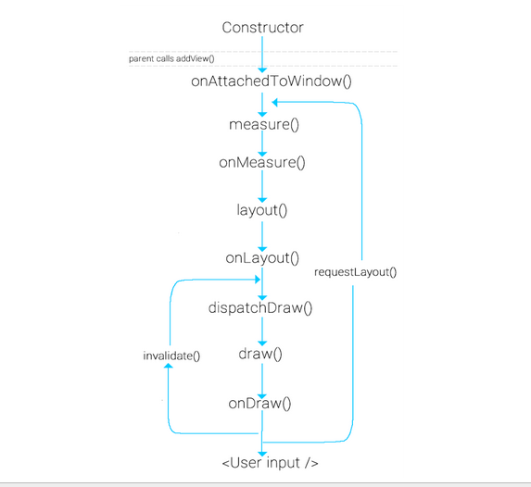

#### 2 measure 和 layout

View树的遍历是有序的，由父视图到子视图，每一个 ViewGroup 负责测绘它所有的子视图，而最底层的 View 会负责测绘自身。

MeasureSpecs

测量规格，包含测量要求和尺寸的信息，有三种模式:

* UNSPECIFIED

父视图不对子视图有任何约束，它可以达到所期望的任意尺寸。比如 ListView、ScrollView，一般自定义 View 中用不到，

* EXACTLY

父视图为子视图指定一个确切的尺寸，而且无论子视图期望多大，它都必须在该指定大小的边界内，对应的属性为 match_parent 或具体值，比如 100dp，父控件可以通过MeasureSpec.getSize(measureSpec)直接得到子控件的尺寸。

* AT_MOST

父视图为子视图指定一个最大尺寸。子视图必须确保它自己所有子视图可以适应在该尺寸范围内，对应的属性为 wrap_content，这种模式下，父控件无法确定子 View 的尺寸，只能由子控件自己根据需求去计算自己的尺寸，这种模式就是我们自定义视图需要实现测量逻辑的情况

#### 3 draw

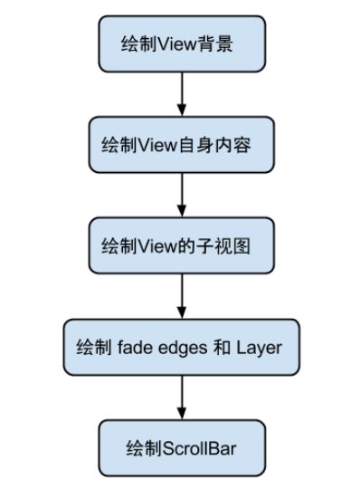

#### 4 几点比较

* requestLayout()方法 ：会导致调用measure()过程 和 layout()过程 。 将会根据标志位判断是否需要ondraw
* onLayout()方法(如果该View是ViewGroup对象，需要实现该方法，对每个子视图进行布局)
* onDraw()方法绘制视图本身 (每个View都需要重载该方法，ViewGroup不需要实现该方法)
* drawChild()去重新回调每个子视图的draw()方法
* invalidate主线程调用，会刷新整个View(也可以局部刷新)，并且当这个View的可见性为VISIBLE的时候，View的onDraw()方法将会被调用
* postInvalidate 子线程调用，是通过Handler将刷新事件通知发到Handler的handlerMessage中去执行invalidate的。

### 2 View事件处理流程

View事件分发分为两部分

#### 1 input子系统通过WMS派发到Activity中

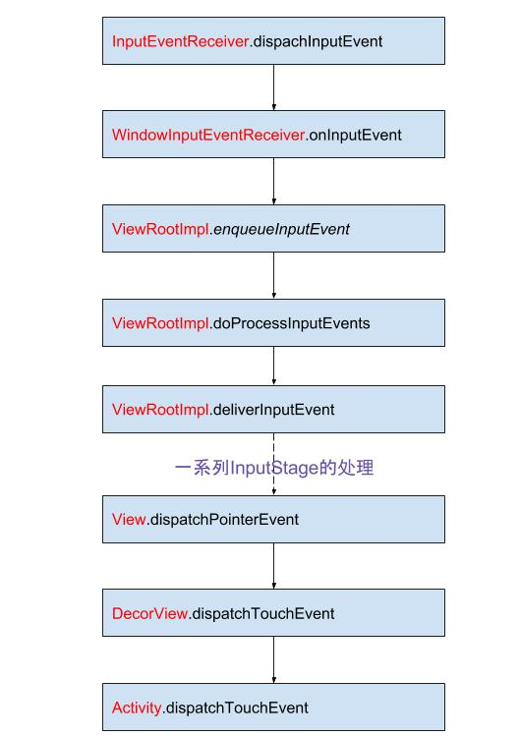

#### 2 Activity分发到View中

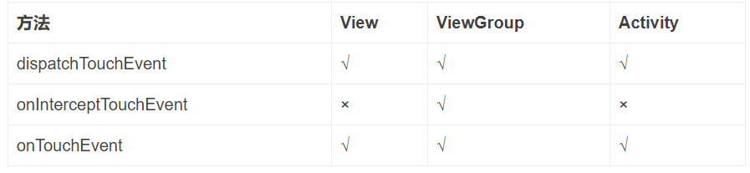

dispatchTouchEvent(MotionEvent ev)：分发事件

onInterceptTouchEvent(MotionEvent ev):拦截事件，ViewGroup有，默认为false

onTouchEvent(MotionEvent event):处理事件

流程如下:

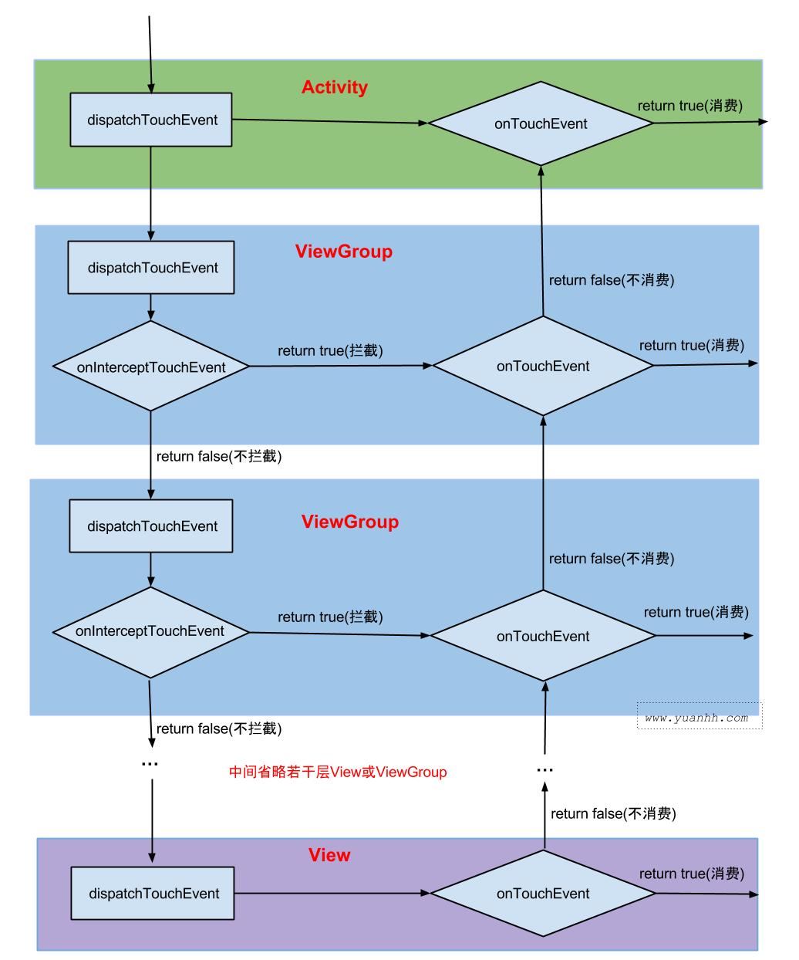

1. onInterceptTouchEvent返回值true表示事件拦截， onTouch/onTouchEvent 返回值true表示事件消费。
2. 触摸事件先交由Activity.dispatchTouchEvent。再一层层往下分发，当中间的ViewGroup都不拦截时，进入最底层的View后，开始由最底层的OnTouchEvent来处理，如果一直不消费，则最后返回到Activity.OnTouchEvent。
3. ViewGroup才有onInterceptTouchEvent拦截方法。在分发过程中，中间任何一层ViewGroup都可以直接拦截，则不再往下分发，而是交由发生拦截操作的ViewGroup的OnTouchEvent来处理。
4. 子View(ViewGroup子类)可调用requestDisallowInterceptTouchEvent方法，来设置disallowIntercept=true，从而阻止父ViewGroup的onInterceptTouchEvent拦截操作。
5. OnTouchEvent由下往上冒泡时，当中间任何一层的OnTouchEvent消费该事件，则不再往上传递，表示事件已处理。
6. 如果View没有消费ACTION_DOWN事件，则之后的ACTION_MOVE等事件都不会再接收。
7. 只要View.onTouchEvent是可点击或可长按，则消费该事件.
8. onTouch优先于onTouchEvent执行，上面流程图中省略，onTouch的位置在onTouchEvent前面。当onTouch返回true,则不执行onTouchEvent,否则会执行onTouchEvent。onTouch只有View设置了OnTouchListener，且是enable的才执行该方法。

OnTouchListener(在dispatchTouchEvent中处理) –> onTouchEvent() -> OnClickListener(onTouchEvent中调用)

## 八 Android 动画系统

### 1 动画及动画原理

1 动画分类

View动画：平移动画 缩放动画 旋转动画 透明度动画

帧动画：

属性动画：

属性动画原理：

改变对象的某个属性，使其为动画

框架如下：



如果改变的属性没有set/get方法，有以下三种版本

1. 加上get/set方法
2. 用另外一个类来包装原始对象，间接提供get/set方法
3. 采用ValueAnimator

动画原理：

## 九 其他

### 1 Android虚拟机与Java虚拟机

1 Android虚拟机基于寄存器的 java虚拟机基于栈的

2 Android运行的Dex(多个class字节码) java虚拟机运行的单个字节码

.class文件存在很多的冗余信息，dex工具会去除冗余信息，并把所有的.class文件整合到.dex文件中。减少了I/O操作，提高了类的查找速度

3 Android 虚拟机根据硬件特点进行过针对性优化，java虚拟机更通用

4 Android虚拟机实现同一个功能指令数更少，但是指令size更长，java虚拟机相反

### 3 Bitmap加载

drawable 与mipmap区别：

mipmap:放应用图标，用mipmap系统会在缩放上提供一定的性能优化。

图片所占内存：

int(x * 手机dpi/资源dpi + 0.5f) * int(y * 手机dpi/资源dpi + 0.5f) *图片格式所占字节

1 BitmapFactory.Options 压缩

2 libjpeg压缩

3 大图局部加载BitmapRegionDecoder

### 4 多屏幕，多分辨适配

#### 1 support包的百分比布局

百分比布局可以解决一些问题

#### 2 基于像素的方案

1 将切图放入drawable-nodpi中。

该文件夹中的图片不会被缩放，在不同分辨率的手机上都只显示原图的大小。如此以来，摒弃了系统对于图片的缩放，为我们以后自己处理图片的缩放做好了铺垫。

2 计算出缩放比。

依据不同的分辨率计算出缩放比。

3 缩放比例的确定是基于屏幕的分辨率而确定的。

屏幕的分辨率均是采用px作为单位的，所以在布局时亦采用px从而保证缩放比例的一致和准确

dp和sp均与设备的dpi有关。

不同设备的dpi值不一样，所以在不同的设备上同一个dp和sp所对应的px值是不尽相同的。如果采用dp和sp作为尺寸的单位，那么在缩放时会产生较大的偏差

#### 3 将屏幕分层很多份，然后根据分数来布局

View宽高设置成多少份

#### 4 今日头条方案

需求：

支持以宽或者高一个维度去适配，保持该维度上和设计图一致；

支持dp和sp单位，控制迁移成本到最小。

找兼容突破口

从dp和px的转换公式 ：px = dp * density

主要思路：修改DisplayMetrics.density densityDpi scaledDensity 来实现

### 5 Android6.0 以上新特性

Android6.0:

1. 运行时权限

2. 取消支持Apache HTTP客户端

android7.0 :

2. Project Svelte：后台优化

Android 7.0 移除了三项隐式广播

面向 Android 7.0 开发的应用不会收到 CONNECTIVITY_ACTION 广播，即使它们已有清单条目来请求接受这些事件的通知。在前台运行的应用如果使用 BroadcastReceiver 请求接收通知，则仍可以在主线程中侦听 CONNECTIVITY_CHANGE。

应用无法发送或接收 ACTION_NEW_PICTURE 或 ACTION_NEW_VIDEO 广播。此项优化会影响所有应用，而不仅仅是面向 Android 7.0 的应用。

3. 系统权限更改

4 FileProvider 类分享私有文件内容

android8.0:

画中画

Notification Dots

系统/应用启动程序加速

加密套件的不支持

Treble计划

android9.0:

刘海屏

隐式广播限制

4、续航提升

5、机器学习

总结：主要是通知栏 后台优化 底层优化 耗电优化 以及AI相关

AAC jetpack navition

# 第八部分 Android Framework

## 一 Android启动流程

### 1 启动init进程

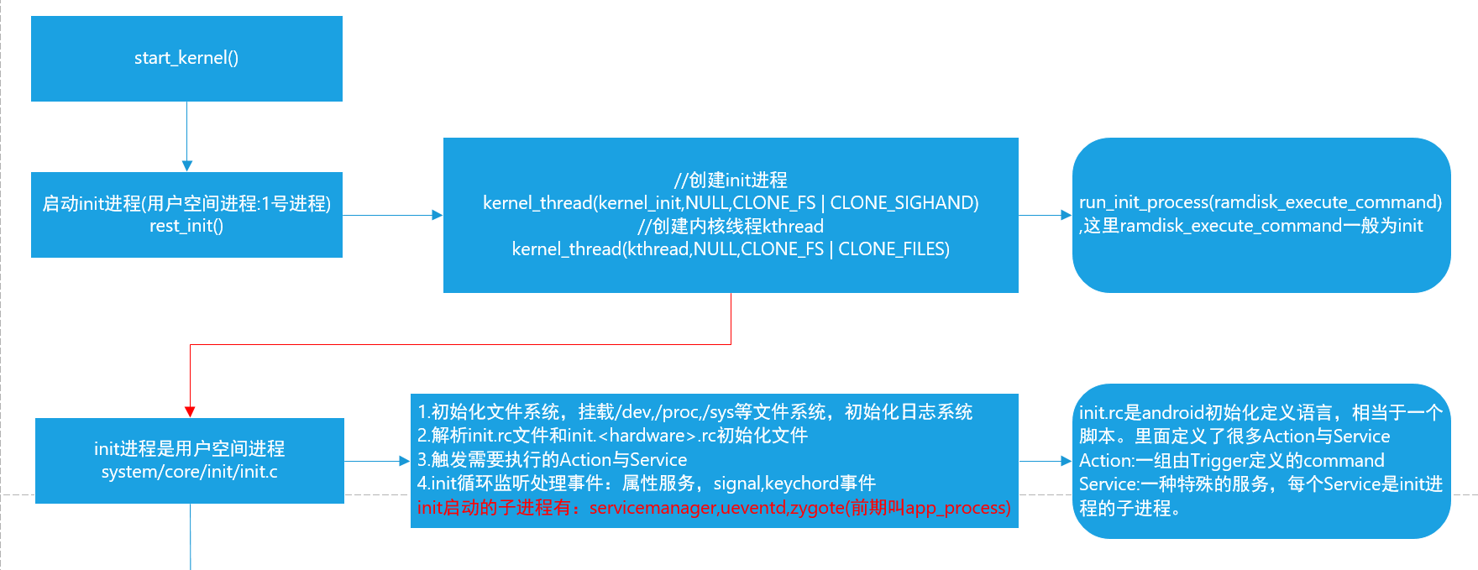

1 初始化文件系统，挂载/dev,/proc,/sys等文件系统，初始化日志系统

2 解析init.rc文件和init.<hardware>.rc初始化文件

3 触发需要执行的Action与Service

注意这里：init将会fork一系列的重要子进程，包括java世界的zygote进程，service_manager进程，ueventd进程等

4 init循环监听处理事件：属性服务，signal,keychord事件

### 2 启动Zygote进程

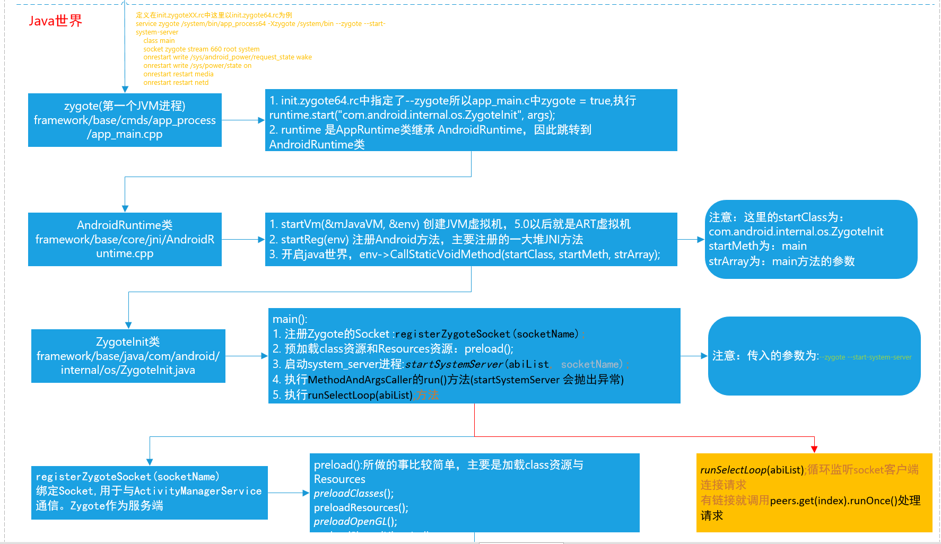

### 3 启动SystemServer进程

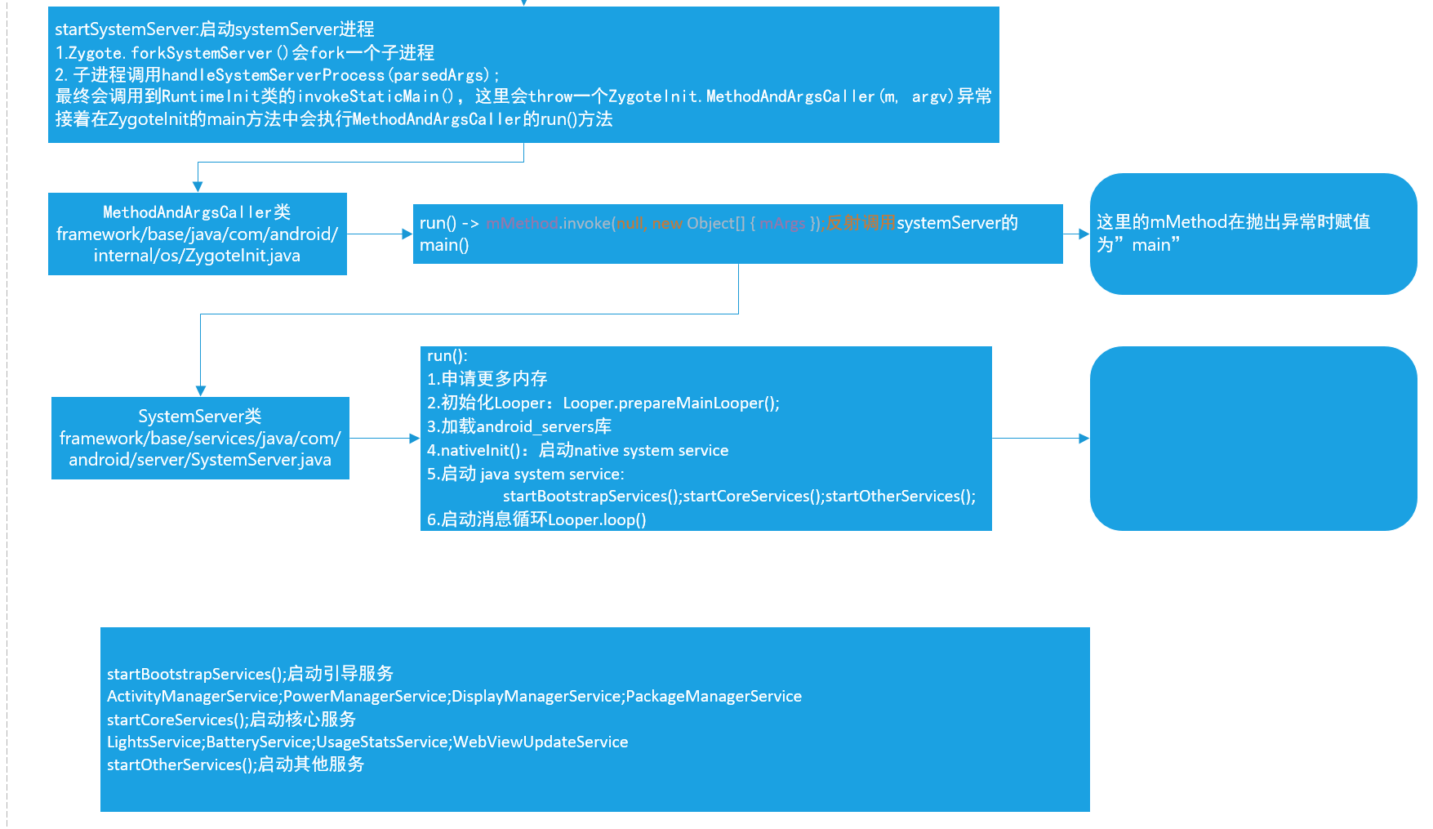

### 4 启动桌面

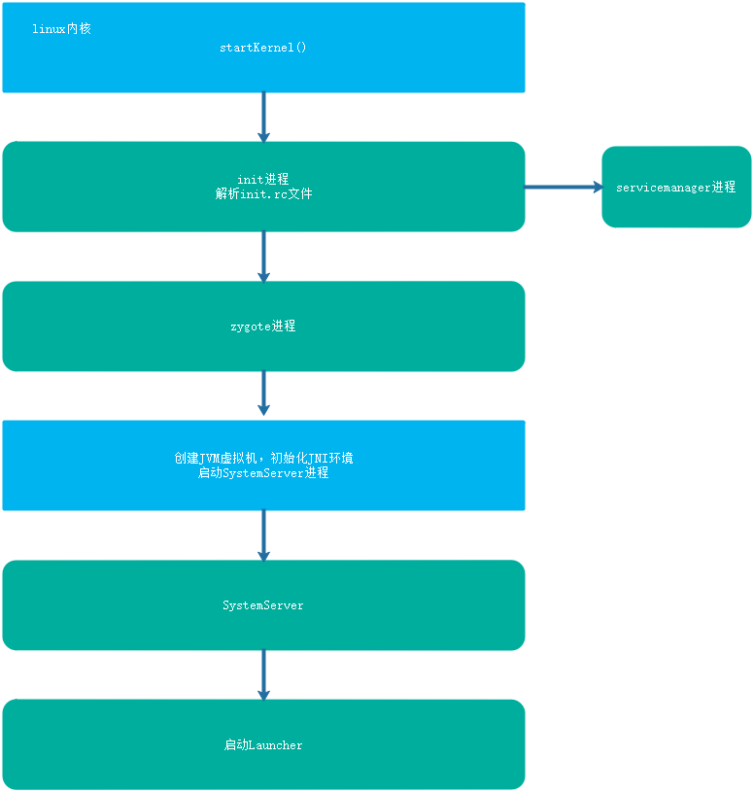

(1) SystemService会启动本地服务，java服务

startBootstrapServices();启动引导服务

ActivityManagerService;PowerManagerService;DisplayManagerService;PackageManagerService

startCoreServices();启动核心服务

LightsService;BatteryService;UsageStatsService;WebViewUpdateService

startOtherServices();启动其他服务

1. 启动Launcher

## 二 Binder通信机制

### 1 Binder机制整体架构

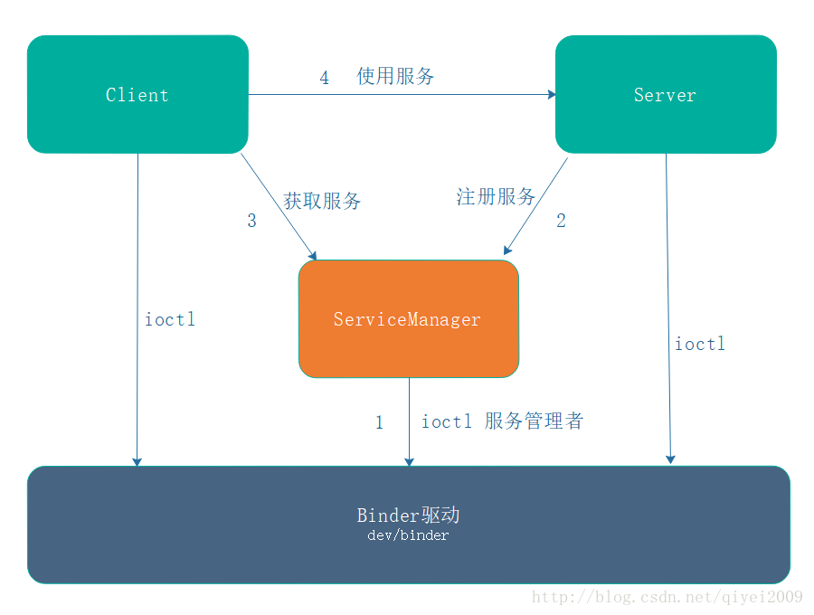

包含native层的架构

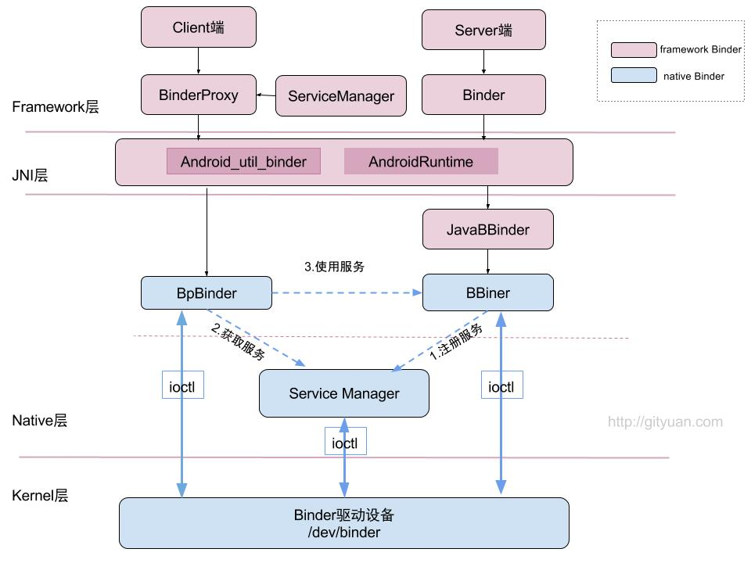

### 2 Binder驱动简介

1 前言

在Binder通信整体框架这篇文章中已经说过Binder驱动是Binder通信的底层载体和支撑。Binder驱动支撑着整个Binder IPC过程。因此还是有必要稍微了解Binder驱动的一些基本概念

2 Binder驱动简介

Binder驱动在Linux内核并不对应于真实的设备，它只是一个虚拟的内存区域。

Binder驱动在内核中是以一个misc device类型驱动注册到内核中，并且不支持动态的添加和移除，主设备号为10，次设备号动态分配

Binder驱动的源码在Linux内核的drivers/staging/android中

binder驱动的file_operations 定义如下

static const struct file_operations binder_fops = {

.owner = THIS_MODULE,

.poll = binder_poll,

.unlocked_ioctl = binder_ioctl,

.mmap = binder_mmap,

.open = binder_open,

.flush = binder_flush,

.release = binder_release,

};

可以看到，binder驱动提供给应用层的接口主要有 open,mmap,poll,ioctl等几个，其中常用的就open,mmap,ioctl三个，其中open表示打开驱动，mmap主要把驱动的内核空间地址映射到用户空间，便于数据的交换，而ioctl主要用于binder协议的通信

3 Binder驱动与应用的交互

要与Binder驱动通信，第一部就是打开打开binder驱动

binder_open

打开binder驱动代码如下：

struct binder_state *bs;

void *svcmgr = BINDER_SERVICE_MANAGER;

bs = binder_open(128*1024);

其中binder_open定义如下：

struct binder_state *binder_open(unsigned mapsize)

{

struct binder_state *bs;

bs = malloc(sizeof(*bs));

if (!bs) {

errno = ENOMEM;

return 0;

}

bs->fd = open("/dev/binder", O_RDWR);

if (bs->fd < 0) {

fprintf(stderr,"binder: cannot open device (%s)\n",

strerror(errno));

goto fail_open;

}

....

fail_map:

close(bs->fd);

fail_open:

free(bs);

return 0;

}

可以看到关键语句就是open("/dev/binder", O_RDWR);并返回一个fd。

打开了binder驱动接下来一般还需要将binder驱动设备与应用程序建立mmap映射内存，这样在用户空间就可以直接操作binder设备上的数据了。映射调用mmap函数，会调用到binder驱动的binder_mmap函数

binde_mmap

映射代码如下：

bs->mapsize = mapsize;

bs->mapped = mmap(NULL, mapsize, PROT_READ, MAP_PRIVATE, bs->fd, 0);

if (bs->mapped == MAP_FAILED) {

fprintf(stderr,"binder: cannot map device (%s)\n",

strerror(errno));

goto fail_map;

}

可以看到，主要调用mmap函数来做映射，并且映射的大小就是传入的参数128K。

一旦我们做了映射，那么当有另外一个应用程序B时，示意图如下：

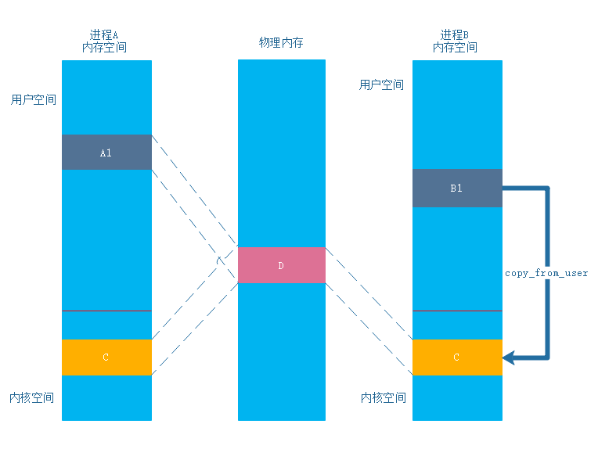

可以看到，这个时候我们在进行IPC时，要将应用B的数据拷贝到应用程序A，只需要在binder驱动中执行一次copy_from_user复制一次数据即可。

上面binder驱动的初始化有两个过程，binder_open和binder_mmap，在真实的Binder通信体系中这个工作一般有ProcessState这个类来完成,这里就不再详细的讨论了，后期会有讨论。

4 Binder协议简介与ioctl

所谓的binder协议就是binder在进行ioctl操作所支持的一些命令以及。下面是binder协议的介绍

Binder协议

Binder协议可以分为控制协议和驱动协议两类。

控制协议是进程通过ioctl(“/dev/binder”) 与Binder设备进行通讯的协议，该协议包含以下几种命令：

| **命令** | **说明** | **参数类型** |
| --- | --- | --- |
| **BINDER_WRITE_READ** | 读写操作，最常用的命令。IPC过程就是通过这个命令进行数据传递 | binder_write_read |
| BINDER_SET_MAX_THREADS | 设置进程支持的最大线程数量 | size_t |
| BINDER_SET_CONTEXT_MGR | 设置自身为ServiceManager | 无 |
| BINDER_THREAD_EXIT | 通知驱动Binder线程退出 | 无 |
| BINDER_VERSION | 获取Binder驱动的版本号 | binder_version |
| BINDER_SET_IDLE_PRIORITY | 暂未用到 | - |
| BINDER_SET_IDLE_TIMEOUT | 暂未用到 | - |

Binder的驱动协议描述了对于Binder驱动的具体使用过程。驱动协议又可以分为两类：

* 一类是binder_driver_command_protocol，描述了**进程发送给Binder驱动的命令**
* 一类是binder_driver_return_protocol，描述了**Binder驱动发送给进程的命令**

binder_driver_command_protocol共包含17个命令，分别是：

| **命令** | **说明** | **参数类型** |
| --- | --- | --- |
| BC_TRANSACTION | Binder事务，即：Client对于Server的请求 | binder_transaction_data |
| BC_REPLY | 事务的应答，即：Server对于Client的回复 | binder_transaction_data |
| BC_FREE_BUFFER | 通知驱动释放Buffer | binder_uintptr_t |
| BC_ACQUIRE | 强引用计数+1 | __u32 |
| BC_RELEASE | 强引用计数-1 | __u32 |
| BC_INCREFS | 弱引用计数+1 | __u32 |
| BC_DECREFS | 弱引用计数-1 | __u32 |
| BC_ACQUIRE_DONE | BR_ACQUIRE的回复 | binder_ptr_cookie |
| BC_INCREFS_DONE | BR_INCREFS的回复 | binder_ptr_cookie |
| BC_ENTER_LOOPER | 通知驱动主线程ready | void |
| BC_REGISTER_LOOPER | 通知驱动子线程ready | void |
| BC_EXIT_LOOPER | 通知驱动线程已经退出 | void |
| BC_REQUEST_DEATH_NOTIFICATION | 请求接收死亡通知 | binder_handle_cookie |
| BC_CLEAR_DEATH_NOTIFICATION | 去除接收死亡通知 | binder_handle_cookie |
| BC_DEAD_BINDER_DONE | 已经处理完死亡通知 | binder_uintptr_t |
| BC_ATTEMPT_ACQUIRE | 暂未实现 | - |

|  |  |  |
| --- | --- | --- |
| BC_ACQUIRE_RESULT | 暂未实现 | - |

binder_driver_return_protocol共包含18个命令，分别是：

| **返回类型** | **说明** | **参数类型** |
| --- | --- | --- |
| BR_OK | 操作完成 | void |
| BR_NOOP | 操作完成 | void |
| BR_ERROR | 发生错误 | __s32 |
| **BR_TRANSACTION** | 通知进程收到一次Binder请求（Server端） | binder_transaction_data |
| **BR_REPLY** | 通知进程收到Binder请求的回复（Client） | binder_transaction_data |
| BR_TRANSACTION_COMPLETE | 驱动对于接受请求的确认回复 | void |
| BR_FAILED_REPLY | 告知发送方通信目标不存在 | void |
| **BR_SPAWN_LOOPER** | 通知Binder进程创建一个新的线程 | void |
| BR_ACQUIRE | 强引用计数+1请求 | binder_ptr_cookie |
| BR_RELEASE | 强引用计数-1请求 | binder_ptr_cookie |
| BR_INCREFS | 弱引用计数+1请求 | binder_ptr_cookie |
| BR_DECREFS | 若引用计数-1请求 | binder_ptr_cookie |
| BR_DEAD_BINDER | 发送死亡通知 | binder_uintptr_t |
| BR_CLEAR_DEATH_NOTIFICATION_DONE | 清理死亡通知完成 | binder_uintptr_t |
| BR_DEAD_REPLY | 告知发送方对方已经死亡 | void |
| BR_ACQUIRE_RESULT | 暂未实现 | - |
| BR_ATTEMPT_ACQUIRE | 暂未实现 | - |
| BR_FINISHED | 暂未实现 | - |

这些命令有个大体的影响就行，对应用开发来说并不需要掌握。

5 binder驱动总结

binder驱动本质上仍然是一个典型的Linux设备驱动，它主要为binder的IPC过程服务，并且google设计了一套binder协议保证binder通信的顺利进行。下一节将结合ServiceManager来介绍通过Binder驱动，client与ServiceManager是如何交互的。

以上就是有关binder驱动的一些相关知识，下一遍将介绍binder通信体系中servicemanager的角色

### 3 ServiceManager

### 4 Server注册服务过程

### 5 Client获取服务

## 三 PackageManagerServgice与APK安装

PackageManager体系主要是管理APK的，主要包括以下功能

1 权限处理，包括APK权限的增加，删除，查询，检查等

2 APK处理，包括扫描安装，卸载APK等

3 签名处理，包括验证APK的签名信息等

4 查询APK中四大组件的信息

5 查询Application,Resource,Package,SharedLibrary,Feature等信息

6 Intent匹配

### 1 PackageManager体系结构

#### 1 整体架构

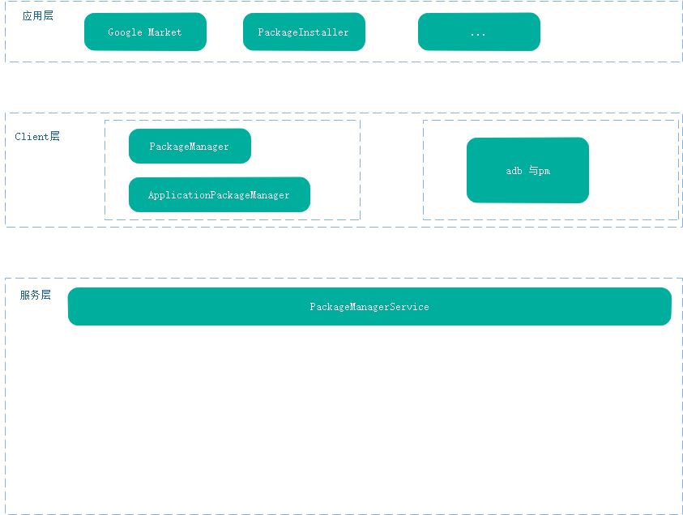

#### 2 各层简介

### 2 PackageManagerService的启动过程

在systemServer的startBootstrapServices() 中启动

mPackageManagerService = PackageManagerService.main(mSystemContext, installer,

mFactoryTestMode != FactoryTest.FACTORY_TEST_OFF, mOnlyCore);

mFirstBoot = mPackageManagerService.isFirstBoot();

1. mSettings = new Settings(mPackages);

mPackageDexOptimizer = new PackageDexOptimizer(installer, mInstallLock, context,

"*dexopt*");

1. 获取系统属性
2. 启动PackageHandler

mHandlerThread = new ServiceThread(TAG,

Process.THREAD_PRIORITY_BACKGROUND, true /*allowIo*/);

mHandlerThread.start();

mHandler = new PackageHandler(mHandlerThread.getLooper());

1. 创建Data目录并初始化UserManagerService

File dataDir = Environment.getDataDirectory();

mAppInstallDir = new File(dataDir, "app");

mAppLib32InstallDir = new File(dataDir, "app-lib");

mAsecInternalPath = new File(dataDir, "app-asec").getPath();

mDrmAppPrivateInstallDir = new File(dataDir, "app-private");

sUserManager = new UserManagerService(context, this,

new UserDataPreparer(mInstaller, mInstallLock, mContext, mOnlyCore), mPackages);

1. 解析系统psermission和feature

// Propagate permission configuration in to package manager.

ArrayMap<String, SystemConfig.PermissionEntry> permConfig

= systemConfig.getPermissions();

for (int i=0; i<permConfig.size(); i++) {

SystemConfig.PermissionEntry perm = permConfig.valueAt(i);

BasePermission bp = mSettings.mPermissions.get(perm.name);

if (bp == null) {

bp = new BasePermission(perm.name, "android", BasePermission.TYPE_BUILTIN);

mSettings.mPermissions.put(perm.name, bp);

}

if (perm.gids != null) {

bp.setGids(perm.gids, perm.perUser);

}

}

ArrayMap<String, String> libConfig = systemConfig.getSharedLibraries();

final int builtInLibCount = libConfig.size();

for (int i = 0; i < builtInLibCount; i++) {

String name = libConfig.keyAt(i);

String path = libConfig.valueAt(i);

addSharedLibraryLPw(path, null, name, SharedLibraryInfo.VERSION_UNDEFINED,

SharedLibraryInfo.TYPE_BUILTIN, PLATFORM_PACKAGE_NAME, 0);

}

(6)

### 3 PackageInstaller安装APK过程

#### 1 Client端安装过程

(1) 应用层APK安装入口

Intent intent = new Intent(Intent.ACTION_VIEW);

intent.addFlags(Intent.FLAG_ACTIVITY_NEW_TASK);

intent.setDataAndType(Uri.parse("file://" + path),"application/vnd.android.package-archive");

context.startActivity(intent);

(2) 调用PackageInstallerActivity中安装

1. 调用InstallInstalling安装

这是一个Activity

InstallInstalling.java中会调用PackageInstaller.Session相关方法来安装，如下：

onCreate(@Nullable Bundle savedInstanceState) 创建session

mSessionId = getPackageManager().getPackageInstaller().createSession(params);

onResume()开启InstallingAsyncTask来运行异步任务

打开session

session = getPackageManager().getPackageInstaller().openSession(mSessionId);

提交session

session.commit(pendingIntent.getIntentSender());

(4) PackageInstaller中进行Binder通信

接下来就是Binder通信了

PackageInstaller.Session的AIDL最终会调用到PackageInstallerSession中

总结：

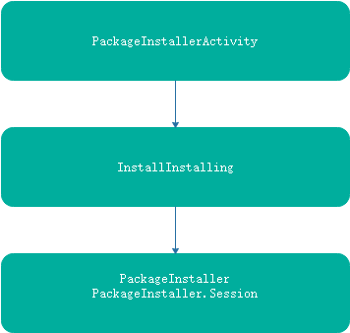

#### 2 Server端安装过程

(1) PackageInstallerService

createSession(params)跳转而来

PackageInstallerService# createSessionInternal()

private int createSessionInternal (SessionParams params, String installerPackageName, int userId)

throws IOException {

final int callingUid = Binder.getCallingUid();

mPm.enforceCrossUserPermission(callingUid, userId, true, true, "createSession");

if (mPm.isUserRestricted(userId, UserManager.DISALLOW_INSTALL_APPS)) {

throw new SecurityException("User restriction prevents installing");

}

if ((callingUid == Process.SHELL_UID) || (callingUid == Process.ROOT_UID)) {

params.installFlags |= PackageManager.INSTALL_FROM_ADB;

} else {

mAppOps.checkPackage(callingUid, installerPackageName);

params.installFlags &= ~PackageManager.INSTALL_FROM_ADB;

params.installFlags &= ~PackageManager.INSTALL_ALL_USERS;

params.installFlags |= PackageManager.INSTALL_REPLACE_EXISTING;

if ((params.installFlags & PackageManager.INSTALL_VIRTUAL_PRELOAD) != 0

&& !mPm.isCallerVerifier(callingUid)) {

params.installFlags &= ~PackageManager.INSTALL_VIRTUAL_PRELOAD;

}

}

// Only system components can circumvent runtime permissions when installing.

if ((params.installFlags & PackageManager.INSTALL_GRANT_RUNTIME_PERMISSIONS) != 0

&& mContext.checkCallingOrSelfPermission(Manifest.permission

.INSTALL_GRANT_RUNTIME_PERMISSIONS) == PackageManager.PERMISSION_DENIED) {

throw new SecurityException("You need the "

+ "android.permission.INSTALL_GRANT_RUNTIME_PERMISSIONS permission "

+ "to use the PackageManager.INSTALL_GRANT_RUNTIME_PERMISSIONS flag");

}

if ((params.installFlags & PackageManager.INSTALL_FORWARD_LOCK) != 0

|| (params.installFlags & PackageManager.INSTALL_EXTERNAL) != 0) {

throw new IllegalArgumentException(

"New installs into ASEC containers no longer supported");

}

// Defensively resize giant app icons

if (params.appIcon != null) {

final ActivityManager am = (ActivityManager) mContext.getSystemService(

Context.ACTIVITY_SERVICE);

final int iconSize = am.getLauncherLargeIconSize();

if ((params.appIcon.getWidth() > iconSize * 2)

|| (params.appIcon.getHeight() > iconSize * 2)) {

params.appIcon = Bitmap.createScaledBitmap(params.appIcon, iconSize, iconSize,

true);

}

}

switch (params.mode) {

case SessionParams.MODE_FULL_INSTALL:

case SessionParams.MODE_INHERIT_EXISTING:

break;

default:

throw new IllegalArgumentException("Invalid install mode: " + params.mode);

}

// If caller requested explicit location, sanity check it, otherwise

// resolve the best internal or adopted location.

if ((params.installFlags & PackageManager.INSTALL_INTERNAL) != 0) {

if (!PackageHelper.fitsOnInternal(mContext, params)) {

throw new IOException("No suitable internal storage available");

}

} else if ((params.installFlags & PackageManager.INSTALL_EXTERNAL) != 0) {

if (!PackageHelper.fitsOnExternal(mContext, params)) {

throw new IOException("No suitable external storage available");

}

} else if ((params.installFlags & PackageManager.INSTALL_FORCE_VOLUME_UUID) != 0) {

// For now, installs to adopted media are treated as internal from

// an install flag point-of-view.

params.setInstallFlagsInternal();

} else {

// For now, installs to adopted media are treated as internal from

// an install flag point-of-view.

params.setInstallFlagsInternal();

// Resolve best location for install, based on combination of

// requested install flags, delta size, and manifest settings.

final long ident = Binder.clearCallingIdentity();

try {

params.volumeUuid = PackageHelper.resolveInstallVolume(mContext, params);

} finally {

Binder.restoreCallingIdentity(ident);

}

}

final int sessionId;

final PackageInstallerSession session;

synchronized (mSessions) {

// Sanity check that installer isn't going crazy

final int activeCount = getSessionCount(mSessions, callingUid);

if (activeCount >= MAX_ACTIVE_SESSIONS) {

throw new IllegalStateException(

"Too many active sessions for UID " + callingUid);

}

final int historicalCount = mHistoricalSessionsByInstaller.get(callingUid);

if (historicalCount >= MAX_HISTORICAL_SESSIONS) {

throw new IllegalStateException(

"Too many historical sessions for UID " + callingUid);

}

sessionId = allocateSessionIdLocked();

}

final long createdMillis = System.currentTimeMillis();

// We're staging to exactly one location

File stageDir = null;

String stageCid = null;

if ((params.installFlags & PackageManager.INSTALL_INTERNAL) != 0) {

final boolean isInstant =

(params.installFlags & PackageManager.INSTALL_INSTANT_APP) != 0;

stageDir = buildStageDir(params.volumeUuid, sessionId, isInstant);

} else {

stageCid = buildExternalStageCid(sessionId);

}

session = new PackageInstallerSession(mInternalCallback, mContext, mPm,

mInstallThread.getLooper(), sessionId, userId, installerPackageName, callingUid,

params, createdMillis, stageDir, stageCid, false, false);

synchronized (mSessions) {

mSessions.put(sessionId, session);

}

mCallbacks.notifySessionCreated(session.sessionId, session.userId);

writeSessionsAsync();

return sessionId;

}

openSession

PackageInstallerService# openSessionInternal ()

private IPackageInstallerSession openSessionInternal (int sessionId) throws IOException {

synchronized (mSessions) {

final PackageInstallerSession session = mSessions.get(sessionId);

if (session == null || !isCallingUidOwner(session)) {

throw new SecurityException("Caller has no access to session " + sessionId);

}

session.open();

return session;

}

}

可以看到，代码最终跳转到了PackageInstallerSession中去

(2) PackageInstallerSession

PackageInstallerSession#open()

public void open() throws IOException {

if (mActiveCount.getAndIncrement() == 0) {

mCallback.onSessionActiveChanged(this, true);

}

boolean wasPrepared;

synchronized (mLock) {

wasPrepared = mPrepared;

if (!mPrepared) {

if (stageDir != null) {

prepareStageDir(stageDir);

} else if (stageCid != null) {

final long identity = Binder.clearCallingIdentity();

try {

prepareExternalStageCid(stageCid, params.sizeBytes);

} finally {

Binder.restoreCallingIdentity(identity);

}

// TODO: deliver more granular progress for ASEC allocation

mInternalProgress = 0.25f;

computeProgressLocked(true);

} else {

throw new IllegalArgumentException(

"Exactly one of stageDir or stageCid stage must be set");

}

mPrepared = true;

}

}

if (!wasPrepared) {

mCallback.onSessionPrepared(this);

}

}

1. PMS中安装入口

### 4 adb 安装APK过程

## 四 GUI框架之SurfaceFlinger

### 1 显示系统底层SurfaceFlinger框架

#### 1 Android 显示系统体系

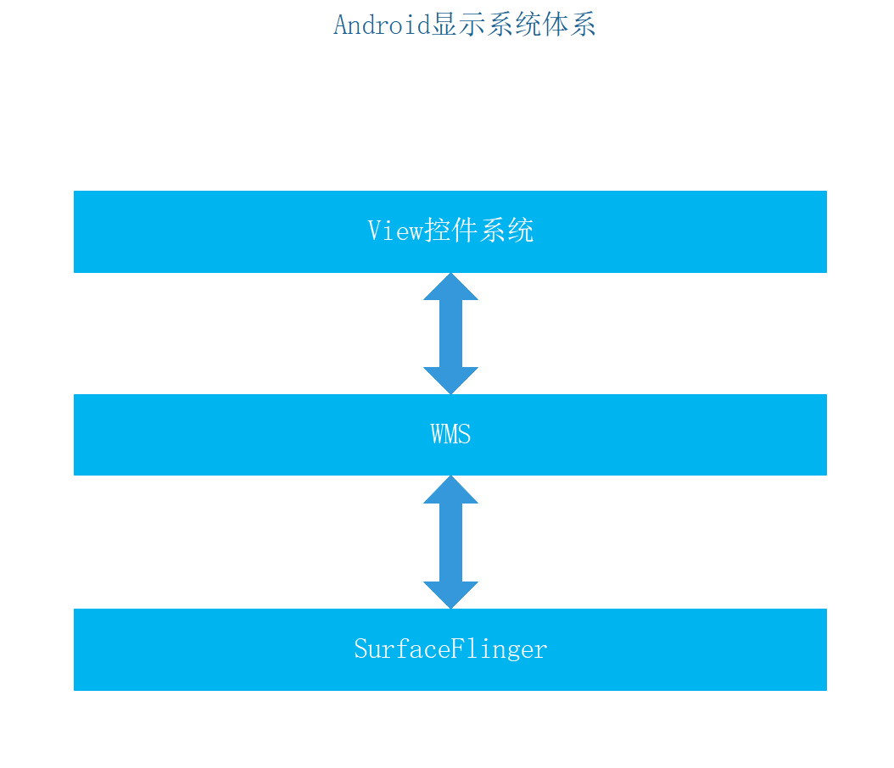

View控件系统:主要管理View的测量，布局，绘制等以及重绘等工作

WMS:窗口管理系统，主要管理窗口的分配，管理，以及申请等

SurfaceFlinger:显示系统的实现以及Buffer的申请，释放，绘制等

#### 2 显示系统底层SurfaceFlinger框架

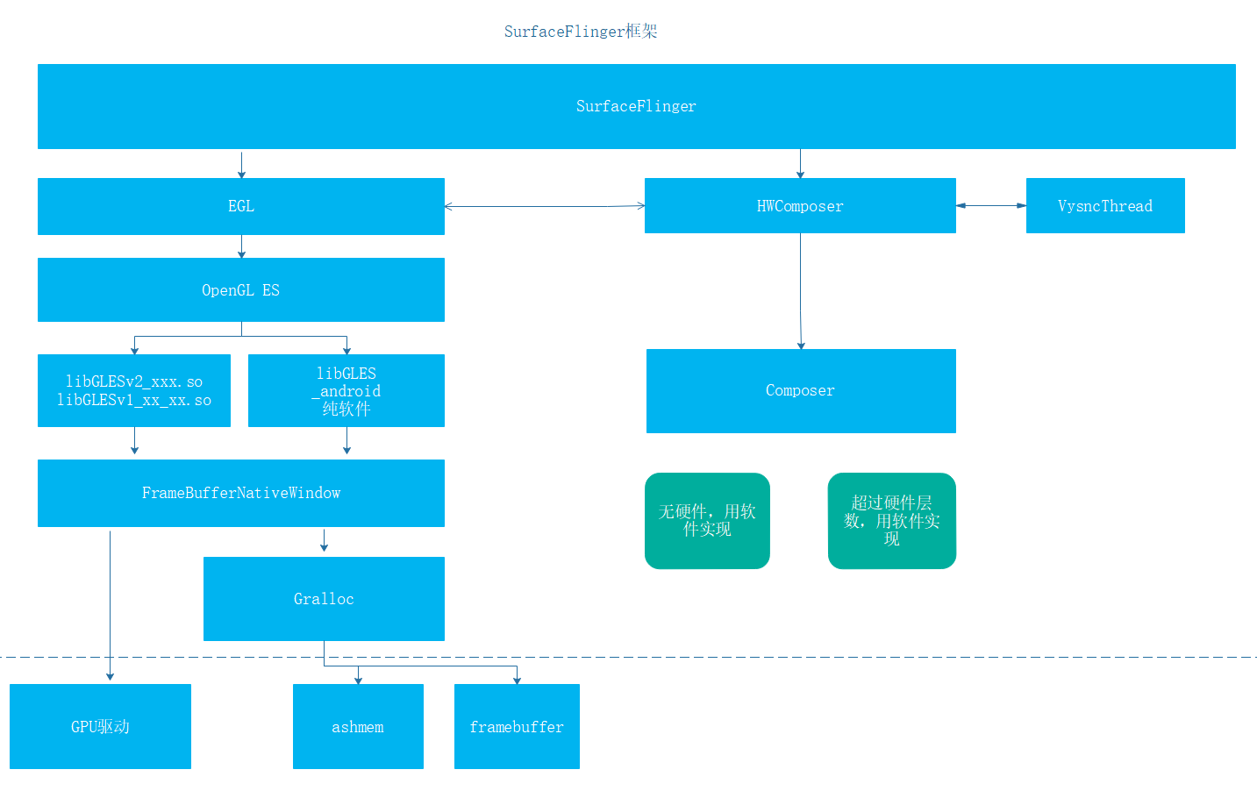

黄油计划

1 VSYNC CPU收到该信号进行Buffer的准备工作

1. 引入多重缓存技术

### 2 Gralloc与FrameBuffer

### 3 FrameBufferNativeWindow

### 4 BufferQueue

### 5 SurfaceFlinger框架

### 6 Vsync

## 五 GUI框架之WindowManagerService机制

WMS主要提供以下功能：

1 管理窗口功能，包括窗口添加，删除，大小，窗口层级，窗口动画等

2 事件派发，接替IMS进行输入事件(按键和触摸事件)的派发，因为输入事件需要根据窗口来派发

### 1 WMS总体架构

#### 1 WMS总体框架

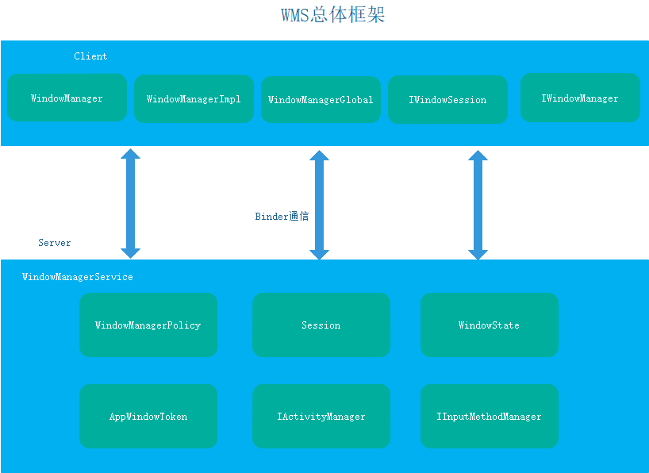

WindowManager：

WMS 的客户端，用于用户使用WMS的各种功能,这是一个接口，具体实现在WindowManagerImpl

WindowManagerImpl:WindowManager的实现者，引用了WindowManagerGlobal对象，具体的接口转交给WindowManagerGlobal对象

WindowManagerGlobal:全局WindowManager服务访问者，内部持有IWindowSession和IWindowManager发起Binder通信服务，用于访问WMS各种服务，其中IWindowSession是匿名Binder

Client端通信过程如下：



#### 2 WMS服务端架构

#### 3 WMS AMS Activity

由于WMS是管理窗口的，而Activity又是一个窗口，在Android中，这三者之间联系密切，Binder交互如下：

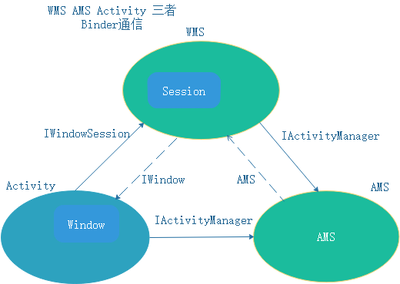

三者之间内部联系

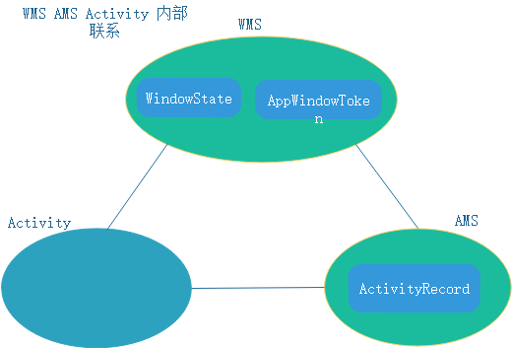

### 2 WMS的启动

1 SystemServer中启动

startOtherServices()

wm = WindowManagerService.main(context, inputManager,

mFactoryTestMode != FactoryTest.FACTORY_TEST_LOW_LEVEL,

!mFirstBoot, mOnlyCore, new PhoneWindowManager());

ServiceManager.addService(Context.WINDOW_SERVICE, wm);

### 3 窗口管理结构

WMS主要是同通过WindowToken,WindownState,DisplayContent来管理窗口的

#### 1 WindowToken

WindowToken将属于同一个引用组件的窗口组织在一起，例如Activity，InputMethod，Wallper等

WindowToken也具有令牌的作用，是对应用组件行为规范管理的一个手段

WindowToken有一个子类AppWindowToken，用于描述Activity等WindowToken

添加WindowToken的方法是在WindowManagerService.addWindowToken()中进行

#### 2 WindowState

WindowState表示一个窗口的所有属性,也是WMS中窗口的表示。WindowState在Client端一侧的对应的类是IWindow.Stub

#### 3 DisplayContent

DispalyContent是一个显示屏幕窗口，由于Android支持多窗口显示。因此用DispalyContent来表示显示在哪一个窗口，这里的窗口指的是一个完整的屏幕。例如手机和电视等

### 4 窗口属性WindowState

#### 1 窗口类型与层级

Android中一共三种窗口

Application Window 1 - 99

Activity

SubWindow 1000 - 1999

Dialog Menu

SystemWindow 2000 - 2999

搜索条窗口，状态栏，导航栏

在WindowState中用mBaseLayer和mSubLayer描述

#### 2 窗口策略WindowPolicy

窗口策略主要用于根据各种不同的产品确定窗口的样式以及相应的管理窗口的策略，例如平板类产品，手机类产品等

默认产生的手机类的窗口和手机类窗口策略

PhoneWindowManager

PhoneWindow

#### 3 窗口属性WindowManager.LayoutParams

Type:窗口类型，前面已经介绍，这里不再说明

Flags:窗口标志，默认是0。主要描述一些窗口的特性，例如是否获取触摸事件，焦点，透明度等

systemUiVisibility:表示系统UI的可见性，主要用于描述系统UI，例如状态栏，导航栏等的可见性。

注意，systemUiVisibility的可选值在View类中，一般对于某一个View(而不是Window)设置它的系统UI可见性，因为View是Window上具体的呈现

### 5 窗口添加

#### 1 系统窗口添加过程

Client端：

WindowManager. addView(View view, ViewGroup.LayoutParams params)

WindowManagerGlobal. addView(View view, ViewGroup.LayoutParams params,Display display, Window parentWindow)

ViewRootImpl.requestLayout()

ViewRootImpl. setView(View view, WindowManager.LayoutParams attrs, View panelParentView)

IWindowSession. addToDisplay(IWindow window, int seq, in WindowManager.LayoutParams attrs,

in int viewVisibility, in int layerStackId, out Rect outContentInsets,

out Rect outStableInsets, out Rect outOutsets, out InputChannel outInputChannel)

server端：

Session. addToDisplay(IWindow window, int seq, WindowManager.LayoutParams attrs,

int viewVisibility, int displayId, Rect outContentInsets, Rect outStableInsets,

Rect outOutsets, InputChannel outInputChannel)

WMS核心服务

WindowManagerService.addWindow(this, window, seq, attrs, viewVisibility, displayId,

outContentInsets, outStableInsets, outOutsets, outInputChannel);

public int addWindow(Session session, IWindow client, int seq,

WindowManager.LayoutParams attrs, int viewVisibility, int displayId,

Rect outContentInsets, Rect outStableInsets, Rect outOutsets,

InputChannel outInputChannel) {

int[] appOp = new int[1];

int res = mPolicy.checkAddPermission(attrs, appOp);

if (res != WindowManagerGlobal.ADD_OKAY) {

return res;

}

boolean reportNewConfig = false;

WindowState parentWindow = null;

long origId;

final int callingUid = Binder.getCallingUid();

final int type = attrs.type;

synchronized(mWindowMap) {

if (!mDisplayReady) {

throw new IllegalStateException("Display has not been initialialized");

}

final DisplayContent displayContent = mRoot.getDisplayContentOrCreate(displayId);

if (displayContent == null) {

Slog.w(TAG_WM, "Attempted to add window to a display that does not exist: "

+ displayId + ". Aborting.");

return WindowManagerGlobal.ADD_INVALID_DISPLAY;

}

if (!displayContent.hasAccess(session.mUid)

&& !mDisplayManagerInternal.isUidPresentOnDisplay(session.mUid, displayId)) {

Slog.w(TAG_WM, "Attempted to add window to a display for which the application "

+ "does not have access: " + displayId + ". Aborting.");

return WindowManagerGlobal.ADD_INVALID_DISPLAY;

}

if (mWindowMap.containsKey(client.asBinder())) {

Slog.w(TAG_WM, "Window " + client + " is already added");

return WindowManagerGlobal.ADD_DUPLICATE_ADD;

}

if (type >= FIRST_SUB_WINDOW && type <= LAST_SUB_WINDOW) {

parentWindow = windowForClientLocked(null, attrs.token, false);

if (parentWindow == null) {

Slog.w(TAG_WM, "Attempted to add window with token that is not a window: "

+ attrs.token + ". Aborting.");

return WindowManagerGlobal.ADD_BAD_SUBWINDOW_TOKEN;

}

if (parentWindow.mAttrs.type >= FIRST_SUB_WINDOW

&& parentWindow.mAttrs.type <= LAST_SUB_WINDOW) {

Slog.w(TAG_WM, "Attempted to add window with token that is a sub-window: "

+ attrs.token + ". Aborting.");

return WindowManagerGlobal.ADD_BAD_SUBWINDOW_TOKEN;

}

}

if (type == TYPE_PRIVATE_PRESENTATION && !displayContent.isPrivate()) {

Slog.w(TAG_WM, "Attempted to add private presentation window to a non-private display. Aborting.");

return WindowManagerGlobal.ADD_PERMISSION_DENIED;

}

AppWindowToken atoken = null;

final boolean hasParent = parentWindow != null;

// Use existing parent window token for child windows since they go in the same token

// as there parent window so we can apply the same policy on them.

WindowToken token = displayContent.getWindowToken(

hasParent ? parentWindow.mAttrs.token : attrs.token);

// If this is a child window, we want to apply the same type checking rules as the

// parent window type.

final int rootType = hasParent ? parentWindow.mAttrs.type : type;

boolean addToastWindowRequiresToken = false;

if (token == null) {

if (rootType >= FIRST_APPLICATION_WINDOW && rootType <= LAST_APPLICATION_WINDOW) {

Slog.w(TAG_WM, "Attempted to add application window with unknown token "

+ attrs.token + ". Aborting.");

return WindowManagerGlobal.ADD_BAD_APP_TOKEN;

}

if (rootType == TYPE_INPUT_METHOD) {

Slog.w(TAG_WM, "Attempted to add input method window with unknown token "

+ attrs.token + ". Aborting.");

return WindowManagerGlobal.ADD_BAD_APP_TOKEN;

}

if (rootType == TYPE_VOICE_INTERACTION) {

Slog.w(TAG_WM, "Attempted to add voice interaction window with unknown token "

+ attrs.token + ". Aborting.");

return WindowManagerGlobal.ADD_BAD_APP_TOKEN;

}

if (rootType == TYPE_WALLPAPER) {

Slog.w(TAG_WM, "Attempted to add wallpaper window with unknown token "

+ attrs.token + ". Aborting.");

return WindowManagerGlobal.ADD_BAD_APP_TOKEN;

}

if (rootType == TYPE_DREAM) {

Slog.w(TAG_WM, "Attempted to add Dream window with unknown token "

+ attrs.token + ". Aborting.");

return WindowManagerGlobal.ADD_BAD_APP_TOKEN;

}

if (rootType == TYPE_QS_DIALOG) {

Slog.w(TAG_WM, "Attempted to add QS dialog window with unknown token "

+ attrs.token + ". Aborting.");

return WindowManagerGlobal.ADD_BAD_APP_TOKEN;

}

if (rootType == TYPE_ACCESSIBILITY_OVERLAY) {

Slog.w(TAG_WM, "Attempted to add Accessibility overlay window with unknown token "

+ attrs.token + ". Aborting.");

return WindowManagerGlobal.ADD_BAD_APP_TOKEN;

}

if (type == TYPE_TOAST) {

// Apps targeting SDK above N MR1 cannot arbitrary add toast windows.

if (doesAddToastWindowRequireToken(attrs.packageName, callingUid,

parentWindow)) {

Slog.w(TAG_WM, "Attempted to add a toast window with unknown token "

+ attrs.token + ". Aborting.");

return WindowManagerGlobal.ADD_BAD_APP_TOKEN;

}

}

final IBinder binder = attrs.token != null ? attrs.token : client.asBinder();

token = new WindowToken(this, binder, type, false, displayContent,

session.mCanAddInternalSystemWindow);

} else if (rootType >= FIRST_APPLICATION_WINDOW && rootType <= LAST_APPLICATION_WINDOW) {

atoken = token.asAppWindowToken();

if (atoken == null) {

Slog.w(TAG_WM, "Attempted to add window with non-application token "

+ token + ". Aborting.");

return WindowManagerGlobal.ADD_NOT_APP_TOKEN;

} else if (atoken.removed) {

Slog.w(TAG_WM, "Attempted to add window with exiting application token "

+ token + ". Aborting.");

return WindowManagerGlobal.ADD_APP_EXITING;

}

} else if (rootType == TYPE_INPUT_METHOD) {

if (token.windowType != TYPE_INPUT_METHOD) {

Slog.w(TAG_WM, "Attempted to add input method window with bad token "

+ attrs.token + ". Aborting.");

return WindowManagerGlobal.ADD_BAD_APP_TOKEN;

}

} else if (rootType == TYPE_VOICE_INTERACTION) {

if (token.windowType != TYPE_VOICE_INTERACTION) {

Slog.w(TAG_WM, "Attempted to add voice interaction window with bad token "

+ attrs.token + ". Aborting.");

return WindowManagerGlobal.ADD_BAD_APP_TOKEN;

}

} else if (rootType == TYPE_WALLPAPER) {

if (token.windowType != TYPE_WALLPAPER) {

Slog.w(TAG_WM, "Attempted to add wallpaper window with bad token "

+ attrs.token + ". Aborting.");

return WindowManagerGlobal.ADD_BAD_APP_TOKEN;

}

} else if (rootType == TYPE_DREAM) {

if (token.windowType != TYPE_DREAM) {

Slog.w(TAG_WM, "Attempted to add Dream window with bad token "

+ attrs.token + ". Aborting.");

return WindowManagerGlobal.ADD_BAD_APP_TOKEN;

}

} else if (rootType == TYPE_ACCESSIBILITY_OVERLAY) {

if (token.windowType != TYPE_ACCESSIBILITY_OVERLAY) {

Slog.w(TAG_WM, "Attempted to add Accessibility overlay window with bad token "

+ attrs.token + ". Aborting.");

return WindowManagerGlobal.ADD_BAD_APP_TOKEN;

}

} else if (type == TYPE_TOAST) {

// Apps targeting SDK above N MR1 cannot arbitrary add toast windows.

addToastWindowRequiresToken = doesAddToastWindowRequireToken(attrs.packageName,

callingUid, parentWindow);

if (addToastWindowRequiresToken && token.windowType != TYPE_TOAST) {

Slog.w(TAG_WM, "Attempted to add a toast window with bad token "

+ attrs.token + ". Aborting.");

return WindowManagerGlobal.ADD_BAD_APP_TOKEN;

}

} else if (type == TYPE_QS_DIALOG) {

if (token.windowType != TYPE_QS_DIALOG) {

Slog.w(TAG_WM, "Attempted to add QS dialog window with bad token "

+ attrs.token + ". Aborting.");

return WindowManagerGlobal.ADD_BAD_APP_TOKEN;

}

} else if (token.asAppWindowToken() != null) {

Slog.w(TAG_WM, "Non-null appWindowToken for system window of rootType=" + rootType);

// It is not valid to use an app token with other system types; we will

// instead make a new token for it (as if null had been passed in for the token).

attrs.token = null;

token = new WindowToken(this, client.asBinder(), type, false, displayContent,

session.mCanAddInternalSystemWindow);

}

final WindowState win = new WindowState(this, session, client, token, parentWindow,

appOp[0], seq, attrs, viewVisibility, session.mUid,

session.mCanAddInternalSystemWindow);

if (win.mDeathRecipient == null) {

// Client has apparently died, so there is no reason to

// continue.

Slog.w(TAG_WM, "Adding window client " + client.asBinder()

+ " that is dead, aborting.");

return WindowManagerGlobal.ADD_APP_EXITING;

}

if (win.getDisplayContent() == null) {

Slog.w(TAG_WM, "Adding window to Display that has been removed.");

return WindowManagerGlobal.ADD_INVALID_DISPLAY;

}

mPolicy.adjustWindowParamsLw(win.mAttrs);

win.setShowToOwnerOnlyLocked(mPolicy.checkShowToOwnerOnly(attrs));

res = mPolicy.prepareAddWindowLw(win, attrs);

if (res != WindowManagerGlobal.ADD_OKAY) {

return res;

}

final boolean openInputChannels = (outInputChannel != null

&& (attrs.inputFeatures & INPUT_FEATURE_NO_INPUT_CHANNEL) == 0);

if (openInputChannels) {

win.openInputChannel(outInputChannel);

}

// If adding a toast requires a token for this app we always schedule hiding

// toast windows to make sure they don't stick around longer then necessary.

// We hide instead of remove such windows as apps aren't prepared to handle

// windows being removed under them.

//

// If the app is older it can add toasts without a token and hence overlay

// other apps. To be maximally compatible with these apps we will hide the

// window after the toast timeout only if the focused window is from another

// UID, otherwise we allow unlimited duration. When a UID looses focus we

// schedule hiding all of its toast windows.

if (type == TYPE_TOAST) {

if (!getDefaultDisplayContentLocked().canAddToastWindowForUid(callingUid)) {

Slog.w(TAG_WM, "Adding more than one toast window for UID at a time.");

return WindowManagerGlobal.ADD_DUPLICATE_ADD;

}

// Make sure this happens before we moved focus as one can make the

// toast focusable to force it not being hidden after the timeout.

// Focusable toasts are always timed out to prevent a focused app to

// show a focusable toasts while it has focus which will be kept on

// the screen after the activity goes away.

if (addToastWindowRequiresToken

|| (attrs.flags & LayoutParams.FLAG_NOT_FOCUSABLE) == 0

|| mCurrentFocus == null

|| mCurrentFocus.mOwnerUid != callingUid) {

mH.sendMessageDelayed(

mH.obtainMessage(H.WINDOW_HIDE_TIMEOUT, win),

win.mAttrs.hideTimeoutMilliseconds);

}

}

// From now on, no exceptions or errors allowed!

res = WindowManagerGlobal.ADD_OKAY;

if (mCurrentFocus == null) {

mWinAddedSinceNullFocus.add(win);

}

if (excludeWindowTypeFromTapOutTask(type)) {

displayContent.mTapExcludedWindows.add(win);

}

origId = Binder.clearCallingIdentity();

win.attach();

mWindowMap.put(client.asBinder(), win);

if (win.mAppOp != AppOpsManager.OP_NONE) {

int startOpResult = mAppOps.startOpNoThrow(win.mAppOp, win.getOwningUid(),

win.getOwningPackage());

if ((startOpResult != AppOpsManager.MODE_ALLOWED) &&

(startOpResult != AppOpsManager.MODE_DEFAULT)) {

win.setAppOpVisibilityLw(false);

}

}

final boolean hideSystemAlertWindows = !mHidingNonSystemOverlayWindows.isEmpty();

win.setForceHideNonSystemOverlayWindowIfNeeded(hideSystemAlertWindows);

final AppWindowToken aToken = token.asAppWindowToken();

if (type == TYPE_APPLICATION_STARTING && aToken != null) {

aToken.startingWindow = win;

if (DEBUG_STARTING_WINDOW) Slog.v (TAG_WM, "addWindow: " + aToken

+ " startingWindow=" + win);

}

boolean imMayMove = true;

win.mToken.addWindow(win);

if (type == TYPE_INPUT_METHOD) {

win.mGivenInsetsPending = true;

setInputMethodWindowLocked(win);

imMayMove = false;

} else if (type == TYPE_INPUT_METHOD_DIALOG) {

displayContent.computeImeTarget(true /* updateImeTarget */);

imMayMove = false;

} else {

if (type == TYPE_WALLPAPER) {

displayContent.mWallpaperController.clearLastWallpaperTimeoutTime();

displayContent.pendingLayoutChanges |= FINISH_LAYOUT_REDO_WALLPAPER;

} else if ((attrs.flags&FLAG_SHOW_WALLPAPER) != 0) {

displayContent.pendingLayoutChanges |= FINISH_LAYOUT_REDO_WALLPAPER;

} else if (displayContent.mWallpaperController.isBelowWallpaperTarget(win)) {

// If there is currently a wallpaper being shown, and

// the base layer of the new window is below the current

// layer of the target window, then adjust the wallpaper.

// This is to avoid a new window being placed between the

// wallpaper and its target.

displayContent.pendingLayoutChanges |= FINISH_LAYOUT_REDO_WALLPAPER;

}

}

// If the window is being added to a stack that's currently adjusted for IME,

// make sure to apply the same adjust to this new window.

win.applyAdjustForImeIfNeeded();

if (type == TYPE_DOCK_DIVIDER) {

mRoot.getDisplayContent(displayId).getDockedDividerController().setWindow(win);

}

final WindowStateAnimator winAnimator = win.mWinAnimator;

winAnimator.mEnterAnimationPending = true;

winAnimator.mEnteringAnimation = true;

// Check if we need to prepare a transition for replacing window first.

if (atoken != null && atoken.isVisible()

&& !prepareWindowReplacementTransition(atoken)) {

// If not, check if need to set up a dummy transition during display freeze

// so that the unfreeze wait for the apps to draw. This might be needed if

// the app is relaunching.

prepareNoneTransitionForRelaunching(atoken);

}

if (displayContent.isDefaultDisplay) {

final DisplayInfo displayInfo = displayContent.getDisplayInfo();

final Rect taskBounds;

if (atoken != null && atoken.getTask() != null) {

taskBounds = mTmpRect;

atoken.getTask().getBounds(mTmpRect);

} else {

taskBounds = null;

}

if (mPolicy.getInsetHintLw(win.mAttrs, taskBounds, displayInfo.rotation,

displayInfo.logicalWidth, displayInfo.logicalHeight, outContentInsets,

outStableInsets, outOutsets)) {

res |= WindowManagerGlobal.ADD_FLAG_ALWAYS_CONSUME_NAV_BAR;

}

} else {

outContentInsets.setEmpty();

outStableInsets.setEmpty();

}

if (mInTouchMode) {

res |= WindowManagerGlobal.ADD_FLAG_IN_TOUCH_MODE;

}

if (win.mAppToken == null || !win.mAppToken.isClientHidden()) {

res |= WindowManagerGlobal.ADD_FLAG_APP_VISIBLE;

}

mInputMonitor.setUpdateInputWindowsNeededLw();

boolean focusChanged = false;

if (win.canReceiveKeys()) {

focusChanged = updateFocusedWindowLocked(UPDATE_FOCUS_WILL_ASSIGN_LAYERS,

false /*updateInputWindows*/);

if (focusChanged) {

imMayMove = false;

}

}

if (imMayMove) {

displayContent.computeImeTarget(true /* updateImeTarget */);

}

// Don't do layout here, the window must call

// relayout to be displayed, so we'll do it there.

displayContent.assignWindowLayers(false /* setLayoutNeeded */);

if (focusChanged) {

mInputMonitor.setInputFocusLw(mCurrentFocus, false /*updateInputWindows*/);

}

mInputMonitor.updateInputWindowsLw(false /*force*/);

if (localLOGV || DEBUG_ADD_REMOVE) Slog.v(TAG_WM, "addWindow: New client "

+ client.asBinder() + ": window=" + win + " Callers=" + Debug.getCallers(5));

if (win.isVisibleOrAdding() && updateOrientationFromAppTokensLocked(false, displayId)) {

reportNewConfig = true;

}

}

if (reportNewConfig) {

sendNewConfiguration(displayId);

}

Binder.restoreCallingIdentity(origId);

return res;

}

主要工作如下：

1 检查权限

2 检查是否添加到HashMap<IBinder, WindowState> mWindowMap中，因此对于每一个窗口，WMS都用WindowState来管理

3 对于子窗口，寻找其父窗口WindowState parentWindow

4 处理WindowToken token，有可能需要与AMS交互

5 根据Token,Session,请求添加参数等信息生成WindowState

final WindowState win = new WindowState(this, session, client, token, parentWindow,

appOp[0], seq, attrs, viewVisibility, session.mUid,

session.mCanAddInternalSystemWindow);

6 WindowManagerPolicy调整窗口参数

7 将新建的WindowState添加到mWindowMap中

mWindowMap.put(client.asBinder(), win);

8 将新添加的窗口在排序

9 计算窗口的大小等

mPolicy.getInsetHintLw(win.mAttrs, taskBounds, displayInfo.rotation,

displayInfo.logicalWidth, displayInfo.logicalHeight, outContentInsets,

outStableInsets, outOutsets)

10 分配窗口的层级值，便于SurefaceFligner渲染显示

displayContent.assignWindowLayers(false /* setLayoutNeeded */);

#### 2 应用窗口的添加过程

Client端类似

server端稍有不同

### 6 窗口布局

窗口的布局时从WMS. relayoutWindow()开始的，布局完成之后将会有一个可用的Surface对象，接下来就可以进行窗口的绘制了。

### 7 Surface管理

### 8 窗口动画

8

## 六 GUI框架之View控件系统

### 1 View控件系统框架

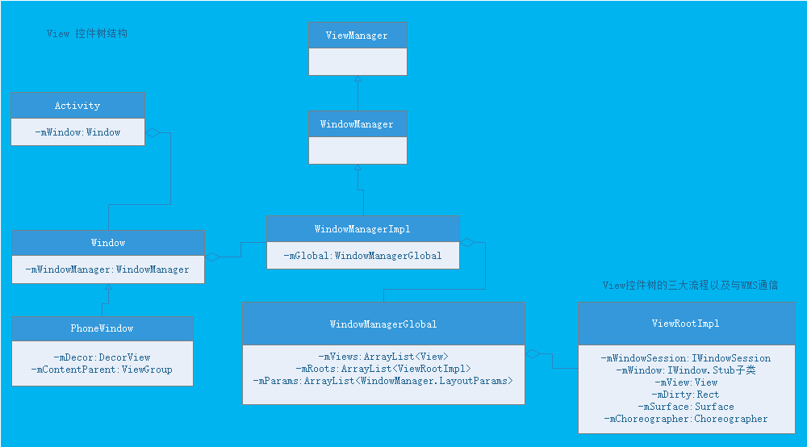

### 2 控件窗口Window与WindowManager

#### 1 Window

window中有三个核心要素，分别是WindowManager.LayoutParams 一颗控件树 以及Window.Callback

分别保存在window的布局，ViewTree 以及输入事件的回调等

Window的实现类实PhoneWindow

#### 2 WindowManager

### 3 View 控件核心ViewRootImpl

#### 1 ViewRootImpl初始化

mView会赋值为setView(View view, WindowManager.LayoutParams attrs, View panelParentView)中的view

就是一个窗口的顶级View，对于Activity来说是mDecorView

#### 2 ViewRootImpl的工作方式

* View Tree内部请求
* 外部状态更新

#### 3 View Tree遍历时机

* Activity刚启动

启动Activity需要初始化View控件树界面，并将它显示出来

* 外部事件

主要有触摸，按键事件

* 内部事件

比如调用View.requestLayout(),View.setLayoutParams(),View.invalidate()等

### 4 View控件树遍历流程

View控件树的遍历主要由ViewRootImpl.performTraversals()完成,整体遍历流程如下：

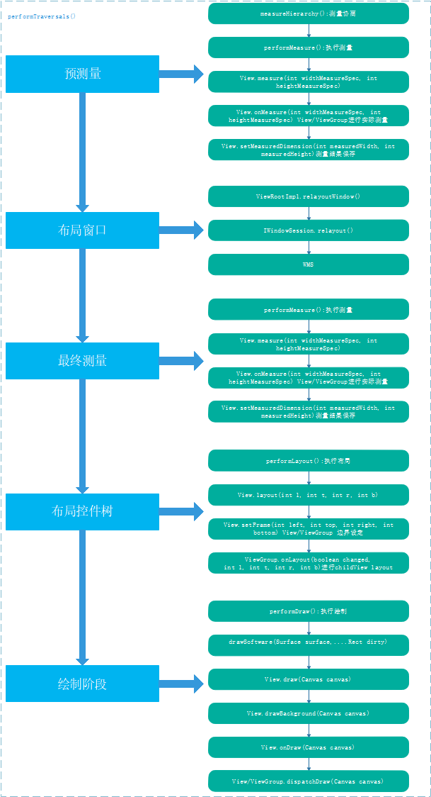

#### 1 预测量 preMeasure

由mFirst

// Ask host how big it wants to be

windowSizeMayChange |= measureHierarchy(host, lp, res,

desiredWindowWidth, desiredWindowHeight);

1 第一次遍历使用应用可用最大尺寸

2 悬浮窗口时(布局Warp_content )使用应用可用最大尺寸

3 其他情况下使用窗口最新尺寸

private boolean measureHierarchy(final View host, final WindowManager.LayoutParams lp,

final Resources res, final int desiredWindowWidth, final int desiredWindowHeight) {

int childWidthMeasureSpec;

int childHeightMeasureSpec;

boolean windowSizeMayChange = false;

if (DEBUG_ORIENTATION || DEBUG_LAYOUT) Log.v(mTag,

"Measuring " + host + " in display " + desiredWindowWidth

+ "x" + desiredWindowHeight + "...");

boolean goodMeasure = false;

if (lp.width == ViewGroup.LayoutParams.WRAP_CONTENT) {

// On large screens, we don't want to allow dialogs to just

// stretch to fill the entire width of the screen to display

// one line of text. First try doing the layout at a smaller

// size to see if it will fit.

final DisplayMetrics packageMetrics = res.getDisplayMetrics();

res.getValue(com.android.internal.R.dimen.config_prefDialogWidth, mTmpValue, true);

int baseSize = 0;

if (mTmpValue.type == TypedValue.TYPE_DIMENSION) {

baseSize = (int)mTmpValue.getDimension(packageMetrics);

}

if (DEBUG_DIALOG) Log.v(mTag, "Window " + mView + ": baseSize=" + baseSize

+ ", desiredWindowWidth=" + desiredWindowWidth);

if (baseSize != 0 && desiredWindowWidth > baseSize) {

childWidthMeasureSpec = getRootMeasureSpec(baseSize, lp.width);

childHeightMeasureSpec = getRootMeasureSpec(desiredWindowHeight, lp.height);

performMeasure(childWidthMeasureSpec, childHeightMeasureSpec);

if (DEBUG_DIALOG) Log.v(mTag, "Window " + mView + ": measured ("

+ host.getMeasuredWidth() + "," + host.getMeasuredHeight()

+ ") from width spec: " + MeasureSpec.toString(childWidthMeasureSpec)

+ " and height spec: " + MeasureSpec.toString(childHeightMeasureSpec));

if ((host.getMeasuredWidthAndState()&View.MEASURED_STATE_TOO_SMALL) == 0) {

goodMeasure = true;

} else {

// Didn't fit in that size... try expanding a bit.

baseSize = (baseSize+desiredWindowWidth)/2;

if (DEBUG_DIALOG) Log.v(mTag, "Window " + mView + ": next baseSize="

+ baseSize);

childWidthMeasureSpec = getRootMeasureSpec(baseSize, lp.width);

performMeasure(childWidthMeasureSpec, childHeightMeasureSpec);

if (DEBUG_DIALOG) Log.v(mTag, "Window " + mView + ": measured ("

+ host.getMeasuredWidth() + "," + host.getMeasuredHeight() + ")");

if ((host.getMeasuredWidthAndState()&View.MEASURED_STATE_TOO_SMALL) == 0) {

if (DEBUG_DIALOG) Log.v(mTag, "Good!");

goodMeasure = true;

}

}

}

}

if (!goodMeasure) {

childWidthMeasureSpec = getRootMeasureSpec(desiredWindowWidth, lp.width);

childHeightMeasureSpec = getRootMeasureSpec(desiredWindowHeight, lp.height);

performMeasure(childWidthMeasureSpec, childHeightMeasureSpec);

if (mWidth != host.getMeasuredWidth() || mHeight != host.getMeasuredHeight()) {

windowSizeMayChange = true;

}

}

if (DBG) {

System.out.println("======================================");

System.out.println("performTraversals -- after measure");

host.debug();

}

return windowSizeMayChange;

}

measureHierarchy测量会进行测量协商，期间会多次调用performMeasure()进行测量

private void performMeasure(int childWidthMeasureSpec, int childHeightMeasureSpec) {

…

try {

mView.measure(childWidthMeasureSpec, childHeightMeasureSpec);

} finally {

Trace.traceEnd(Trace.TRACE_TAG_VIEW);

}

}

performMeasure()会直接调用mView的测量，即控件树的ViewRoot来进行测量

View. measure(int widthMeasureSpec, int heightMeasureSpec)

public final void measure(int widthMeasureSpec, int heightMeasureSpec) {

boolean optical = isLayoutModeOptical(this);

if (optical != isLayoutModeOptical(mParent)) {

Insets insets = getOpticalInsets();

int oWidth = insets.left + insets.right;

int oHeight = insets.top + insets.bottom;

widthMeasureSpec = MeasureSpec.adjust(widthMeasureSpec, optical ? -oWidth : oWidth);

heightMeasureSpec = MeasureSpec.adjust(heightMeasureSpec, optical ? -oHeight : oHeight);

}

// Suppress sign extension for the low bytes

long key = (long) widthMeasureSpec << 32 | (long) heightMeasureSpec & 0xffffffffL;

if (mMeasureCache == null) mMeasureCache = new LongSparseLongArray(2);

final boolean forceLayout = (mPrivateFlags & PFLAG_FORCE_LAYOUT) == PFLAG_FORCE_LAYOUT;

// Optimize layout by avoiding an extra EXACTLY pass when the view is

// already measured as the correct size. In API 23 and below, this

// extra pass is required to make LinearLayout re-distribute weight.

final boolean specChanged = widthMeasureSpec != mOldWidthMeasureSpec

|| heightMeasureSpec != mOldHeightMeasureSpec;

final boolean isSpecExactly = MeasureSpec.getMode(widthMeasureSpec) == MeasureSpec.EXACTLY

&& MeasureSpec.getMode(heightMeasureSpec) == MeasureSpec.EXACTLY;

final boolean matchesSpecSize = getMeasuredWidth() == MeasureSpec.getSize(widthMeasureSpec)

&& getMeasuredHeight() == MeasureSpec.getSize(heightMeasureSpec);

final boolean needsLayout = specChanged

&& (sAlwaysRemeasureExactly || !isSpecExactly || !matchesSpecSize);

if (forceLayout || needsLayout) {

// first clears the measured dimension flag

mPrivateFlags &= ~PFLAG_MEASURED_DIMENSION_SET;

resolveRtlPropertiesIfNeeded();

int cacheIndex = forceLayout ? -1 : mMeasureCache.indexOfKey(key);

if (cacheIndex < 0 || sIgnoreMeasureCache) {

// measure ourselves, this should set the measured dimension flag back

onMeasure(widthMeasureSpec, heightMeasureSpec);

mPrivateFlags3 &= ~PFLAG3_MEASURE_NEEDED_BEFORE_LAYOUT;

} else {

long value = mMeasureCache.valueAt(cacheIndex);

// Casting a long to int drops the high 32 bits, no mask needed

setMeasuredDimensionRaw((int) (value >> 32), (int) value);

mPrivateFlags3 |= PFLAG3_MEASURE_NEEDED_BEFORE_LAYOUT;

}

// flag not set, setMeasuredDimension() was not invoked, we raise

// an exception to warn the developer

if ((mPrivateFlags & PFLAG_MEASURED_DIMENSION_SET) != PFLAG_MEASURED_DIMENSION_SET) {

throw new IllegalStateException("View with id " + getId() + ": "

+ getClass().getName() + "#onMeasure() did not set the"

+ " measured dimension by calling"

+ " setMeasuredDimension()");

}

mPrivateFlags |= PFLAG_LAYOUT_REQUIRED;

}

mOldWidthMeasureSpec = widthMeasureSpec;

mOldHeightMeasureSpec = heightMeasureSpec;

mMeasureCache.put(key, ((long) mMeasuredWidth) << 32 |

(long) mMeasuredHeight & 0xffffffffL); // suppress sign extension

}

该类直接调用View的onMeasure(int widthMeasureSpec, int heightMeasureSpec)方法来进行测量

protected void onMeasure(int widthMeasureSpec, int heightMeasureSpec) {

setMeasuredDimension(getDefaultSize(getSuggestedMinimumWidth(), widthMeasureSpec),

getDefaultSize(getSuggestedMinimumHeight(), heightMeasureSpec));

}

对于View来说直接测量自己即可

对于ViewGroup来说，一般需要测量childView之后再调用setMeasuredDimension()进行结果保存，参考LinearLayout

@Override

protected void onMeasure(int widthMeasureSpec, int heightMeasureSpec) {

if (mOrientation == VERTICAL) {

measureVertical(widthMeasureSpec, heightMeasureSpec);

} else {

measureHorizontal(widthMeasureSpec, heightMeasureSpec);

}

}

void measureVertical(int widthMeasureSpec, int heightMeasureSpec) {

....

// See how tall everyone is. Also remember max width.

for (int i = 0; i < count; ++i) {

final View child = getVirtualChildAt(i);

if (child == null) {

mTotalLength += measureNullChild(i);

continue;

}

if (child.getVisibility() == View.GONE) {

i += getChildrenSkipCount(child, i);

continue;

}

nonSkippedChildCount++;

if (hasDividerBeforeChildAt(i)) {

mTotalLength += mDividerHeight;

}

final LayoutParams lp = (LayoutParams) child.getLayoutParams();

totalWeight += lp.weight;

final boolean useExcessSpace = lp.height == 0 && lp.weight > 0;

if (heightMode == MeasureSpec.EXACTLY && useExcessSpace) {

// Optimization: don't bother measuring children who are only

// laid out using excess space. These views will get measured

// later if we have space to distribute.

final int totalLength = mTotalLength;

mTotalLength = Math.max(totalLength, totalLength + lp.topMargin + lp.bottomMargin);

skippedMeasure = true;

} else {

if (useExcessSpace) {

// The heightMode is either UNSPECIFIED or AT_MOST, and

// this child is only laid out using excess space. Measure

// using WRAP_CONTENT so that we can find out the view's

// optimal height. We'll restore the original height of 0

// after measurement.

lp.height = LayoutParams.WRAP_CONTENT;

}

// Determine how big this child would like to be. If this or

// previous children have given a weight, then we allow it to

// use all available space (and we will shrink things later

// if needed).

final int usedHeight = totalWeight == 0 ? mTotalLength : 0;

measureChildBeforeLayout(child, i, widthMeasureSpec, 0,

heightMeasureSpec, usedHeight);

final int childHeight = child.getMeasuredHeight();

if (useExcessSpace) {

// Restore the original height and record how much space

// we've allocated to excess-only children so that we can

// match the behavior of EXACTLY measurement.

lp.height = 0;

consumedExcessSpace += childHeight;

}

final int totalLength = mTotalLength;

mTotalLength = Math.max(totalLength, totalLength + childHeight + lp.topMargin +

lp.bottomMargin + getNextLocationOffset(child));

if (useLargestChild) {

largestChildHeight = Math.max(childHeight, largestChildHeight);

}

}

/**

* If applicable, compute the additional offset to the child's baseline

* we'll need later when asked {@link #getBaseline}.

*/

if ((baselineChildIndex >= 0) && (baselineChildIndex == i + 1)) {

mBaselineChildTop = mTotalLength;

}

// if we are trying to use a child index for our baseline, the above

// book keeping only works if there are no children above it with

// weight. fail fast to aid the developer.

if (i < baselineChildIndex && lp.weight > 0) {

throw new RuntimeException("A child of LinearLayout with index "

+ "less than mBaselineAlignedChildIndex has weight > 0, which "

+ "won't work. Either remove the weight, or don't set "

+ "mBaselineAlignedChildIndex.");

}

boolean matchWidthLocally = false;

if (widthMode != MeasureSpec.EXACTLY && lp.width == LayoutParams.MATCH_PARENT) {

// The width of the linear layout will scale, and at least one

// child said it wanted to match our width. Set a flag

// indicating that we need to remeasure at least that view when

// we know our width.

matchWidth = true;

matchWidthLocally = true;

}

final int margin = lp.leftMargin + lp.rightMargin;

final int measuredWidth = child.getMeasuredWidth() + margin;

maxWidth = Math.max(maxWidth, measuredWidth);

childState = combineMeasuredStates(childState, child.getMeasuredState());

allFillParent = allFillParent && lp.width == LayoutParams.MATCH_PARENT;

if (lp.weight > 0) {

/*

* Widths of weighted Views are bogus if we end up

* remeasuring, so keep them separate.

*/

weightedMaxWidth = Math.max(weightedMaxWidth,

matchWidthLocally ? margin : measuredWidth);

} else {

alternativeMaxWidth = Math.max(alternativeMaxWidth,

matchWidthLocally ? margin : measuredWidth);

}

i += getChildrenSkipCount(child, i);

}

if (nonSkippedChildCount > 0 && hasDividerBeforeChildAt(count)) {

mTotalLength += mDividerHeight;

}

if (useLargestChild &&

(heightMode == MeasureSpec.AT_MOST || heightMode == MeasureSpec.UNSPECIFIED)) {

mTotalLength = 0;

for (int i = 0; i < count; ++i) {

final View child = getVirtualChildAt(i);

if (child == null) {

mTotalLength += measureNullChild(i);

continue;

}

if (child.getVisibility() == GONE) {

i += getChildrenSkipCount(child, i);

continue;

}

final LinearLayout.LayoutParams lp = (LinearLayout.LayoutParams)

child.getLayoutParams();

// Account for negative margins

final int totalLength = mTotalLength;

mTotalLength = Math.max(totalLength, totalLength + largestChildHeight +

lp.topMargin + lp.bottomMargin + getNextLocationOffset(child));

}

}

// Add in our padding

mTotalLength += mPaddingTop + mPaddingBottom;

int heightSize = mTotalLength;

// Check against our minimum height

heightSize = Math.max(heightSize, getSuggestedMinimumHeight());

// Reconcile our calculated size with the heightMeasureSpec

int heightSizeAndState = resolveSizeAndState(heightSize, heightMeasureSpec, 0);

heightSize = heightSizeAndState & MEASURED_SIZE_MASK;

// Either expand children with weight to take up available space or

// shrink them if they extend beyond our current bounds. If we skipped

// measurement on any children, we need to measure them now.

int remainingExcess = heightSize - mTotalLength

+ (mAllowInconsistentMeasurement ? 0 : consumedExcessSpace);

if (skippedMeasure || remainingExcess != 0 && totalWeight > 0.0f) {

float remainingWeightSum = mWeightSum > 0.0f ? mWeightSum : totalWeight;

mTotalLength = 0;

for (int i = 0; i < count; ++i) {

final View child = getVirtualChildAt(i);

if (child == null || child.getVisibility() == View.GONE) {

continue;

}

final LayoutParams lp = (LayoutParams) child.getLayoutParams();

final float childWeight = lp.weight;

if (childWeight > 0) {

final int share = (int) (childWeight * remainingExcess / remainingWeightSum);

remainingExcess -= share;

remainingWeightSum -= childWeight;

final int childHeight;

if (mUseLargestChild && heightMode != MeasureSpec.EXACTLY) {

childHeight = largestChildHeight;

} else if (lp.height == 0 && (!mAllowInconsistentMeasurement

|| heightMode == MeasureSpec.EXACTLY)) {

// This child needs to be laid out from scratch using

// only its share of excess space.

childHeight = share;

} else {

// This child had some intrinsic height to which we

// need to add its share of excess space.

childHeight = child.getMeasuredHeight() + share;

}

final int childHeightMeasureSpec = MeasureSpec.makeMeasureSpec(

Math.max(0, childHeight), MeasureSpec.EXACTLY);

final int childWidthMeasureSpec = getChildMeasureSpec(widthMeasureSpec,

mPaddingLeft + mPaddingRight + lp.leftMargin + lp.rightMargin,

lp.width);

child.measure(childWidthMeasureSpec, childHeightMeasureSpec);

// Child may now not fit in vertical dimension.

childState = combineMeasuredStates(childState, child.getMeasuredState()

& (MEASURED_STATE_MASK>>MEASURED_HEIGHT_STATE_SHIFT));

}

final int margin = lp.leftMargin + lp.rightMargin;

final int measuredWidth = child.getMeasuredWidth() + margin;

maxWidth = Math.max(maxWidth, measuredWidth);

boolean matchWidthLocally = widthMode != MeasureSpec.EXACTLY &&

lp.width == LayoutParams.MATCH_PARENT;

alternativeMaxWidth = Math.max(alternativeMaxWidth,

matchWidthLocally ? margin : measuredWidth);

allFillParent = allFillParent && lp.width == LayoutParams.MATCH_PARENT;

final int totalLength = mTotalLength;

mTotalLength = Math.max(totalLength, totalLength + child.getMeasuredHeight() +

lp.topMargin + lp.bottomMargin + getNextLocationOffset(child));

}

// Add in our padding

mTotalLength += mPaddingTop + mPaddingBottom;

// TODO: Should we recompute the heightSpec based on the new total length?

} else {

alternativeMaxWidth = Math.max(alternativeMaxWidth,

weightedMaxWidth);

// We have no limit, so make all weighted views as tall as the largest child.

// Children will have already been measured once.

if (useLargestChild && heightMode != MeasureSpec.EXACTLY) {

for (int i = 0; i < count; i++) {

final View child = getVirtualChildAt(i);

if (child == null || child.getVisibility() == View.GONE) {

continue;

}

final LinearLayout.LayoutParams lp =

(LinearLayout.LayoutParams) child.getLayoutParams();

float childExtra = lp.weight;

if (childExtra > 0) {

child.measure(

MeasureSpec.makeMeasureSpec(child.getMeasuredWidth(),

MeasureSpec.EXACTLY),

MeasureSpec.makeMeasureSpec(largestChildHeight,

MeasureSpec.EXACTLY));

}

}

}

}

if (!allFillParent && widthMode != MeasureSpec.EXACTLY) {

maxWidth = alternativeMaxWidth;

}

maxWidth += mPaddingLeft + mPaddingRight;

// Check against our minimum width

maxWidth = Math.max(maxWidth, getSuggestedMinimumWidth());

setMeasuredDimension(resolveSizeAndState(maxWidth, widthMeasureSpec, childState),

heightSizeAndState);

if (matchWidth) {

forceUniformWidth(count, heightMeasureSpec);

}

}

不管View还是ViewGroup都会调用setMeasuredDimension()保存测量结果

protected final void setMeasuredDimension(int measuredWidth, int measuredHeight) {

boolean optical = isLayoutModeOptical(this);

if (optical != isLayoutModeOptical(mParent)) {

Insets insets = getOpticalInsets();

int opticalWidth = insets.left + insets.right;

int opticalHeight = insets.top + insets.bottom;

measuredWidth += optical ? opticalWidth : -opticalWidth;

measuredHeight += optical ? opticalHeight : -opticalHeight;

}

setMeasuredDimensionRaw(measuredWidth, measuredHeight);

}

….

private void setMeasuredDimensionRaw(int measuredWidth, int measuredHeight) {

mMeasuredWidth = measuredWidth;

mMeasuredHeight = measuredHeight;

mPrivateFlags |= PFLAG_MEASURED_DIMENSION_SET;

}

最终会调用setMeasuredDimension()将测量结果保存

最后ViewRootImpl需要判断是否改变窗口尺寸，判断依据如下：

* layoutRequest = true 主要是ViewRootImpl.requestLayout()方法被调用过
* windowSizeMayChanage = true 表示WMS单方面改变了窗口尺寸

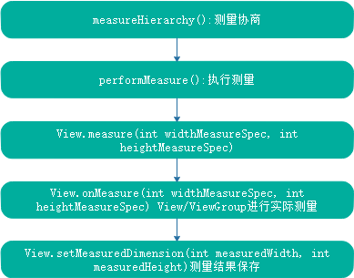

总结：预测量阶段主要是给后续阶段做准备的，该阶段的主要收获如下：

* 得知了控件树对窗口尺寸的要求
* viewVisbilityChanged 即View的可见性是否发生了变化
* 搜集LayoutParams

#### 2 布局窗口 layout Window

if (mFirst || windowShouldResize || insetsChanged ||

viewVisibilityChanged || params != null || mForceNextWindowRelayout) {

mForceNextWindowRelayout = false;

....

try {

....

relayoutResult = relayoutWindow (params, viewVisibility, insetsPending);

....

}

} else {

maybeHandleWindowMove(frame);

}

mFirst:第一次遍历，此时窗口只是添加到WMS中，但是没有进行布局，没有有效的surface

windowSizeResize:表示预测量结果与窗口当前尺寸有差异，需要通过布局窗口阶段向WMS提出修改窗口尺寸请求以满足控件树

insertsChange:表示WMS单方面改变了窗口的ContentInsets.一般是SystemUI可见性发生了变化，以及输入法弹出关闭等。严格来说，这种情况下不需要重新进行窗口布局，但是需要执行动画

params!=null:进入performtraversal()后该变量为null,当其他函数调用以及预测量阶段改变时，该变量将重新赋值

布局主要是ViewRootImpl.relayoutWindow(WindowManager.LayoutParams params, int viewVisibility,

boolean insetsPending)实现的

private int relayoutWindow(WindowManager.LayoutParams params, int viewVisibility,

boolean insetsPending) throws RemoteException {

....

int relayoutResult = mWindowSession.relayout(

mWindow, mSeq, params,

(int) (mView.getMeasuredWidth() * appScale + 0.5f),

(int) (mView.getMeasuredHeight() * appScale + 0.5f),

viewVisibility, insetsPending ? WindowManagerGlobal.RELAYOUT_INSETS_PENDING : 0,

mWinFrame, mPendingOverscanInsets, mPendingContentInsets, mPendingVisibleInsets,

mPendingStableInsets, mPendingOutsets, mPendingBackDropFrame,

mPendingMergedConfiguration, mSurface);

....

return relayoutResult;

}

可以看到最终是调用IWindowSession.relayout()向WMS进行布局的

布局之后就能得到有效的Surface了以及窗口最新尺寸等信息，会将这些信息保存在相应的变量中

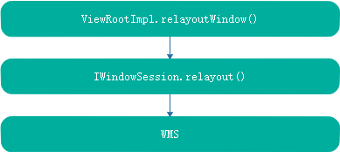

布局窗口的主要诉求有以下几点

* 控件系统有修改窗口属性的需求，例如第一次遍历需要确定窗口尺寸以及Surface等
* 预测量结果与窗口当前尺寸不一致，需要重新进行窗口尺寸调整
* mView可见性发生变化需要将窗口隐藏或显示
* LayoutParams发生变化以及需要WMS以新的参数进行重新布局

#### 3 最终测量 final Measure

if (!mStopped || mReportNextDraw) {

boolean focusChangedDueToTouchMode = ensureTouchModeLocally(

(relayoutResult&WindowManagerGlobal.RELAYOUT_RES_IN_TOUCH_MODE) != 0);

if (focusChangedDueToTouchMode || mWidth != host.getMeasuredWidth()

|| mHeight != host.getMeasuredHeight() || contentInsetsChanged ||

updatedConfiguration) {

int childWidthMeasureSpec = getRootMeasureSpec(mWidth, lp.width);

int childHeightMeasureSpec = getRootMeasureSpec(mHeight, lp.height);

.....

// Ask host how big it wants to be

performMeasure(childWidthMeasureSpec, childHeightMeasureSpec);

// Implementation of weights from WindowManager.LayoutParams

// We just grow the dimensions as needed and re-measure if

// needs be

int width = host.getMeasuredWidth();

int height = host.getMeasuredHeight();

boolean measureAgain = false;

if (lp.horizontalWeight > 0.0f) {

width += (int) ((mWidth - width) * lp.horizontalWeight);

childWidthMeasureSpec = MeasureSpec.makeMeasureSpec(width,

MeasureSpec.EXACTLY);

measureAgain = true;

}

if (lp.verticalWeight > 0.0f) {

height += (int) ((mHeight - height) * lp.verticalWeight);

childHeightMeasureSpec = MeasureSpec.makeMeasureSpec(height,

MeasureSpec.EXACTLY);

measureAgain = true;

}

if (measureAgain) {

if (DEBUG_LAYOUT) Log.v(mTag,

"And hey let's measure once more: width=" + width

+ " height=" + height);

performMeasure(childWidthMeasureSpec, childHeightMeasureSpec);

}

layoutRequested = true;

}

}

最终测量的是在布局窗口阶段之后进行的，调用的方法是 ViewRootImpl.performMeasure(childWidthMeasureSpec, childHeightMeasureSpec);进行的，后续的测量过程与预测量类似。这里不再详细讲述了。

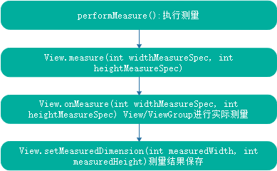

最终测量与预测量的区别如下：

* 参数不同，预测量使用了屏幕可用空间或窗口当前尺寸作为参数。最终测量使用的是窗口的最新尺寸作为参数
* 预测量阶段调用了measureHierarchy()进行协商。最终测量结果调用的是performMeasure()直接测量，没有协商过程
* 预测量测量结果是控件树期望尺寸，该结果会交给WMS期望窗口重新布局。最终测量阶段是后续的布局控件树的参考依据。

#### 4 布局控件树 layout ViewTree

if (didLayout) {

performLayout(lp, mWidth, mHeight);

if ((host.mPrivateFlags & View.PFLAG_REQUEST_TRANSPARENT_REGIONS) != 0) {

// start out transparent

// TODO: AVOID THAT CALL BY CACHING THE RESULT?

host.getLocationInWindow(mTmpLocation);

mTransparentRegion.set(mTmpLocation[0], mTmpLocation[1],

mTmpLocation[0] + host.mRight - host.mLeft,

mTmpLocation[1] + host.mBottom - host.mTop);

host.gatherTransparentRegion(mTransparentRegion);

if (mTranslator != null) {

mTranslator.translateRegionInWindowToScreen(mTransparentRegion);

}

if (!mTransparentRegion.equals(mPreviousTransparentRegion)) {

mPreviousTransparentRegion.set(mTransparentRegion);

mFullRedrawNeeded = true;

// reconfigure window manager

try {

mWindowSession.setTransparentRegion(mWindow, mTransparentRegion);

} catch (RemoteException e) {

}

}

}

}

布局控件树主要执行的就是performLayout()方法

private void performLayout(WindowManager.LayoutParams lp, int desiredWindowWidth,

int desiredWindowHeight) {

mLayoutRequested = false;

mScrollMayChange = true;

mInLayout = true;

final View host = mView;

if (host == null) {

return;

}

if (DEBUG_ORIENTATION || DEBUG_LAYOUT) {

Log.v(mTag, "Laying out " + host + " to (" +

host.getMeasuredWidth() + ", " + host.getMeasuredHeight() + ")");

}

Trace.traceBegin(Trace.TRACE_TAG_VIEW, "layout");

try {

host.layout(0, 0, host.getMeasuredWidth(), host.getMeasuredHeight());

mInLayout = false;

int numViewsRequestingLayout = mLayoutRequesters.size();

if (numViewsRequestingLayout > 0) {

// requestLayout() was called during layout.

// If no layout-request flags are set on the requesting views, there is no problem.

// If some requests are still pending, then we need to clear those flags and do

// a full request/measure/layout pass to handle this situation.

ArrayList<View> validLayoutRequesters = getValidLayoutRequesters(mLayoutRequesters,

false);

if (validLayoutRequesters != null) {

// Set this flag to indicate that any further requests are happening during

// the second pass, which may result in posting those requests to the next

// frame instead

mHandlingLayoutInLayoutRequest = true;

// Process fresh layout requests, then measure and layout

int numValidRequests = validLayoutRequesters.size();

for (int i = 0; i < numValidRequests; ++i) {

final View view = validLayoutRequesters.get(i);

Log.w("View", "requestLayout() improperly called by " + view +

" during layout: running second layout pass");

view.requestLayout();

}

measureHierarchy(host, lp, mView.getContext().getResources(),

desiredWindowWidth, desiredWindowHeight);

mInLayout = true;

host.layout(0, 0, host.getMeasuredWidth(), host.getMeasuredHeight());

mHandlingLayoutInLayoutRequest = false;

// Check the valid requests again, this time without checking/clearing the

// layout flags, since requests happening during the second pass get noop'd

validLayoutRequesters = getValidLayoutRequesters(mLayoutRequesters, true);

if (validLayoutRequesters != null) {

final ArrayList<View> finalRequesters = validLayoutRequesters;

// Post second-pass requests to the next frame

getRunQueue().post(new Runnable() {

@Override

public void run() {

int numValidRequests = finalRequesters.size();

for (int i = 0; i < numValidRequests; ++i) {

final View view = finalRequesters.get(i);

Log.w("View", "requestLayout() improperly called by " + view +

" during second layout pass: posting in next frame");

view.requestLayout();

}

}

});

}

}

}

} finally {

Trace.traceEnd(Trace.TRACE_TAG_VIEW);

}

mInLayout = false;

}

主要调用mView的layout()方法

public void layout(int l, int t, int r, int b) {

if ((mPrivateFlags3 & PFLAG3_MEASURE_NEEDED_BEFORE_LAYOUT) != 0) {

onMeasure(mOldWidthMeasureSpec, mOldHeightMeasureSpec);

mPrivateFlags3 &= ~PFLAG3_MEASURE_NEEDED_BEFORE_LAYOUT;

}

int oldL = mLeft;

int oldT = mTop;

int oldB = mBottom;

int oldR = mRight;

boolean changed = isLayoutModeOptical(mParent) ?

setOpticalFrame(l, t, r, b) : setFrame(l, t, r, b);

if (changed || (mPrivateFlags & PFLAG_LAYOUT_REQUIRED) == PFLAG_LAYOUT_REQUIRED) {

onLayout(changed, l, t, r, b);

if (shouldDrawRoundScrollbar()) {

if(mRoundScrollbarRenderer == null) {

mRoundScrollbarRenderer = new RoundScrollbarRenderer(this);

}

} else {

mRoundScrollbarRenderer = null;

}

mPrivateFlags &= ~PFLAG_LAYOUT_REQUIRED;

ListenerInfo li = mListenerInfo;

if (li != null && li.mOnLayoutChangeListeners != null) {

ArrayList<OnLayoutChangeListener> listenersCopy =

(ArrayList<OnLayoutChangeListener>)li.mOnLayoutChangeListeners.clone();

int numListeners = listenersCopy.size();

for (int i = 0; i < numListeners; ++i) {

listenersCopy.get(i).onLayoutChange(this, l, t, r, b, oldL, oldT, oldR, oldB);

}

}

}

mPrivateFlags &= ~PFLAG_FORCE_LAYOUT;

mPrivateFlags3 |= PFLAG3_IS_LAID_OUT;

if ((mPrivateFlags3 & PFLAG3_NOTIFY_AUTOFILL_ENTER_ON_LAYOUT) != 0) {

mPrivateFlags3 &= ~PFLAG3_NOTIFY_AUTOFILL_ENTER_ON_LAYOUT;

notifyEnterOrExitForAutoFillIfNeeded(true);

}

}

layout主要做的事如下：

* 通过setFrame()设置布局的四个坐标
* 调用onLayout()方法，使其子类得到布局变更的通知
* 通知对布局感兴趣的listener

首先会调用View.setFrame(int left, int top, int right, int bottom)设置View的坐标

protected boolean setFrame(int left, int top, int right, int bottom) {

boolean changed = false;

if (DBG) {

Log.d("View", this + " View.setFrame(" + left + "," + top + ","

+ right + "," + bottom + ")");

}

if (mLeft != left || mRight != right || mTop != top || mBottom != bottom) {

changed = true;

// Remember our drawn bit

int drawn = mPrivateFlags & PFLAG_DRAWN;

int oldWidth = mRight - mLeft;

int oldHeight = mBottom - mTop;

int newWidth = right - left;

int newHeight = bottom - top;

boolean sizeChanged = (newWidth != oldWidth) || (newHeight != oldHeight);

// Invalidate our old position

invalidate(sizeChanged);

mLeft = left;

mTop = top;

mRight = right;

mBottom = bottom;

mRenderNode.setLeftTopRightBottom(mLeft, mTop, mRight, mBottom);

mPrivateFlags |= PFLAG_HAS_BOUNDS;

if (sizeChanged) {

sizeChange(newWidth, newHeight, oldWidth, oldHeight);

}

if ((mViewFlags & VISIBILITY_MASK) == VISIBLE || mGhostView != null) {

// If we are visible, force the DRAWN bit to on so that

// this invalidate will go through (at least to our parent).

// This is because someone may have invalidated this view

// before this call to setFrame came in, thereby clearing

// the DRAWN bit.

mPrivateFlags |= PFLAG_DRAWN;

invalidate(sizeChanged);

// parent display list may need to be recreated based on a change in the bounds

// of any child

invalidateParentCaches();

}

// Reset drawn bit to original value (invalidate turns it off)

mPrivateFlags |= drawn;

mBackgroundSizeChanged = true;

mDefaultFocusHighlightSizeChanged = true;

if (mForegroundInfo != null) {

mForegroundInfo.mBoundsChanged = true;

}

notifySubtreeAccessibilityStateChangedIfNeeded();

}

return changed;

}

主要是保存四个边角的位置，这样子就可以确定下来View的位置了

最终会调用到View. onLayout(boolean changed, int left, int top, int right, int bottom) 和ViewGroup的onLayout(boolean changed,int l, int t, int r, int b)。

protected void onLayout(boolean changed, int left, int top, int right, int bottom) {

}

对于View来说并无太大的作用，主要用于ViewGroup来对childView 进行layout。因此在自定义ViewGroup时，该方法中必须对childView 进行layout()。参考LinearLayout，我们可以发现在onLayout()中调用了child.layout()进行子View布局

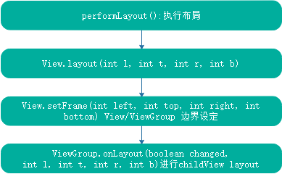

布局与测量的区别

* 测量确定的是控件的尺寸，布局则是确定控件的位置
* 测量结果对布局过程无约束力
* 子控件的测量影响父控件的测量结果，因此测量时后根遍历。布局是父布局的结果影响子控件,布局是先根遍历

#### 5 绘制阶段 draw

最后是绘制阶段

boolean cancelDraw = mAttachInfo.mTreeObserver.dispatchOnPreDraw() || !isViewVisible;

if (!cancelDraw && !newSurface) {

if (mPendingTransitions != null && mPendingTransitions.size() > 0) {

for (int i = 0; i < mPendingTransitions.size(); ++i) {

mPendingTransitions.get(i).startChangingAnimations();

}

mPendingTransitions.clear();

}

performDraw();

} else {

if (isViewVisible) {

// Try again

scheduleTraversals();

} else if (mPendingTransitions != null && mPendingTransitions.size() > 0) {

for (int i = 0; i < mPendingTransitions.size(); ++i) {

mPendingTransitions.get(i).endChangingAnimations();

}

mPendingTransitions.clear();

}

}

调用performDraw()执行绘制

private void performDraw() {

if (mAttachInfo.mDisplayState == Display.STATE_OFF && !mReportNextDraw) {

return;

} else if (mView == null) {

return;

}

final boolean fullRedrawNeeded = mFullRedrawNeeded;

mFullRedrawNeeded = false;

mIsDrawing = true;

Trace.traceBegin(Trace.TRACE_TAG_VIEW, "draw");

try {

draw(fullRedrawNeeded);

} finally {

mIsDrawing = false;

Trace.traceEnd(Trace.TRACE_TAG_VIEW);

}

// For whatever reason we didn't create a HardwareRenderer, end any

// hardware animations that are now dangling

if (mAttachInfo.mPendingAnimatingRenderNodes != null) {

final int count = mAttachInfo.mPendingAnimatingRenderNodes.size();

for (int i = 0; i < count; i++) {

mAttachInfo.mPendingAnimatingRenderNodes.get(i).endAllAnimators();

}

mAttachInfo.mPendingAnimatingRenderNodes.clear();

}

if (mReportNextDraw) {

mReportNextDraw = false;

// if we're using multi-thread renderer, wait for the window frame draws

if (mWindowDrawCountDown != null) {

try {

mWindowDrawCountDown.await();

} catch (InterruptedException e) {

Log.e(mTag, "Window redraw count down interruped!");

}

mWindowDrawCountDown = null;

}

if (mAttachInfo.mThreadedRenderer != null) {

mAttachInfo.mThreadedRenderer.fence();

mAttachInfo.mThreadedRenderer.setStopped(mStopped);

}

if (LOCAL_LOGV) {

Log.v(mTag, "FINISHED DRAWING: " + mWindowAttributes.getTitle());

}

if (mSurfaceHolder != null && mSurface.isValid()) {

SurfaceCallbackHelper sch = new SurfaceCallbackHelper(this::postDrawFinished);

SurfaceHolder.Callback callbacks[] = mSurfaceHolder.getCallbacks();

sch.dispatchSurfaceRedrawNeededAsync(mSurfaceHolder, callbacks);

} else {

pendingDrawFinished();

}

}

}

该方法会调用draw(boolean fullRedrawNeeded)进行具体绘制，而后又会调用drawSoftware(Surface surface, AttachInfo attachInfo, int xoff, int yoff,boolean scalingRequired, Rect dirty)进行绘制

/**

* @return true if drawing was successful, false if an error occurred

*/

private boolean drawSoftware(Surface surface, AttachInfo attachInfo, int xoff, int yoff,

boolean scalingRequired, Rect dirty) {

// Draw with software renderer.

final Canvas canvas;

try {

....

canvas = mSurface.lockCanvas(dirty);

....

// TODO: Do this in native

canvas.setDensity(mDensity);

} catch (Surface.OutOfResourcesException e) {

handleOutOfResourcesException(e);

return false;

} catch (IllegalArgumentException e) {

Log.e(mTag, "Could not lock surface", e);

// Don't assume this is due to out of memory, it could be

// something else, and if it is something else then we could

// kill stuff (or ourself) for no reason.

mLayoutRequested = true; // ask wm for a new surface next time.

return false;

}

try {

if (DEBUG_ORIENTATION || DEBUG_DRAW) {

Log.v(mTag, "Surface " + surface + " drawing to bitmap w="

+ canvas.getWidth() + ", h=" + canvas.getHeight());

//canvas.drawARGB(255, 255, 0, 0);

}

// If this bitmap's format includes an alpha channel, we

// need to clear it before drawing so that the child will

// properly re-composite its drawing on a transparent

// background. This automatically respects the clip/dirty region

// or

// If we are applying an offset, we need to clear the area

// where the offset doesn't appear to avoid having garbage

// left in the blank areas.

if (!canvas.isOpaque() || yoff != 0 || xoff != 0) {

canvas.drawColor(0, PorterDuff.Mode.CLEAR);

}

dirty.setEmpty();

mIsAnimating = false;

mView.mPrivateFlags |= View.PFLAG_DRAWN;

if (DEBUG_DRAW) {

Context cxt = mView.getContext();

Log.i(mTag, "Drawing: package:" + cxt.getPackageName() +

", metrics=" + cxt.getResources().getDisplayMetrics() +

", compatibilityInfo=" + cxt.getResources().getCompatibilityInfo());

}

try {

**canvas.translate(-xoff, -yoff);**

if (mTranslator != null) {

mTranslator.translateCanvas(canvas);

}

canvas.setScreenDensity(scalingRequired ? mNoncompatDensity : 0);

attachInfo.mSetIgnoreDirtyState = false;

**mView.draw(canvas);**

drawAccessibilityFocusedDrawableIfNeeded(canvas);

} finally {

if (!attachInfo.mSetIgnoreDirtyState) {

// Only clear the flag if it was not set during the mView.draw() call

attachInfo.mIgnoreDirtyState = false;

}

}

} finally {

try {

**surface.unlockCanvasAndPost(canvas);**

} catch (IllegalArgumentException e) {

Log.e(mTag, "Could not unlock surface", e);

mLayoutRequested = true; // ask wm for a new surface next time.

//noinspection ReturnInsideFinallyBlock

return false;

}

if (LOCAL_LOGV) {

Log.v(mTag, "Surface " + surface + " unlockCanvasAndPost");

}

}

return true;

}

可以看到会调用View.draw()方法进行绘制

public void draw(Canvas canvas) {

....

if (!dirtyOpaque) {

drawBackground(canvas);

}

if (!verticalEdges && !horizontalEdges) {

.....

// Step 4, draw the children

dispatchDraw(canvas);

drawAutofilledHighlight(canvas);

// Overlay is part of the content and draws beneath Foreground

if (mOverlay != null && !mOverlay.isEmpty()) {

mOverlay.getOverlayView().dispatchDraw(canvas);

}

// Step 6, draw decorations (foreground, scrollbars)

onDrawForeground(canvas);

// Step 7, draw the default focus highlight

drawDefaultFocusHighlight(canvas);

if (debugDraw()) {

debugDrawFocus(canvas);

}

// we're done...

return;

}

/*

* Here we do the full fledged routine...

* (this is an uncommon case where speed matters less,

* this is why we repeat some of the tests that have been

* done above)

*/

boolean drawTop = false;

boolean drawBottom = false;

boolean drawLeft = false;

boolean drawRight = false;

float topFadeStrength = 0.0f;

float bottomFadeStrength = 0.0f;

float leftFadeStrength = 0.0f;

float rightFadeStrength = 0.0f;

// Step 2, save the canvas' layers

int paddingLeft = mPaddingLeft;

final boolean offsetRequired = isPaddingOffsetRequired();

if (offsetRequired) {

paddingLeft += getLeftPaddingOffset();

}

int left = mScrollX + paddingLeft;

int right = left + mRight - mLeft - mPaddingRight - paddingLeft;

int top = mScrollY + getFadeTop(offsetRequired);

int bottom = top + getFadeHeight(offsetRequired);

if (offsetRequired) {

right += getRightPaddingOffset();

bottom += getBottomPaddingOffset();

}

final ScrollabilityCache scrollabilityCache = mScrollCache;

final float fadeHeight = scrollabilityCache.fadingEdgeLength;

int length = (int) fadeHeight;

// clip the fade length if top and bottom fades overlap

// overlapping fades produce odd-looking artifacts

if (verticalEdges && (top + length > bottom - length)) {

length = (bottom - top) / 2;

}

// also clip horizontal fades if necessary

if (horizontalEdges && (left + length > right - length)) {

length = (right - left) / 2;

}

if (verticalEdges) {

topFadeStrength = Math.max(0.0f, Math.min(1.0f, getTopFadingEdgeStrength()));

drawTop = topFadeStrength * fadeHeight > 1.0f;

bottomFadeStrength = Math.max(0.0f, Math.min(1.0f, getBottomFadingEdgeStrength()));

drawBottom = bottomFadeStrength * fadeHeight > 1.0f;

}

if (horizontalEdges) {

leftFadeStrength = Math.max(0.0f, Math.min(1.0f, getLeftFadingEdgeStrength()));

drawLeft = leftFadeStrength * fadeHeight > 1.0f;

rightFadeStrength = Math.max(0.0f, Math.min(1.0f, getRightFadingEdgeStrength()));

drawRight = rightFadeStrength * fadeHeight > 1.0f;

}

saveCount = canvas.getSaveCount();

int solidColor = getSolidColor();

if (solidColor == 0) {

final int flags = Canvas.HAS_ALPHA_LAYER_SAVE_FLAG;

if (drawTop) {

canvas.saveLayer(left, top, right, top + length, null, flags);

}

if (drawBottom) {

canvas.saveLayer(left, bottom - length, right, bottom, null, flags);

}

if (drawLeft) {

canvas.saveLayer(left, top, left + length, bottom, null, flags);

}

if (drawRight) {

canvas.saveLayer(right - length, top, right, bottom, null, flags);

}

} else {

scrollabilityCache.setFadeColor(solidColor);

}

// Step 3, draw the content

if (!dirtyOpaque) onDraw(canvas);

// Step 4, draw the children

dispatchDraw(canvas);

....

canvas.restoreToCount(saveCount);

drawAutofilledHighlight(canvas);

// Overlay is part of the content and draws beneath Foreground

if (mOverlay != null && !mOverlay.isEmpty()) {

mOverlay.getOverlayView().dispatchDraw(canvas);

}

// Step 6, draw decorations (foreground, scrollbars)

onDrawForeground(canvas);

if (debugDraw()) {

debugDrawFocus(canvas);

}

}

首先会调用onDraw(Canvas canvas)进行绘制自己

最后会调用dispatchDraw(Canvas canvas)进行绘制的分发，这个主要是指针对ViewGroup的

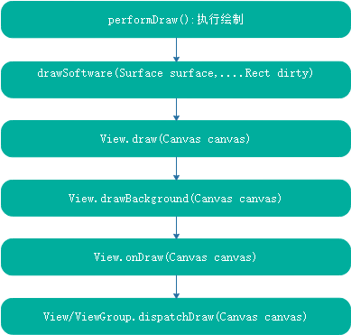

### 5 Canvas与Draw

### 6 View控件树的事件派发

### 7 Activity 窗口添加及显示

#### 1 Activity.attach()初始化WindowManager，窗口令牌等

主要在Activity创建好之后的attach()方法中，并且先与onCreate()方法之前

在ActivityThread中收到AMS的消息后，会转到Handler H 中的LAUNCH_ACTIVITY，从而最终会调用

performLaunchActivity(ActivityClientRecord r, Intent customIntent)创建Activity的实例

private Activity performLaunchActivity(ActivityClientRecord r, Intent customIntent) {

....

Activity activity = null;

try {

java.lang.ClassLoader cl = appContext.getClassLoader();

activity = mInstrumentation.newActivity(

cl, component.getClassName(), r.intent);

....

} catch (Exception e) {

if (!mInstrumentation.onException(activity, e)) {

throw new RuntimeException(

"Unable to instantiate activity " + component

+ ": " + e.toString(), e);

}

}

try {

Application app = r.packageInfo.makeApplication(false, mInstrumentation);

if (localLOGV) Slog.v(TAG, "Performing launch of " + r);

if (localLOGV) Slog.v(

TAG, r + ": app=" + app

+ ", appName=" + app.getPackageName()

+ ", pkg=" + r.packageInfo.getPackageName()

+ ", comp=" + r.intent.getComponent().toShortString()

+ ", dir=" + r.packageInfo.getAppDir());

if (activity != null) {

....

appContext.setOuterContext(activity);

activity.attach(appContext, this, getInstrumentation(), r.token,

r.ident, app, r.intent, r.activityInfo, title, r.parent,

r.embeddedID, r.lastNonConfigurationInstances, config,

r.referrer, r.voiceInteractor, window, r.configCallback);

....

}

r.paused = true;

mActivities.put(r.token, r);

} catch (SuperNotCalledException e) {

throw e;

} catch (Exception e) {

if (!mInstrumentation.onException(activity, e)) {

throw new RuntimeException(

"Unable to start activity " + component

+ ": " + e.toString(), e);

}

}

return activity;

}

可以看到会调用Activity.attach()进行activity的初始化

final void attach(Context context, ActivityThread aThread,

Instrumentation instr, IBinder token, int ident,

Application application, Intent intent, ActivityInfo info,

CharSequence title, Activity parent, String id,

NonConfigurationInstances lastNonConfigurationInstances,

Configuration config, String referrer, IVoiceInteractor voiceInteractor,

Window window, ActivityConfigCallback activityConfigCallback) {

attachBaseContext(context);

mFragments.attachHost(null /*parent*/);

mWindow = new PhoneWindow (this, window, activityConfigCallback);

mWindow.setWindowControllerCallback(this);

mWindow.setCallback(this);

mWindow.setOnWindowDismissedCallback(this);

mWindow.getLayoutInflater().setPrivateFactory(this);

if (info.softInputMode != WindowManager.LayoutParams.SOFT_INPUT_STATE_UNSPECIFIED) {

mWindow.setSoftInputMode(info.softInputMode);

}

if (info.uiOptions != 0) {

mWindow.setUiOptions(info.uiOptions);

}

mUiThread = Thread.currentThread();

mMainThread = aThread;

mInstrumentation = instr;

mToken = token;

mIdent = ident;

mApplication = application;

mIntent = intent;

mReferrer = referrer;

mComponent = intent.getComponent();

mActivityInfo = info;

mTitle = title;

mParent = parent;

mEmbeddedID = id;

mLastNonConfigurationInstances = lastNonConfigurationInstances;

if (voiceInteractor != null) {

if (lastNonConfigurationInstances != null) {

mVoiceInteractor = lastNonConfigurationInstances.voiceInteractor;

} else {

mVoiceInteractor = new VoiceInteractor(voiceInteractor, this, this,

Looper.myLooper());

}

}

mWindow.setWindowManager(

(WindowManager)context.getSystemService(Context.WINDOW_SERVICE),

mToken, mComponent.flattenToString(),

(info.flags & ActivityInfo.FLAG_HARDWARE_ACCELERATED) != 0);

if (mParent != null) {

mWindow.setContainer(mParent.getWindow());

}

mWindowManager = mWindow.getWindowManager();

mCurrentConfig = config;

mWindow.setColorMode(info.colorMode);

}

可以看到，这一步主要是进行初始化PhoneWindow mWindow，WindowManager mWindowManager,IBinder mToken等

这些都是后续添加窗口必须的

#### 2 Activity的View Tree创建

Activity中ViewTree的创建是从setContentView()开始的，最终会调用到PhoneWindow中的setContentView(int layoutResID)

@Override

public void setContentView(int layoutResID) {

// Note: FEATURE_CONTENT_TRANSITIONS may be set in the process of installing the window

// decor, when theme attributes and the like are crystalized. Do not check the feature

// before this happens.

if (mContentParent == null) {

installDecor();

} else if (!hasFeature(FEATURE_CONTENT_TRANSITIONS)) {

mContentParent.removeAllViews();

}

if (hasFeature(FEATURE_CONTENT_TRANSITIONS)) {

final Scene newScene = Scene.getSceneForLayout(mContentParent, layoutResID,

getContext());

transitionTo(newScene);

} else {

mLayoutInflater.inflate(layoutResID, mContentParent);

}

mContentParent.requestApplyInsets();

final Callback cb = getCallback();

if (cb != null && !isDestroyed()) {

cb.onContentChanged();

}

mContentParentExplicitlySet = true;

}

这里首先判断mContentParent是否为null，为null表示没有创建DecorView mDecor。那么需要调用installDecor()来创建mDecor

private void installDecor() {

mForceDecorInstall = false;

if (mDecor == null) {

mDecor = generateDecor(-1);

mDecor.setDescendantFocusability(ViewGroup.FOCUS_AFTER_DESCENDANTS);

mDecor.setIsRootNamespace(true);

if (!mInvalidatePanelMenuPosted && mInvalidatePanelMenuFeatures != 0) {

mDecor.postOnAnimation(mInvalidatePanelMenuRunnable);

}

} else {

mDecor.setWindow(this);

}

if (mContentParent == null) {

mContentParent = generateLayout(mDecor);

// Set up decor part of UI to ignore fitsSystemWindows if appropriate.

mDecor.makeOptionalFitsSystemWindows();

final DecorContentParent decorContentParent = (DecorContentParent) mDecor.findViewById(

R.id.decor_content_parent);

if (decorContentParent != null) {

mDecorContentParent = decorContentParent;

mDecorContentParent.setWindowCallback(getCallback());

if (mDecorContentParent.getTitle() == null) {

mDecorContentParent.setWindowTitle(mTitle);

}

final int localFeatures = getLocalFeatures();

for (int i = 0; i < FEATURE_MAX; i++) {

if ((localFeatures & (1 << i)) != 0) {

mDecorContentParent.initFeature(i);

}

}

mDecorContentParent.setUiOptions(mUiOptions);

if ((mResourcesSetFlags & FLAG_RESOURCE_SET_ICON) != 0 ||

(mIconRes != 0 && !mDecorContentParent.hasIcon())) {

mDecorContentParent.setIcon(mIconRes);

} else if ((mResourcesSetFlags & FLAG_RESOURCE_SET_ICON) == 0 &&

mIconRes == 0 && !mDecorContentParent.hasIcon()) {

mDecorContentParent.setIcon(

getContext().getPackageManager().getDefaultActivityIcon());

mResourcesSetFlags |= FLAG_RESOURCE_SET_ICON_FALLBACK;

}

if ((mResourcesSetFlags & FLAG_RESOURCE_SET_LOGO) != 0 ||

(mLogoRes != 0 && !mDecorContentParent.hasLogo())) {

mDecorContentParent.setLogo(mLogoRes);

}

// Invalidate if the panel menu hasn't been created before this.

// Panel menu invalidation is deferred avoiding application onCreateOptionsMenu

// being called in the middle of onCreate or similar.

// A pending invalidation will typically be resolved before the posted message

// would run normally in order to satisfy instance state restoration.

PanelFeatureState st = getPanelState(FEATURE_OPTIONS_PANEL, false);

if (!isDestroyed() && (st == null || st.menu == null) && !mIsStartingWindow) {

invalidatePanelMenu(FEATURE_ACTION_BAR);

}

} else {

mTitleView = findViewById(R.id.title);

if (mTitleView != null) {

if ((getLocalFeatures() & (1 << FEATURE_NO_TITLE)) != 0) {

final View titleContainer = findViewById(R.id.title_container);

if (titleContainer != null) {

titleContainer.setVisibility(View.GONE);

} else {

mTitleView.setVisibility(View.GONE);

}

mContentParent.setForeground(null);

} else {

mTitleView.setText(mTitle);

}

}

}

if (mDecor.getBackground() == null && mBackgroundFallbackResource != 0) {

mDecor.setBackgroundFallback(mBackgroundFallbackResource);

}

// Only inflate or create a new TransitionManager if the caller hasn't

// already set a custom one.

if (hasFeature(FEATURE_ACTIVITY_TRANSITIONS)) {

if (mTransitionManager == null) {

final int transitionRes = getWindowStyle().getResourceId(

R.styleable.Window_windowContentTransitionManager,

0);

if (transitionRes != 0) {

final TransitionInflater inflater = TransitionInflater.from(getContext());

mTransitionManager = inflater.inflateTransitionManager(transitionRes,

mContentParent);

} else {

mTransitionManager = new TransitionManager();

}

}

mEnterTransition = getTransition(mEnterTransition, null,

R.styleable.Window_windowEnterTransition);

mReturnTransition = getTransition(mReturnTransition, USE_DEFAULT_TRANSITION,

R.styleable.Window_windowReturnTransition);

mExitTransition = getTransition(mExitTransition, null,

R.styleable.Window_windowExitTransition);

mReenterTransition = getTransition(mReenterTransition, USE_DEFAULT_TRANSITION,

R.styleable.Window_windowReenterTransition);

mSharedElementEnterTransition = getTransition(mSharedElementEnterTransition, null,

R.styleable.Window_windowSharedElementEnterTransition);

mSharedElementReturnTransition = getTransition(mSharedElementReturnTransition,

USE_DEFAULT_TRANSITION,

R.styleable.Window_windowSharedElementReturnTransition);

mSharedElementExitTransition = getTransition(mSharedElementExitTransition, null,

R.styleable.Window_windowSharedElementExitTransition);

mSharedElementReenterTransition = getTransition(mSharedElementReenterTransition,

USE_DEFAULT_TRANSITION,

R.styleable.Window_windowSharedElementReenterTransition);

if (mAllowEnterTransitionOverlap == null) {

mAllowEnterTransitionOverlap = getWindowStyle().getBoolean(

R.styleable.Window_windowAllowEnterTransitionOverlap, true);

}

if (mAllowReturnTransitionOverlap == null) {

mAllowReturnTransitionOverlap = getWindowStyle().getBoolean(

R.styleable.Window_windowAllowReturnTransitionOverlap, true);

}

if (mBackgroundFadeDurationMillis < 0) {

mBackgroundFadeDurationMillis = getWindowStyle().getInteger(

R.styleable.Window_windowTransitionBackgroundFadeDuration,

DEFAULT_BACKGROUND_FADE_DURATION_MS);

}

if (mSharedElementsUseOverlay == null) {

mSharedElementsUseOverlay = getWindowStyle().getBoolean(

R.styleable.Window_windowSharedElementsUseOverlay, true);

}

}

}

}

创建好mDecor和mContentParent之后，调用mLayoutInflater.inflate(layoutResID, mContentParent);将我们的布局设置到mContentParent中，这样一颗以mDecor为根的控件树就创建好了。



而setContentView()中真正的View作为mContentParent的第一个childView添加到控件树中的

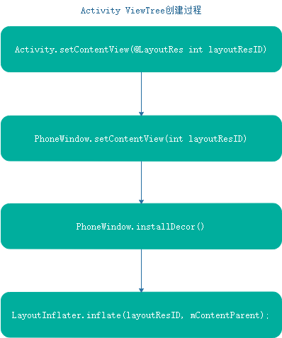

在实际开发中可以使用如下代码来获取contentView

ViewGroup contentParent = getWindow().getDecorView().findViewById(android.R.id.content);

View contentView = contentParent.getChildAt(0);

#### 3 Activity窗口的添加

真正添加窗口是在ActivityThread中的handleResumeActivity()方法中

该方法也是在ActivityThread.handleLaunchActivity()中调用的

final void handleResumeActivity(IBinder token,

boolean clearHide, boolean isForward, boolean reallyResume, int seq, String reason) {

....

r = performResumeActivity(token, clearHide, reason);

if (r != null) {

final Activity a = r.activity;

.....

if (r.window == null && !a.mFinished && willBeVisible) {

r.window = r.activity.getWindow();

**View decor = r.window.getDecorView();**

**decor.setVisibility(View.INVISIBLE);**

**ViewManager wm = a.getWindowManager();**

WindowManager.LayoutParams l = r.window.getAttributes();

a.mDecor = decor;

l.type = WindowManager.LayoutParams.TYPE_BASE_APPLICATION;

l.softInputMode |= forwardBit;

if (r.mPreserveWindow) {

a.mWindowAdded = true;

r.mPreserveWindow = false;

// Normally the ViewRoot sets up callbacks with the Activity

// in addView->ViewRootImpl#setView. If we are instead reusing

// the decor view we have to notify the view root that the

// callbacks may have changed.

ViewRootImpl impl = decor.getViewRootImpl();

if (impl != null) {

impl.notifyChildRebuilt();

}

}

if (a.mVisibleFromClient) {

if (!a.mWindowAdded) {

a.mWindowAdded = true;

**wm.addView(decor, l);**

} else {

// The activity will get a callback for this {@link LayoutParams} change

// earlier. However, at that time the decor will not be set (this is set

// in this method), so no action will be taken. This call ensures the

// callback occurs with the decor set.

a.onWindowAttributesChanged(l);

}

}

....

}

可以看到在Activity回调了onResume()方法之后才会调用WindowManager.addView()方法，不过此时DecorView是不显示的。后续会有窗口显示操作

#### 4 Activity窗口的显示

接上面一节，当WindowManager添加窗口时，此时DecorView是不显示的。窗口的显示主要修改DecorView的显示属性为VISIBLE来实现的

final void handleResumeActivity(IBinder token,

boolean clearHide, boolean isForward, boolean reallyResume, int seq, String reason) {

ActivityClientRecord r = mActivities.get(token);

if (!checkAndUpdateLifecycleSeq(seq, r, "resumeActivity")) {

return;

}

// If we are getting ready to gc after going to the background, well

// we are back active so skip it.

unscheduleGcIdler();

mSomeActivitiesChanged = true;

// TODO Push resumeArgs into the activity for consideration

r = performResumeActivity(token, clearHide, reason);

if (r != null) {

final Activity a = r.activity;

if (localLOGV) Slog.v(

TAG, "Resume " + r + " started activity: " +

a.mStartedActivity + ", hideForNow: " + r.hideForNow

+ ", finished: " + a.mFinished);

final int forwardBit = isForward ?

WindowManager.LayoutParams.SOFT_INPUT_IS_FORWARD_NAVIGATION : 0;

// If the window hasn't yet been added to the window manager,

// and this guy didn't finish itself or start another activity,

// then go ahead and add the window.

boolean willBeVisible = !a.mStartedActivity;

if (!willBeVisible) {

try {

willBeVisible = ActivityManager.getService().willActivityBeVisible(

a.getActivityToken());

} catch (RemoteException e) {

throw e.rethrowFromSystemServer();

}

}

if (r.window == null && !a.mFinished && willBeVisible) {

r.window = r.activity.getWindow();

View decor = r.window.getDecorView();

decor.setVisibility(View.INVISIBLE);

ViewManager wm = a.getWindowManager();

WindowManager.LayoutParams l = r.window.getAttributes();

a.mDecor = decor;

l.type = WindowManager.LayoutParams.TYPE_BASE_APPLICATION;

l.softInputMode |= forwardBit;

if (r.mPreserveWindow) {

a.mWindowAdded = true;

r.mPreserveWindow = false;

// Normally the ViewRoot sets up callbacks with the Activity

// in addView->ViewRootImpl#setView. If we are instead reusing

// the decor view we have to notify the view root that the

// callbacks may have changed.

ViewRootImpl impl = decor.getViewRootImpl();

if (impl != null) {

impl.notifyChildRebuilt();

}

}

if (a.mVisibleFromClient) {

if (!a.mWindowAdded) {

a.mWindowAdded = true;

wm.addView(decor, l);

} else {

// The activity will get a callback for this {@link LayoutParams} change

// earlier. However, at that time the decor will not be set (this is set

// in this method), so no action will be taken. This call ensures the

// callback occurs with the decor set.

a.onWindowAttributesChanged(l);

}

}

// If the window has already been added, but during resume

// we started another activity, then don't yet make the

// window visible.

} else if (!willBeVisible) {

if (localLOGV) Slog.v(

TAG, "Launch " + r + " mStartedActivity set");

r.hideForNow = true;

}

// Get rid of anything left hanging around.

cleanUpPendingRemoveWindows(r, false /* force */);

// The window is now visible if it has been added, we are not

// simply finishing, and we are not starting another activity.

if (!r.activity.mFinished && willBeVisible

&& r.activity.mDecor != null && !r.hideForNow) {

if (r.newConfig != null) {

performConfigurationChangedForActivity(r, r.newConfig);

if (DEBUG_CONFIGURATION) Slog.v(TAG, "Resuming activity "

+ r.activityInfo.name + " with newConfig " + r.activity.mCurrentConfig);

r.newConfig = null;

}

if (localLOGV) Slog.v(TAG, "Resuming " + r + " with isForward="

+ isForward);

WindowManager.LayoutParams l = r.window.getAttributes();

if ((l.softInputMode

& WindowManager.LayoutParams.SOFT_INPUT_IS_FORWARD_NAVIGATION)

!= forwardBit) {

l.softInputMode = (l.softInputMode

& (~WindowManager.LayoutParams.SOFT_INPUT_IS_FORWARD_NAVIGATION))

| forwardBit;

if (r.activity.mVisibleFromClient) {

ViewManager wm = a.getWindowManager();

View decor = r.window.getDecorView();

wm.updateViewLayout(decor, l);

}

}

r.activity.mVisibleFromServer = true;

mNumVisibleActivities++;

if (r.activity.mVisibleFromClient) {

**r.activity.makeVisible();**

}

}

....

} else {

....

}

}

我们可以看到最终调用到Activity中了

void makeVisible() {

if (!mWindowAdded) {

ViewManager wm = getWindowManager();

wm.addView(mDecor, getWindow().getAttributes());

mWindowAdded = true;

}

mDecor.setVisibility(View.VISIBLE);

}

最终会出发ViewTree控件树的遍历，绘制会将ViewTree进行绘制等

注：Activity的onStop() onStart()也是通过修改DecorView的可见性来达到的，并没有销毁窗口

整个Activity的添加窗口过程如下：

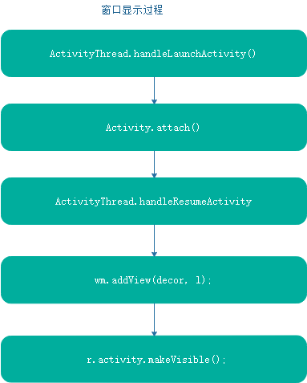

#### 5 Activity窗口的销毁

Activity窗口的销毁是在ActivityThread.handleDestroyActivity()中进行的，这里就不再详细分析了

## 七 InputManagerService与输入系统

## 八 ActivityManagerService

### 1 AMS功能概述

#### 1 AMS主要功能

组件状态管理，主要包括四大组件的状态，例如Activity的启动，调度，广播的分发，service的管理等

组件状态查询：查询当前组件的运行状态

调度Task

进程调度

其他功能，例如查询系统当前运行状态，内存，CPU，GRU，DataBase等

#### 2 AMS架构图

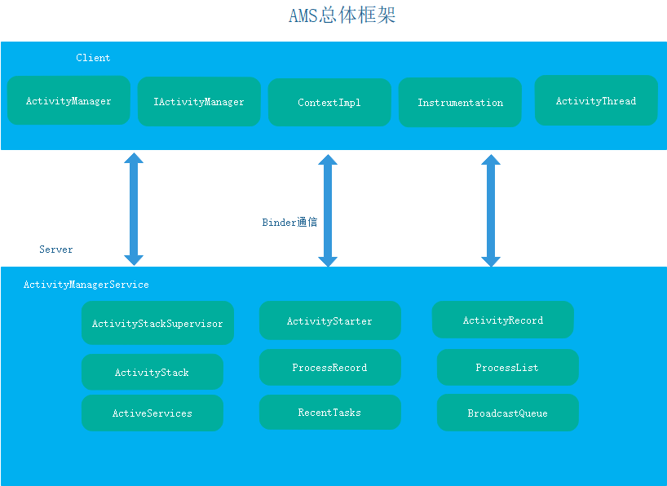

### 2 AMS的启动

AMS的启动也是在SystemServer.startBootstrapServices()中启动的

private void startBootstrapServices() {

...

// Activity manager runs the show.

traceBeginAndSlog("StartActivityManager");

mActivityManagerService = mSystemServiceManager.startService(

ActivityManagerService.Lifecycle.class).getService();

mActivityManagerService.setSystemServiceManager(mSystemServiceManager);

mActivityManagerService.setInstaller(installer);

traceEnd();

...

// Now that the power manager has been started, let the activity manager

// initialize power management features.

traceBeginAndSlog("InitPowerManagement");

mActivityManagerService.initPowerManagement();

traceEnd();

...

// Set up the Application instance for the system process and get started.

traceBeginAndSlog("SetSystemProcess");

mActivityManagerService.setSystemProcess();

traceEnd();

...

}

并且在startOtherServices() 中设置了systemReady()回调

mActivityManagerService.systemReady(()

private void startBootstrapServices() {

...

mActivityManagerService.systemReady(…)

}

启动流程图：

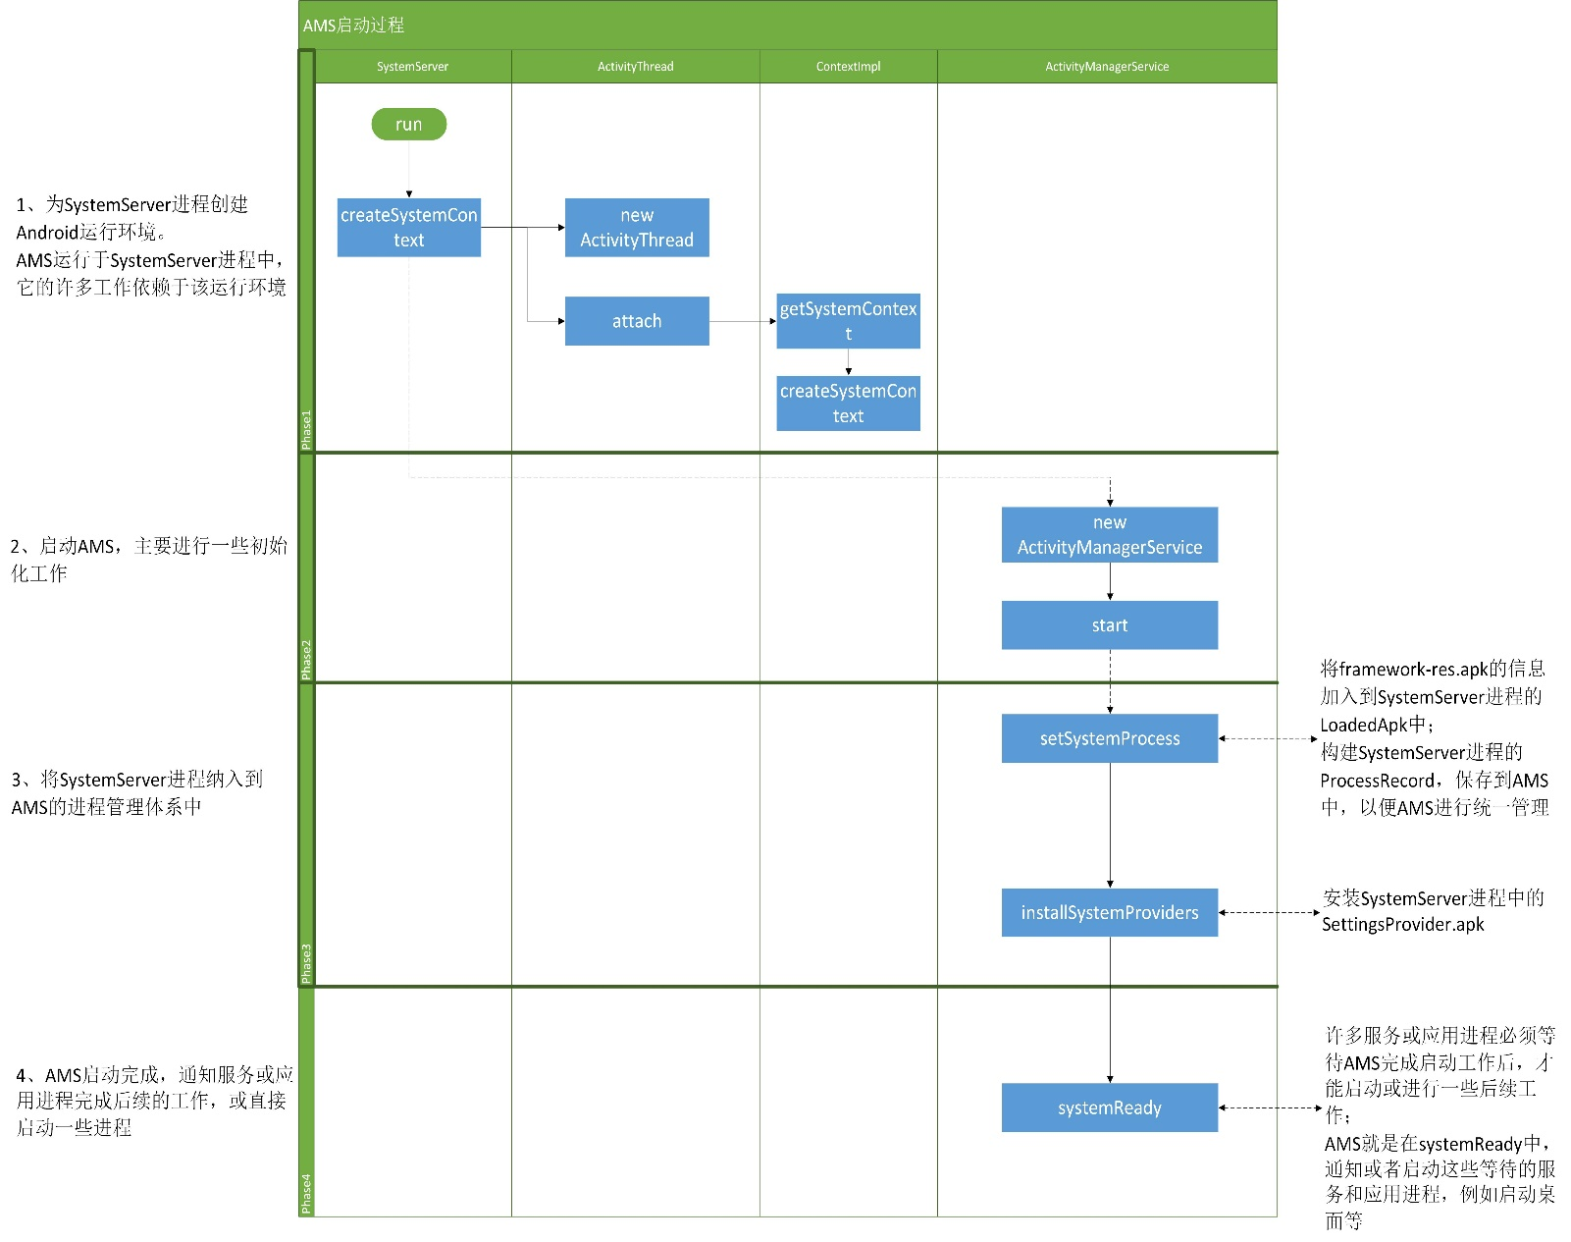

1、创建出SystemServer进程的Android运行环境。

在这一部分，SystemServer进程主要创建出对应的ActivityThread和ContextImpl，构成Android运行环境。

AMS的后续工作依赖于SystemServer在此创建出的运行环境。

2、完成AMS的初始化和启动。

在这一部分，单纯地调用AMS的构造函数和start函数，完成AMS的一些初始化工作。

3、将SystemServer进程纳入到AMS的管理体系中。

AMS作为Java世界的进程管理和调度中心，要对所有Java进程一视同仁，因此SystemServer进程也必须被AMS管理。

在这个过程中，AMS加载了SystemServer中framework-res.apk的信息，并启动和注册了SettingsProvider.apk。

4、开始执行AMS启动完毕后才能进行的工作。

系统中的一些服务和进程，必须等待AMS完成启动后，才能展开后续工作。

在这一部分，AMS通过调用systemReady函数，通知系统中的其它服务和进程，可以进行对应工作了。

在这个过程中，值得我们关注的是：Home Activity被启动了。当该Activity被加载完成后，最终会触发ACTION_BOOT_COMPLETED广播。

### 3 Activity的管理与调度

#### 1 Activity的启动

### 4 Broadcast管理

### 5 service管理

### 6 AMS进程管理

### 7 Crash处理

## 九 Android音视频系统

## 十 SystemUI与壁纸

## 十一 Android安全机制

## 十二 NDK开发

### 1 JNI编程基础

**1 基本数据类型**

下图是Java基本数据类型和本地类型的映射关系，这些基本数据类型都是可以**直接在 Native 层直接使用**的   
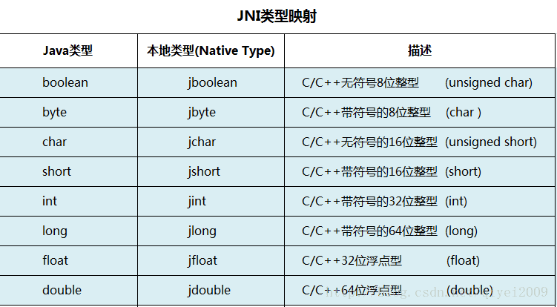

2 引用数据类型   
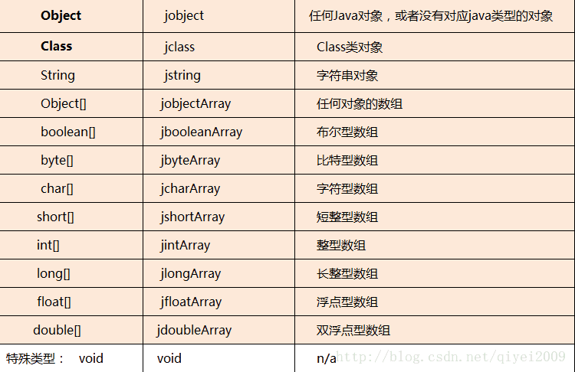

需要注意的是，在native层我们无法直接使用java对象，需要进行转化   
1）引用类型不能直接在 Native 层使用，需要根据 JNI 函数进行类型的转化后，才能使用;一般转化为Jobject 或者jclass   
2）多维数组（含二维数组）都是引用类型，需要使用 jobjectArray 类型存取其值；   
例如，二维整型数组就是指向一位数组的数组，其声明使用方式如下：

JNI方法命名规则

java_全限定类名_方法名

增加第一个参数JNIEnv*env

增加第二个参数Jobject clazz

### 2 JNI总管JNIEnv

### 3 java层调用JNI

java层：声明native方法

jni:层:jni方法

jobject 表示调用该方法的java对象

动态注册：

直接告诉 native 方法其在JNI 中对应函数的指针。通过使用 JNINativeMethod 结构来保存 Java native 方法和 JNI 函数关联关系，步骤：

先编写 Java 的 native 方法；

编写 JNI 函数的实现（函数名可以随便命名）；

利用结构体 JNINativeMethod 保存Java native方法和 JNI函数的对应关系；

利用registerNatives(JNIEnv* env)注册类的所有本地方法；

在 JNI_OnLoad 方法中调用注册方法；

在Java中通过System.loadLibrary加载完JNI动态库之后，会调用JNI_OnLoad函数，完成动态注册；

静态注册：

根据函数名建立 Java 方法和 JNI 函数的一一对应关系，静态注册的方式有两个重要的关键词 JNIEXPORT 和 JNICALL

### 4 JNI层调用java

1 访问java对象

找到该类或者对象

//查找类信息

jclass findClass(const char* name);

//返回对象的类

jclass getObjectClass(jobject obj);

2 获取方法和变量 ID

jfieldID (*GetFieldID)(JNIEnv*, jclass, const char*, const char*);

jmethodID (*GetMethodID)(JNIEnv*, jclass, const char*, const char*);

3 调用env的CallXXX()方法来实现方法的调用

env->CallVoidMethod(jobj,jmid,jsex);

env->CallStaticIntMethod

十二 匿名共享内存机制

1 匿名共享内存设备驱动

2 ashmem是一个misc设备注册到驱动中

3 扩展了Linux的内存共享机制

6 动态库 静态库

这类库的名字一般是libxxx.a，函数库的所有数据都会被整合进目标代码中。编译后的执行程序不需要外部的函数库支持，因为所有使用的函数都已经被编译进去了。当然这也会成为他的缺点，因为如果静态函数库改变了，那么你的程序必须重新编译。

这类库的名字一般是libxxx.so;相对于静态函数库，动态函数库在编译的时候 并没有被编译进目标代码中，你的程序执行到相关函数时才调用该函数库里的相应函数，因此动态函数库所产生的可执行文件比较小。由于函数库没有被整合进你的程序，而是程序运行时动态的申请并调用，所以程序的运行环境中必须提供相应的库。动态函数库的改变并不影响你的程序，所以动态函数库的升级比较方便。

# 第三部分 Android 高级开发进阶

后续博客更新步骤

3 CrashHanlder框架

高级View框架

1 – 5篇 10 – 11月份

高级技术探讨

3篇 1月 到12月

通用框架打造

1 IOC注解框架

2 图片管理框架

3 数据库框架

4 Http网络框架

4 篇 1月到2月

明年主要是架构设计

3 篇

纵向

横向

典型APP设计

## 一 Class类加载机制

### 1 java加载类的三种方式

#### 1 命令行启动时候由JVM加载

#### 2 Class.forName()加载

加载类，解析类，会执行static{}

#### 3 ClassLoader.loadClass()方法动态加载

加载类，不会解析类信息。不会执行static{}

### 2 java类加载器

#### 1 java中三种类加载器

**Bootstrap ClassLoader** ：是用C++语言实现的,最顶层的加载类，主要加载核心类库，%JRE_HOME%\lib下的rt.jar、resources.jar、charsets.jar和class等。另外需要注意的是可以通过启动jvm时指定-Xbootclasspath和路径来改变Bootstrap ClassLoader的加载目录。比如java -Xbootclasspath/a:path被指定的文件追加到默认的bootstrap路径中。我们可以打开我的电脑，在上面的目录下查看，看看这些jar包是不是存在于这个目录。   
- **Extention ClassLoader** ：扩展的类加载器，加载目录%JRE_HOME%\lib\ext目录下的jar包和class文件。还可以加载-D java.ext.dirs选项指定的目录。   
- **Appclass Loader：也称为SystemAppClass** 加载当前应用的classpath的所有类。

**加载顺序**

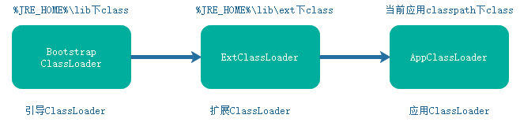

**三者引用关系**



可以看到，AppClassLoader中有一个成员变量parent用来标识父加载器，ExtClassloader类似

**ClassLoader继承关系**

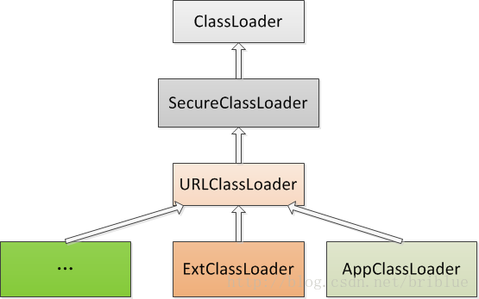

详细见这篇博客

http://blog.csdn.net/briblue/article/details/54973413

一看你就懂，超详细java中的ClassLoader详解 - frank 的专栏 - CSDN博客

#### 2 类加载的双亲委托机制

类加载的双亲委托机制是这样的

如果某个类由AppClassLoader加载，首先判断是否加载，如果加载过直接返回，否则在其父ClassLoader中ExtClassLoader中加载，如果在ExtClassLoader加载，也返回，否则在父ClassLoader中加载，如果在BootstrapClassLoad中也无法加载，再在AppClassLoader中加载。

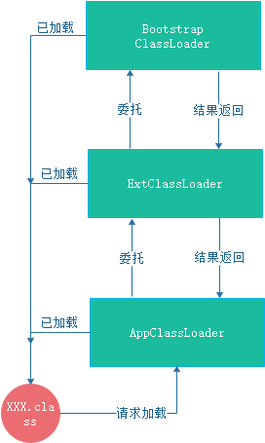

### 3 android中class加载机制

android是有java编写的，因此Class加载机制类似。不同的是ClassLoader不同。

#### 1 Android中的ClassLoader

Android中主要关心以下几种ClassLoader

BaseDexClassLoader:ClassLoader子类，完成findClass的主要逻辑

PathClassLoader：BaseDexClassLoader子类，用来加载系统和应用程序的类。它加载的类是已经安装好的Dex,或者是内部路径下data/app/目录下的dex文件以及包含dex的apk文件或jar文件

DexClassLoader: BaseDexClassLoader子类,可用于加载dex文件以及包含dex的apk文件或jar文件，也支持从SD卡进行加载，这也就意味着DexClassLoader可以在应用未安装的情况下加载dex相关文件。

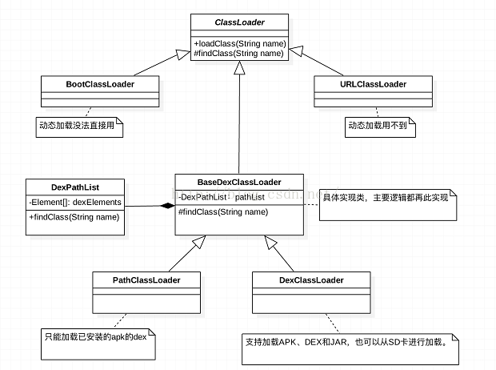

**DexClassLoader是热修复等技术的基础。**

另外，关于DexClassLoader和PathClassLoader的区别，主要在构造方法中optimizedDirectory参数是否可以为NULL

由于这两者的父类都是BaseDexClassLoader，因此就是该类的optimizedDirectory

public BaseDexClassLoader(String dexPath, File optimizedDirectory,

String librarySearchPath, ClassLoader parent) {

super(parent);

this.pathList = new DexPathList(this, dexPath, librarySearchPath, optimizedDirectory);

}

## 二 热修复技术探讨及开源框架

### 1 热修复技术介绍

Sophix与业界主流热修复技术对比

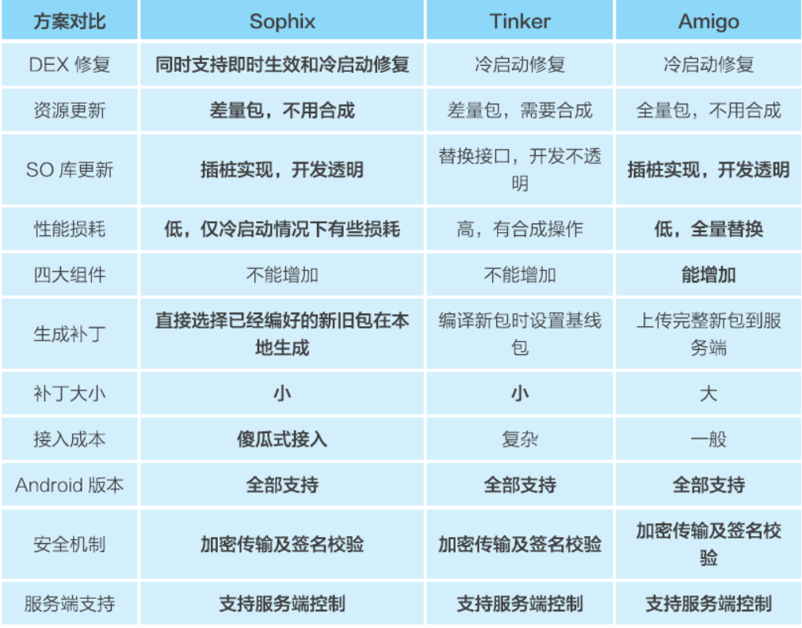

### 2 class热修复技术

class热修复一般有两种

1底层替换方法：虚拟机中替换方法，限制多，但是时效性快，轻量级，但是不用冷启动

例如Andfix。Sophix采用的是替换整个ArtMethod数组

2类加载替换方案:时效性差，需要冷启动，但是修复范围广，限制少

类加载方案包括全量替换(Thinker)，差分替换(QQ空间超级补丁)，优缺点如下：

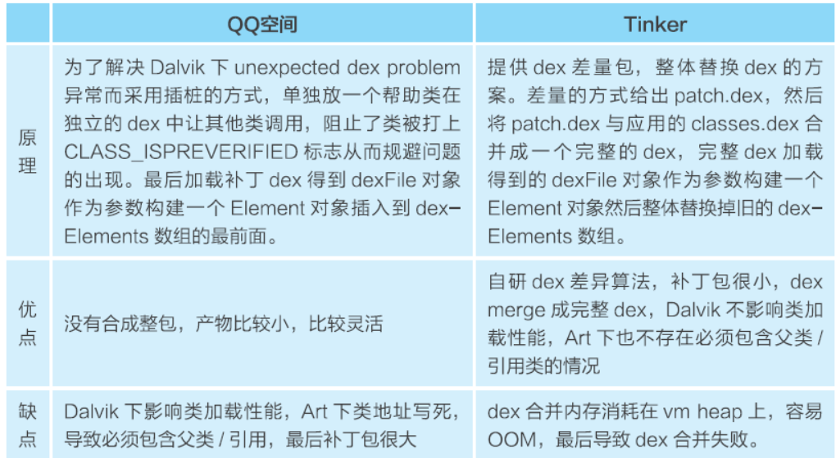

SopHix方案：

Dalvik:自研的全量dex方案，去除原来dex中在补丁dex中的类，然后再合成

ART：把补丁包作为主dex classex.dex即可(art下支持多dex加载)

### 3 资源热修复技术

大部分资源修复方案参考了installRun方案

installRun方案：

1构造一个AssetManager 反射调用addAssetPath(),将资源添加到该

AssetManager对象中

2 找到之前所有引用AssetManager的地方，反射替换为新的AssetManager对象

sopfix:

构造新的资源包(差分包 id 0x66)，然后添加到原来AssetManager的path中

### 4 so库热修复技术

本质：对Native方法的修复和替换

sophix:

反射将补丁so库插入到nativeLibraryDirectories数组的最前面，就能达到加载so库就会加载补丁的so库

### 5 几种热修复方案对比

## 三 插件化技术探讨

## 四 插件式换肤技术探讨

## 五 Android APK增量更新技术

# 第六部分 开源框架原理解析

## 一 OKHTTP

### 1 总体结构与总体流程

#### 1 OkHttp整体结构

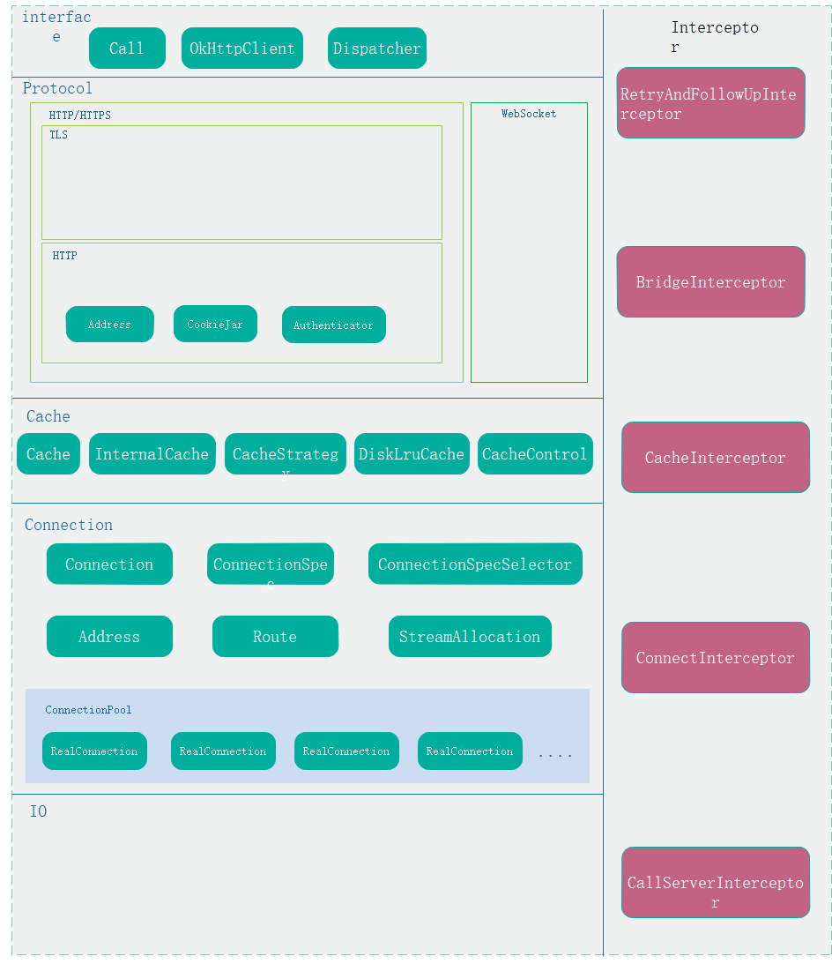

#### 2 OkHttp整体流程图

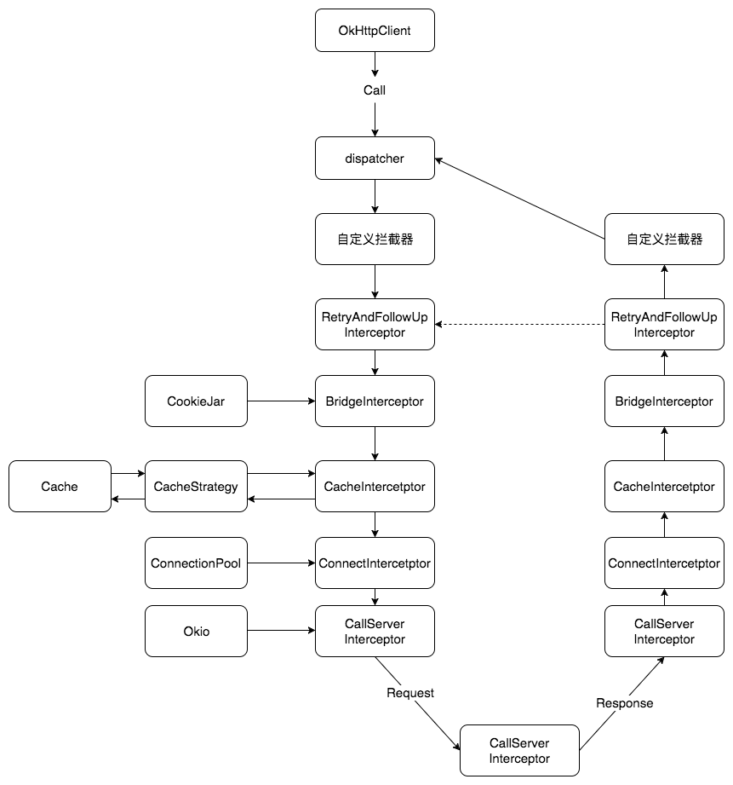

### 2 Dispatcher与线程池

上面介绍了OkHttp的总体流程，接下来我们看一下Dispatcher分发与线程池

我们都知道，Call最终回忆RealCall的形式调用到RealCall中的以下两个方法

@Override

public Response execute() throws IOException {

….

try {

client.dispatcher().executed(this);

Response result = getResponseWithInterceptorChain();

….

} catch (IOException e) {

eventListener.callFailed(this, e);

throw e;

} finally {

client.dispatcher().finished(this);

}

}

@Override public void enqueue(Callback responseCallback) {

…..

client.dispatcher().enqueue(new AsyncCall(responseCallback));

}

可以看到最终都会调用到Dispatcher的相关方法中。

Dispatcher相关介绍如下

#### 1 线程池

Dispatcher中有一个线程池，默认实现为：

private @Nullable ExecutorService executorService;

…..

public synchronized ExecutorService executorService() {

if (executorService == null) {

executorService = new ThreadPoolExecutor(0, Integer.MAX_VALUE, 60, TimeUnit.SECONDS,

new SynchronousQueue<Runnable>(), Util.threadFactory("OkHttp Dispatcher", false));

}

return executorService;

}

从上面可以看到，线程池的核心线程为0，最大允许线程为Integer.MAX_VALUE，线程保活为60秒，线程队列为同步队列，按照先后顺序执行。

(1)SynchronousQueue每个插入操作必须等待另一个线程的移除操作，同样任何一个移除操作都等待另一个线程的插入操作。因此队列内部其实没有任何一个元素，或者说容量为0，严格说并不是一种容器，由于队列没有容量，因此不能调用peek等操作，因此只有移除元素才有元素，显然这是一种快速传递元素的方式，也就是说在这种情况下元素总是以最快的方式从插入者(生产者)传递给移除者(消费者),这在多任务队列中最快的处理任务方式。对于高频请求场景，无疑是最合适的。

(2)在OKHttp中，创建了一个阀值是Integer.MAX_VALUE的线程池，它不保留任何最小线程，随时创建更多的线程数，而且如果线程空闲后，只能多活60秒。所以也就说如果收到20个并发请求，线程池会创建20个线程，当完成后的60秒后会自动关闭所有20个线程。他这样设计成不设上限的线程，以保证I/O任务中高阻塞低占用的过程，不会长时间卡在阻塞上。

#### 2 同步队列与异步队列

Dispatcher中一共有三个队列，如下：

/** Running synchronous calls. Includes canceled calls that haven't finished yet. */

private final Deque<RealCall> runningSyncCalls = new ArrayDeque<>();

维护着同步请求，会将同步请求加入到该队列中。

/** Ready async calls in the order they'll be run. */

private final Deque<AsyncCall> readyAsyncCalls = new ArrayDeque<>();

/** Running asynchronous calls. Includes canceled calls that haven't finished yet. */

private final Deque<AsyncCall> runningAsyncCalls = new ArrayDeque<>();

两个异步Call队列,一个表示正在运行，一个表示将要运行。正在运行的Call，同一个url不能超过5个。

#### 3 同步Call的调度过程

同步Call在OkHttp中就是RealCall，调度过程如下：

1. RealCall中execute()调用Disptacher

client.dispatcher().executed(this);

1. Dispatcher中executed调用如下

/** Used by {@code Call#execute} to signal it is in-flight. */

synchronized void executed(RealCall call) {

runningSyncCalls.add(call);

}

可以看到，这里并没有真正的执行RealCall，只是将其加入到队列中，做一个记录。正在执行RealCall是RealCall# getResponseWithInterceptorChain()

1. RealCall中结束Call

client.dispatcher().finished(this);

1. Dispatcher中移除runningSyncCalls中的call

/** Used by {@code Call#execute} to signal completion. */

void finished(RealCall call) {

finished(runningSyncCalls, call, false);

}

private <T> void finished(Deque<T> calls, T call, boolean promoteCalls) {

int runningCallsCount;

Runnable idleCallback;

synchronized (this) {

if (!calls.remove(call)) throw new AssertionError("Call wasn't in-flight!");

if (promoteCalls) promoteCalls();

runningCallsCount = runningCallsCount();

idleCallback = this.idleCallback;

}

if (runningCallsCount == 0 && idleCallback != null) {

idleCallback.run();

}

}

至此，同步请求RealCall的调度完成。

#### 4 异步Call的调度过程

异步Call AsyncCall本质是一个Runnable对象，其实现了父类NamedRunnable的抽象方法execute()

final class AsyncCall extends NamedRunnable {

….

@Override protected void execute() {

…..

}

}

因此AsyncCall是一个可以加入到线程池中的Task。

(1) RealCall中execute()调用Disptacher

构造AsyncCall并调用Disptacher的enqueue()方法

@Override public void enqueue(Callback responseCallback) {

synchronized (this) {

if (executed) throw new IllegalStateException("Already Executed");

executed = true;

}

captureCallStackTrace();

eventListener.callStart(this);

client.dispatcher().enqueue(new AsyncCall(responseCallback));

}

(2) Dispatcher中enqueue()将AsyncCall入队

synchronized void enqueue(AsyncCall call) {

if (runningAsyncCalls.size() < maxRequests && runningCallsForHost(call) < maxRequestsPerHost) {

runningAsyncCalls.add(call);

executorService().execute(call);

} else {

readyAsyncCalls.add(call);

}

}

如果满足条件，那么就直接把AsyncCall直接加到runningCalls的队列中，并在线程池中执行（线程池会根据当前负载自动创建，销毁，缓存相应的线程）。反之就放入readyAsyncCalls进行缓存等待。

runningAsyncCalls.size() < maxRequests 表示当前正在运行的AsyncCall是否小于maxRequests = 64

runningCallsForHost(call) < maxRequestsPerHos 表示同一个地址访问的AsyncCall是否小于maxRequestsPerHost = 5;

即 当前正在并发的请求不能超过64且同一个地址的访问不能超过5个

**如果可以入runningAsyncCalls队列，那么会依次执行下面的(3)(4)(5)**

**如果没法入runningAsyncCalls队列，那么久加入readyAsyncCalls队列。说明runningAsyncCalls已满，必须等待其runningAsyncCalls队列中task执行完毕，才能执行。runningAsyncCalls会在(5)中将readyAsyncCalls的task执行。**

(3) 如果可以入runningAsyncCalls队，那么执行其AsyncCall# execute()方法，如下：

@Override protected void execute() {

boolean signalledCallback = false;

try {

Response response = getResponseWithInterceptorChain();

if (retryAndFollowUpInterceptor.isCanceled()) {

signalledCallback = true;

responseCallback.onFailure(RealCall.this, new IOException("Canceled"));

} else {

signalledCallback = true;

responseCallback.onResponse(RealCall.this, response);

}

} catch (IOException e) {

if (signalledCallback) {

// Do not signal the callback twice!

Platform.get().log(INFO, "Callback failure for " + toLoggableString(), e);

} else {

eventListener.callFailed(RealCall.this, e);

responseCallback.onFailure(RealCall.this, e);

}

} finally {

client.dispatcher().finished(this);

}

}

首先调用RealCall#getResponseWithInterceptorChain()获取响应，这里后续再细说。然后执行下一步

(4) AsyncCall中调用client.dispatcher().finished(this)结束AsyncCall

最终会调用到finished(AsyncCall call)

/** Used by {@code AsyncCall#run} to signal completion. */

void finished(AsyncCall call) {

finished(runningAsyncCalls, call, true);

}

private <T> void finished(Deque<T> calls, T call, boolean promoteCalls) {

int runningCallsCount;

Runnable idleCallback;

synchronized (this) {

if (!calls.remove(call)) throw new AssertionError("Call wasn't in-flight!");

if (promoteCalls) promoteCalls();

runningCallsCount = runningCallsCount();

idleCallback = this.idleCallback;

}

if (runningCallsCount == 0 && idleCallback != null) {

idleCallback.run();

}

}

由于这里传入的promoteCalls参数为true，因此会调用到promoteCalls()

1. Diapatcher中调用promoteCalls()将readyAsync变成runningAsync。

private void promoteCalls() {

if (runningAsyncCalls.size() >= maxRequests) return; // Already running max capacity.

if (readyAsyncCalls.isEmpty()) return; // No ready calls to promote.

for (Iterator<AsyncCall> i = readyAsyncCalls.iterator(); i.hasNext(); ) {

AsyncCall call = i.next();

if (runningCallsForHost(call) < maxRequestsPerHost) {

i.remove();

runningAsyncCalls.add(call);

executorService().execute(call);

}

if (runningAsyncCalls.size() >= maxRequests) return; // Reached max capacity.

}

}

可以看到Diapatcher中将取出readyAsyncCalls中task执行。这样readyAsyncCalls的Call就会得到执行，然后会重复(3)(4)(5)这个过程。

这样异步请求AsyncCall的调度也完成了。

流程如下：

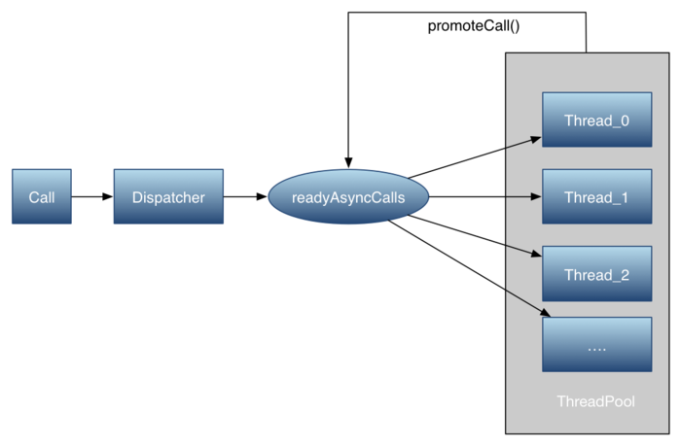

#### 5 Dispatcher总结

1. 同步调度总结

同步调度在Dispatcher中主要是用了一个队列来记录RealCall，并没有做真正的执行。

2. 异步调度总结

所以简单的描述下异步调度为：如果当前还能可以执行异步任务，则入队，并立即执行，否则加入readyAsyncCalls队列，当一个请求执行完毕后，会调用promoteCalls()，来把readyAsyncCalls队列中的Async移出来并加入到runningAsyncCalls，并开始执行。然后在当前线程中去执行Call的getResponseWithInterceptorChain（）方法，直接获取当前的返回数据Response

3. 对比同步和异步任务

我们会发现:同步请求和异步请求原理都是一样的，都是在getResponseWithInterceptorChain()函数通过Interceptor链条来实现网络请求逻辑，而异步任务则通过ExecutorService来实现的。PS:在Dispatcher中添加一个封装了Callback的Call的匿名内部类AsyncCall来执行当前 的Call。这个AsyncCall是Call的匿名内部类。AsyncCall的execute方法仍然会回调到Call的 getResponseWithInterceptorChain方法来完成请求，同时将返回数据或者状态通过Callback来完成。

### 3 InterceptorChain及链式调用过程

#### 1 几大拦截器的调用流程

入口：

RealCall的getResponseWithInterceptorChain()中

Interceptor.Chain chain = new RealInterceptorChain(interceptors, null, null, null, 0,

originalRequest, this, eventListener, client.connectTimeoutMillis(),

client.readTimeoutMillis(), client.writeTimeoutMillis());

return chain.proceed(originalRequest);

其中interceptors添加了各种拦截器，传入的request,Call等。然后在RealInterceptorChain的proceed方法中：

@Override

public Response proceed(Request request) throws IOException {

return proceed(request, streamAllocation, httpCodec, connection);

}

转到

public Response proceed(Request request, StreamAllocation streamAllocation, HttpCodec httpCodec,

RealConnection connection) throws IOException

这里面会调用：

// Call the next interceptor in the chain.

RealInterceptorChain next = new RealInterceptorChain(interceptors, streamAllocation, httpCodec,

connection, index + 1, request, call, eventListener, connectTimeout, readTimeout,

writeTimeout);

Interceptor interceptor = interceptors.get(index);

Response response = interceptor.intercept(next);

其中interceptors等参数都是是RealCall中传来的，第一次index是0，现在加了1，然后在new了一个RealInterceptorChain对象了。然后Interceptor interceptor = interceptors.get(index);如果client没有添加，就调用的是RetryAndFollowUpInterceptor了。

RetryAndFollowUpInterceptor中代码如下：

@Override

public Response intercept(Chain chain) throws IOException {

Request request = chain.request();

RealInterceptorChain realChain = (RealInterceptorChain) chain;

Call call = realChain.call();

EventListener eventListener = realChain.eventListener();

StreamAllocation streamAllocation = new StreamAllocation(client.connectionPool(),

createAddress(request.url()), call, eventListener, callStackTrace);

this.streamAllocation = streamAllocation;

….

while (true) {

….

Response response;

boolean releaseConnection = true;

try {

response = realChain.proceed(request, streamAllocation, null, null);

releaseConnection = false;

} catch (RouteException e) {

……

}

}

可以看到，又跳转到了RealInterceptorChain的proceed(Request request, StreamAllocation streamAllocation, HttpCodec httpCodec,RealConnection connection)方法。

不过此时的realChain对象是第一次在RealInterceptorChain中new的RealInterceptorChain对象next。注意此时的index是1了。那么继续RealInterceptorChain# proceed(Request request, StreamAllocation streamAllocation, HttpCodec httpCodec,RealConnection connection)流程。

// Call the next interceptor in the chain.

RealInterceptorChain next = new RealInterceptorChain(interceptors, streamAllocation, httpCodec,

connection, index + 1, request, call, eventListener, connectTimeout, readTimeout,

writeTimeout);

Interceptor interceptor = interceptors.get(index);

Response response = interceptor.intercept(next);

可以看到index是1了，再次创建了一个next对象，并且传入的index参数是2.这时获取的interceptor

对象就是BridgeInterceptor对象了。我们直接来看BridgeInterceptor的intercept(Chain chain)方法。

先不管BridgeInterceptor的intercept(Chain chain)的其他工作，先来看这一段代码

@Override public Response intercept(Chain chain) throws IOException {

….

Response networkResponse = chain.proceed(requestBuilder.build());

….

}

可以看到，又跳转到了RealInterceptorChain#proceed(Request request)，最终还是跳转到了RealInterceptorChain的proceed(Request request, StreamAllocation streamAllocation, HttpCodec httpCodec,RealConnection connection)方法。只是此时的RealInterceptorChain是第二次创建的next对象:index是2…..

这样，OkHttp的拦截器链就是这样一步一步的调用的，最终会调用到CallServerInterceptor#intercept(Chain chain)中去。

注意：在RealCall#getResponseWithInterceptorChain()中有这样一段代码：

ist<Interceptor> interceptors = new ArrayList<>();

interceptors.addAll(client.interceptors());

interceptors.add(retryAndFollowUpInterceptor);

interceptors.add(new BridgeInterceptor(client.cookieJar()));

interceptors.add(new CacheInterceptor(client.internalCache()));

interceptors.add(new ConnectInterceptor(client));

…..

可以看到OkHttp总是把我们自己的拦截器添加到list的最前面。

#### 2 RetryAndFollowUpInterceptor

RetryAndFollowUpInterceptor拦截器主要用作失败重试和处理重定向相关的工作，核心在intercept(Chain chain)方法

@Override public Response intercept(Chain chain) throws IOException {

Request request = chain.request();

RealInterceptorChain realChain = (RealInterceptorChain) chain;

Call call = realChain.call();

EventListener eventListener = realChain.eventListener();

StreamAllocation streamAllocation = new StreamAllocation(client.connectionPool(),

createAddress(request.url()), call, eventListener, callStackTrace);

this.streamAllocation = streamAllocation;

int followUpCount = 0;

Response priorResponse = null;

while (true) {

if (canceled) {

streamAllocation.release();

throw new IOException("Canceled");

}

Response response;

boolean releaseConnection = true;

try {

response = realChain.proceed(request, streamAllocation, null, null);

releaseConnection = false;

} catch (RouteException e) {

// The attempt to connect via a route failed. The request will not have been sent.

if (!recover(e.getLastConnectException(), streamAllocation, false, request)) {

throw e.getLastConnectException();

}

releaseConnection = false;

continue;

} catch (IOException e) {

// An attempt to communicate with a server failed. The request may have been sent.

boolean requestSendStarted = !(e instanceof ConnectionShutdownException);

if (!recover(e, streamAllocation, requestSendStarted, request)) throw e;

releaseConnection = false;

continue;

} finally {

// We're throwing an unchecked exception. Release any resources.

if (releaseConnection) {

streamAllocation.streamFailed(null);

streamAllocation.release();

}

}

// Attach the prior response if it exists. Such responses never have a body.

if (priorResponse != null) {

response = response.newBuilder()

.priorResponse(priorResponse.newBuilder()

.body(null)

.build())

.build();

}

Request followUp = followUpRequest(response, streamAllocation.route());

if (followUp == null) {

if (!forWebSocket) {

streamAllocation.release();

}

return response;

}

closeQuietly(response.body());

if (++followUpCount > MAX_FOLLOW_UPS) {

streamAllocation.release();

throw new ProtocolException("Too many follow-up requests: " + followUpCount);

}

if (followUp.body() instanceof UnrepeatableRequestBody) {

streamAllocation.release();

throw new HttpRetryException("Cannot retry streamed HTTP body", response.code());

}

if (!sameConnection(response, followUp.url())) {

streamAllocation.release();

streamAllocation = new StreamAllocation(client.connectionPool(),

createAddress(followUp.url()), call, eventListener, callStackTrace);

this.streamAllocation = streamAllocation;

} else if (streamAllocation.codec() != null) {

throw new IllegalStateException("Closing the body of " + response

+ " didn't close its backing stream. Bad interceptor?");

}

request = followUp;

priorResponse = response;

}

}

里面有一个while循环，重试和重定向等都是在循环里面发生的。

可以看到当发生RouteException 和IOException并且

recover(e.getLastConnectException(), streamAllocation, false, request)和recover(e, streamAllocation, requestSendStarted, request)为true时就会重新发起链接。我们接下来看recover方法。

/**

* Report and attempt to recover from a failure to communicate with a server. Returns true if

* {@code e} is recoverable, or false if the failure is permanent. Requests with a body can only

* be recovered if the body is buffered or if the failure occurred before the request has been

* sent.

*/

private boolean recover(IOException e, StreamAllocation streamAllocation,

boolean requestSendStarted, Request userRequest) {

streamAllocation.streamFailed(e);

// The application layer has forbidden retries.

if (!client.retryOnConnectionFailure()) return false;

// We can't send the request body again.

if (requestSendStarted && userRequest.body() instanceof UnrepeatableRequestBody) return false;

// This exception is fatal.

if (!isRecoverable(e, requestSendStarted)) return false;

// No more routes to attempt.

if (!streamAllocation.hasMoreRoutes()) return false;

// For failure recovery, use the same route selector with a new connection.

return true;

}

可以看到，有以下几种情况不重试，其他都要重试

* 应用层禁止重试
* request请求出错，不重试
* 返回的异常无法恢复，不重试
* 没有更多连接可供选择也不重试

另外在拦截器中我们看到，如果followUpRequest(response, streamAllocation.route());不为null表示重定向，也需要进行重新连接。

我们来看followUpRequest的代码

/**

* Figures out the HTTP request to make in response to receiving {@code userResponse}. This will

* either add authentication headers, follow redirects or handle a client request timeout. If a

* follow-up is either unnecessary or not applicable, this returns null.

*/

private Request followUpRequest(Response userResponse, Route route) throws IOException {

if (userResponse == null) throw new IllegalStateException();

int responseCode = userResponse.code();

final String method = userResponse.request().method();

switch (responseCode) {

case HTTP_PROXY_AUTH:

Proxy selectedProxy = route != null

? route.proxy()

: client.proxy();

if (selectedProxy.type() != Proxy.Type.HTTP) {

throw new ProtocolException("Received HTTP_PROXY_AUTH (407) code while not using proxy");

}

return client.proxyAuthenticator().authenticate(route, userResponse);

case HTTP_UNAUTHORIZED:

return client.authenticator().authenticate(route, userResponse);

case HTTP_PERM_REDIRECT:

case HTTP_TEMP_REDIRECT:

// "If the 307 or 308 status code is received in response to a request other than GET

// or HEAD, the user agent MUST NOT automatically redirect the request"

if (!method.equals("GET") && !method.equals("HEAD")) {

return null;

}

// fall-through

case HTTP_MULT_CHOICE:

case HTTP_MOVED_PERM:

case HTTP_MOVED_TEMP:

case HTTP_SEE_OTHER:

// Does the client allow redirects?

if (!client.followRedirects()) return null;

String location = userResponse.header("Location");

if (location == null) return null;

HttpUrl url = userResponse.request().url().resolve(location);

// Don't follow redirects to unsupported protocols.

if (url == null) return null;

// If configured, don't follow redirects between SSL and non-SSL.

boolean sameScheme = url.scheme().equals(userResponse.request().url().scheme());

if (!sameScheme && !client.followSslRedirects()) return null;

// Most redirects don't include a request body.

Request.Builder requestBuilder = userResponse.request().newBuilder();

if (HttpMethod.permitsRequestBody(method)) {

final boolean maintainBody = HttpMethod.redirectsWithBody(method);

if (HttpMethod.redirectsToGet(method)) {

requestBuilder.method("GET", null);

} else {

RequestBody requestBody = maintainBody ? userResponse.request().body() : null;

requestBuilder.method(method, requestBody);

}

if (!maintainBody) {

requestBuilder.removeHeader("Transfer-Encoding");

requestBuilder.removeHeader("Content-Length");

requestBuilder.removeHeader("Content-Type");

}

}

// When redirecting across hosts, drop all authentication headers. This

// is potentially annoying to the application layer since they have no

// way to retain them.

if (!sameConnection(userResponse, url)) {

requestBuilder.removeHeader("Authorization");

}

return requestBuilder.url(url).build();

case HTTP_CLIENT_TIMEOUT:

// 408's are rare in practice, but some servers like HAProxy use this response code. The

// spec says that we may repeat the request without modifications. Modern browsers also

// repeat the request (even non-idempotent ones.)

if (!client.retryOnConnectionFailure()) {

// The application layer has directed us not to retry the request.

return null;

}

if (userResponse.request().body() instanceof UnrepeatableRequestBody) {

return null;

}

if (userResponse.priorResponse() != null

&& userResponse.priorResponse().code() == HTTP_CLIENT_TIMEOUT) {

// We attempted to retry and got another timeout. Give up.

return null;

}

if (retryAfter(userResponse, 0) > 0) {

return null;

}

return userResponse.request();

case HTTP_UNAVAILABLE:

if (userResponse.priorResponse() != null

&& userResponse.priorResponse().code() == HTTP_UNAVAILABLE) {

// We attempted to retry and got another timeout. Give up.

return null;

}

if (retryAfter(userResponse, Integer.MAX_VALUE) == 0) {

// specifically received an instruction to retry without delay

return userResponse.request();

}

return null;

default:

return null;

}

}

主要是一些HTTP状态码的相关处理，有关这一部分的详细细节不做解释

#### 3 BridgeInterceptor

第二个执行的拦截器是BridgeInterceptor，这个拦截器主要执行的是一些和HTTP协议相关的内容，例如对HTTP头的处理以及cookie的管理

@Override public Response intercept(Chain chain) throws IOException {

Request userRequest = chain.request();

Request.Builder requestBuilder = userRequest.newBuilder();

RequestBody body = userRequest.body();

if (body != null) {

MediaType contentType = body.contentType();

if (contentType != null) {

requestBuilder.header("Content-Type", contentType.toString());

}

long contentLength = body.contentLength();

if (contentLength != -1) {

requestBuilder.header("Content-Length", Long.toString(contentLength));

requestBuilder.removeHeader("Transfer-Encoding");

} else {

requestBuilder.header("Transfer-Encoding", "chunked");

requestBuilder.removeHeader("Content-Length");

}

}

if (userRequest.header("Host") == null) {

requestBuilder.header("Host", hostHeader(userRequest.url(), false));

}

if (userRequest.header("Connection") == null) {

requestBuilder.header("Connection", "Keep-Alive");

}

// If we add an "Accept-Encoding: gzip" header field we're responsible for also decompressing

// the transfer stream.

boolean transparentGzip = false;

if (userRequest.header("Accept-Encoding") == null && userRequest.header("Range") == null) {

transparentGzip = true;

requestBuilder.header("Accept-Encoding", "gzip");

}

List<Cookie> cookies = cookieJar.loadForRequest(userRequest.url());

if (!cookies.isEmpty()) {

requestBuilder.header("Cookie", cookieHeader(cookies));

}

if (userRequest.header("User-Agent") == null) {

requestBuilder.header("User-Agent", Version.userAgent());

}

Response networkResponse = chain.proceed(requestBuilder.build());

HttpHeaders.receiveHeaders(cookieJar, userRequest.url(), networkResponse.headers());

Response.Builder responseBuilder = networkResponse.newBuilder()

.request(userRequest);

if (transparentGzip

&& "gzip".equalsIgnoreCase(networkResponse.header("Content-Encoding"))

&& HttpHeaders.hasBody(networkResponse)) {

GzipSource responseBody = new GzipSource(networkResponse.body().source());

Headers strippedHeaders = networkResponse.headers().newBuilder()

.removeAll("Content-Encoding")

.removeAll("Content-Length")

.build();

responseBuilder.headers(strippedHeaders);

String contentType = networkResponse.header("Content-Type");

responseBuilder.body(new RealResponseBody(contentType, -1L, Okio.buffer(responseBody)));

}

return responseBuilder.build();

}

主要做了以下几件事

1 对request添加 Content-Type Content-Length Host 等并设置Connection 为Keep-Alive。

2 设置支持header支持gzip压缩，Accept-Encoding = gzip 并对返回的响应做相应处理

3 设置Header的User-Agent 为okhttp对应版本

4 通过CookieJar管理Http的cookie。

cookie管理如下：

将okhttpclient中的CookieJar传递过来。OKHttp默认的CookieJar是CookieJar.NO_COOKIES。需要开发者自己去实现响应的CookieJar。其定义如下：

public interface CookieJar {

/**

* Saves {@code cookies} from an HTTP response to this store according to this jar's policy.

*

* <p>Note that this method may be called a second time for a single HTTP response if the response

* includes a trailer. For this obscure HTTP feature, {@code cookies} contains only the trailer's

* cookies.

*/

void saveFromResponse(HttpUrl url, List<Cookie> cookies);

/**

* Load cookies from the jar for an HTTP request to {@code url}. This method returns a possibly

* empty list of cookies for the network request.

*

* <p>Simple implementations will return the accepted cookies that have not yet expired and that

* {@linkplain Cookie#matches match} {@code url}.

*/

List<Cookie> loadForRequest(HttpUrl url);

}

开发者自己实现CookieJar，复写响应的方法，分别对应保存cookie和加载cookie

在BridgeInterceptor request时判断是否有cookie，如果有就添加到Header中

List<Cookie> cookies = cookieJar.loadForRequest(userRequest.url());

if (!cookies.isEmpty()) {

requestBuilder.header("Cookie", cookieHeader(cookies));

}

接着对响应的cookie进行存储

Response networkResponse = chain.proceed(requestBuilder.build());

HttpHeaders.receiveHeaders(cookieJar, userRequest.url(), networkResponse.headers());

总结 BridgeInterceptor主要的工作就是处理HTTP请求的Request 和Response的Header。主要包括Content-Type Content-Length Host Connection 以及Cookie等

其他几个拦截器留到后面讲

### 4 缓存策略

接下讲解OkHttp的缓存，缓存的主要逻辑是由CacheInterceptor实现的。OkHttp的缓存其实就是HTTP缓存，不过它是通过Okio来实现的。所以先介绍Okio和Http缓存

#### 1 Okio简介

略，后面介绍

#### 2 HTTP缓存

HTTP为了加宽请求速度，减少不必要的访问请求，有一个缓存机制。改缓存机制主要是HTTP请求Header中不同的标志位，一般有以下几种

**Expires**

响应头，后面会跟一个时间值。用来告诉客户端该资源在什么时候过期。当客户端需要再次请求相同资源时先比较其过期时间，如果尚未超过过期时间则直接返回缓存结果，如果已经超过则重新请求。

注：HTTP1.1使用Cache-Control代替了。

**Cache-Control**

相对值，单位秒。表示当前资源的有效期。Cache-Control比Expires优先级更高

Cache-Control:max-age=31536000,public

条件请求

主要涉及以下几个Header

**Last-Modified**

响应头，后面跟日期。用于告诉客户端资源最后被修改的日期。

Last-Modified: Tue, 12 Jan 2016 09:31:27 GMT

**If-Modified-Since**

请求头，后面跟日期。客户端发该请求，服务器收到请求后发现有If-Modified-Since则与被请求资源的最后修改时间进行对比。若资源的最后修改时间大于If-Modified-Since，说明资源又被改动过，则响应整个内容，返回状态码是200.如果资源的最后修改时间小于或者等于If-Modified-Since，说明资源没有修改，则响应状态码为304，告诉客户端继续使用cache.

If-Modified-Since: Tue, 12 Jan 2016 09:31:27 GMT

但是由于客户端与服务器时间若不同步，则也会造成一定的误差。

**ETag**

ETag是对资源文件的一种摘要，可以通过ETag值来判断文件是否有修改。

当客户端第一次请求某资源时，服务器返回：

ETag: "5694c7ef-24dc"

客户端再次请求时，可在头部加上如下域：

If-None-Match: "5694c7ef-24dc"

如果文件并未改变，则服务器返回304告知客户端可以复用本地缓存

**no-cache/no-store**

不使用缓存

**only-if-cached**

只使用缓存

以上就是HTTP的缓存策略，可以看到HTTP的缓存主要是通过请求Header与Response的Header来实现的。

#### 3 OkHttp缓存策略

OKHttp的缓存主要涉及到以下几个类：

InternalCache:内部缓存类，可以看做Cache操作的内部类，Cache主要用于上层设置缓存策略，InternalCache用于OkHttp内部操作。

默认不设置Cache时，InternalCache为null,当OkHttp设置了Cache时，CacheInterceptor中的cache变量就是Cache中的InternalCache。因此在CacheInterceptor中对cache的操作转变Cache的操作，有关这一细节在Cache中可以看到。

这个主要是操作缓存细节，后续再讲，还涉及到DiskLruCache及CacheControl

CacheStrategy:缓存策略类，主要负责缓存的管理及策略

缓存的思路很简单：就是根据HTTP缓存来操作，详细可以参考CacheStrategy,里面就是标准的HTTP请求与缓存处理。

缓存算法是LRU，采用的是DiskLruCache缓存到本地

#### 4 OkHttp缓存流程

当OkHttp设置了Cache时。主要创建Cache对象设置进去。

public Cache(File directory, long maxSize) {

this(directory, maxSize, FileSystem.SYSTEM);

}

该流程主要由CacheInterceptor控制，主要在intercept(Chain chain)方法中

@Override public Response intercept(Chain chain) throws IOException {

Response cacheCandidate = cache != null

? cache.get(chain.request())

: null;

long now = System.currentTimeMillis();

CacheStrategy strategy = new CacheStrategy.Factory(now, chain.request(), cacheCandidate).get();

Request networkRequest = strategy.networkRequest;

Response cacheResponse = strategy.cacheResponse;

if (cache != null) {

cache.trackResponse(strategy);

}

if (cacheCandidate != null && cacheResponse == null) {

closeQuietly(cacheCandidate.body()); // The cache candidate wasn't applicable. Close it.

}

// If we're forbidden from using the network and the cache is insufficient, fail.

if (networkRequest == null && cacheResponse == null) {

return new Response.Builder()

.request(chain.request())

.protocol(Protocol.HTTP_1_1)

.code(504)

.message("Unsatisfiable Request (only-if-cached)")

.body(Util.EMPTY_RESPONSE)

.sentRequestAtMillis(-1L)

.receivedResponseAtMillis(System.currentTimeMillis())

.build();

}

// If we don't need the network, we're done.

if (networkRequest == null) {

return cacheResponse.newBuilder()

.cacheResponse(stripBody(cacheResponse))

.build();

}

Response networkResponse = null;

try {

networkResponse = chain.proceed(networkRequest);

} finally {

// If we're crashing on I/O or otherwise, don't leak the cache body.

if (networkResponse == null && cacheCandidate != null) {

closeQuietly(cacheCandidate.body());

}

}

// If we have a cache response too, then we're doing a conditional get.

if (cacheResponse != null) {

if (networkResponse.code() == HTTP_NOT_MODIFIED) {

Response response = cacheResponse.newBuilder()

.headers(combine(cacheResponse.headers(), networkResponse.headers()))

.sentRequestAtMillis(networkResponse.sentRequestAtMillis())

.receivedResponseAtMillis(networkResponse.receivedResponseAtMillis())

.cacheResponse(stripBody(cacheResponse))

.networkResponse(stripBody(networkResponse))

.build();

networkResponse.body().close();

// Update the cache after combining headers but before stripping the

// Content-Encoding header (as performed by initContentStream()).

cache.trackConditionalCacheHit();

cache.update(cacheResponse, response);

return response;

} else {

closeQuietly(cacheResponse.body());

}

}

Response response = networkResponse.newBuilder()

.cacheResponse(stripBody(cacheResponse))

.networkResponse(stripBody(networkResponse))

.build();

if (cache != null) {

if (HttpHeaders.hasBody(response) && CacheStrategy.isCacheable(response, networkRequest)) {

// Offer this request to the cache.

CacheRequest cacheRequest = cache.put(response);

return cacheWritingResponse(cacheRequest, response);

}

if (HttpMethod.invalidatesCache(networkRequest.method())) {

try {

cache.remove(networkRequest);

} catch (IOException ignored) {

// The cache cannot be written.

}

}

}

return response;

}

当OkHttp设置了Cache缓存策略时，cache不为null

1 根据request的CacheControl及cacheCandidate生成响应的CacheStrategy对象，并获取对应的networkRequest和

cacheResponse

CacheStrategy strategy = new CacheStrategy.Factory(now, chain.request(), cacheCandidate).get();

Request networkRequest = strategy.networkRequest;

Response cacheResponse = strategy.cacheResponse;

生成CacheStrategy的过程比较复杂，主要和request的CacheControl相关，这里先不讨论。

2 networkRequest == null && cacheResponse == null 表示不进行网络请求，响应的缓存也为null,直接返回504响应

3 networkRequest == null 不进行网络请求，且响应有缓存，直接返回缓存

4 接着进行网络请求

Response networkResponse = null;

try {

networkResponse = chain.proceed(networkRequest);

} finally {

// If we're crashing on I/O or otherwise, don't leak the cache body.

if (networkResponse == null && cacheCandidate != null) {

closeQuietly(cacheCandidate.body());

}

}

这一步发起网络请求，并返回响应到networkResponse中

5 如果此时响应也有缓存，并且返回的响应是HTTP_NOT_MODIFIED 304 资源未修改，则更新缓存，返回响应缓存

if (cacheResponse != null) {

if (networkResponse.code() == HTTP_NOT_MODIFIED) {

Response response = cacheResponse.newBuilder()

.headers(combine(cacheResponse.headers(), networkResponse.headers()))

.sentRequestAtMillis(networkResponse.sentRequestAtMillis())

.receivedResponseAtMillis(networkResponse.receivedResponseAtMillis())

.cacheResponse(stripBody(cacheResponse))

.networkResponse(stripBody(networkResponse))

.build();

networkResponse.body().close();

// Update the cache after combining headers but before stripping the

// Content-Encoding header (as performed by initContentStream()).

cache.trackConditionalCacheHit();

cache.update(cacheResponse, response);

return response;

} else {

closeQuietly(cacheResponse.body());

}

}

注意，此时会更新响应缓存的请求时间，接受时间等信息。

6 如果返回的响应body不为null，并且根据缓存策略来说新的响应应该被存储，那么就把缓存存储起来，并返回响应

if (HttpHeaders.hasBody(response) && CacheStrategy.isCacheable(response, networkRequest)) {

// Offer this request to the cache.

CacheRequest cacheRequest = cache.put(response);

return cacheWritingResponse(cacheRequest, response);

}

这里存储缓存主要是cacheWritingResponse()，里面主要通过Okio来实现的。这里不详细介绍

7 如果不是GET请求，则会移除缓存

if (HttpMethod.invalidatesCache(networkRequest.method())) {

try {

cache.remove(networkRequest);

} catch (IOException ignored) {

// The cache cannot be written.

}

}

也就是说即使POST等请求我们设置了缓存，也不会生效。只有GET请求才会生效

在Cache的Put方法中也有说明

@Nullable CacheRequest put(Response response) {

String requestMethod = response.request().method();

if (HttpMethod.invalidatesCache(response.request().method())) {

try {

remove(response.request());

} catch (IOException ignored) {

// The cache cannot be written.

}

return null;

}

if (!requestMethod.equals("GET")) {

// Don't cache non-GET responses. We're technically allowed to cache

// HEAD requests and some POST requests, but the complexity of doing

// so is high and the benefit is low.

return null;

}

if (HttpHeaders.hasVaryAll(response)) {

return null;

}

Entry entry = new Entry(response);

DiskLruCache.Editor editor = null;

try {

editor = cache.edit(key(response.request().url()));

if (editor == null) {

return null;

}

entry.writeTo(editor);

return new CacheRequestImpl(editor);

} catch (IOException e) {

abortQuietly(editor);

return null;

}

}

如果不是GET请求，不会缓存。不会缓存Head和POST请求，因为这样成本很高。

### 5 Connection多路复用

#### 1 HTTP连接

HTTP1.x

HTTP1.x时代，HTTP通信过程是这样的



可以看到，这样每个HTTP请求都会有TCP三次握手的过程，这个过程往往比较耗时，为了解决多个HTPP请求共用一个TCP连接(串行方式)。HTTP1.1增加了keep-Alive机制。这样整个通信过程就如下：

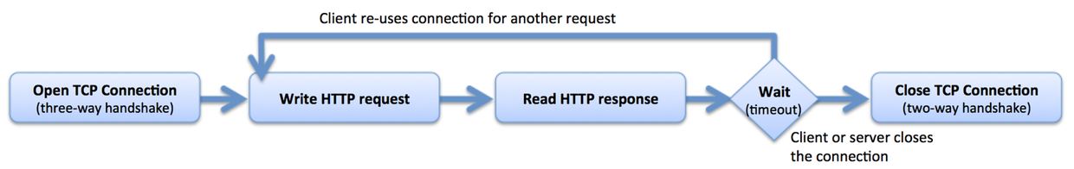

在现代浏览器中，一般同时开启6～8个keepalive connections的socket连接，并保持一定的链路生命，当不需要时再关闭；而在服务器中，一般是由软件根据负载情况(比如FD最大值、Socket内存、超时时间、栈内存、栈数量等)决定是否主动关闭。

HTTP2

由于HTTP1.x无法同时并行多个请求，即使引入了keep-Alive机制也只能串行的发多个请求。HTTP2改进了这一点。引入了HPACK和新的二进制分帧解决了这些问题。所以HTTP2可以在同一个TCP连接上并发的请求和响应。

HTTP2将Header和body都会进行分帧

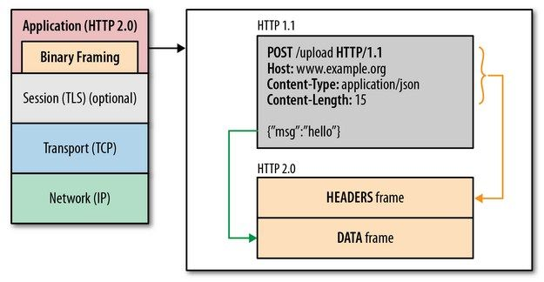

通信结构如下：

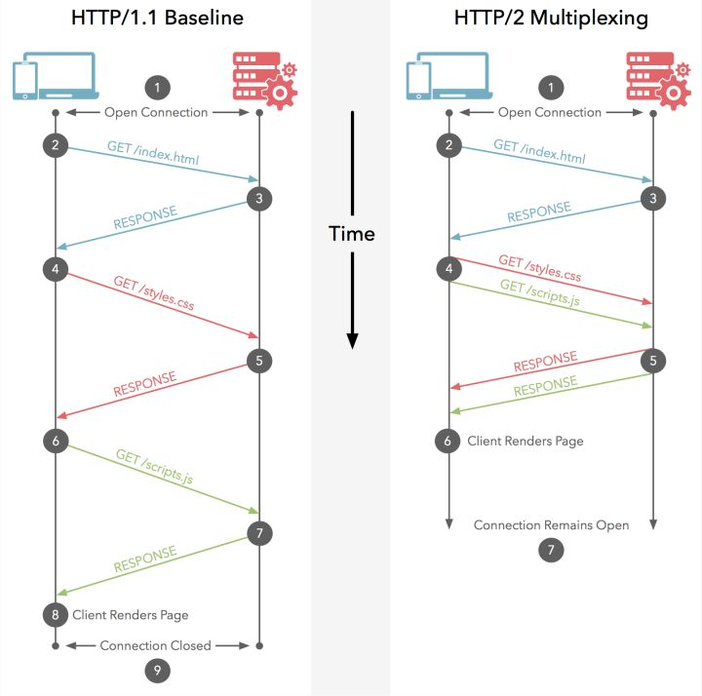

#### 2 OkHttp中与连接相关的类

不管是HTTP2还是HTTP1.x整个通信模型都会涉及到连接，数据流，socket等

下面介绍OkHttp中与连接和多路复用的相关类

**Connection**

先来看注释

The sockets and streams of an HTTP, HTTPS, or HTTPS+HTTP/2 connection. May be used for multiple

HTTP request/response exchanges. Connections may be direct to the origin server or via a proxy.

Connection表示HTTP的连接，包括scoket和流。这个连接可能多路复用。可能是是与服务器直连，也可能通过代理

其实Connection就是表示一个与服务器的连接。

public interface Connection {

/** Returns the route used by this connection. */

Route route();

/**

* Returns the socket that this connection is using. Returns an {@linkplain

* javax.net.ssl.SSLSocket SSL socket} if this connection is HTTPS. If this is an HTTP/2

* connection the socket may be shared by multiple concurrent calls.

*/

Socket socket();

/**

* Returns the TLS handshake used to establish this connection, or null if the connection is not

* HTTPS.

*/

@Nullable Handshake handshake();

/**

* Returns the protocol negotiated by this connection, or {@link Protocol#HTTP_1_1} if no protocol

* has been negotiated. This method returns {@link Protocol#HTTP_1_1} even if the remote peer is

* using {@link Protocol#HTTP_1_0}.

*/

Protocol protocol();

}

可以看到，主要涉及到连接的路由，socket，握手，协议等，是一个接口。真正的实现是RealConnection类

**ConnectionSpec**

连接配置，主要是socket上的配置，用于HTTPS加密通信时的Socket配置等

ConnectionSpec里面定义主要和TLS加密相关的内容，包括加密证书算法等，这个类不用了解的太详细。

**RealConnection**

表示一个真正的连接，一个RealConnection表示一条和服务器通信的链路，后续的请求写入和响应读取，以及数据流的传递都是通过这条连接传输的。我们来看其定义

public final class RealConnection extends Http2Connection.Listener implements Connection {

private static final String NPE_THROW_WITH_NULL = "throw with null exception";

private static final int MAX_TUNNEL_ATTEMPTS = 21;

//连接池

private final ConnectionPool connectionPool;

//路由

private final Route route;

// The fields below are initialized by connect() and never reassigned.

/** The low-level TCP socket. */

private Socket rawSocket;

/**

* The application layer socket. Either an {@link SSLSocket} layered over {@link #rawSocket}, or

* {@link #rawSocket} itself if this connection does not use SSL.

*/

private Socket socket;

private Handshake handshake;

private Protocol protocol;

private Http2Connection http2Connection;

private BufferedSource source;

private BufferedSink sink;

// The fields below track connection state and are guarded by connectionPool.

/** If true, no new streams can be created on this connection. Once true this is always true. */

public boolean noNewStreams;

public int successCount;

/**

* The maximum number of concurrent streams that can be carried by this connection. If {@code

* allocations.size() < allocationLimit} then new streams can be created on this connection.

*/

public int allocationLimit = 1;

/** Current streams carried by this connection. */

public final List<Reference<StreamAllocation>> allocations = new ArrayList<>();

/** Nanotime timestamp when {@code allocations.size()} reached zero. */

public long idleAtNanos = Long.MAX_VALUE;

public RealConnection(ConnectionPool connectionPool, Route route) {

this.connectionPool = connectionPool;

this.route = route;

}

…..

}

可以看到RealConnection持有Socket, ConnectionPool,Route, Handshake, BufferedSource, BufferedSink等变量

该类主要的功能就是完成连接的打开，关闭，以及将数据流的写入和读取等。我们来看几个比价重要的方法

public RealConnection(ConnectionPool connectionPool, Route route) {

this.connectionPool = connectionPool;

this.route = route;

}

构造方法，指定连接池和路由。因为OkHttp会复用连接，所以会有一个连接池来管理各个连接，至于路由，可以当成连接的一个地址。

public void connect(int connectTimeout, int readTimeout, int writeTimeout,

int pingIntervalMillis, boolean connectionRetryEnabled, Call call,

EventListener eventListener) {

if (protocol != null) throw new IllegalStateException("already connected");

RouteException routeException = null;

List<ConnectionSpec> connectionSpecs = route.address().connectionSpecs();

ConnectionSpecSelector connectionSpecSelector = new ConnectionSpecSelector(connectionSpecs);

if (route.address().sslSocketFactory() == null) {

if (!connectionSpecs.contains(ConnectionSpec.CLEARTEXT)) {

throw new RouteException(new UnknownServiceException(

"CLEARTEXT communication not enabled for client"));

}

String host = route.address().url().host();

if (!Platform.get().isCleartextTrafficPermitted(host)) {

throw new RouteException(new UnknownServiceException(

"CLEARTEXT communication to " + host + " not permitted by network security policy"));

}

}

while (true) {

try {

if (route.requiresTunnel()) {

connectTunnel(connectTimeout, readTimeout, writeTimeout, call, eventListener);

if (rawSocket == null) {

// We were unable to connect the tunnel but properly closed down our resources.

break;

}

} else {

connectSocket(connectTimeout, readTimeout, call, eventListener);

}

establishProtocol(connectionSpecSelector, pingIntervalMillis, call, eventListener);

eventListener.connectEnd(call, route.socketAddress(), route.proxy(), protocol);

break;

} catch (IOException e) {

closeQuietly(socket);

closeQuietly(rawSocket);

socket = null;

rawSocket = null;

source = null;

sink = null;

handshake = null;

protocol = null;

http2Connection = null;

eventListener.connectFailed(call, route.socketAddress(), route.proxy(), null, e);

if (routeException == null) {

routeException = new RouteException(e);

} else {

routeException.addConnectException(e);

}

if (!connectionRetryEnabled || !connectionSpecSelector.connectionFailed(e)) {

throw routeException;

}

}

}

if (route.requiresTunnel() && rawSocket == null) {

ProtocolException exception = new ProtocolException("Too many tunnel connections attempted: "

+ MAX_TUNNEL_ATTEMPTS);

throw new RouteException(exception);

}

if (http2Connection != null) {

synchronized (connectionPool) {

allocationLimit = http2Connection.maxConcurrentStreams();

}

}

}

connect方法是很重要的一个方法，主要做了以下几件事

1 根据路由route得到socket配置(TLS) connectionSpecs,然后创建ConnectionSpecSelector对象

List<ConnectionSpec> connectionSpecs = route.address().connectionSpecs();

ConnectionSpecSelector connectionSpecSelector = new ConnectionSpecSelector(connectionSpecs);

ConnectionSpecSelector表示ConnectionSpec的选择类，当握手或者协议出现问题的时候，需要尝试不同的协议进行连接。

2 while循环里面处理连接过程

3 如果是隧道连接，就创建隧道连接

connectTunnel(connectTimeout, readTimeout, writeTimeout, call, eventListener);

4 不是隧道连接就创建普通的socket连接

connectSocket(connectTimeout, readTimeout, call, eventListener);

由于隧道连接最终也会创建socket连接，我们直接看connectSocket(int connectTimeout, int readTimeout, Call call,

EventListener eventListener)方法

/** Does all the work necessary to build a full HTTP or HTTPS connection on a raw socket. */

private void connectSocket(int connectTimeout, int readTimeout, Call call,

EventListener eventListener) throws IOException {

Proxy proxy = route.proxy();

Address address = route.address();

rawSocket = proxy.type() == Proxy.Type.DIRECT || proxy.type() == Proxy.Type.HTTP

? address.socketFactory().createSocket()

: new Socket(proxy);

eventListener.connectStart(call, route.socketAddress(), proxy);

rawSocket.setSoTimeout(readTimeout);

try {

Platform.get().connectSocket(rawSocket, route.socketAddress(), connectTimeout);

} catch (ConnectException e) {

ConnectException ce = new ConnectException("Failed to connect to " + route.socketAddress());

ce.initCause(e);

throw ce;

}

// The following try/catch block is a pseudo hacky way to get around a crash on Android 7.0

// More details:

// https://github.com/square/okhttp/issues/3245

// https://android-review.googlesource.com/#/c/271775/

try {

source = Okio.buffer(Okio.source(rawSocket));

sink = Okio.buffer(Okio.sink(rawSocket));

} catch (NullPointerException npe) {

if (NPE_THROW_WITH_NULL.equals(npe.getMessage())) {

throw new IOException(npe);

}

}

}

该方法主要的工作如下：

(1) 获取route的Address和Proxy对象

Proxy proxy = route.proxy();

Address address = route.address();

(2) 根据proxy对象创建socket对象，并对rawSocket赋值

rawSocket = proxy.type() == Proxy.Type.DIRECT || proxy.type() == Proxy.Type.HTTP

? address.socketFactory().createSocket()

: new Socket(proxy);

(3) 调用平台的相关方法来真正的创建socket连接

Platform.get().connectSocket(rawSocket, route.socketAddress(), connectTimeout);

这一步就是创建socket连接，进行与服务器的对话

(4) 底层socket rawSocket创建成功后，对socket进行输入输出流关联

source = Okio.buffer(Okio.source(rawSocket));

sink = Okio.buffer(Okio.sink(rawSocket));

这样，后续就可以通过source和sink进行socket的读写操作了

下面回到connect的while循环中，我们成功创建了socket之后，会进行下一步

5 establishProtocol进行协议建立

establishProtocol(connectionSpecSelector, pingIntervalMillis, call, eventListener);

这一步主要是根据是HTTP1.1还是HTTP2协议，进行逻辑上socket 和protocol赋值

如果route.address().sslSocketFactory()不为null，表示进行的是HTTPS通信，还将进行TLS的握手，主要在

connectTls中完成

private void connectTls(ConnectionSpecSelector connectionSpecSelector) throws IOException {

Address address = route.address();

SSLSocketFactory sslSocketFactory = address.sslSocketFactory();

boolean success = false;

SSLSocket sslSocket = null;

try {

// Create the wrapper over the connected socket.

sslSocket = (SSLSocket) sslSocketFactory.createSocket(

rawSocket, address.url().host(), address.url().port(), true /* autoClose */);

// Configure the socket's ciphers, TLS versions, and extensions.

ConnectionSpec connectionSpec = connectionSpecSelector.configureSecureSocket(sslSocket);

if (connectionSpec.supportsTlsExtensions()) {

Platform.get().configureTlsExtensions(

sslSocket, address.url().host(), address.protocols());

}

// Force handshake. This can throw!

sslSocket.startHandshake();

// block for session establishment

SSLSession sslSocketSession = sslSocket.getSession();

if (!isValid(sslSocketSession)) {

throw new IOException("a valid ssl session was not established");

}

Handshake unverifiedHandshake = Handshake.get(sslSocketSession);

// Verify that the socket's certificates are acceptable for the target host.

if (!address.hostnameVerifier().verify(address.url().host(), sslSocketSession)) {

X509Certificate cert = (X509Certificate) unverifiedHandshake.peerCertificates().get(0);

throw new SSLPeerUnverifiedException("Hostname " + address.url().host() + " not verified:"

+ "\n certificate: " + CertificatePinner.pin(cert)

+ "\n DN: " + cert.getSubjectDN().getName()

+ "\n subjectAltNames: " + OkHostnameVerifier.allSubjectAltNames(cert));

}

// Check that the certificate pinner is satisfied by the certificates presented.

address.certificatePinner().check(address.url().host(),

unverifiedHandshake.peerCertificates());

// Success! Save the handshake and the ALPN protocol.

String maybeProtocol = connectionSpec.supportsTlsExtensions()

? Platform.get().getSelectedProtocol(sslSocket)

: null;

socket = sslSocket;

source = Okio.buffer(Okio.source(socket));

sink = Okio.buffer(Okio.sink(socket));

handshake = unverifiedHandshake;

protocol = maybeProtocol != null

? Protocol.get(maybeProtocol)

: Protocol.HTTP_1_1;

success = true;

} catch (AssertionError e) {

if (Util.isAndroidGetsocknameError(e)) throw new IOException(e);

throw e;

} finally {

if (sslSocket != null) {

Platform.get().afterHandshake(sslSocket);

}

if (!success) {

closeQuietly(sslSocket);

}

}

}

6 处理socket连接后的相关工作

eventListener.connectEnd(call, route.socketAddress(), route.proxy(), protocol);

基本上RealConnection的connect方法过程就讲解完了，可以看到，RealConnection表示一个通信链路的建立，对应着HTTP通信中socket的打开，TLS握手及TCP三次握手完成。后面可以真正开始传递数据了。

**ConnectionPool**

前面提到，OkHttp为了提高效率，会对连接进行复用(符合HTTP协议)。这个连接主要是host相同的TCP通道。

那么对于那么多存活的连接，OkHttp就引入了连接池来进行连接的管理,这就是ConnectionPool的由来

public final class ConnectionPool {

/**

* Background threads are used to cleanup expired connections. There will be at most a single

* thread running per connection pool. The thread pool executor permits the pool itself to be

* garbage collected.

*/

private static final Executor executor = new ThreadPoolExecutor(0 /* corePoolSize */,

Integer.MAX_VALUE /* maximumPoolSize */, 60L /* keepAliveTime */, TimeUnit.SECONDS,

new SynchronousQueue<Runnable>(), Util.threadFactory("OkHttp ConnectionPool", true));

/** The maximum number of idle connections for each address. */

private final int maxIdleConnections;

private final long keepAliveDurationNs;

private final Runnable cleanupRunnable = new Runnable() {

@Override public void run() {

while (true) {

long waitNanos = cleanup(System.nanoTime());

if (waitNanos == -1) return;

if (waitNanos > 0) {

long waitMillis = waitNanos / 1000000L;

waitNanos -= (waitMillis * 1000000L);

synchronized (ConnectionPool.this) {

try {

ConnectionPool.this.wait(waitMillis, (int) waitNanos);

} catch (InterruptedException ignored) {

}

}

}

}

}

};

private final Deque<RealConnection> connections = new ArrayDeque<>();

final RouteDatabase routeDatabase = new RouteDatabase();

boolean cleanupRunning;

public ConnectionPool() {

this(5, 5, TimeUnit.MINUTES);

}

public ConnectionPool(int maxIdleConnections, long keepAliveDuration, TimeUnit timeUnit) {

this.maxIdleConnections = maxIdleConnections;

this.keepAliveDurationNs = timeUnit.toNanos(keepAliveDuration);

// Put a floor on the keep alive duration, otherwise cleanup will spin loop.

if (keepAliveDuration <= 0) {

throw new IllegalArgumentException("keepAliveDuration <= 0: " + keepAliveDuration);

}

}

}

ConnectionPool中有一个队列Deque<RealConnection> connections专门用来存放连接，另外还有一个空闲线程用来清理连接

还有一个routeDatabase用来记录不可达的路由

private final int maxIdleConnections;

private final long keepAliveDurationNs;

这两个变量保存的同一个host的最大空闲连接数和存活时间。默认是5个连接和5分钟，maxIdleConnections和keepAliveDurationNs则是清理中淘汰连接的的指标。

在OkHttpClient的Builder中会创建的默认的连接池，代码如下：

connectionPool = new ConnectionPool();

对连接的操作和管理主要涉及到以下几个方法

//根据Address和StreamAllocation Route获取一个连接

RealConnection get(Address address, StreamAllocation streamAllocation, Route route)

//socket去重

Socket deduplicate(Address address, StreamAllocation streamAllocation)

//存入连接

put(RealConnection connection)

有关这部分的详细讲解，后续再说吧

**StreamAllocation**

StreamAllocation也是OkHttp连接中一个很重要的类，但是它的概念很不好理解。官方的注释如下：

* This class coordinates the relationship between three entities:

*

* <ul>

* <li><strong>Connections:</strong> physical socket connections to remote servers. These are

* potentially slow to establish so it is necessary to be able to cancel a connection

* currently being connected.

* <li><strong>Streams:</strong> logical HTTP request/response pairs that are layered on

* connections. Each connection has its own allocation limit, which defines how many

* concurrent streams that connection can carry. HTTP/1.x connections can carry 1 stream

* at a time, HTTP/2 typically carry multiple.

* <li><strong>Calls:</strong> a logical sequence of streams, typically an initial request and

* its follow up requests. We prefer to keep all streams of a single call on the same

* connection for better behavior and locality.

* </ul>

可以看到StreamAllocation和流 Call请求以及socket连接都有关系。StreamAllocation直译就是流分配。我们可以把它翻译成流分配器，我们来看这个类的定义

public final class StreamAllocation {

public final Address address;

private RouteSelector.Selection routeSelection;

private Route route;

private final ConnectionPool connectionPool;

public final Call call;

public final EventListener eventListener;

private final Object callStackTrace;

// State guarded by connectionPool.

private final RouteSelector routeSelector;

private int refusedStreamCount;

private RealConnection connection;

private boolean reportedAcquired;

private boolean released;

private boolean canceled;

private HttpCodec codec;

public StreamAllocation(ConnectionPool connectionPool, Address address, Call call,

EventListener eventListener, Object callStackTrace) {

this.connectionPool = connectionPool;

this.address = address;

this.call = call;

this.eventListener = eventListener;

this.routeSelector = new RouteSelector(address, routeDatabase(), call, eventListener);

this.callStackTrace = callStackTrace;

}

…….

}

可以看到里面有几个很重要的变量，包括Address Route Call RealConnection HttpCodec 等。

我们来看一个很重要的方法HttpCodec newStream()

public HttpCodec newStream(

OkHttpClient client, Interceptor.Chain chain, boolean doExtensiveHealthChecks) {

int connectTimeout = chain.connectTimeoutMillis();

int readTimeout = chain.readTimeoutMillis();

int writeTimeout = chain.writeTimeoutMillis();

int pingIntervalMillis = client.pingIntervalMillis();

boolean connectionRetryEnabled = client.retryOnConnectionFailure();

try {

RealConnection resultConnection = findHealthyConnection(connectTimeout, readTimeout,

writeTimeout, pingIntervalMillis, connectionRetryEnabled, doExtensiveHealthChecks);

HttpCodec resultCodec = resultConnection.newCodec(client, chain, this);

synchronized (connectionPool) {

codec = resultCodec;

return resultCodec;

}

} catch (IOException e) {

throw new RouteException(e);

}

}

这里面主要做了以下两件事

1 在连接池中找到一个健康的可用的连接RealConnection

RealConnection resultConnection = findHealthyConnection(connectTimeout, readTimeout,

writeTimeout, pingIntervalMillis, connectionRetryEnabled, doExtensiveHealthChecks);

2 根据这个连接返回HttpCodec对象

HttpCodec resultCodec = resultConnection.newCodec(client, chain, this);

HttpCodec 是编码请求和解码响应对象，可以看成真正操作HTTP请求和响应的对象

通过StreamAllocation我们返回了连接RealConnection上读写HTTP请求与响应的接口对象，那么我们就可以在连接上读取响应和写入请求了。

因此可以认为StreamAllocation是连接RealConnection和HttpCodec的桥梁，也是连接上流Stream的分配器，因为拿到流Stream了我们就可以读写HTTP响应和请求了。

**HttpCodec**

这个类比较简单，主要就是对HTTP请求和响应进行的流操作，定义如下

public interface HttpCodec {

/**

* The timeout to use while discarding a stream of input data. Since this is used for connection

* reuse, this timeout should be significantly less than the time it takes to establish a new

* connection.

*/

int DISCARD_STREAM_TIMEOUT_MILLIS = 100;

/** Returns an output stream where the request body can be streamed. */

Sink createRequestBody(Request request, long contentLength);

/** This should update the HTTP engine's sentRequestMillis field. */

void writeRequestHeaders(Request request) throws IOException;

/** Flush the request to the underlying socket. */

void flushRequest() throws IOException;

/** Flush the request to the underlying socket and signal no more bytes will be transmitted. */

void finishRequest() throws IOException;

/**

* Parses bytes of a response header from an HTTP transport.

*

* @param expectContinue true to return null if this is an intermediate response with a "100"

* response code. Otherwise this method never returns null.

*/

Response.Builder readResponseHeaders(boolean expectContinue) throws IOException;

/** Returns a stream that reads the response body. */

ResponseBody openResponseBody(Response response) throws IOException;

/**

* Cancel this stream. Resources held by this stream will be cleaned up, though not synchronously.

* That may happen later by the connection pool thread.

*/

void cancel();

}

可以看到，主要涉及到四种操作

**写请求头**

**写请求体**

**读响应头**

**读响应体**

另外，根据HTTP协议版本的不同，分别有两个子类Http1Codec和Http2Codec来实现。

详细细节也就是利用Okio来进行数据的读写，这里不讨论。

#### 3 OkHttp中连接过程

OKHttp连接过程主要由ConnectInterceptor和CallServerInterceptor来完成，我们接下来看这两个拦截器的流程

**ConnectInterceptor**

我们主要来看其intercept()方法

@Override public Response intercept(Chain chain) throws IOException {

RealInterceptorChain realChain = (RealInterceptorChain) chain;

Request request = realChain.request();

StreamAllocation streamAllocation = realChain.streamAllocation();

// We need the network to satisfy this request. Possibly for validating a conditional GET.

boolean doExtensiveHealthChecks = !request.method().equals("GET");

HttpCodec httpCodec = streamAllocation.newStream(client, chain, doExtensiveHealthChecks);

RealConnection connection = streamAllocation.connection();

return realChain.proceed(request, streamAllocation, httpCodec, connection);

}

主要工作如下：

1 获取StreamAllocation 对象，该对象是在RetryAndFollowUpInterceptor中创建并赋值的

StreamAllocation streamAllocation = new StreamAllocation(client.connectionPool(),

createAddress(request.url()), call, eventListener, callStackTrace);

this.streamAllocation = streamAllocation;

2 通过StreamAllocation new一个HttpCodec对象和获取RealConnection传递到下一个拦截器

HttpCodec httpCodec = streamAllocation.newStream(client, chain, doExtensiveHealthChecks);

RealConnection connection = streamAllocation.connection();

return realChain.proceed(request, streamAllocation, httpCodec, connection);

CallServerInterceptor

根据上面的解析，RealConnection 和 HttpCodec对象会被传递到CallServerInterceptor中，我们来看其处理流程

@Override public Response intercept(Chain chain) throws IOException {

RealInterceptorChain realChain = (RealInterceptorChain) chain;

HttpCodec httpCodec = realChain.httpStream();

StreamAllocation streamAllocation = realChain.streamAllocation();

RealConnection connection = (RealConnection) realChain.connection();

Request request = realChain.request();

long sentRequestMillis = System.currentTimeMillis();

realChain.eventListener().requestHeadersStart(realChain.call());

httpCodec.writeRequestHeaders(request);

realChain.eventListener().requestHeadersEnd(realChain.call(), request);

Response.Builder responseBuilder = null;

if (HttpMethod.permitsRequestBody(request.method()) && request.body() != null) {

// If there's a "Expect: 100-continue" header on the request, wait for a "HTTP/1.1 100

// Continue" response before transmitting the request body. If we don't get that, return

// what we did get (such as a 4xx response) without ever transmitting the request body.

if ("100-continue".equalsIgnoreCase(request.header("Expect"))) {

httpCodec.flushRequest();

realChain.eventListener().responseHeadersStart(realChain.call());

responseBuilder = httpCodec.readResponseHeaders(true);

}

if (responseBuilder == null) {

// Write the request body if the "Expect: 100-continue" expectation was met.

realChain.eventListener().requestBodyStart(realChain.call());

long contentLength = request.body().contentLength();

CountingSink requestBodyOut =

new CountingSink(httpCodec.createRequestBody(request, contentLength));

BufferedSink bufferedRequestBody = Okio.buffer(requestBodyOut);

request.body().writeTo(bufferedRequestBody);

bufferedRequestBody.close();

realChain.eventListener()

.requestBodyEnd(realChain.call(), requestBodyOut.successfulCount);

} else if (!connection.isMultiplexed()) {

// If the "Expect: 100-continue" expectation wasn't met, prevent the HTTP/1 connection

// from being reused. Otherwise we're still obligated to transmit the request body to

// leave the connection in a consistent state.

streamAllocation.noNewStreams();

}

}

httpCodec.finishRequest();

if (responseBuilder == null) {

realChain.eventListener().responseHeadersStart(realChain.call());

responseBuilder = httpCodec.readResponseHeaders(false);

}

Response response = responseBuilder

.request(request)

.handshake(streamAllocation.connection().handshake())

.sentRequestAtMillis(sentRequestMillis)

.receivedResponseAtMillis(System.currentTimeMillis())

.build();

int code = response.code();

if (code == 100) {

// server sent a 100-continue even though we did not request one.

// try again to read the actual response

responseBuilder = httpCodec.readResponseHeaders(false);

response = responseBuilder

.request(request)

.handshake(streamAllocation.connection().handshake())

.sentRequestAtMillis(sentRequestMillis)

.receivedResponseAtMillis(System.currentTimeMillis())

.build();

code = response.code();

}

realChain.eventListener()

.responseHeadersEnd(realChain.call(), response);

if (forWebSocket && code == 101) {

// Connection is upgrading, but we need to ensure interceptors see a non-null response body.

response = response.newBuilder()

.body(Util.EMPTY_RESPONSE)

.build();

} else {

response = response.newBuilder()

.body(httpCodec.openResponseBody(response))

.build();

}

if ("close".equalsIgnoreCase(response.request().header("Connection"))

|| "close".equalsIgnoreCase(response.header("Connection"))) {

streamAllocation.noNewStreams();

}

if ((code == 204 || code == 205) && response.body().contentLength() > 0) {

throw new ProtocolException(

"HTTP " + code + " had non-zero Content-Length: " + response.body().contentLength());

}

return response;

}

CallServerInterceptor的拦截器主要做了以下几件事

1 获取对应的HttpCodec StreamAllocation RealConnection 对象

HttpCodec httpCodec = realChain.httpStream();

StreamAllocation streamAllocation = realChain.streamAllocation();

RealConnection connection = (RealConnection) realChain.connection();

Request request = realChain.request();

2 httpCodec 写入请求头

httpCodec.writeRequestHeaders(request);

3 httpCodec写入请求体

long contentLength = request.body().contentLength();

CountingSink requestBodyOut =

new CountingSink(httpCodec.createRequestBody(request, contentLength));

BufferedSink bufferedRequestBody = Okio.buffer(requestBodyOut);

request.body().writeTo(bufferedRequestBody);

这一步通过BufferedSink对象辅助来完成，有了BufferedSink对于大文件上传，那么写入请求体就很高效了

4 进行请求刷新和流的关闭

bufferedRequestBody.close();

…..

httpCodec.finishRequest();

这样，HTTP请求就发送刀片服务端了

5 httpCodec读取响应头

if (responseBuilder == null) {

realChain.eventListener().responseHeadersStart(realChain.call());

responseBuilder = httpCodec.readResponseHeaders(false);

}

这里主要通过httpCodec来进行的

6 httpCodec读取响应体，并且返回响应

Response response = responseBuilder

.request(request)

.handshake(streamAllocation.connection().handshake())

.sentRequestAtMillis(sentRequestMillis)

.receivedResponseAtMillis(System.currentTimeMillis())

.build();

….

response = response.newBuilder()

.body(httpCodec.openResponseBody(response))

.build();

HttpCodec对象根据连接握手的结果，读取响应体存放在ResponseBody中。这样我们就得到了服务端返回的HTTP响应了。整个网络通信过程就结束了。

至此，OkHttp网络框架的解析也就告一段落了

## 二 Retrofit

### 1 总体架构

#### 1 整体结构

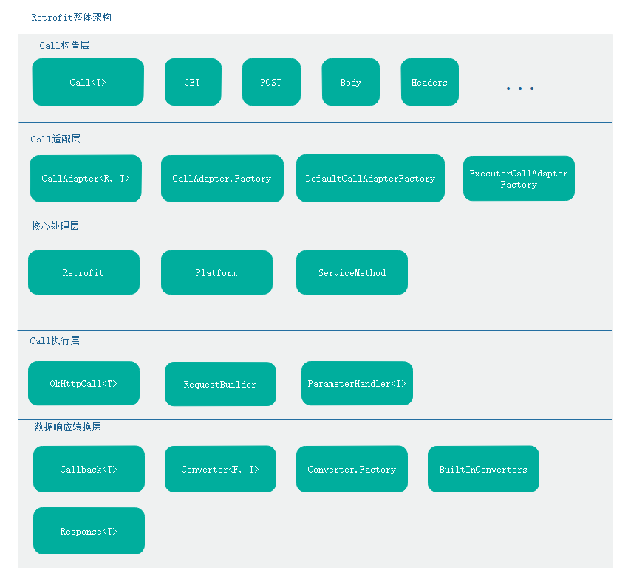

整体分为五层

#### 2 整体流程

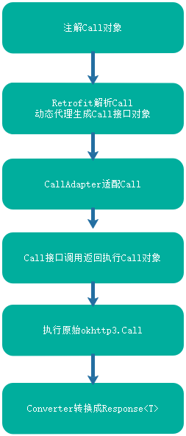

#### 3 Retrofit的核心功能

retrofit:核心工作

1 根据注解将Call转换为工作Call okHttpCall

2 解析okHttp的响应并回调给CallBack

### 2 Call与CallAdapter

#### 1 Call<T>接口

Call<T> 是Retrofit定义的发起HTTP请求的对象，其中泛型T表示返回值类型。我们知道Retrofit的响应不再是一个okhttp3.Response对象，而是一个经过Converter接口转换的Response<T>对象。其中T表示具体的实际类型。

这样，Retrofit它直接能给我们想要的JavaBean对象。省去了我们gson或者xml等转换成实体的过程。

Call<T>接口定义如下：

public interface Call<T> extends Cloneable {

/**

* Synchronously send the request and return its response.

*

* @throws IOException if a problem occurred talking to the server.

* @throws RuntimeException (and subclasses) if an unexpected error occurs creating the request

* or decoding the response.

*/

Response<T> execute() throws IOException;

/**

* Asynchronously send the request and notify {@code callback} of its response or if an error

* occurred talking to the server, creating the request, or processing the response.

*/

void enqueue(Callback<T> callback);

/**

* Returns true if this call has been either {@linkplain #execute() executed} or {@linkplain

* #enqueue(Callback) enqueued}. It is an error to execute or enqueue a call more than once.

*/

boolean isExecuted();

/**

* Cancel this call. An attempt will be made to cancel in-flight calls, and if the call has not

* yet been executed it never will be.

*/

void cancel();

/** True if {@link #cancel()} was called. */

boolean isCanceled();

/**

* Create a new, identical call to this one which can be enqueued or executed even if this call

* has already been.

*/

Call<T> clone();

/** The original HTTP request. */

Request request();

}

Call<T>中几个比较重要的方法是

**Response<T> execute() :**执行同步请求

**void enqueue(Callback<T> callback):**执行异步请求

**void cancel():**取消该次请求

**Request request():**获取原始的OkHttp请求，如果我们需要对原始请求读取一些信息，可以采用该方法

Call<T>比较重要的一个实现类就是 执行Call OkHttpCall<T>，这个我们再后面的小节中讲解。

#### 2 CallAdapter<R, T>

我们知道，Retrofit Call请求支持多种平台，例如原始Call<T>，Rxjava,以及java8形式等。例如Rxjava形式的Call就是这样的

@GET("book/search")

Observable<Book> getSearchBook(@Query("q") String name,

@Query("tag") String tag, @Query("start") int start,

@Query("count") int count);

可以看到，我们将Call<T>形式转换成了Observable<T>形式

为此Retrofit采用了适配器模式来进行这种转换

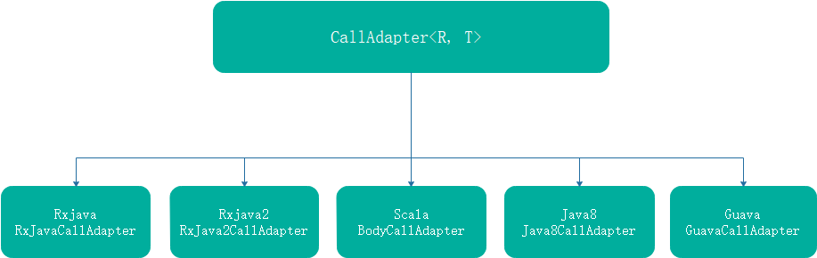

我们先来看CallAdapter接口

/**

* Adapts a {@link Call} with response type {@code R} into the type of {@code T}. Instances are

* created by {@linkplain Factory a factory} which is

* {@linkplain Retrofit.Builder#addCallAdapterFactory(Factory) installed} into the {@link Retrofit}

* instance.

*/

public interface CallAdapter<R, T> {

/**

* Returns the value type that this adapter uses when converting the HTTP response body to a Java

* object. For example, the response type for {@code Call<Repo>} is {@code Repo}. This type

* is used to prepare the {@code call} passed to {@code #adapt}.

* <p>

* Note: This is typically not the same type as the {@code returnType} provided to this call

* adapter's factory.

*/

Type responseType();

/**

* Returns an instance of {@code T} which delegates to {@code call}.

* <p>

* For example, given an instance for a hypothetical utility, {@code Async}, this instance would

* return a new {@code Async<R>} which invoked {@code call} when run.

* <pre><code>

* &#64;Override

* public &lt;R&gt; Async&lt;R&gt; adapt(final Call&lt;R&gt; call) {

* return Async.create(new Callable&lt;Response&lt;R&gt;&gt;() {

* &#64;Override

* public Response&lt;R&gt; call() throws Exception {

* return call.execute();

* }

* });

* }

* </code></pre>

*/

T adapt(Call<R> call);

/**

* Creates {@link CallAdapter} instances based on the return type of {@linkplain

* Retrofit#create(Class) the service interface} methods.

*/

abstract class Factory {

/**

* Returns a call adapter for interface methods that return {@code returnType}, or null if it

* cannot be handled by this factory.

*/

public abstract @Nullable CallAdapter<?, ?> get(Type returnType, Annotation[] annotations,

Retrofit retrofit);

/**

* Extract the upper bound of the generic parameter at {@code index} from {@code type}. For

* example, index 1 of {@code Map<String, ? extends Runnable>} returns {@code Runnable}.

*/

protected static Type getParameterUpperBound(int index, ParameterizedType type) {

return Utils.getParameterUpperBound(index, type);

}

/**

* Extract the raw class type from {@code type}. For example, the type representing

* {@code List<? extends Runnable>} returns {@code List.class}.

*/

protected static Class<?> getRawType(Type type) {

return Utils.getRawType(type);

}

}

}

先忽略掉内部类Factory

CallAdapter<R,T> 主要工作就是将Call<R>转换成T类型，它的实例化是由其内部类Factory的CallAdapter<?, ?> get(Type returnType, Annotation[] annotations,Retrofit retrofit)完成

CallAdapter<R,T>两个主要方法是

**Type responseType():** 返回响应类型的type，例如一个Call<T>请求，返回的是T类型的type。实现类实现

**T adapt(Call<R> call);** 将Call<T> 转换成T类型。实现类实现

我们可以看一下CallAdapter<R,T>的Rxjava2实现类

final class RxJava2CallAdapter<R> implements CallAdapter<R, Object> {

private final Type responseType;

....

@Override public Type responseType() {

return responseType;

}

@Override public Object adapt(Call<R> call) {

....

Observable<?> observable;

....

return observable;

}

}

可以看到，返回的T类型就是Observable<?>类型了,这样就把原始Call<T>转换成了Rxjava2的Observable<?>，我们就可以采用Rxjava2的api来进行HTTP网络请求了。这个转换过程暂时不详细讲解

#### 3 CallAdapter. Factory

Retrofit采用工厂模式来创建CallAdapter对象，对于每一种平台，例如Rxjava2,Rxjava,java8等，都会去继承该类去实现创建CallAdapter的方法。由于该工厂的产品只有一个，可以认为是工厂方法模式。

abstract class Factory {

/**

* Returns a call adapter for interface methods that return {@code returnType}, or null if it

* cannot be handled by this factory.

*/

public abstract @Nullable CallAdapter<?, ?> get(Type returnType, Annotation[] annotations,

Retrofit retrofit);

/**

* Extract the upper bound of the generic parameter at {@code index} from {@code type}. For

* example, index 1 of {@code Map<String, ? extends Runnable>} returns {@code Runnable}.

*/

protected static Type getParameterUpperBound(int index, ParameterizedType type) {

return Utils.getParameterUpperBound(index, type);

}

/**

* Extract the raw class type from {@code type}. For example, the type representing

* {@code List<? extends Runnable>} returns {@code List.class}.

*/

protected static Class<?> getRawType(Type type) {

return Utils.getRawType(type);

}

}

主要的几个方法如下：

**CallAdapter<?, ?> get(Type returnType, Annotation[] annotations,Retrofit retrofit):**根据响应返回类型和注解创建CallAdapter<?, ?>

**static Type getParameterUpperBound(int index, ParameterizedType type):**返回其参数类型的上边界类型

**static Class<?> getRawType(Type type):**根据type类型返回其原始类型，例如List<T>,返回List.class

我们来看一个例子DefaultCallAdapterFactory

#### 4 DefaultCallAdapterFactory

DefaultCallAdapterFactory是Retrofit默认的CallAdapterFactory,它创建的CallAdapter对象对Call<T>不会做任何适配，直接返回原始的Call<T>。

代码如下：

/**

* Creates call adapters for that uses the same thread for both I/O and application-level

* callbacks. For synchronous calls this is the application thread making the request; for

* asynchronous calls this is a thread provided by OkHttp's dispatcher.

*/

final class DefaultCallAdapterFactory extends CallAdapter.Factory {

static final CallAdapter.Factory INSTANCE = new DefaultCallAdapterFactory();

@Override

public CallAdapter<?, ?> get(Type returnType, Annotation[] annotations, Retrofit retrofit) {

if (getRawType(returnType) != Call.class) {

return null;

}

final Type responseType = Utils.getCallResponseType(returnType);

return new CallAdapter<Object, Call<?>>() {

@Override public Type responseType() {

return responseType;

}

@Override public Call<Object> adapt(Call<Object> call) {

return call;

}

};

}

}

可以看到，get()方法做了如下几件事

(1) getRawType(returnType)判断是不是Call.class，因为retrofit要求请求接口的返回是Call<T>类型，如果不符合直接返回null

(2) 调用Utils.getCallResponseType(returnType)返回其Call<T>的T的type类型responseType

(3) 创建CallAdapter对象，其中responseType()返回responseType。Call<T>返回原始的Call<Object>类型即可

这样子，我们就成功的创建了适配原始Call<T>的CallAdapter。

#### 5 ExecutorCallAdapterFactory

关联Executor 的CallAdapterFactory，主要作用就是将Call<T>的回调Callback<T>分发到对应的Executor线程

final class ExecutorCallAdapterFactory extends CallAdapter.Factory {

final Executor callbackExecutor;

ExecutorCallAdapterFactory(Executor callbackExecutor) {

this.callbackExecutor = callbackExecutor;

}

@Override

public CallAdapter<?, ?> get(Type returnType, Annotation[] annotations, Retrofit retrofit) {

if (getRawType(returnType) != Call.class) {

return null;

}

final Type responseType = Utils.getCallResponseType(returnType);

return new CallAdapter<Object, Call<?>>() {

@Override public Type responseType() {

return responseType;

}

@Override public Call<Object> adapt(Call<Object> call) {

return new ExecutorCallbackCall<>(callbackExecutor, call);

}

};

}

static final class ExecutorCallbackCall<T> implements Call<T> {

final Executor callbackExecutor;

final Call<T> delegate;

ExecutorCallbackCall(Executor callbackExecutor, Call<T> delegate) {

this.callbackExecutor = callbackExecutor;

this.delegate = delegate;

}

@Override public void enqueue(final Callback<T> callback) {

checkNotNull(callback, "callback == null");

delegate.enqueue(new Callback<T>() {

@Override public void onResponse(Call<T> call, final Response<T> response) {

callbackExecutor.execute(new Runnable() {

@Override public void run() {

if (delegate.isCanceled()) {

// Emulate OkHttp's behavior of throwing/delivering an IOException on cancellation.

callback.onFailure(ExecutorCallbackCall.this, new IOException("Canceled"));

} else {

callback.onResponse(ExecutorCallbackCall.this, response);

}

}

});

}

@Override public void onFailure(Call<T> call, final Throwable t) {

callbackExecutor.execute(new Runnable() {

@Override public void run() {

callback.onFailure(ExecutorCallbackCall.this, t);

}

});

}

});

}

@Override public boolean isExecuted() {

return delegate.isExecuted();

}

@Override public Response<T> execute() throws IOException {

return delegate.execute();

}

@Override public void cancel() {

delegate.cancel();

}

@Override public boolean isCanceled() {

return delegate.isCanceled();

}

@SuppressWarnings("CloneDoesntCallSuperClone") // Performing deep clone.

@Override public Call<T> clone() {

return new ExecutorCallbackCall<>(callbackExecutor, delegate.clone());

}

@Override public Request request() {

return delegate.request();

}

}

}

该类逻辑比较简单，主要有以下几点

(1) 回调线程callbackExecutor，最终Call<T>的回调Callback<T>会在该线程中运行

(2) get(Type returnType, Annotation[] annotations, Retrofit retrofit)返回的CallAdapter会将Call<T>适配成Call<T>子类ExecutorCallbackCall

(3) ExecutorCallbackCall继承Call<T>，并且会将CallBack的onResponse() onFailure()在callbackExecutor线程中运行。

**注意：**DefaultCallAdapterFactory是java8和Platform平台默认的CallAdapterFactory。Android平台的CallAdapterFactory是ExecutorCallAdapterFactory，其中callbackExecutor会赋值成MainThreadExecutor，该对象在主线程中运行，因此Callback<T>在Android主线程运行。

### 3 Converter<R,T>数据响应转换层

#### 1 Converter接口定义

Converter<R,T>本身定义接口如下

/**

* Convert objects to and from their representation in HTTP. Instances are created by {@linkplain

* Factory a factory} which is {@linkplain Retrofit.Builder#addConverterFactory(Factory) installed}

* into the {@link Retrofit} instance.

*/

public interface Converter<F, T> {

T convert(F value) throws IOException;

}

可以看到，该接口就是将F类型转为T类型，其中又是采用了工厂设计模式来创建对象。这里创建的是一组相关的Converter转换器

#### 2 Converter.Factory

Converter.Factory定义如下：

public interface Converter<F, T> {

....

/** Creates {@link Converter} instances based on a type and target usage. */

abstract class Factory {

/**

* Returns a {@link Converter} for converting an HTTP response body to {@code type}, or null if

* {@code type} cannot be handled by this factory. This is used to create converters for

* response types such as {@code SimpleResponse} from a {@code Call<SimpleResponse>}

* declaration.

*/

public @Nullable Converter<ResponseBody, ?> responseBodyConverter(Type type,

Annotation[] annotations, Retrofit retrofit) {

return null;

}

/**

* Returns a {@link Converter} for converting {@code type} to an HTTP request body, or null if

* {@code type} cannot be handled by this factory. This is used to create converters for types

* specified by {@link Body @Body}, {@link Part @Part}, and {@link PartMap @PartMap}

* values.

*/

public @Nullable Converter<?, RequestBody> requestBodyConverter(Type type,

Annotation[] parameterAnnotations, Annotation[] methodAnnotations, Retrofit retrofit) {

return null;

}

/**

* Returns a {@link Converter} for converting {@code type} to a {@link String}, or null if

* {@code type} cannot be handled by this factory. This is used to create converters for types

* specified by {@link Field @Field}, {@link FieldMap @FieldMap} values,

* {@link Header @Header}, {@link HeaderMap @HeaderMap}, {@link Path @Path},

* {@link Query @Query}, and {@link QueryMap @QueryMap} values.

*/

public @Nullable Converter<?, String> stringConverter(Type type, Annotation[] annotations,

Retrofit retrofit) {

return null;

}

/**

* Extract the upper bound of the generic parameter at {@code index} from {@code type}. For

* example, index 1 of {@code Map<String, ? extends Runnable>} returns {@code Runnable}.

*/

protected static Type getParameterUpperBound(int index, ParameterizedType type) {

return Utils.getParameterUpperBound(index, type);

}

/**

* Extract the raw class type from {@code type}. For example, the type representing

* {@code List<? extends Runnable>} returns {@code List.class}.

*/

protected static Class<?> getRawType(Type type) {

return Utils.getRawType(type);

}

}

}

有几个重要的方法如下：

Converter<ResponseBody, ?> responseBodyConverter(Type type,Annotation[] annotations, Retrofit retrofit)

将ResponseBody响应转换成?类型，用于在OkHttp响应中将ResponseBody转为T类型

Converter<?, RequestBody> requestBodyConverter(Type type,Annotation[] parameterAnnotations, Annotation[] methodAnnotations, Retrofit retrofit)

将任意类型？转换为RequestBody类型，用于供OkHttp发起请求使用

Converter<?, String> stringConverter(Type type, Annotation[] annotations,Retrofit retrofit)

将任意类型转换为String类型

#### 3 GsonConverterFactory

作为我们熟悉的例子，我们来看一个gson转换的例子

public final class GsonConverterFactory extends Converter.Factory {

/**

* Create an instance using a default {@link Gson} instance for conversion. Encoding to JSON and

* decoding from JSON (when no charset is specified by a header) will use UTF-8.

*/

public static GsonConverterFactory create() {

return create(new Gson());

}

/**

* Create an instance using {@code gson} for conversion. Encoding to JSON and

* decoding from JSON (when no charset is specified by a header) will use UTF-8.

*/

@SuppressWarnings("ConstantConditions") // Guarding public API nullability.

public static GsonConverterFactory create(Gson gson) {

if (gson == null) throw new NullPointerException("gson == null");

return new GsonConverterFactory(gson);

}

private final Gson gson;

private GsonConverterFactory(Gson gson) {

this.gson = gson;

}

@Override

public Converter<ResponseBody, ?> responseBodyConverter(Type type, Annotation[] annotations,

Retrofit retrofit) {

TypeAdapter<?> adapter = gson.getAdapter(TypeToken.get(type));

return new GsonResponseBodyConverter<>(gson, adapter);

}

@Override

public Converter<?, RequestBody> requestBodyConverter(Type type,

Annotation[] parameterAnnotations, Annotation[] methodAnnotations, Retrofit retrofit) {

TypeAdapter<?> adapter = gson.getAdapter(TypeToken.get(type));

return new GsonRequestBodyConverter<>(gson, adapter);

}

}

可以看到Gson转换，创建了两种类型的Converter,一种是GsonResponseBodyConverter,一种是GsonRequestBodyConverter。这两种分别用于在okKHttp转换响应和转换请求时用。

4 Converter

调用Converter实例在进行转为的过程在OkHttpCall响应返回回调之前

OkHttpCall#parseResponse()

Response<T> parseResponse(okhttp3.Response rawResponse) throws IOException {

ResponseBody rawBody = rawResponse.body();

// Remove the body's source (the only stateful object) so we can pass the response along.

rawResponse = rawResponse.newBuilder()

.body(new NoContentResponseBody(rawBody.contentType(), rawBody.contentLength()))

.build();

int code = rawResponse.code();

if (code < 200 || code >= 300) {

try {

// Buffer the entire body to avoid future I/O.

ResponseBody bufferedBody = Utils.buffer(rawBody);

return Response.error(bufferedBody, rawResponse);

} finally {

rawBody.close();

}

}

if (code == 204 || code == 205) {

rawBody.close();

return Response.success(null, rawResponse);

}

ExceptionCatchingRequestBody catchingBody = new ExceptionCatchingRequestBody(rawBody);

try {

T body = serviceMethod.toResponse(catchingBody);

return Response.success(body, rawResponse);

} catch (RuntimeException e) {

// If the underlying source threw an exception, propagate that rather than indicating it was

// a runtime exception.

catchingBody.throwIfCaught();

throw e;

}

}

这里调用了ServiceMethod# toResponse()

R toResponse(ResponseBody body) throws IOException {

return responseConverter.convert(body);

}

至于RequestBody的转换，是在ServiceMethod # okhttp3.Call toCall(@Nullable Object... args)中调用

### 4 Retrofit 核心层

#### 1 Retrofit

Retrofit类是Retrofit的核心类，它提供的功能主要是关联OkHttp引擎，动态代理创建Call接口类实例等。内部采用Builder设计模式，先来看一下其内部成员

public final class Retrofit {

private final Map<Method, ServiceMethod<?, ?>> serviceMethodCache = new ConcurrentHashMap<>();

final okhttp3.Call.Factory callFactory;

final HttpUrl baseUrl;

final List<Converter.Factory> converterFactories;

final List<CallAdapter.Factory> callAdapterFactories;

final @Nullable Executor callbackExecutor;

final boolean validateEagerly;

Retrofit(okhttp3.Call.Factory callFactory, HttpUrl baseUrl,

List<Converter.Factory> converterFactories, List<CallAdapter.Factory> callAdapterFactories,

@Nullable Executor callbackExecutor, boolean validateEagerly) {

this.callFactory = callFactory;

this.baseUrl = baseUrl;

this.converterFactories = converterFactories; // Copy+unmodifiable at call site.

this.callAdapterFactories = callAdapterFactories; // Copy+unmodifiable at call site.

this.callbackExecutor = callbackExecutor;

this.validateEagerly = validateEagerly;

}

....

}

可以看到Retrofit里面引用了很多很重要的变量，主要有serviceMethodCache 方法解析结果缓存，OkHttpClient

baseUrl 以及两个List等，下面是成员变量解析

**serviceMethodCache:**以Method为key的方法解析结果Map，主要用来缓存根据注解解析的结果

**callFactory:**OkHttpClient,主要通过它来创建OkHttp Call，是Retrofit Call的最终执行者

**baseUrl:**基础url，由于Retrofit符合RestFul标准，这里是它的基础url

**converterFactories:**响应转换器集合

**callAdapterFactories:**CallAdapter集合

**callbackExecutor:**回调线程

**validateEagerly:**用于标识是否提早进行Method验证解析

#### 2 Retrofit实例化

Retrofit采用了Builder设计模式，那么来看一下Retrofit.Builder

Retrofit.Builder代码如下：

public static final class Builder {

private final Platform platform;

private @Nullable okhttp3.Call.Factory callFactory;

private HttpUrl baseUrl;

private final List<Converter.Factory> converterFactories = new ArrayList<>();

private final List<CallAdapter.Factory> callAdapterFactories = new ArrayList<>();

private @Nullable Executor callbackExecutor;

private boolean validateEagerly;

Builder(Platform platform) {

this.platform = platform;

}

public Builder() {

this(Platform.get());

}

Builder(Retrofit retrofit) {

platform = Platform.get();

callFactory = retrofit.callFactory;

baseUrl = retrofit.baseUrl;

converterFactories.addAll(retrofit.converterFactories);

// Remove the default BuiltInConverters instance added by build().

converterFactories.remove(0);

callAdapterFactories.addAll(retrofit.callAdapterFactories);

// Remove the default, platform-aware call adapter added by build().

callAdapterFactories.remove(callAdapterFactories.size() - 1);

callbackExecutor = retrofit.callbackExecutor;

validateEagerly = retrofit.validateEagerly;

}

public Builder client(OkHttpClient client) {

return callFactory(checkNotNull(client, "client == null"));

}

public Builder callFactory(okhttp3.Call.Factory factory) {

this.callFactory = checkNotNull(factory, "factory == null");

return this;

}

public Builder baseUrl(String baseUrl) {

checkNotNull(baseUrl, "baseUrl == null");

HttpUrl httpUrl = HttpUrl.parse(baseUrl);

if (httpUrl == null) {

throw new IllegalArgumentException("Illegal URL: " + baseUrl);

}

return baseUrl(httpUrl);

}

public Builder baseUrl(HttpUrl baseUrl) {

checkNotNull(baseUrl, "baseUrl == null");

List<String> pathSegments = baseUrl.pathSegments();

if (!"".equals(pathSegments.get(pathSegments.size() - 1))) {

throw new IllegalArgumentException("baseUrl must end in /: " + baseUrl);

}

this.baseUrl = baseUrl;

return this;

}

/** Add converter factory for serialization and deserialization of objects. */

public Builder addConverterFactory(Converter.Factory factory) {

converterFactories.add(checkNotNull(factory, "factory == null"));

return this;

}

/**

* Add a call adapter factory for supporting service method return types other than {@link

* Call}.

*/

public Builder addCallAdapterFactory(CallAdapter.Factory factory) {

callAdapterFactories.add(checkNotNull(factory, "factory == null"));

return this;

}

public Builder callbackExecutor(Executor executor) {

this.callbackExecutor = checkNotNull(executor, "executor == null");

return this;

}

/** Returns a modifiable list of call adapter factories. */

public List<CallAdapter.Factory> callAdapterFactories() {

return this.callAdapterFactories;

}

/** Returns a modifiable list of converter factories. */

public List<Converter.Factory> converterFactories() {

return this.converterFactories;

}

/**

* When calling {@link #create} on the resulting {@link Retrofit} instance, eagerly validate

* the configuration of all methods in the supplied interface.

*/

public Builder validateEagerly(boolean validateEagerly) {

this.validateEagerly = validateEagerly;

return this;

}

public Retrofit build() {

if (baseUrl == null) {

throw new IllegalStateException("Base URL required.");

}

okhttp3.Call.Factory callFactory = this.callFactory;

if (callFactory == null) {

callFactory = new OkHttpClient();

}

Executor callbackExecutor = this.callbackExecutor;

if (callbackExecutor == null) {

callbackExecutor = platform.defaultCallbackExecutor();

}

// Make a defensive copy of the adapters and add the default Call adapter.

List<CallAdapter.Factory> callAdapterFactories = new ArrayList<>(this.callAdapterFactories);

callAdapterFactories.add(platform.defaultCallAdapterFactory(callbackExecutor));

// Make a defensive copy of the converters.

List<Converter.Factory> converterFactories =

new ArrayList<>(1 + this.converterFactories.size());

// Add the built-in converter factory first. This prevents overriding its behavior but also

// ensures correct behavior when using converters that consume all types.

converterFactories.add(new BuiltInConverters());

converterFactories.addAll(this.converterFactories);

return new Retrofit(callFactory, baseUrl, unmodifiableList(converterFactories),

unmodifiableList(callAdapterFactories), callbackExecutor, validateEagerly);

}

}

其实做的事就是对Retrofit中各个成员变量进行赋值,熟悉Builder设计模式的同学理解其他非常容易。

Retrofit实例化过程如下：

在Android平台上创建Retrofit实例我们采用Builder模式

Retrofit retrofit = new Retrofit.Builder()

.addConverterFactory(GsonConverterFactory.create())

.baseUrl(baseUrl)

.client(okHttpClient)

.build();

首先Retrofit.Builder中各个成员变量赋值如下：

Platform platform = new Android ();

okhttp3.Call.Factory callFactory = okHttpClient;

HttpUrl baseUrl = HttpUrl.parse(baseUrl);

List<Converter.Factory> converterFactories = new ArrayList<>();

converterFactories.add(new GsonConverterFactory());

List<CallAdapter.Factory> callAdapterFactories = new ArrayList<>();

Executor callbackExecutor = null;

boolean validateEagerly = false;

所以在执行Builder#build()

public Retrofit build() {

if (baseUrl == null) {

throw new IllegalStateException("Base URL required.");

}

okhttp3.Call.Factory callFactory = this.callFactory;

if (callFactory == null) {

callFactory = new OkHttpClient();

}

Executor callbackExecutor = this.callbackExecutor;

if (callbackExecutor == null) {

callbackExecutor = platform.defaultCallbackExecutor();

}

// Make a defensive copy of the adapters and add the default Call adapter.

List<CallAdapter.Factory> callAdapterFactories = new ArrayList<>(this.callAdapterFactories);

callAdapterFactories.add(platform.defaultCallAdapterFactory(callbackExecutor));

// Make a defensive copy of the converters.

List<Converter.Factory> converterFactories =

new ArrayList<>(1 + this.converterFactories.size());

// Add the built-in converter factory first. This prevents overriding its behavior but also

// ensures correct behavior when using converters that consume all types.

converterFactories.add(new BuiltInConverters());

converterFactories.addAll(this.converterFactories);

return new Retrofit(callFactory, baseUrl, unmodifiableList(converterFactories),

unmodifiableList(callAdapterFactories), callbackExecutor, validateEagerly);

}

调用Builder.build()方法之后。我们可以看到Retrofit中各个成员赋值如下

serviceMethodCache //里面map内容为空

callFactory = okHttpClient;

baseUrl = HttpUrl.parse(baseUrl);

converterFactories 包含BuiltInConverters对象和GsonConverterFactory对象

callAdapterFactories 包含ExecutorCallAdapterFactory对象，其中关联主线程

callbackExecutor = new MainThreadExecutor()

validateEagerly = false;

这样一个完整的Retrofit实例就创建成功了，可以看到Retrofit默认就会关联OkHttp的，并且其Callback回调在主线程中。

Retrofit.Builder中很关键的一个类Platform,我们来看看这个类

#### 3 Platform

注意到Retrofit.Builder中多了一个成员变量platform

private final Platform platform;

这个代表平台，例如时Android平台，还是java8平台，可以看一下其源代码

class Platform {

private static final Platform PLATFORM = findPlatform();

static Platform get() {

return PLATFORM;

}

private static Platform findPlatform() {

try {

Class.forName("android.os.Build");

if (Build.VERSION.SDK_INT != 0) {

return new Android();

}

} catch (ClassNotFoundException ignored) {

}

try {

Class.forName("java.util.Optional");

return new Java8();

} catch (ClassNotFoundException ignored) {

}

return new Platform();

}

@Nullable Executor defaultCallbackExecutor() {

return null;

}

CallAdapter.Factory defaultCallAdapterFactory(@Nullable Executor callbackExecutor) {

if (callbackExecutor != null) {

return new ExecutorCallAdapterFactory(callbackExecutor);

}

return DefaultCallAdapterFactory.INSTANCE;

}

boolean isDefaultMethod(Method method) {

return false;

}

@Nullable Object invokeDefaultMethod(Method method, Class<?> declaringClass, Object object,

@Nullable Object... args) throws Throwable {

throw new UnsupportedOperationException();

}

....

}

该类有以下几个方法需要注意下：

**Executor defaultCallbackExecutor():**返回默认的回调线程，Android是主线程MainThreadExecutor，java8是NULL

**CallAdapter.Factory defaultCallAdapterFactory(@Nullable Executor callbackExecutor):**根据回调线程返回默认的CallAdapter.Factory对象，用于创建CallAdapter。对于Android来说是ExecutorCallAdapterFactory，java8是DefaultCallAdapterFactory

Platform通过findPlatform()找到对应的Platform对象，从而赋值给Retrofit.Builder中的platform对象

如果在Android 平台上运行Retrofit，那么找到的是Android,该类继承于Platform，代码如下：

static class Android extends Platform {

@Override public Executor defaultCallbackExecutor() {

return new MainThreadExecutor();

}

@Override CallAdapter.Factory defaultCallAdapterFactory(@Nullable Executor callbackExecutor) {

if (callbackExecutor == null) throw new AssertionError();

return new ExecutorCallAdapterFactory(callbackExecutor);

}

static class MainThreadExecutor implements Executor {

private final Handler handler = new Handler(Looper.getMainLooper());

@Override public void execute(Runnable r) {

handler.post(r);

}

}

Android复写了Platform的方法，并且内部类MainThreadExecutor关联了Android主线程的Looper。这样MainThreadExecutor里执行的task将会通过Handler post到主线程中。

前面已经讲解过ExecutorCallAdapterFactory了，这里我们传递的运行在主线程中的Executor，那么其Call<T>的Callback<T>也运行在主线程。

这样，也就是说在Android平台上采用Retrofit后，默认回调就是在Android的主线程

它的实现机制总结如下：

Android平台关联Android主线程Handler 🡪 返回MainThreadExecutor –> 返回 ExecutorCallAdapterFactory

好，现在我们回到Retrofit.Builder中，我们以Retrofit运行在Android上为例，看看其实例化过程

通过这种方式解耦，Retrofit可以运行在任何java平台，例如java8,Android等

#### 4 Retrofit中创建Call接口实例

我们知道Retrofit会通过动态代理来创建Call接口的实例，从而再调用该实例对象的对应方法就可以进行Call请求了。创建Call<T>接口实例方法是<T> T create(final Class<T> service)

源码如下：

public <T> T create(final Class<T> service) {

Utils.validateServiceInterface(service);

if (validateEagerly) {

eagerlyValidateMethods(service);

}

return (T) Proxy.newProxyInstance(service.getClassLoader(), new Class<?>[] { service },

new InvocationHandler() {

private final Platform platform = Platform.get();

@Override public Object invoke(Object proxy, Method method, @Nullable Object[] args)

throws Throwable {

// If the method is a method from Object then defer to normal invocation.

if (method.getDeclaringClass() == Object.class) {

return method.invoke(this, args);

}

if (platform.isDefaultMethod(method)) {

return platform.invokeDefaultMethod(method, service, proxy, args);

}

ServiceMethod<Object, Object> serviceMethod =

(ServiceMethod<Object, Object>) loadServiceMethod(method);

OkHttpCall<Object> okHttpCall = new OkHttpCall<>(serviceMethod, args);

return serviceMethod.adapt(okHttpCall);

}

});

}

这里采用的额是动态代理，传入的是被代理的接口类Ixxx.class，那么就可以创建一个被代理类的接口对象。例如：

public interface RetrofitApiService {

/**

* 获取发现列表

* @param params get请求参数 建议都按照这样写，方便参数传递

* @return

*/

@Headers({"Content-Type: application/json", "Accept: application/json"})

@GET("discovery/v3/")

Call<DiscoverListResult> getDiscoverList(@QueryMap Map<String, String> params);

….

}

通过调用 retrofit.create(RetrofitApiService.class)我们就可以创建一个RetrofitApiService对象

当调用RetrofitApiService对象的getDiscoverList()方法将会触发InvocationHandler的invoke方法调用,这是jdk的动态代理机制。同时返回的就是Call<T>对象，Call<T>这样就得到了我们通过CallAdapter适配过的对象。

在invoke方法中，我们看到有以下代码

ServiceMethod<Object, Object> serviceMethod = (ServiceMethod<Object, Object>) loadServiceMethod(method);

OkHttpCall<Object> okHttpCall = new OkHttpCall<>(serviceMethod, args);

return serviceMethod.adapt(okHttpCall);

可以看到，执行invoke之后返回的就是Call<T>对象，或者其他适配的对象T

我们看到loadServiceMethod(method)会获取一个ServiceMethod对象，该方法代码如下：

ServiceMethod<?, ?> loadServiceMethod(Method method) {

ServiceMethod<?, ?> result = serviceMethodCache.get(method);

if (result != null) return result;

synchronized (serviceMethodCache) {

result = serviceMethodCache.get(method);

if (result == null) {

result = new ServiceMethod.Builder<>(this, method).build();

serviceMethodCache.put(method, result);

}

}

return result;

}

这里就引入到了ServiceMethod这个类。

### 5 ServiceMethod

ServiceMethod是Retrofit核心层非常重要的一个类。该类主要有以下几个功能

1. 加载解析注解Call<T>请求，并将相应信息存储到ServiceMethod个成员变量中
2. 根据Retrofit实例的CallAdapter.Factory创建callAdapter以及Converter.Factory创建responseConverter
3. 根据callAdapter将注解Call适配成适配层Call T
4. 根据适配层Call创建原始的okhttp3.Call
5. 根据responseConverter转换OkHttp相应

#### 1 ServiceMethod的创建

ServiceMethod定义如下，也采用了Builder设计模式

final class ServiceMethod<R, T> {

// Upper and lower characters, digits, underscores, and hyphens, starting with a character.

static final String PARAM = "[a-zA-Z][a-zA-Z0-9_-]*";

static final Pattern PARAM_URL_REGEX = Pattern.compile("\\{(" + PARAM + ")\\}");

static final Pattern PARAM_NAME_REGEX = Pattern.compile(PARAM);

private final okhttp3.Call.Factory callFactory;

private final CallAdapter<R, T> callAdapter;

private final HttpUrl baseUrl;

private final Converter<ResponseBody, R> responseConverter;

private final String httpMethod;

private final String relativeUrl;

private final Headers headers;

private final MediaType contentType;

private final boolean hasBody;

private final boolean isFormEncoded;

private final boolean isMultipart;

private final ParameterHandler<?>[] parameterHandlers;

....

}

该类成员变量如上，该类也是Retrofit的核心类，其中几个重要的变量初始化为：

**callFactory:**来源于Retrofit中的callFactory

**callAdapter:**调用Retrofit中CallAdapterFactory实例创建callAdapter

**responseConverter:**调用Retrofit中converterFactories创建Converter<ResponseBody, R>实例对象

当invoke中调用serviceMethod.adapt(okHttpCall)时，会调用CallAdapter的adapt(Call<R> call)，如果是默认的CallAdapterFactory，返回的就是ExecutorCallbackCall对象

#### 2 解析注解Call

该过程有以下几步

(1) 在Retrofit.Builder构造方法中，获取了Method的注解，参数以及参数注解等信息

**Annotation[] methodAnnotations:**方法上的注解信息，例如GET，HTTP，POST等注解

**Annotation[][] parameterAnnotationsArray:**方法参数注解数组，主要是方法中参数的注解

**Type[] parameterTypes:**方法参数的type数组，用于解析方法使用

Builder(Retrofit retrofit, Method method) {

this.retrofit = retrofit;

this.method = method;

this.methodAnnotations = method.getAnnotations();

this.parameterTypes = method.getGenericParameterTypes();

this.parameterAnnotationsArray = method.getParameterAnnotations();

}

(2) 解析方法注解methodAnnotations

for (Annotation annotation : methodAnnotations) {

parseMethodAnnotation(annotation);

}

主要遍历methodAnnotations，然后解析每一个注解，主要由parseMethodAnnotation(Annotation annotation)实现

解析结果存在相应的变量中，该方法又调用了相应的注解解析方法，我们以解析POST请求为例，来看一下

private void parseMethodAnnotation(Annotation annotation) {

....

} else if (annotation instanceof POST) {

parseHttpMethodAndPath("POST", ((POST) annotation).value(), true);

} else if (annotation instanceof PUT) {

....

}

可以看到，最终调用了parseHttpMethodAndPath(String httpMethod, String value, boolean hasBody)方法

private void parseHttpMethodAndPath(String httpMethod, String value, boolean hasBody) {

if (this.httpMethod != null) {

throw methodError("Only one HTTP method is allowed. Found: %s and %s.",

this.httpMethod, httpMethod);

}

this.httpMethod = httpMethod;

this.hasBody = hasBody;

if (value.isEmpty()) {

return;

}

// Get the relative URL path and existing query string, if present.

int question = value.indexOf('?');

if (question != -1 && question < value.length() - 1) {

// Ensure the query string does not have any named parameters.

String queryParams = value.substring(question + 1);

Matcher queryParamMatcher = PARAM_URL_REGEX.matcher(queryParams);

if (queryParamMatcher.find()) {

throw methodError("URL query string \"%s\" must not have replace block. "

+ "For dynamic query parameters use @Query.", queryParams);

}

}

this.relativeUrl = value;

this.relativeUrlParamNames = parsePathParameters(value);

}

该方法主要工作就是对Builder中的各个成员赋值，结果如下：

httpMethod = POST

hasBody = true

relativeUrl = 注解的相对地址

relativeUrlParamNames = 注解参数集合

(3) 根据parameterTypes与parameterAnnotationsArray创建相应的ParameterHandler

主要代码如下：

int parameterCount = parameterAnnotationsArray.length;

parameterHandlers = new ParameterHandler<?>[parameterCount];

for (int p = 0; p < parameterCount; p++) {

Type parameterType = parameterTypes[p];

if (Utils.hasUnresolvableType(parameterType)) {

throw parameterError(p, "Parameter type must not include a type variable or wildcard: %s",

parameterType);

}

Annotation[] parameterAnnotations = parameterAnnotationsArray[p];

if (parameterAnnotations == null) {

throw parameterError(p, "No Retrofit annotation found.");

}

parameterHandlers[p] = parseParameter(p, parameterType, parameterAnnotations);

}

其中调用的方法逻辑较为复杂，暂时可以不看。ParameterHandler主要用在后面构造okHttp.Call时需要

#### 3 callAdapter及responseConverter的创建

创建callAdapter及responseConverter的过程都在Builder的build()方法中

public ServiceMethod build() {

callAdapter = createCallAdapter();

....

responseConverter = createResponseConverter();

....

return new ServiceMethod<>(this);

}

先来看callAdapter的创建

private CallAdapter<T, R> createCallAdapter() {

Type returnType = method.getGenericReturnType();

if (Utils.hasUnresolvableType(returnType)) {

throw methodError(

"Method return type must not include a type variable or wildcard: %s", returnType);

}

if (returnType == void.class) {

throw methodError("Service methods cannot return void.");

}

Annotation[] annotations = method.getAnnotations();

try {

//noinspection unchecked

return (CallAdapter<T, R>) retrofit.callAdapter(returnType, annotations);

} catch (RuntimeException e) { // Wide exception range because factories are user code.

throw methodError(e, "Unable to create call adapter for %s", returnType);

}

}

可以看到，最终调用到了retrofit中的callAdapter(Type returnType, Annotation[] annotations)方法中

public CallAdapter<?, ?> callAdapter(Type returnType, Annotation[] annotations) {

return nextCallAdapter(null, returnType, annotations);

}

最终会调用如下：

public CallAdapter<?, ?> nextCallAdapter(@Nullable CallAdapter.Factory skipPast, Type returnType,

Annotation[] annotations) {

checkNotNull(returnType, "returnType == null");

checkNotNull(annotations, "annotations == null");

int start = callAdapterFactories.indexOf(skipPast) + 1;

for (int i = start, count = callAdapterFactories.size(); i < count; i++) {

CallAdapter<?, ?> adapter = callAdapterFactories.get(i).get(returnType, annotations, this);

if (adapter != null) {

return adapter;

}

}

StringBuilder builder = new StringBuilder("Could not locate call adapter for ")

.append(returnType)

.append(".\n");

if (skipPast != null) {

builder.append(" Skipped:");

for (int i = 0; i < start; i++) {

builder.append("\n * ").append(callAdapterFactories.get(i).getClass().getName());

}

builder.append('\n');

}

builder.append(" Tried:");

for (int i = start, count = callAdapterFactories.size(); i < count; i++) {

builder.append("\n * ").append(callAdapterFactories.get(i).getClass().getName());

}

throw new IllegalArgumentException(builder.toString());

}

可以看到callAdapter实例由callAdapterFactories中的Factory根据returnType 和 annotations创建

类似的responseConverter也是由converterFactories的Factory创建

#### 4 callAdapter适配注解Call

创建好了CallAdapter对象之后，就是来适配注解Call了，主要方法如下：

T adapt(Call<R> call) {

return callAdapter.adapt(call);

}

可以看到，最终调用callAdapter对象的T adapt(Call<R> call)方法

返回的对象，根据加入的CallAdapterFactory创建的CallAdapter有关

例如，对于Retrofit默认的ExecutorCallAdapterFactory来说，返回的T就是ExecutorCallbackCall<T>对象，它是Call<T>的实例

对于Rxjava来说，由于要在Retrofit的实例化中添加RxJava2CallAdapterFactory对象到callAdapterFactories集合中，因此返回的T就是Observable<?>对象

#### 5 根据适配层Call创建okHttp.Call

我们以ExecutorCallAdapterFactory中创建的Call<T> ExecutorCallbackCall<T>为例，来讲解

当调用ExecutorCallbackCall对象的enqueue()方法时，如下：

@Override public void enqueue(final Callback<T> callback) {

checkNotNull(callback, "callback == null");

delegate.enqueue(new Callback<T>() {

@Override public void onResponse(Call<T> call, final Response<T> response) {

callbackExecutor.execute(new Runnable() {

@Override public void run() {

if (delegate.isCanceled()) {

// Emulate OkHttp's behavior of throwing/delivering an IOException on cancellation.

callback.onFailure(ExecutorCallbackCall.this, new IOException("Canceled"));

} else {

callback.onResponse(ExecutorCallbackCall.this, response);

}

}

});

}

@Override public void onFailure(Call<T> call, final Throwable t) {

callbackExecutor.execute(new Runnable() {

@Override public void run() {

callback.onFailure(ExecutorCallbackCall.this, t);

}

});

}

});

}

最终会调用到delegate的enqueue方法，delegate对象就是OkHttpCall对象，我们在Retrofit的动态代理的invoke中设置进去的，因此最后会调用到OkHttpCall#enqueue()

这样就将适配层Call的执行转换到工作Call OkHttpCall中去了

@Override public void enqueue(final Callback<T> callback) {

checkNotNull(callback, "callback == null");

okhttp3.Call call;

Throwable failure;

synchronized (this) {

if (executed) throw new IllegalStateException("Already executed.");

executed = true;

call = rawCall;

failure = creationFailure;

if (call == null && failure == null) {

try {

call = rawCall = createRawCall();

} catch (Throwable t) {

throwIfFatal(t);

failure = creationFailure = t;

}

}

}

if (failure != null) {

callback.onFailure(this, failure);

return;

}

if (canceled) {

call.cancel();

}

call.enqueue(new okhttp3.Callback() {

@Override public void onResponse(okhttp3.Call call, okhttp3.Response rawResponse) {

Response<T> response;

try {

response = parseResponse(rawResponse);

} catch (Throwable e) {

callFailure(e);

return;

}

try {

callback.onResponse(OkHttpCall.this, response);

} catch (Throwable t) {

t.printStackTrace();

}

}

@Override public void onFailure(okhttp3.Call call, IOException e) {

callFailure(e);

}

private void callFailure(Throwable e) {

try {

callback.onFailure(OkHttpCall.this, e);

} catch (Throwable t) {

t.printStackTrace();

}

}

});

}

当然在这里面会调用到ServiceMethod的toCall(@Nullable Object... args)方法来创建okHttp.Call请求

/** Builds an HTTP request from method arguments. */

okhttp3.Call toCall(@Nullable Object... args) throws IOException {

RequestBuilder requestBuilder = new RequestBuilder(httpMethod, baseUrl, relativeUrl, headers,

contentType, hasBody, isFormEncoded, isMultipart);

@SuppressWarnings("unchecked") // It is an error to invoke a method with the wrong arg types.

ParameterHandler<Object>[] handlers = (ParameterHandler<Object>[]) parameterHandlers;

int argumentCount = args != null ? args.length : 0;

if (argumentCount != handlers.length) {

throw new IllegalArgumentException("Argument count (" + argumentCount

+ ") doesn't match expected count (" + handlers.length + ")");

}

for (int p = 0; p < argumentCount; p++) {

handlers[p].apply(requestBuilder, args[p]);

}

return callFactory.newCall(requestBuilder.build());

}

最后执行该请求，就真正的发起HTTP请求了。

#### 6 okHttp响应数据转换

这里主要是指在OKHttpCall中的响应数据转换。

我们知道在OkHttpCall的enqueue()代码如下：

call.enqueue(new okhttp3.Callback() {

@Override public void onResponse(okhttp3.Call call, okhttp3.Response rawResponse) {

Response<T> response;

try {

response = parseResponse(rawResponse);

} catch (Throwable e) {

callFailure(e);

return;

}

try {

callback.onResponse(OkHttpCall.this, response);

} catch (Throwable t) {

t.printStackTrace();

}

}

在OKHttpCall中调用parseResponse()转换响应如下：

Response<T> parseResponse(okhttp3.Response rawResponse) throws IOException {

ResponseBody rawBody = rawResponse.body();

// Remove the body's source (the only stateful object) so we can pass the response along.

rawResponse = rawResponse.newBuilder()

.body(new NoContentResponseBody(rawBody.contentType(), rawBody.contentLength()))

.build();

int code = rawResponse.code();

if (code < 200 || code >= 300) {

try {

// Buffer the entire body to avoid future I/O.

ResponseBody bufferedBody = Utils.buffer(rawBody);

return Response.error(bufferedBody, rawResponse);

} finally {

rawBody.close();

}

}

if (code == 204 || code == 205) {

rawBody.close();

return Response.success(null, rawResponse);

}

ExceptionCatchingRequestBody catchingBody = new ExceptionCatchingRequestBody(rawBody);

try {

T body = serviceMethod.toResponse(catchingBody);

return Response.success(body, rawResponse);

} catch (RuntimeException e) {

// If the underlying source threw an exception, propagate that rather than indicating it was

// a runtime exception.

catchingBody.throwIfCaught();

throw e;

}

}

可以看到，最终会调用ServiceMethod的toResponse(ResponseBody body)方法来完成

R toResponse(ResponseBody body) throws IOException {

return responseConverter.convert(body);

}

可以看到ServiceMethod直接调用responseConverter来转换，这样直接将工作转交给了Converter对象来完成，关于这个请参考具体的Converter实例来完成。例如GsonResponseBodyConverter等。

### 6 Call执行层

#### 1 Callback<T>

CallBack主要是回调的接口，定义如下：

public interface Callback<T> {

/**

* Invoked for a received HTTP response.

* <p>

* Note: An HTTP response may still indicate an application-level failure such as a 404 or 500.

* Call {@link Response#isSuccessful()} to determine if the response indicates success.

*/

void onResponse(Call<T> call, Response<T> response);

/**

* Invoked when a network exception occurred talking to the server or when an unexpected

* exception occurred creating the request or processing the response.

*/

void onFailure(Call<T> call, Throwable t);

}

分别有成功和失败的回调，主要用于Call<T>的异步执行中

Call<T>

void enqueue(Callback<T> callback);

#### 2 Response<T>

Response是Retrofit抽象的响应接口，它描述了数据返回后的一个总的接口，但是它不是一个接口，是以类的形式定义的

public final class Response<T> {

/** Create a synthetic successful response with {@code body} as the deserialized body. */

public static <T> Response<T> success(@Nullable T body) {

return success(body, new okhttp3.Response.Builder() //

.code(200)

.message("OK")

.protocol(Protocol.HTTP_1_1)

.request(new Request.Builder().url("http://localhost/").build())

.build());

}

/**

* Create a synthetic successful response using {@code headers} with {@code body} as the

* deserialized body.

*/

public static <T> Response<T> success(@Nullable T body, Headers headers) {

checkNotNull(headers, "headers == null");

return success(body, new okhttp3.Response.Builder() //

.code(200)

.message("OK")

.protocol(Protocol.HTTP_1_1)

.headers(headers)

.request(new Request.Builder().url("http://localhost/").build())

.build());

}

/**

* Create a successful response from {@code rawResponse} with {@code body} as the deserialized

* body.

*/

public static <T> Response<T> success(@Nullable T body, okhttp3.Response rawResponse) {

checkNotNull(rawResponse, "rawResponse == null");

if (!rawResponse.isSuccessful()) {

throw new IllegalArgumentException("rawResponse must be successful response");

}

return new Response<>(rawResponse, body, null);

}

/**

* Create a synthetic error response with an HTTP status code of {@code code} and {@code body}

* as the error body.

*/

public static <T> Response<T> error(int code, ResponseBody body) {

if (code < 400) throw new IllegalArgumentException("code < 400: " + code);

return error(body, new okhttp3.Response.Builder() //

.code(code)

.message("Response.error()")

.protocol(Protocol.HTTP_1_1)

.request(new Request.Builder().url("http://localhost/").build())

.build());

}

/** Create an error response from {@code rawResponse} with {@code body} as the error body. */

public static <T> Response<T> error(ResponseBody body, okhttp3.Response rawResponse) {

checkNotNull(body, "body == null");

checkNotNull(rawResponse, "rawResponse == null");

if (rawResponse.isSuccessful()) {

throw new IllegalArgumentException("rawResponse should not be successful response");

}

return new Response<>(rawResponse, null, body);

}

private final okhttp3.Response rawResponse;

private final @Nullable T body;

private final @Nullable ResponseBody errorBody;

private Response(okhttp3.Response rawResponse, @Nullable T body,

@Nullable ResponseBody errorBody) {

this.rawResponse = rawResponse;

this.body = body;

this.errorBody = errorBody;

}

/** The raw response from the HTTP client. */

public okhttp3.Response raw() {

return rawResponse;

}

/** HTTP status code. */

public int code() {

return rawResponse.code();

}

/** HTTP status message or null if unknown. */

public String message() {

return rawResponse.message();

}

/** HTTP headers. */

public Headers headers() {

return rawResponse.headers();

}

/** Returns true if {@link #code()} is in the range [200..300). */

public boolean isSuccessful() {

return rawResponse.isSuccessful();

}

/** The deserialized response body of a {@linkplain #isSuccessful() successful} response. */

public @Nullable T body() {

return body;

}

/** The raw response body of an {@linkplain #isSuccessful() unsuccessful} response. */

public @Nullable ResponseBody errorBody() {

return errorBody;

}

@Override public String toString() {

return rawResponse.toString();

}

}

该类一共有三个成员：

private final okhttp3.Response rawResponse;

private final @Nullable T body;

private final @Nullable ResponseBody errorBody;

注意，该类的构造方法是私有的，因此我们是无法通过构造方法来构造Response对象。我们只能通过一些静态方法来创建Response对象

public static <T> Response<T> success(@Nullable T body, okhttp3.Response rawResponse) {

checkNotNull(rawResponse, "rawResponse == null");

if (!rawResponse.isSuccessful()) {

throw new IllegalArgumentException("rawResponse must be successful response");

}

return new Response<>(rawResponse, body, null);

}

/** Create an error response from {@code rawResponse} with {@code body} as the error body. */

public static <T> Response<T> error(ResponseBody body, okhttp3.Response rawResponse) {

checkNotNull(body, "body == null");

checkNotNull(rawResponse, "rawResponse == null");

if (rawResponse.isSuccessful()) {

throw new IllegalArgumentException("rawResponse should not be successful response");

}

return new Response<>(rawResponse, null, body);

}

#### 3 OkHttpCall

ExecutorCallbackCall就是我们的Call执行层对象，当我们调用它的enqueue()或者execute()方法时，最终会调用到OkHttpCall# enqueue(final Callback<T> callback)或execute()方法，这样就会将HTTP请求转到Call执行层。这里以ExecutorCallbackCall#enqueue()为例

static final class ExecutorCallbackCall<T> implements Call<T> {

final Executor callbackExecutor;

final Call<T> delegate;

ExecutorCallbackCall(Executor callbackExecutor, Call<T> delegate) {

this.callbackExecutor = callbackExecutor;

this.delegate = delegate;

}

@Override public void enqueue(final Callback<T> callback) {

checkNotNull(callback, "callback == null");

delegate.enqueue(new Callback<T>() {

@Override public void onResponse(Call<T> call, final Response<T> response) {

callbackExecutor.execute(new Runnable() {

@Override public void run() {

if (delegate.isCanceled()) {

// Emulate OkHttp's behavior of throwing/delivering an IOException on cancellation.

callback.onFailure(ExecutorCallbackCall.this, new IOException("Canceled"));

} else {

callback.onResponse(ExecutorCallbackCall.this, response);

}

}

});

}

@Override public void onFailure(Call<T> call, final Throwable t) {

callbackExecutor.execute(new Runnable() {

@Override public void run() {

callback.onFailure(ExecutorCallbackCall.this, t);

}

});

}

});

}

....

}

根据前面分析，我们知道这里delegate为OkHttpCall对象，callbackExecutor为MainThreadExecutor对象

那么程序就跳转到了OkHttpCall#enqueue()中，并且回调在主线程中

OkHttpCall# enqueue(final Callback<T> callback)代码如下

@Override public void enqueue(final Callback<T> callback) {

checkNotNull(callback, "callback == null");

okhttp3.Call call;

Throwable failure;

synchronized (this) {

if (executed) throw new IllegalStateException("Already executed.");

executed = true;

call = rawCall;

failure = creationFailure;

if (call == null && failure == null) {

try {

call = rawCall = createRawCall();

} catch (Throwable t) {

throwIfFatal(t);

failure = creationFailure = t;

}

}

}

if (failure != null) {

callback.onFailure(this, failure);

return;

}

if (canceled) {

call.cancel();

}

call.enqueue(new okhttp3.Callback() {

@Override public void onResponse(okhttp3.Call call, okhttp3.Response rawResponse) {

Response<T> response;

try {

response = parseResponse(rawResponse);

} catch (Throwable e) {

callFailure(e);

return;

}

try {

callback.onResponse(OkHttpCall.this, response);

} catch (Throwable t) {

t.printStackTrace();

}

}

@Override public void onFailure(okhttp3.Call call, IOException e) {

callFailure(e);

}

private void callFailure(Throwable e) {

try {

callback.onFailure(OkHttpCall.this, e);

} catch (Throwable t) {

t.printStackTrace();

}

}

});

}

这里主要做了以下几件事

1. 调用createRawCall()创建原始okhttp3.Call rawCall

private okhttp3.Call createRawCall() throws IOException {

okhttp3.Call call = serviceMethod.toCall(args);

if (call == null) {

throw new NullPointerException("Call.Factory returned null.");

}

return call;

}

这里主要调用ServiceMethod#toCall()来创建请求

/** Builds an HTTP request from method arguments. */

okhttp3.Call toCall(@Nullable Object... args) throws IOException {

RequestBuilder requestBuilder = new RequestBuilder(httpMethod, baseUrl, relativeUrl, headers,

contentType, hasBody, isFormEncoded, isMultipart);

@SuppressWarnings("unchecked") // It is an error to invoke a method with the wrong arg types.

ParameterHandler<Object>[] handlers = (ParameterHandler<Object>[]) parameterHandlers;

int argumentCount = args != null ? args.length : 0;

if (argumentCount != handlers.length) {

throw new IllegalArgumentException("Argument count (" + argumentCount

+ ") doesn't match expected count (" + handlers.length + ")");

}

for (int p = 0; p < argumentCount; p++) {

handlers[p].apply(requestBuilder, args[p]);

}

return callFactory.newCall(requestBuilder.build());

}

可以看到，我们最终的请求会调用到okHttpClient创建请求

(2) 调用okhttp3.Call 执行OkHttp#enqueue()请求

(3) 调用parseResponse(rawResponse)解析响应将okhttp3.Response 转换成Response<T>

解析响应，将okhttp3.Response 转换成Response<T>是Converter做的事，我们在下一小节来介绍。

(4) 回调响应成功或者失败

## 三 RxJava2

### 1 Rxjava2基本原理

核心：事件流，线程切换

#### 1 事件流模型

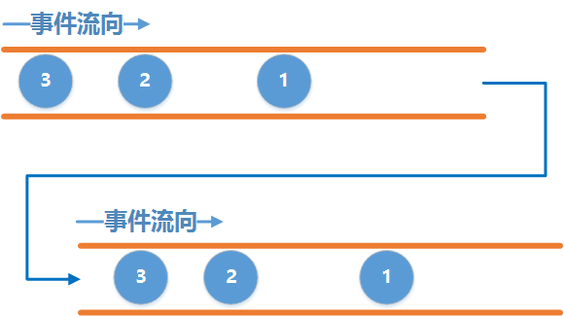

上游：被观察者Observable 下游：观察者Observer

连接：subscribe()方法

ObservableEmitter:事件发射器，主要用于发射事件，主要发送onNext(),onComplete(),onError()事件

* 上游可以发送无限个onNext, 下游也可以接收无限个onNext.
* 当上游发送了一个onComplete后, 上游onComplete之后的事件将会继续发送, 而下游收到onComplete事件之后将不再继续接收事件.
* 当上游发送了一个onError后, 上游onError之后的事件将继续发送, 而下游收到onError事件之后将不再继续接收事件.
* 上游可以不发送onComplete或onError.
* 最为关键的是onComplete和onError必须唯一并且互斥, 即不能发多个onComplete, 也不能发多个onError, 也不能先发一个onComplete, 然后再发一个onError, 反之亦然

注：如果发送了onComplete，再发送onError会抛异常。发多个onError也会抛异常

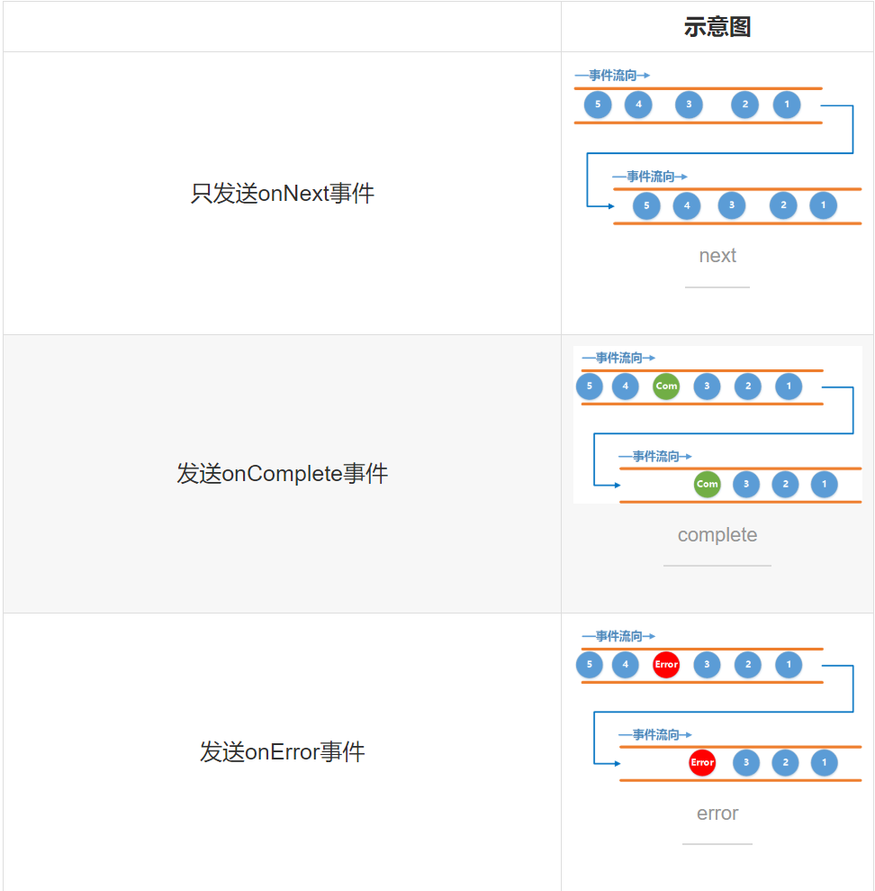

Disposable:截断器

可用于在下游选择截断事件，截断后下游就无法再收到事件了。

#### 2 线程切换

##### 1 线程切换

Rxjava强大之处在于方便的线程切换

例如如下，我们可以使上下游运行在不同的线程

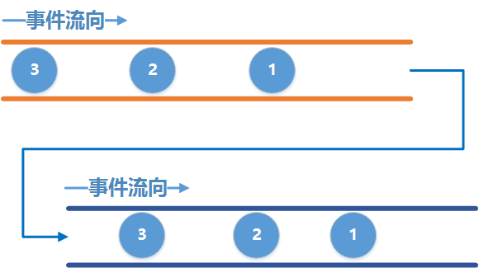

RxJava内置的线程调度器

被观察者线程调度器

**subscribeOn(Scheduler scheduler):指定发送者的线程**

观察者调度器

**observeOn(Scheduler scheduler):指定观察者的线程**

多次指定上游的线程只有第一次指定的有效, 也就是说多次调用subscribeOn() 只有第一次的有效, 其余的会被忽略.

多次指定下游的线程是可以的, 也就是说每调用一次observeOn() , 下游的线程就会切换一次.

Scheduler常有以下几种

**Schedulers.io()** 代表io操作的线程, 通常用于网络,读写文件等io密集型的操作

**Schedulers.computation()** 代表CPU计算密集型的操作, 例如需要大量计算的操作

**Schedulers.newThread()** 代表一个常规的新线程

**AndroidSchedulers.mainThread()** 代表Android的主线程

Observable.create(new ObservableOnSubscribe<String>() {

@Override

public void subscribe(ObservableEmitter<String> emitter) {

emitter.onNext("111");

emitter.onNext("222");

emitter.onNext("333");

//Schedulers.newThread()线程

LogManager.i(TAG,"subscribe " + Thread.currentThread());

// emitter.onComplete();

// emitter.onComplete();

// emitter.onNext("444");

emitter.onError(new UnknownError("ahhh"));

emitter.onComplete();

}

})

.subscribeOn(Schedulers.newThread())

.observeOn(AndroidSchedulers.mainThread())

.subscribe(new Observer<String>() {

@Override

public void onSubscribe(Disposable d) {

//当前线程，指调用该方法线程

LogManager.i(TAG,"onSubscribe " + Thread.currentThread());

}

@Override

public void onNext(String s) {

//主线程

LogManager.i(TAG,"onNext " + s + Thread.currentThread());

}

@Override

public void onError(Throwable e) {

LogManager.i(TAG,"onError " + Thread.currentThread());

}

@Override

public void onComplete() {

LogManager.i(TAG,"onComplete " + Thread.currentThread());

}

});

##### 2 同步订阅与异步订阅

**同步订阅**：当上下游工作在同一个线程中时, 这时候是一个**同步的订阅关系**, 也就是说上游每发送一个事件必须等到下游接收处理完了以后才能接着发送下一个事件.

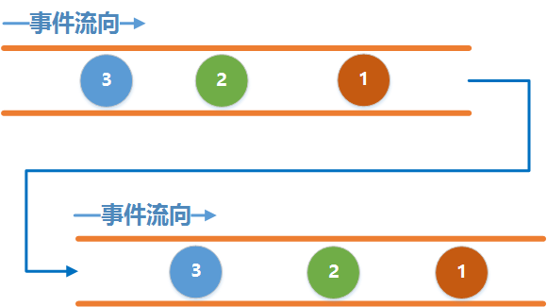

**异步订阅**：当上下游工作在不同的线程中时, 这时候是一个异步的订阅关系, 这个时候上游发送数据不需要等待下游接收, 为什么呢, 因为两个线程并不能直接进行通信, 因此上游发送的事件并不能直接到下游里去, 这个时候就需要一个田螺姑娘来帮助它们俩, 这个田螺姑娘就是我们刚才说的水缸 ! 上游把事件发送到水缸里去, 下游从水缸里取出事件来处理, 因此, 当上游发事件的速度太快, 下游取事件的速度太慢, 水缸就会迅速装满, 然后溢出来, 最后就OOM了.

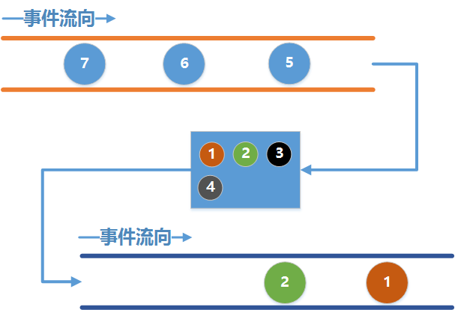

#### 3 操作符

##### Create

创建一个上游被观察者对象，即创建Observerable对象

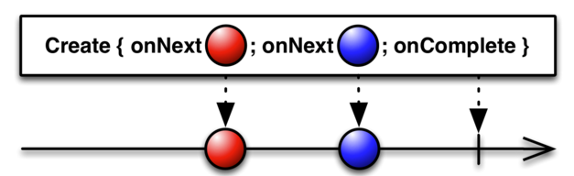

##### Map

Map是一个变换操作符，作用就是对上游发送的每一个事件应用一个函数, 使得每一个事件都按照指定的函数去变化. 用事件图表示如下

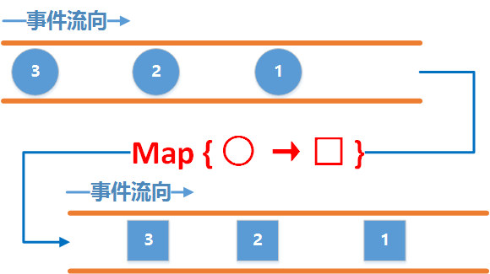

Observable.create(new ObservableOnSubscribe<Integer>() {

@Override

public void subscribe(ObservableEmitter<Integer> emitter) throws Exception {

LogManager.i(TAG, "ObservableEmitter onNext" + 1);

emitter.onNext(1);

LogManager.i(TAG, "ObservableEmitter onNext" + 2);

emitter.onNext(2);

LogManager.i(TAG, "ObservableEmitter onNext" + 3);

emitter.onNext(3);

LogManager.i(TAG, "ObservableEmitter onNext" + 4);

emitter.onNext(4);

}

}).map(new Function<Integer, String>() {

@Override

public String apply(Integer integer) throws Exception {

LogManager.i(TAG, "Function apply for:" + integer);

return "apply " + integer;

}

}).subscribe(new Observer<String>() {

@Override

public void onSubscribe(Disposable d) {

}

@Override

public void onNext(String s) {

LogManager.i(TAG, "Observer onNext " + s);

}

@Override

public void onError(Throwable e) {

}

@Override

public void onComplete() {

}

});

##### FlatMap

将上游的Observerable变换成多个发送事件的Observerables,然后将它们发射的事件合并后放进一个单独的Observable里.

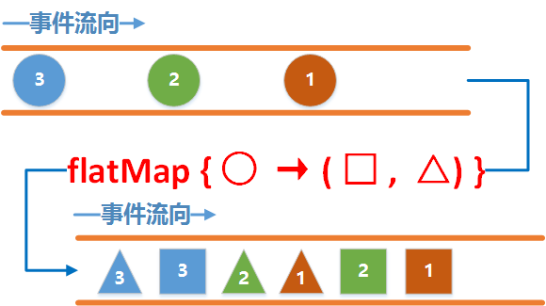

先看看上游, 上游发送了三个事件, 分别是1,2,3, 注意它们的颜色.

中间flatMap的作用是将圆形的事件转换为一个发送矩形事件和三角形事件的新的上游Observable.

还是不能理解? 别急, 再来看看分解动作:

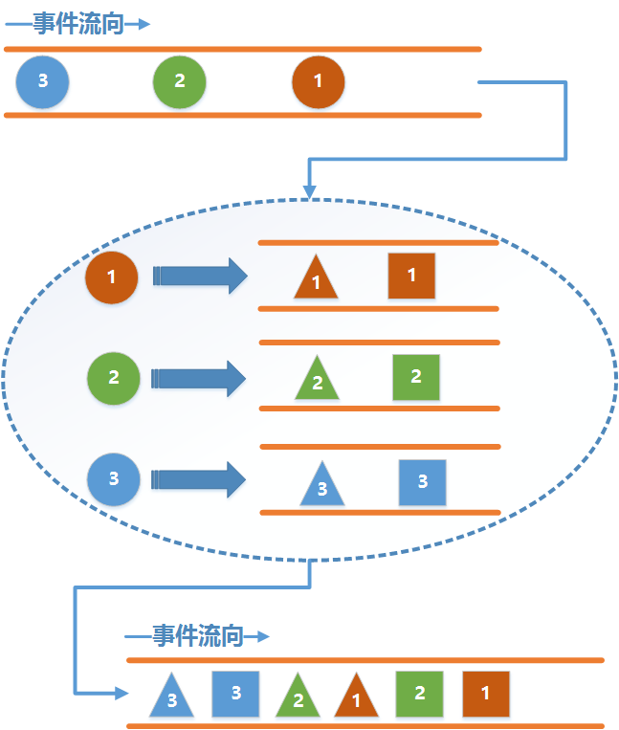

上游每发送一个事件, flatMap都将创建一个新的水管, 然后发送转换之后的新的事件, 下游接收到的就是这些新的水管发送的数据. 这里需要注意的是, flatMap并不保证事件的顺序, 也就是图中所看到的, 并不是事件1就在事件2的前面. 如果需要保证顺序则需要使用concatMap.

//测试FlatMap

Observable.create(new ObservableOnSubscribe<Integer>() {

@Override

public void subscribe(ObservableEmitter<Integer> emitter) {

emitter.onNext(1);

emitter.onNext(2);

emitter.onNext(3);

}

}).flatMap(new Function<Integer, ObservableSource<String>>() {

@Override

public ObservableSource<String> apply(Integer integer) throws Exception {

ArrayList<String> list = new ArrayList<>();

//将一个发射器变为5个发射器，并应用函数

for (int i = 0 ;i < 5;i++){

list.add(integer + "_" + i);

}

return Observable.fromIterable(list) ;

}

}).subscribe(new Consumer<String>() {

@Override

public void accept(String s) throws Exception {

LogManager.i(TAG, "Consumer accept " + s);

}

});

##### Zip

通过一个函数将多个Observable发送的事件结合到一起，然后发送这些组合到一起的事件. 它按照严格的顺序应用这个函数。它只发射与发射数据项最少的那个Observable一样多的数据。

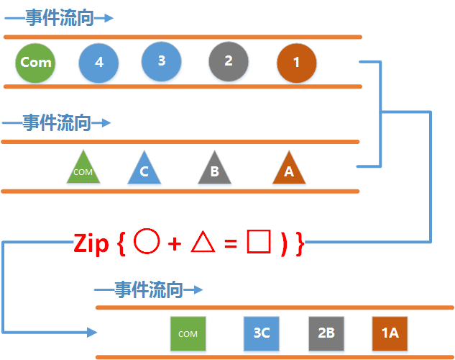

从这个图中可以看见, 这次上游和以往不同的是, 我们有两根水管了.

其中一根水管负责发送圆形事件 , 另外一根水管负责发送三角形事件 , 通过Zip操作符, 使得圆形事件 和三角形事件 合并为了一个矩形事件 .

下面我们再来看看分解动作：

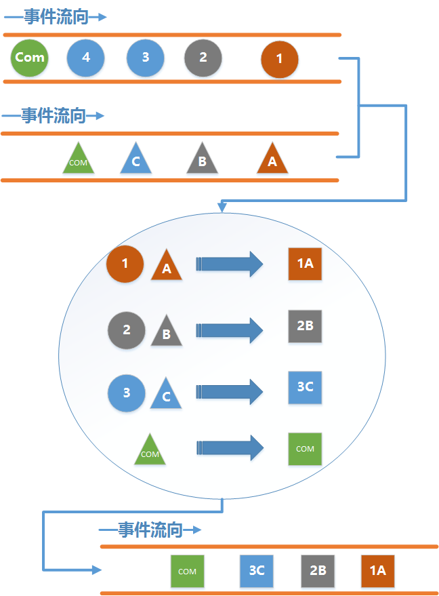

通过分解动作我们可以看出:

组合的过程是分别从 两根水管里各取出一个事件 来进行组合, 并且一个事件只能被使用一次, 组合的顺序是严格按照事件发送的顺利 来进行的, 也就是说不会出现圆形1 事件和三角形B 事件进行合并, 也不可能出现圆形2 和三角形A 进行合并的情况.

最终下游收到的事件数量 是和上游中发送事件最少的那一根水管的事件数量 相同. 这个也很好理解, 因为是从每一根水管 里取一个事件来进行合并, 最少的 那个肯定就最先取完 , 这个时候其他的水管尽管还有事件 , 但是已经没有足够的事件来组合了, 因此下游就不会收到剩余的事件了.

//两个在不同的线程中

Observable observable1 = Observable.create(new ObservableOnSubscribe<Integer>() {

@Override

public void subscribe(ObservableEmitter<Integer> emitter) {

emitter.onNext(1);

emitter.onNext(2);

emitter.onNext(3);

}

}).subscribeOn(Schedulers.io());

Observable observable2 = Observable.create(new ObservableOnSubscribe<String>() {

@Override

public void subscribe(ObservableEmitter<String> emitter) {

emitter.onNext("a");

emitter.onNext("b");

emitter.onNext("c");

emitter.onNext("d");

emitter.onNext("e");

}

}).subscribeOn(Schedulers.io());

Observable.zip(observable1, observable2, new BiFunction<Integer, String, String>() {

@Override

public String apply(Integer integer, String s) {

return s + "_" + integer;

}

}).subscribe(new Consumer<String>() {

@Override

public void accept(String o) throws Exception {

LogManager.i(TAG, "Consumer accept " + o);

}

});

Flowable

背压：背压是指在异步场景中，被观察者发送事件速度远快于观察者的处理速度的情况下，一种告诉上游的被观察者降低发送速度的策略。背压是流速控制的一种策略

### 2 Rxjava2应用场景

1 网络请求

注意Activity销毁的场景(截断操作)

2 查询，读取数据库

### 3 Rxjava2源码解析

1 基本订阅流程

2 线程切换

3

## 四 LeakCanary

### 1 原理

监测机制利用了Java的WeakReference和ReferenceQueue。

当被 WeakReference 引用的对象(Activity)的生命周期结束，一旦被 GC 检查到，GC 将会把该对象添加到 ReferenceQueue 中，待ReferenceQueue处理。当 GC 过后对象一直不被加入 ReferenceQueue，它可能存在内存泄漏

## 五 AndroidPerformanceMonitor

1 原理

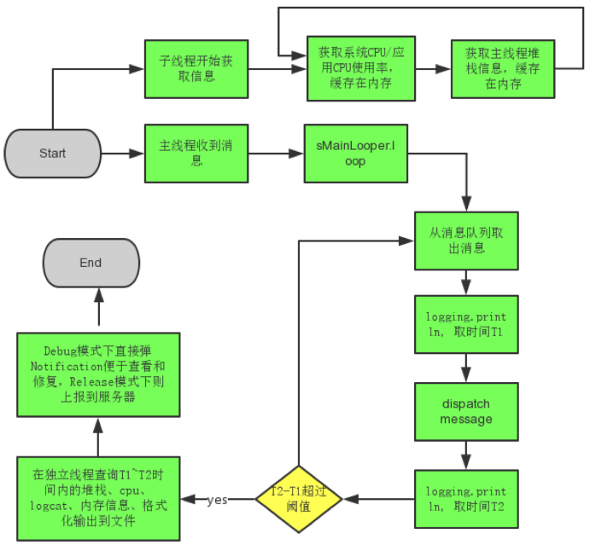

该组件利用了主线程的消息队列处理机制，通过

Looper.getMainLooper().setMessageLogging(mainLooperPrinter);

核心代码如下：

@Override

public void println(String x) {

if (mStopWhenDebugging && Debug.isDebuggerConnected()) {

return;

}

if (!mPrintingStarted) {

mStartTimestamp = System.currentTimeMillis();

mStartThreadTimestamp = SystemClock.currentThreadTimeMillis();

mPrintingStarted = true;

startDump();

} else {

final long endTime = System.currentTimeMillis();

mPrintingStarted = false;

if (isBlock(endTime)) {

notifyBlockEvent(endTime);

}

stopDump();

}

}

## 六 Glide

## 七 Dagger2

### 一 Dagger2的简单使用

#### 1 导入依赖

##### 1 基础依赖

//Dagger2

api "com.google.dagger:dagger:$dagger_version"

api "com.google.dagger:dagger-android-support:$dagger_version" //使用support包

##### 2 annotationProcessor依赖

annotationProcessor "com.google.dagger:dagger-compiler:$dagger_compiler_version"

annotationProcessor “com.google.dagger:dagger-android-processor: $ version “

##### 3 kotlin依赖

如果是使用kotlin，则需要引入以下依赖

//Dagger2

kapt "com.google.dagger:dagger-compiler:$dagger_version"

kapt "com.google.dagger:dagger-android-processor:$dagger_version"

#### 2 使用实例

##### 1 不带Module的Inject方式

使用Inject和Component

@Inject 修饰被依赖的类及需要注入的类

@Component Component就是注入者与被注入者之间联系的桥梁

/**

* @author Created by qiyei2015 on 2018/10/7.

* @version: 1.0

* @email: 1273482124@qq.com

* @description:

*/

public class User {

int id;

String name;

@Inject

public User() {

id = 10;

name = "hello";

}

/**

* @return {@link #id}

*/

public int getId() {

return id;

}

/**

* @param id the {@link #id} to set

*/

public void setId(int id) {

this.id = id;

}

/**

* @return {@link #name}

*/

public String getName() {

return name;

}

/**

* @param name the {@link #name} to set

*/

public void setName(String name) {

this.name = name;

}

}

/**

* @author Created by qiyei2015 on 2018/10/7.

* @version: 1.0

* @email: 1273482124@qq.com

* @description:

*/

@Component

public interface DaggerDemoComponent {

/**

* 需要注入的对象

* @param activity

*/

void inject(DaggerDemoActivity activity);

}

第一，将我们需要注入的对象的类的构造参数使用@Inject标注，告诉dagger2它可以实例化这个类；

第二，编写Component接口使用@Component进行标注，里面的void inject()的参数表示要将依赖注入到的目标位置；

第三，使用android studio的Build菜单编译一下项目，使它自动生成我们编写的Component所对应的类，生成的类的名字的格式为 "Dagger+我们所定义的Component的名字"；

第四，在需要注入的类中使用@Inject标注要注入的变量；然后调用自动生成的Component类的方法create()或builder().build()，然后inject到当前类；在这之后就可以使用这个@Inject标注的变量了。

使用如下：

/**

* @author Created by qiyei2015 on 2018/6/7.

* @version: 1.0

* @email: 1273482124@qq.com

* @description:

*/

public class DaggerDemoActivity extends AppCompatActivity {

/**

* 需要包级可见

*/

@Inject

User mUser;

// @Inject

// UserModel mUserModel;

@Override

protected void onCreate(Bundle savedInstanceState) {

super.onCreate(savedInstanceState);

setContentView(R.layout.activity_dagger_demo);

findViewById(R.id.button).setOnClickListener(new View.OnClickListener() {

@Override

public void onClick(View v) {

ToastUtil.showLongToast(mUser.getName());

}

});

findViewById(R.id.button2).setOnClickListener(new View.OnClickListener() {

@Override

public void onClick(View v) {

// mUserModel.getName();

}

});

DaggerDaggerDemoComponent.create().inject(this);

}

}

可以看到，这样mUser就被注入了

上面是对于无参数的注入，对于有参数的注入，只需要在所依赖的参数类型的变量也添加注入@Inject即可

/**

* @author Created by qiyei2015 on 2018/10/7.

* @version: 1.0

* @email: 1273482124@qq.com

* @description:

*/

public class WarpUser {

private User mUser;

@Inject

public WarpUser(User user) {

mUser = user;

}

public String getName(){

return mUser.getName();

}

}

如上所示，我们还需要将User的构造方法也用@Inject修饰即可

使用如下：

/**

* @author Created by qiyei2015 on 2018/6/7.

* @version: 1.0

* @email: 1273482124@qq.com

* @description:

*/

public class DaggerDemoActivity extends AppCompatActivity {

// /**

// * 需要包级可见

// */

// @Inject

// User mUser;

@Inject

WarpUser mWarpUser;

// @Inject

// UserModel mUserModel;

@Override

protected void onCreate(Bundle savedInstanceState) {

super.onCreate(savedInstanceState);

setContentView(R.layout.activity_dagger_demo);

findViewById(R.id.button).setOnClickListener(new View.OnClickListener() {

@Override

public void onClick(View v) {

//ToastUtil.showLongToast(mUser.getName());

}

});

findViewById(R.id.button2).setOnClickListener(new View.OnClickListener() {

@Override

public void onClick(View v) {

ToastUtil.showLongToast(mWarpUser.getName());

// mUserModel.getName();

}

});

DaggerDaggerDemoComponent.create().inject(this);

}

}

简单讲一下注入过程

当调用DaggerDaggerDemoComponent.create().inject(this);首先会检查被@Inject标记的变量，这里只有一个WarpUser mWarpUser，那么会看DaggerDaggerDemoComponent是否有Module类型的注入，这里没有，接着就会直接查找

WarpUser的构造函数是否被@Inject修饰，如果没有则注入失败

接着发现WarpUser的构造函数有参数User，接下来检查参数User的的构造方法是否被@Inject标记，如果没有则

注入失败，否则继续注入下去。

##### 2 带Module的Inject方式

直接给构造函数添加@Inject标注的方式对于我们自己编写的代码肯定是没问题，但若是我们引入的第三方库不能随意改动代码的话就不方便了，这个时候需要编写Module类手工来提供构造实例的方式

这里以UserModel的注入为例，演示带Module是如何注入的

第一步，编写Module类并使用@Module标注这个类，编写方法返回值为我们需要inject的类型并使用@Provides标注这个方法；

/**

* @author Created by qiyei2015 on 2018/10/7.

* @version: 1.0

* @email: 1273482124@qq.com

* @description:

*/

@Module

public class UserModelModule {

@Provides

public UserModel providerUserModel(){

return new UserModel();

}

}

第二步，编写Component接口，使用@Component标注这个接口，并使用modules=的方法链接上第一步中编写的Module类；

@Component(modules = UserModelModule.class)

public interface UserModelComponent {

/**

* 需要注入的对象

* @param activity

*/

void inject(DaggerDemoActivity activity);

}

使用如下：

/**

* @author Created by qiyei2015 on 2018/6/7.

* @version: 1.0

* @email: 1273482124@qq.com

* @description:

*/

public class DaggerDemoActivity extends AppCompatActivity {

/**

* 需要包级可见

// */

// @Inject

// User mUser;

//

// @Inject

// WarpUser mWarpUser;

@Inject

UserModel mUserModel;

@Override

protected void onCreate(Bundle savedInstanceState) {

super.onCreate(savedInstanceState);

setContentView(R.layout.activity_dagger_demo);

findViewById(R.id.button).setOnClickListener(new View.OnClickListener() {

@Override

public void onClick(View v) {

// ToastUtil.showLongToast(mUser.getName());

}

});

findViewById(R.id.button2).setOnClickListener(new View.OnClickListener() {

@Override

public void onClick(View v) {

// ToastUtil.showLongToast(mWarpUser.getName());

mUserModel.getName();

}

});

// DaggerDaggerDemoComponent.create().inject(this);

DaggerUserModelComponent.builder()

.userModelModule(new UserModelModule())

.build()

.inject(this);

}

}

之后的步骤就和 1 中的inject一样了。

如果我们希望在使用的时候才传入一些配置，直接使用Module的构造参数传入即可

在注入目标对象时，我们的注入方式也需要改变一下

优先级

Module优先级高于Inject构造函数

## 八 Replugin

### 1 Replugin总体架构

先分析宿主

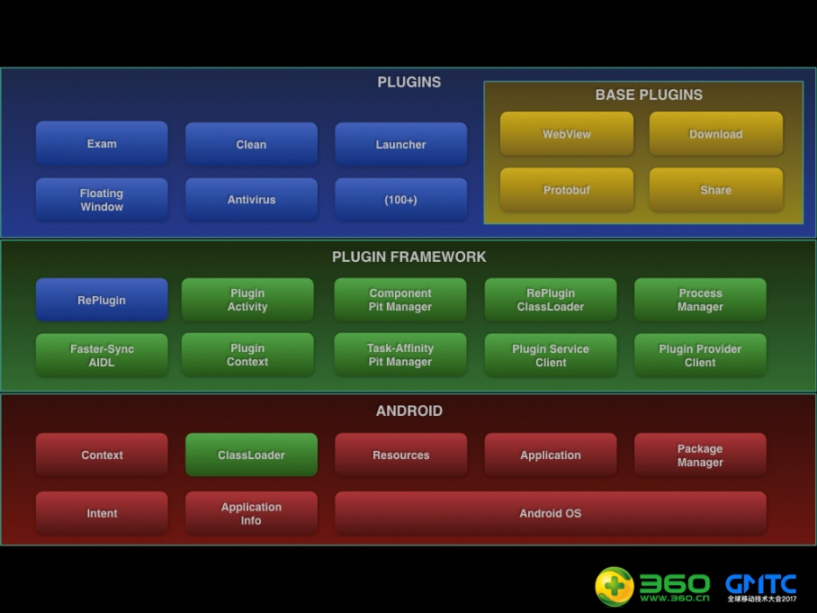

其实Replugin和核心框架如下：

Replugin有三个核心，分别是

* Replugin核心框架的初始化：Replugin的整个实现的主体，整体框架感觉非常像一个微型的Android系统，对所有插件的控制操作和系统的AMS等一些类非常的相似
* Hook住系统的ClassLoader：这也是Replugin与其他插件框架众不同之处，唯一的Hook点保证了系统的稳定性和后期的维护成本
* 加载默认插件：在上面两点初始化完成后，进行了默认插件的加载，加载插件并不只是主程序的工作，其实还要初始化插件工程，将主工程和插件工程绑定，后面才可以完美的相互调用。

### 2 Replugin核心框架初始化

Replugin的初始化有两种，要么继承RePluginApplication要么调用RePlugin.App的各种方法来进行初始话，这里我们就从Replugin.App来开始分析

#### 1 初始化入口Replugin.App.attachBaseContext()

public static void attachBaseContext(Application app, RePluginConfig config) {

if (sAttached) {

if (LogDebug.LOG) {

LogDebug.d(TAG, "attachBaseContext: Already called");

}

return;

}

RePluginInternal.init(app);

sConfig = config;

sConfig.initDefaults(app);

IPC.init(app);

// 打印当前内存占用情况

// 只有开启“详细日志”才会输出，防止“消耗性能”

if (LOG && RePlugin.getConfig().isPrintDetailLog()) {

LogDebug.printMemoryStatus(LogDebug.TAG, "act=, init, flag=, Start, pn=, framework, func=, attachBaseContext, lib=, RePlugin");

}

// 初始化HostConfigHelper（通过反射HostConfig来实现）

// NOTE 一定要在IPC类初始化之后才使用

HostConfigHelper.init();

// FIXME 此处需要优化掉

AppVar.sAppContext = app;

// Plugin Status Controller

PluginStatusController.setAppContext(app);

PMF.init(app);

PMF.callAttach();

sAttached = true;

}

主要做了以下几件事

1. 初始化RePluginInternal
2. 保存Replugin配置RePluginConfig，获取插件安装目录，即context.getFilesDir()并初始化RePluginCallbacks和RePluginEventCallbacks等，用于Replugin API使用回调等
3. 初始化IPC
4. 初始化HostConfigHelper
5. 初始化PluginStatusController
6. 初始化PMF

从这里我们也可以看出Replugin中框架层的几个类RePluginInternal，IPC，HostConfigHelper，PluginStatusController，PMF等，下面依次介绍这些类

RePluginInternal：Replugin内部使用的一些接口，主要用于获取应用本身的Context及Classloader

IPC：用于“进程间通信”的类。插件和宿主可使用此类来做一些跨进程发送广播、判断进程等工作。

HostConfigHelper：宿主配置操作的相关类，从宿主的 RePluginHostConfig 中获取一些字段值，RepluginHostConfig 文件由 replugin-host-gradle 自动生成

PluginStatusController:插件状态控制器，用来管理插件的状态：正常运行、被禁用，还是其它情况

PMF:框架和主程序接口

#### 2 RePluginInternal.init()

static void init(Application app) {

sAppContext = app;

}

主要是缓存Application,其他没做什么

#### 3 IPC.init()

接着分析IPC.init(app)

/**

* [HIDE] 外界请不要调用此方法

*/

public static void init(Context context) {

sCurrentProcess = SysUtils.getCurrentProcessName();

sCurrentPid = Process.myPid();

sPackageName = context.getApplicationInfo().packageName;

// 设置最终的常驻进程名

if (HostConfigHelper.PERSISTENT_ENABLE) {

String cppn = HostConfigHelper.PERSISTENT_NAME;

if (!TextUtils.isEmpty(cppn)) {

if (cppn.startsWith(":")) {

sPersistentProcessName = sPackageName + cppn;

} else {

sPersistentProcessName = cppn;

}

}

} else {

sPersistentProcessName = sPackageName;

}

sIsUIProcess = sCurrentProcess.equals(sPackageName);

sIsPersistentProcess = sCurrentProcess.equals(sPersistentProcessName);

}

1. 获取当前正在运行的进程( /proc/self/cmdline),进程id,包名等
2. 判断是否使用常驻进程作为插件的管理进程，如果是设置给sPersistentProcessName变量，如果不是默认使用该应用的主进程来作为插件管理进程
3. 判断当前进程是否是UI进程和常驻进程，并分别赋值给sIsUIProcess和sPersistentProcessName

#### 4 HostConfigHelper.init()

该方法为null,主要初始化该类的static{}

static {

try {

HOST_CONFIG_CLASS = ReflectUtils.getClass(HOST_CONFIG_FILE_PATH + HOST_CONFIG_FILE_NAME);

} catch (ClassNotFoundException e) {

// Ignore, Just use default value

}

try {

PERSISTENT_ENABLE = readField("PERSISTENT_ENABLE");

} catch (NoSuchFieldException e) {

// Ignore, Just use default value

}

try {

PERSISTENT_NAME = readField("PERSISTENT_NAME");

} catch (NoSuchFieldException e) {

// Ignore, Just use default value

}

try {

ACTIVITY_PIT_USE_APPCOMPAT = readField("ACTIVITY_PIT_USE_APPCOMPAT");

} catch (NoSuchFieldException e) {

// Ignore, Just use default value

}

try {

ACTIVITY_PIT_COUNT_TS_STANDARD = readField("ACTIVITY_PIT_COUNT_TS_STANDARD");

} catch (NoSuchFieldException e) {

// Ignore, Just use default value

}

try {

ACTIVITY_PIT_COUNT_TS_SINGLE_TOP = readField("ACTIVITY_PIT_COUNT_TS_SINGLE_TOP");

} catch (NoSuchFieldException e) {

// Ignore, Just use default value

}

try {

ACTIVITY_PIT_COUNT_TS_SINGLE_TASK = readField("ACTIVITY_PIT_COUNT_TS_SINGLE_TASK");

} catch (NoSuchFieldException e) {

// Ignore, Just use default value

}

try {

ACTIVITY_PIT_COUNT_TS_SINGLE_INSTANCE = readField("ACTIVITY_PIT_COUNT_TS_SINGLE_INSTANCE");

} catch (NoSuchFieldException e) {

// Ignore, Just use default value

}

try {

ACTIVITY_PIT_COUNT_NTS_STANDARD = readField("ACTIVITY_PIT_COUNT_NTS_STANDARD");

} catch (NoSuchFieldException e) {

// Ignore, Just use default value

}

try {

ACTIVITY_PIT_COUNT_NTS_SINGLE_TOP = readField("ACTIVITY_PIT_COUNT_NTS_SINGLE_TOP");

} catch (NoSuchFieldException e) {

// Ignore, Just use default value

}

try {

ACTIVITY_PIT_COUNT_NTS_SINGLE_TASK = readField("ACTIVITY_PIT_COUNT_NTS_SINGLE_TASK");

} catch (NoSuchFieldException e) {

// Ignore, Just use default value

}

try {

ACTIVITY_PIT_COUNT_NTS_SINGLE_INSTANCE = readField("ACTIVITY_PIT_COUNT_NTS_SINGLE_INSTANCE");

} catch (NoSuchFieldException e) {

// Ignore, Just use default value

}

try {

ACTIVITY_PIT_COUNT_TASK = readField("ACTIVITY_PIT_COUNT_TASK");

} catch (NoSuchFieldException e) {

// Ignore, Just use default value

}

try {

ADAPTER_COMPATIBLE_VERSION = readField("ADAPTER_COMPATIBLE_VERSION");

} catch (NoSuchFieldException e) {

// Ignore, Just use default value

}

try {

ADAPTER_CURRENT_VERSION = readField("ADAPTER_CURRENT_VERSION");

} catch (NoSuchFieldException e) {

// Ignore, Just use default value

}

}

可以看到，主要通过反射的方式去读取RePluginHostConfig的配置信息，该类由编译时自动生成

#### 5 PluginStatusController.setAppContext()

/** 设置ApplicationContext，仅在MobileSafeApplication中使用 */

public static void setAppContext(Application context) {

sAppContext = context;

}

该方法也主要是缓存Application Context

#### 6 PMF.init()框架核心初始化

/**

* @param application

*/

public static final void init(Application application) {

setApplicationContext(application);

PluginManager.init(application);

sPluginMgr = new PmBase(application);

sPluginMgr.init();

Factory.sPluginManager = PMF.getLocal();

Factory2.sPLProxy = PMF.getInternal();

PatchClassLoaderUtils.patch(application);

}

先来看PmBase的初始化

PmBase (Context context) {

//

mContext = context;

// TODO init

//init(context, this);

if (PluginManager.sPluginProcessIndex == IPluginManager.PROCESS_UI || PluginManager.isPluginProcess()) {

String suffix;

if (PluginManager.sPluginProcessIndex == IPluginManager.PROCESS_UI) {

suffix = "N1";

} else {

suffix = "" + PluginManager.sPluginProcessIndex;

}

//

mContainerProviders.add(IPC.getPackageName() + CONTAINER_PROVIDER_PART + suffix);

//

mContainerServices.add(IPC.getPackageName() + CONTAINER_SERVICE_PART + suffix);

}

//

mClient = new PluginProcessPer(context, this, PluginManager.sPluginProcessIndex, mContainerActivities);

//

mLocal = new PluginCommImpl(context, this);

//

mInternal = new PluginLibraryInternalProxy(this);

}

初始化主要做了以下几件事

(1)根据当前进程类型，拼接坑位provider和Service所对应名称并存入不同的HashSet中，PmBase类中处理保存了Provider、Service、Activitiy的坑位信息，这些名字全部都是Replugin在编译的时候在AndroidManifest.xml中声明的坑位名字

在set中加入provider的名字:包名.loader.p.ProviderN1 或者 包名.loader.p.Provider0 或者 包名.loader.p.Provider1

在set中加入service的名称 包名.loader.s.ServiceN1 或者 包名.loader.s.Service0 或者包名.loader.s.Service1

1. 创建了PluginProcessPer类，代表了当前Clent进程, 它是一个Binder对象，它代表了“当前Clent端”，使用它来和Server端进行通信，这个类的构造中有创建了两个类，一个是PluginContainers，用来管理Activity坑位信息的容器，初始化了多种不同启动模式和样式Activity的坑位信息。另一个PluginServiceServer类，这个类是Replugin中的一个核心类，主要负责了对Service的提供和调度工作，例如startService、stopService、bindService、unbindService全部都由这个类管理
2. 创建了PluginCommImpl类，负责宿主与插件、插件间的互通，可通过插件的Factory直接调用，也可通过RePlugin来跳转,创建的时候只是引用了Application和PmBase
3. 创建了一个PluginLibraryInternalProxy类，Replugin框架中内部逻辑使用的很多方法都在这里，包括插件中通过“反射”调用的内部逻辑如PluginActivity类的调用、Factory2等

接下来我们看PmBase初始化

void init() {

RePlugin.getConfig().getCallbacks().initPnPluginOverride();

if (HostConfigHelper.PERSISTENT_ENABLE) {

// （默认）“常驻进程”作为插件管理进程，则常驻进程作为Server，其余进程作为Client

if (IPC.isPersistentProcess()) {

// 初始化“Server”所做工作

initForServer();

} else {

// 连接到Server

initForClient();

}

} else {

// “UI进程”作为插件管理进程（唯一进程），则UI进程既可以作为Server也可以作为Client

if (IPC.isUIProcess()) {

// 1. 尝试初始化Server所做工作，

initForServer();

// 2. 注册该进程信息到“插件管理进程”中

// 注意：这里无需再做 initForClient，因为不需要再走一次Binder

PMF.sPluginMgr.attach();

} else {

// 其它进程？直接连接到Server即可

initForClient();

}

}

// 最新快照

PluginTable.initPlugins(mPlugins);

// 输出

if (LOG) {

for (Plugin p : mPlugins.values()) {

LogDebug.d(PLUGIN_TAG, "plugin: p=" + p.mInfo);

}

}

}

主要做了以下几件事

1. 根据当前是常驻进程还是非常驻进程进行initForServer()和initForClient()

常驻进程或UI进程作为server需要initForServer()，非常驻进程不是UI进程需要initForClient()

那么我们来看initForServer()

/**

* Persistent(常驻)进程的初始化

*

*/

private final void initForServer() {

if (LOG) {

LogDebug.d(PLUGIN_TAG, "search plugins from file system");

}

mHostSvc = new PmHostSvc(mContext, this);

PluginProcessMain.installHost(mHostSvc);

PluginProcessMain.schedulePluginProcessLoop(PluginProcessMain.CHECK_STAGE1_DELAY);

// 兼容即将废弃的p-n方案 by Jiongxuan Zhang

mAll = new Builder.PxAll();

Builder.builder(mContext, mAll);

refreshPluginMap(mAll.getPlugins());

// [Newest!] 使用全新的RePlugin APK方案

// Added by Jiongxuan Zhang

try {

List<PluginInfo> l = PluginManagerProxy.load();

if (l != null) {

// 将"纯APK"插件信息并入总的插件信息表中，方便查询

// 这里有可能会覆盖之前在p-n中加入的信息。本来我们就想这么干，以"纯APK"插件为准

refreshPluginMap(l);

}

} catch (RemoteException e) {

if (LOGR) {

LogRelease.e(PLUGIN_TAG, "lst.p: " + e.getMessage(), e);

}

}

}

这里的看点就非常的多了

1. 这里最主要是就是创建了PmHostSvc类，这个类可以理解成是我们的Server端，它直接或间接参与了Server端要做的所有事情，
2. 将PmHostSvc对象赋值给了PluginProcessMain的sPluginHostLocal，并连接到server,就是返回了server的PluginManagerServer中的stub binder对象给了PluginManagerProxy的sRemote对象
3. PluginProcessMain清理之前的任务
4. 初始化Builder.PxAll对象，这个类里封装了各种插件类型的集合，还有生成插件模型信息和删除信息的方法
5. 搜索所有本地插件和V5插件信息,并添加进Builder集合中就是mAll字段,然后删除一些不符合规则的插件信息

//这里搜索了所以本地插件，也就是放在assest中的插件，是通过插件自动生成的json文件来扫描的

//v5是通过context.getDir路径来扫描的

1. 将刚扫描的本地插件封装成Plugin添加进mPlugins中，mPlugins代表所有插件的集合

总结initForServer()

1、首先创建了一个PmHostSvc对象，这个类继承IPluginHost.Stub，是一个IPluginHost类型的Binder对象，可以说所有的插件的管理工作都是直接或者间接由它处理的，PmHostSvc它代表了Server端要处理的事情，也就是插件管理进程处理的事情

2、在PmHostSvc的构造方法中又创建了两个对象，一个是PluginServiceServer，这个类是用来管理插件Service的远程Server端，还有一个是PluginManagerServer，这个类在创建的时候在构造中又创建了一个继承自IPluginServiceServer.Stub的Stub对象，Stub也是一个Binder对象，通过后来查看IPluginServiceServer的代码，发现这个类掌管了所有对插件的的操作，例如插件的安装、加载、卸载、更新等等

3、调用PluginProcessMain.installHost(mHostSvc)方法将PmHostSvc对象也就是IPluginHost类型赋值给PluginProcessMain中的字段sPluginHostLocal，这个IPluginHost是Binder对象。接着调用了IPluginHost.fetchManagerServer()方法将PluginManagerServer中的Stub对象，也就是IPluginServiceServer类型的Binder对象赋值给PluginManagerProxy类中的字段sRemote，这个IPluginServiceServer类型的Binder对象掌握了对插件的安装、卸载、更新等等的操作

4、剩下的几行代码全部都是来更新插件信息的。先搜索本地插件和V5插件信息，创建插件模型并添加进Builder.PxAll相应的集合中，然后判断删除一些不符合规则的信息，然后同步所有的插件信息，最后判断是否有插件需要更新或删除，对应的执行一些操作。本地插件的扫描是通过assest目录下的一个叫plugins-builtin.json的文件，这个文件是replugin-host-gradle插件自动生成的。V5插件是通过context.getDir的文件目录遍历

initForClient()

/**

* Client(UI进程)的初始化

*

*/

private final void initForClient() {

if (LOG) {

LogDebug.d(PLUGIN_TAG, "list plugins from persistent process");

}

// 1. 先尝试连接

PluginProcessMain.connectToHostSvc();

// 2. 然后从常驻进程获取插件列表

refreshPluginsFromHostSvc();

}

先连接到Server端，也就是插件的管理进程。然后从常驻进程获取插件列表，判断列表中是否有需要更新的插件，如果有调用Binder对象在Server端更新插件信息,后续操作都和上边分析过的initForServer()中更新插件信息类似,我们就主要看一下是怎么连接到Server端的就好了

PluginProcessMain. connectToHostSvc()

/**

* 非常驻进程调用，获取常驻进程的 IPluginHost

*/

static final void connectToHostSvc() {

Context context = PMF.getApplicationContext();

//

IBinder binder = PluginProviderStub.proxyFetchHostBinder(context);

if (LOG) {

LogDebug.d(PLUGIN_TAG, "host binder = " + binder);

}

if (binder == null) {

// 无法连接到常驻进程，当前进程自杀

if (LOGR) {

LogRelease.e(PLUGIN_TAG, "p.p fhb fail");

}

System.exit(1);

}

//

try {

binder.linkToDeath(new IBinder.DeathRecipient() {

@Override

public void binderDied() {

if (LOGR) {

LogRelease.i(PLUGIN_TAG, "p.p d, p.h s n");

}

// 检测到常驻进程退出，插件进程自杀

if (PluginManager.isPluginProcess()) {

if (LOGR) {

// persistent process exception, PLUGIN process quit now

LogRelease.i(MAIN_TAG, "p p e, pp q n");

}

System.exit(0);

}

sPluginHostRemote = null;

// 断开和插件化管理器服务端的连接，因为已经失效

PluginManagerProxy.disconnect();

}

}, 0);

} catch (RemoteException e) {

// 无法连接到常驻进程，当前进程自杀

if (LOGR) {

LogRelease.e(PLUGIN_TAG, "p.p p.h l2a: " + e.getMessage(), e);

}

System.exit(1);

}

//

sPluginHostRemote = IPluginHost.Stub.asInterface(binder);

if (LOG) {

LogDebug.d(PLUGIN_TAG, "host binder.i = " + PluginProcessMain.sPluginHostRemote);

}

// 连接到插件化管理器的服务端

// Added by Jiongxuan Zhang

try {

PluginManagerProxy.connectToServer(sPluginHostRemote);

// 将当前进程的"正在运行"列表和常驻做同步

// TODO 若常驻进程重启，则应在启动时发送广播，各存活着的进程调用该方法来同步

PluginManagerProxy.syncRunningPlugins();

} catch (RemoteException e) {

// 获取PluginManagerServer时出现问题，可能常驻进程突然挂掉等，当前进程自杀

if (LOGR) {

LogRelease.e(PLUGIN_TAG, "p.p p.h l3a: " + e.getMessage(), e);

}

System.exit(1);

}

// 注册该进程信息到“插件管理进程”中

PMF.sPluginMgr.attach();

}

这里获取binder的原理是通过Provider传递Binder来实现多进程沟通的，关于这一点可以详细的跟踪代码

这个Provider的uri是：content://包名.loader.p.main/main，包名每个宿主都不一样，注意要去宿主的AndroidManifest.xml中去搜索

/**

* 从HostSvc（插件管理所在进程）获取所有的插件信息

*/

private void refreshPluginsFromHostSvc() {

List<PluginInfo> plugins = null;

try {

plugins = PluginProcessMain.getPluginHost().listPlugins();

} catch (Throwable e) {

if (LOGR) {

LogRelease.e(PLUGIN_TAG, "lst.p: " + e.getMessage(), e);

}

}

// 判断是否有需要更新的插件

// FIXME 执行此操作前，判断下当前插件的运行进程，具体可以限制仅允许该插件运行在一个进程且为自身进程中

List<PluginInfo> updatedPlugins = null;

if (isNeedToUpdate(plugins)) {

if (LOG) {

LogDebug.d(PLUGIN_TAG, "plugins need to perform update operations");

}

try {

updatedPlugins = PluginManagerProxy.updateAllPlugins();

} catch (RemoteException e) {

e.printStackTrace();

}

}

if (updatedPlugins != null) {

refreshPluginMap(updatedPlugins);

} else {

refreshPluginMap(plugins);

}

}

插件管理进程：initForServer()

插件管理进程最主要干的事情就是创建了PmHostSvc这个Binder对象，它其中还管理着另外两个重要的Binder对象一个是用来管理Service的PluginServiceServer，还有一个是来管理插件安装、卸载等的PluginManagerServer。接着从assest的json文件中和v5安装目录中扫描本地的插件信息，将信息添加进一个叫mPlugins的ConcurrentHashMap中，然后再去查看之前是否有已经安装的插件，如果有判断是否需要更新、删除等操作，并做相应的处理后返回处理后的插件信息集合，将集合中的内容也添加进mPlugins中。存入的key是包名或者别名，value是Plugin

其他进程：initForClient()

这个进程干的事情就简单了，就是通过Provider的方式请求插件管理进程返回PmHostSvc这个Binder对象，接着通过PmHostSvc再得到PluginManagerServer这个Binder对象并把当前进程信息注册到Server端，最后通过得到的Binder对象来同步进程信息和更新插件信息，

2）在上面各进程操作完后会遍历mPlugins中的所有插件信息，并将他们存入到一个叫PluginTable类中一个叫PLUGINS的HashMap中，存入的key是包名或者别名，value是PluginInfo，这就是

#### 7 PMF.callAttach()

该方法直接调用了PmBase.callAttach()

public static final void callAttach() {

sPluginMgr.callAttach();

}

PmBase.callAttach()

final void callAttach() {

//

mClassLoader = PmBase.class.getClassLoader();

// 挂载

for (Plugin p : mPlugins.values()) {

p.attach(mContext, mClassLoader, mLocal);

}

// 加载默认插件

if (PluginManager.isPluginProcess()) {

if (!TextUtils.isEmpty(mDefaultPluginName)) {

//

Plugin p = mPlugins.get(mDefaultPluginName);

if (p != null) {

boolean rc = p.load(Plugin.LOAD_APP, true);

if (!rc) {

if (LOG) {

LogDebug.d(PLUGIN_TAG, "failed to load default plugin=" + mDefaultPluginName);

}

}

if (rc) {

mDefaultPlugin = p;

mClient.init(p);

}

}

}

}

}

核心框架初始化总结：

Replugin框架将插件的管理工作统一放在一个进程中，而其他进程需要通过插件管理进程返回的Binder对象来进行操作，这样既保证了信息的安全性，又可以分担其他进程的工作压力。框架的初始化主要创建了一些来管理和操作插件的Binder对象，然后通过区分进程来分别初始化插件管理进程和Clent进程各自要做的事情，插件管理进程主要是对插件信息的更新和维护，而Clent进程主要是需要获取到插件管理的进程的Binder对象来进行后续的操作等,在各进程出来完后会将所有插件的进行进行存储，然后hook系统ClassLoader，最后加载了默认插件。

### 3 hook系统classloader

hook系统classloader主要在PMF.init()方法中

public static final void init(Application application) {

setApplicationContext(application);

PluginManager.init(application);

sPluginMgr = new PmBase(application);

sPluginMgr.init();

Factory.sPluginManager = PMF.getLocal();

Factory2.sPLProxy = PMF.getInternal();

PatchClassLoaderUtils.patch(application);

}

### 4 插件的安装,卸载

### 5 activity启动原理

## 九 ButterKnife

## 十 ARouter

# 第九部分 Gradle

## 一 gradle 基础用法

### 1 基本配置

基本配置主要有以下配置

apply plugin: 'com.android.application'

android {

compileSdkVersion rootProject.ext.compileSdkVersion

buildToolsVersion rootProject.ext.buildToolsVersion

defaultConfig {

applicationId "com.qiyei.essayjoke"

minSdkVersion rootProject.ext.minSdkVersion

targetSdkVersion rootProject.ext.targetSdkVersion

versionCode 1

versionName "1.0"

testInstrumentationRunner "android.support.test.runner.AndroidJUnitRunner"

externalNativeBuild {

cmake {

cppFlags ""

}

}

}

compileOptions {

sourceCompatibility JavaVersion.VERSION_1_8

targetCompatibility JavaVersion.VERSION_1_8

}

buildTypes {

debug {

minifyEnabled false

proguardFiles getDefaultProguardFile('proguard-android.txt'), 'proguard-rules.pro'

}

release {

minifyEnabled true

proguardFiles getDefaultProguardFile('proguard-android.txt'), 'proguard-rules.pro'

}

}

externalNativeBuild {

cmake {

path "CMakeLists.txt"

}

}

sourceSets {

main {

jni.srcDirs = ['src/main/jni', 'src/main/cpp/']

jniLibs.srcDirs = ['libs'] //配置生成jniLibs

}

}

//解决国际化资源文件不全

lintOptions{

checkReleaseBuilds false

abortOnError false

}

}

dependencies {

api fileTree(include: ['*.jar'], dir: 'libs')

androidTestImplementation('com.android.support.test.espresso:espresso-core:2.2.2', {

exclude group: 'com.android.support', module: 'support-annotations'

})

api 'com.android.support:appcompat-v7:26.0.0'

api 'com.makeramen:roundedimageview:2.2.1'

testImplementation 'junit:junit:4.12'

api project(':Framework')

}

2 签名配置signingConfigs

signingConfigs {

release { // 正式版本的签名

storeFile file("../koku.jks") // 密钥文件位置

storePassword "xxxxxxxxx" // 密钥密码

keyAlias "koku" // 密钥别名

keyPassword "xxxxxxxxx" // 别名密码

}

debug { // debug版本的签名

// no keystore

}

}

3 多渠道信息配置productFlavors

/**

* 多渠道打包

*/

productFlavors {

kuan {

//这里可以配置不同的包名

// applicationId="com.cn"

applicationIdSuffix ".kuan"

//这里是在 applicationId 中添加了一个后缀

// manifestPlaceholders = [app_icon: "@mipmap/login_logo",

// app_name: "app1"]

manifestPlaceholders = [app_name: "kuan"]

}

xiaomi {

applicationIdSuffix ".xiaomi"

manifestPlaceholders = [app_name: "xiaomi"]

}

qh360 {

applicationIdSuffix ".qh360"

manifestPlaceholders = [app_name: "qh360"]

}

baidu {

applicationIdSuffix ".baidu"

manifestPlaceholders = [app_name: "baidu"]

}

}

## 二 gradle 高级用法

## 三 gradle插件开发